Usage multistage approach for detailed definition of spent nuclear fuel thermal State

D. Lunov
V. N. Karazin Kharkiv National University
Kharkov, Ukraine
Email: d.lunev21@gmail.com

S. Alyokhina
V. N. Karazin Kharkiv National University
Kharkov, Ukraine

Abstract

Two approaches usually are used at thermal safety assessment of the spent nuclear fuel storage: conservative calculation and detailed simulation of thermal state. For the second one the multistage approach was developed which allows to calculate thermal contours of containers’ group, single container, spent fuel assembly and fuel rod with taking into account their mutual influence and influence of outer factors (weather conditions and solar irradiation). All calculations were done for the Dry Spent Nuclear Fuel Storage Facility on Zaporizhska NPP. Temperature state of containers on the open-air storage platform under wind influence were received. With taking into account the changes inside container’s ventilation system the temperature of spent fuel assemblies and maximum temperatures of each fuel rods were calculated. Detailed data about thermal state of spent fuel during dry storage are planned to be used at thermal stress calculations and ageing assessment.
Research is carried out under CRP-20605 (SPAR-IV).

INTRODUCTION
The nuclear industry is one of the main sources of electricity. In 2017, about 50 percent of all electricity received in Ukraine is produced at nuclear power plants. But while focusing on atomic energy, we are faced with one of the main problems in the future - spent nuclear fuel (SNF). According to IAEA-TECDOC-1587 [1], the total amount of fuel that is taken from the reactors is 10500 tons per year. It follows that by 2020 the amount of spent fuel generated will be approximately 445000 tons. So, the problem of the SNF handling is very actual.
The safety of SNF storage includes radiation and thermal investigations. Many researchers neglect the thermal state of main storage equipment and stored SNF, giving radiation processes more importance. That approach creates a blind spot in the general understanding of all the processes taking place inside the container. In this paper we will consider only the thermal part.
All calculation were done to the containers used on Zaporizhzhya Nuclear Power Plant since 2001 year.

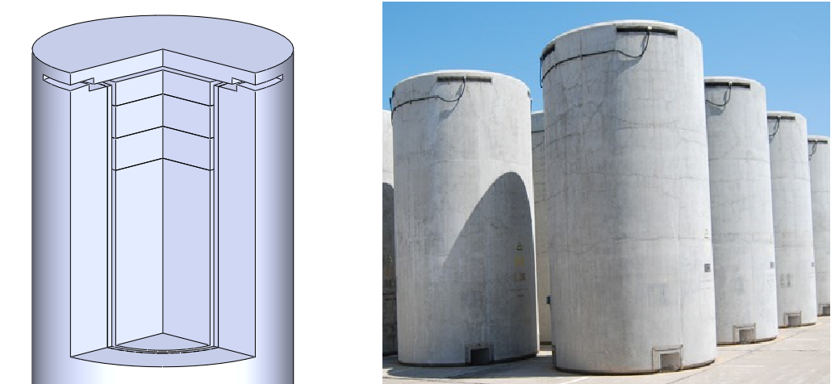
FIG. 1.Storage containers for storage of spent nuclear fuel used on Zaporizhzhya NPP
Many works devoted to the study of the thermal state of fuel use simplified models without detailed internal geometry of the container, some physical processes are ignored, or physical properties are generalized. Usually the cask is considered as a one unit with summarized properties, for example, thermal conductivity, heat generation, heat capacity, etc [2-3]. Two-dimensional models are also researched, it’s help to see a generalized picture, but leave blind spots [4]. To obtain a complete picture of the thermal state of the fuel, it is necessary to use a more detailed model of the cask, taking into account internal geometries. This will give us the opportunity to optimize the thermal state by improving the placement of fuel assemblies and changing the geometry of the ventilation ducts.

Methodology
Due to dangerous and high level of radioactivity of the investigated object, only numerical simulation was carried out. The effective methodology in this situation is conjugate heat transfer problems, which allow modelling mutual heat transfer in solid and fluid media. Mathematical model includes [5]:
- continuity equation;
- equation of motion of viscous gas;
- energy equation for fluids;
- heat conduction equation for solids;
- equations of k-ε turbulent flow model;
- ideal gas law for calculation of cooling air density;
- equations for calculating thermal properties of helium as a function of temperature;
- equations which describe the radiative heat transfer.
Equations are solved by standard program complexes, which are used methodology based on finite-elements methods.
Two models were used in the simulation. In the first model, the cask was a solid object with equivalent thermal properties. The power of the SFA is uniformly distributed inside cask. With this model, the boundary conditions (the temperature of the ventilation air and the heat transfer coefficient at the cask surface) were obtained. In the second model, a cask with complex geometry inside (assemblies were simplified as a solid body) and with boundary conditions, which were found in the first model.

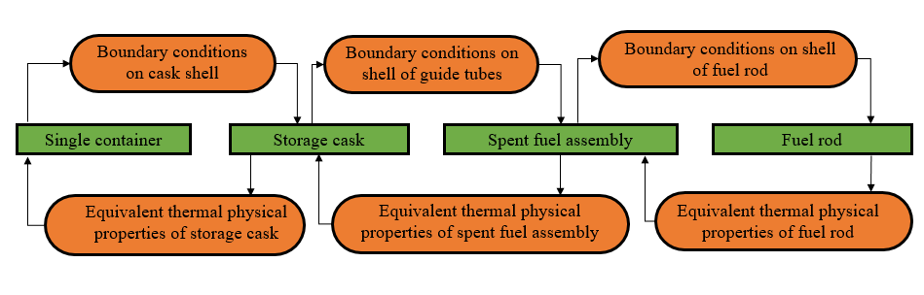
FIG. 2. Method diagram

results
In accordance with the methodology, boundary conditions on the surface of the basket were obtained. Then, using them, the detailed temperatures in the basket (Fig. 3), the temperatures on the surfaces of the guide tubes and the temperature field of the assemblies were obtained (Fig. 4).
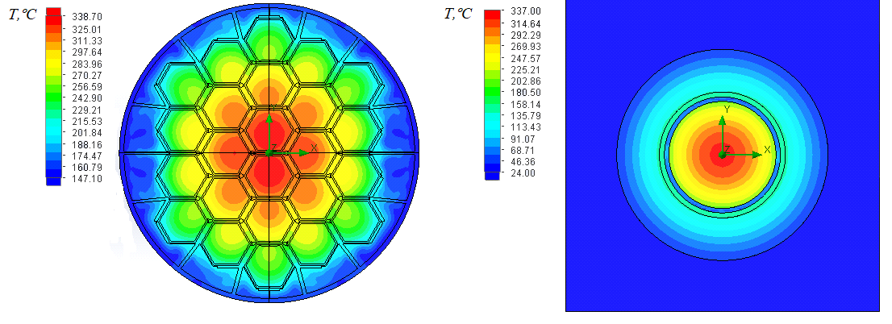
FIG. 3. Cross-section of the cask XY (left - detailed model, right - simplified model)

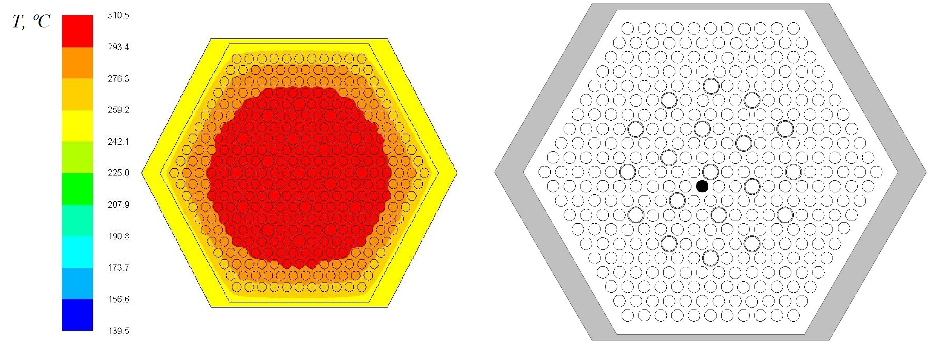
FIG. 4. Temperature distribution in the hottest assembly and location of the hottest fuel element

The dependence of the heat transfer coefficient of the surface of the basket on the height was obtained.
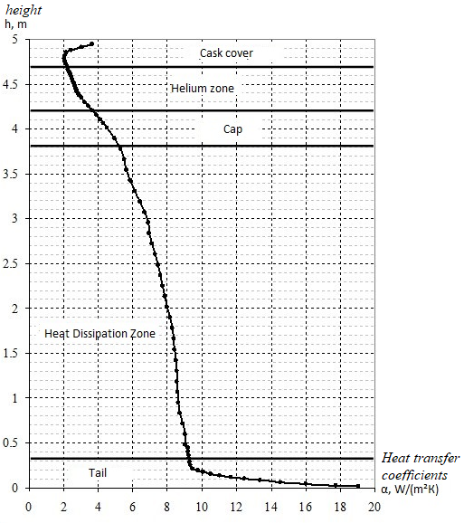
FIG. 5. The dependence of the heat transfer coefficient on the surface of the basket of height

Conclusion
This method of separating the task helps to obtain a large amount of information about the thermal state of the fuel. The obtained information is used to assess security and other studies. This method can be adapted for the second storage for spent nuclear fuel (SSNF-2) located on the territory of the Chernobyl Nuclear Power Plant.
References
- Spent Fuel Reprocessing Options. IAEA-TECDOC-1587. 2008. 144 p.
- Wataru M., Takeda H., Shirai K., Saegusa T. Thermal hydraulic analysis compared with tests of full-scale concrete casks. Nuclear Engineering and Design 2008; 238: 1213 – 1219, DOI: 10.1016/j.nucengdes.2007.03.036
- Ju-Chan Lee, Kyung-Sik Bang, Ki-Seog Seo, Ho-Dong Kim Thermal analysis of a storage cask for 24 spent PWR fuel assemblies. Packaging, Transport, Storage & Security of Radioactive Material 2005. V.16, I.1. – P.19-26. DOI: 10.1179/174650905775295611
- H. Yamakawa, M. Wataru, Y. Kouno, T. Saegusa Demonstration test for a shipping cask transport high burn-up spent fuel. Thermal test and analyses
- Alyokhina S. Simulation of thermal state of containers with spent nuclear fuel: multistage approach / S. Alyokhina, V. Goloshchapov, A. Kostikov, Yu. Matsevity // International Journal of Energy Research. – 2015. – V. 39, Iss. 14, Nov. – P. 1917–1924, DOI: 10.1002/er.3387

