Cost drivers associated with spent nuclear fuel storage options and technologies

Y.AHN
Sejong University
Seoul, Republic of Korea
Email: energyerin17@gmail.com

S.DARDOUR, D.SUBBOTNITSKIY, A.GONZALEZ-ESPARTERO, L.MCMANNIMAN
International Atomic Energy Agency

Abstract

The work was conducted in the context of the International Atomic Energy Agency’s (IAEA) newly initiated activity on “approaches for nuclear power costs estimation and analysis” (the “Nuclear Cost Basis”, or NCB, project). The NCB provides guidelines and resources for developing consistent cost estimates and analyses covering, basically, all areas of a country’s nuclear power programme; from nuclear infrastructure development; to reactor construction and operation; to management of radioactive waste. The paper focuses on technologically mature, widely used, spent nuclear fuel storage options and technologies. Storage of spent nuclear fuel can be made At-Reactor (AR) or Away-from-Reactor (AFR) ― at Reactor-Site (AFR-RS) or Off-Site (AFR-OS) ―. These options may involve wet (water pools) and dry storage technologies (casks, vaults, silos). For each of these technologies and options, an effort has been made to synthesize existing literature and compile a comprehensive list of key factors affecting costs. This list will be used as a basis for developing standard cost categories and cost breakdown structures for costing purposes.

INTRODUCTION

Background
Early nuclear power used and developed countries have taken short-term measures at the existing AR pools. However, as these facile options are exhausted, additional AFR storage technologies will have to be provided. Considering the owner’s capacity needs, diverse options can be made for new spent fuel storage facilities. Nuclear power plant owners can perform the selection and pick up the suitable AFR facilities. In the point of view of designing the new storage facilities, to extend the storage period until the endpoint idea becomes feasible is the crucial part of the sustainable use of nuclear power. Identify the possible period of the storage extension and estimate the costs so that each implementing organization could make a long term investment for it is essential in this case.

Objectives and approach
This paper builds on work performed in the context of the International Atomic Energy Agency’s newly initiated activity on the “approaches for nuclear power costs estimation and analysis” (the “Nuclear Cost Basis”, or NCB, project). Multiple IAEA Member States, especially nuclear newcomer countries have been requested for IAEA assistance toward sharing best practices in the areas of nuclear project cost management. The NCB will be primarily focused on methodologies for cost estimation and analysis.
The paper focuses on the technologically mature, widely used spent nuclear fuel storage options and technologies. An effort has been made to synthesize existing literature and compile a comprehensive list of key factors affecting costs. Three main considerations to classify the cost factors were used for this work:
- Configurations: At-Reactor (AR) or Away-from-Reactor (AFR) ― at Reactor-Site (AFR-RS) or Off-Site (AFR-OS) ―
- Technologies: wet (water pools) and dry storage technologies (casks, vaults, silos)
- Cost Categories: Capital, Operation & Maintenance (O&M), Decontamination and Decommissioning (D&D)
This list will be used as a basis for the developing standard cost categories and cost breakdown structures for costing purposes.

Comprehensive overview of waste management solutions

Basis to the waste classification
The IAEA Safety Standards classifies radioactive waste into six classes according to the activity and half-life of radionuclides. A conceptual illustration of the waste classification scheme is presented in Fig.1. Figure 1 describes the association between waste classes, activity levels and half-lives, with the boundaries between classes (shown as dashed lines).
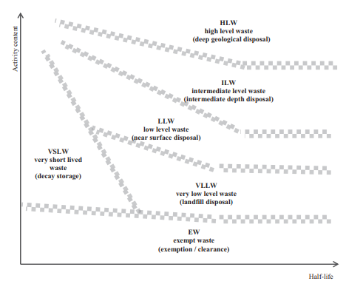
Figure 1 Conceptual illustration of the waste classification scheme (by IAEA Safety Standards)

Six classes of waste as the basis for the classification scheme:
- Exempt waste (EW): Waste that meets the criteria for clearance, exemption or exclusion from regulatory control for radiation protection purposes.
- Very short lived waste (VSLW): Waste that can be stored for decay over a limited period of up to a few years and subsequently cleared for uncontrolled disposal, use or discharge.
- Very low level waste (VLLW): Waste that does not necessarily meet the criteria of EW, but that does not need a high level of containment and isolation and, therefore, is suitable for disposal in near surface landfill type facilities with limited regulatory control.
- Low level waste (LLW): Radioactive waste with only limited amounts of long-lived radionuclides. Such waste requires robust isolation and containment for periods of up to a few hundred years, and is suitable for disposal in engineered near surface facilities.
- Intermediate level waste (ILW): Waste that, because of its content, particularly of long-lived radionuclides, requires disposal at greater depths, of the order of tens of metres to a few hundred metres.
- High level waste (HLW): Waste with levels of activity concentration high enough to generate significant quantities of heat, or waste with large amounts of long-lived radionuclides. Disposal in deep, stable geological formations, usually several hundred metres or more below the surface, is the generally recognized option for disposal of HLW. [1]

Origin of the waste
Radioactive waste is mainly produced through all stages of the nuclear fuel cycle. The fuel cycle includes the mining and milling of uranium ore, its conversion, enrichment and fabrication into nuclear fuel. [2] When it comes to the use in the reactor, two options are available from the used fuel, reprocessing or disposal. According to the policy decision, if reprocessing is the next step, the treatment of the used fuel taken from the reactor and the disposal of the waste are performed or the used fuel directly are moved to the disposal repositories. While waste is also produced during mining and milling and fuel fabrication, the major part comes from the actual burning of the uranium to produce electricity which is also called as back-end fuel cycle; from interim storage of the used fuel to the disposal.
In this regard, no matter which option did they choose challenges to address these kinds of waste is the management of HLW, spent nuclear fuel, which needs more technologies to make a distance from the public, and it needs a longer time than other types of wastes.

spent nuclear fuel storage options and technologies
Spent nuclear fuel has been managed for many years in multiple countries, and the management process is generally divided as AR (pool), interim storage (various types of facilities), reprocessing (ex. PUREX, etc.) or recycling (ex. Pyro-process, SFR, LBFR) pending its policy decision. Fig.2 describes this concept as a flow chart.

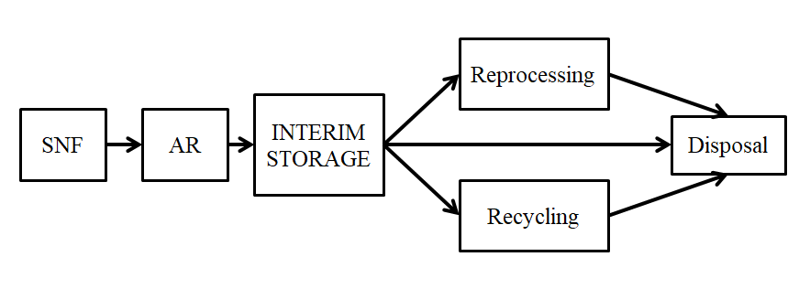
Figure 2 Spent Nuclear Fuel Management Flow Chart
The first step of the management of all the spent fuel is the AR pool. Unloaded spent fuel is immediately moved to the AR pool. Forced cooling method is the way how to cool and store the spent nuclear fuel at reactor pool storage. Wet storage of nuclear fuel is the essential facilities for the nuclear fuel replacement and cooling the highly radioactive and high-heated spent fuel. After cooling it for some years, this fuel is usually moved to the interim storage facilities. The interim storage facilities are classified as its configuration, technology. According to the way how to cool the fuel, two main technical options can be varied, dry storage and wet storage. Configurations are At-Reactor (AR) or Away-from-Reactor (AFR) ― at Reactor-Site (AFR-RS) or Off-Site (AFR-OS) ―.

Dry storage options
- Cask
There are two major types of casks, which are metal casks and concrete casks. They look similar in shape, but the differences are here:
      - Metal cask: conduction through cask wall, double lid metal gasket as a containment and shielding through metallic wall
      - Concrete cask: air convection around canister, cavity lining/seal welding as a containment and shielding through concrete and steel over pack

- Concrete module
      - Air convection around canister, canister sealing as a containment and shielding through concrete wall

- Vault
      - Air convection around thimble tube, thimble tube as a containment and shielding through concrete wall

Wet storage option
The most classic and widely used spent fuel storage method is water pool storage. Almost 90% of the worldwide spent nuclear fuel is currently stored and managed in the AR or AFR pool storage safely. Decay heat generated from the spent nuclear fuel is removed through the heat exchanger based on the forced air cooling system. Wet storage option has its advantage on that it has higher storage density than the dry storage options. Thanks to the properties of water for heat removal and shielding, wet storage has been selected for a long time. For the long history requires significant modifications to the internals of the pool.

a comprehensive list of key factors affecting costs
In this paper, three main considerations were applied to classify the costs for the spent fuel storage options: cost categories, configurations, technologies. Major cost categories are three steps, which are capital-related costs, Operation & Maintenance (O&M) costs, Decontamination and Decommissioning (D&D) costs. Each cost category contains multiple project phases of the nuclear power plant. Capital costs contain project definitions, design engineering, regulatory approval, and construction. O&M costs are from spent fuel loading to unloading including storage between those. D&D is the step of the Decontamination and Decommissioning, literally. Configurations here it means the location of the storage site such as At-Reactor (AR) or Away-from-Reactor (AFR) ― at Reactor-Site (AFR-RS) or Off-Site (AFR-OS) ―. These options may involve wet (water pools) and dry storage technologies (casks, canister/basket, and vault storage).
Cost categories here are classified by the technologies specific cost categories, the configurations specific cost categories, and the common items which are more or less independent from the technologies and configurations. For these technologies specific costs, pending on the technologies they applied to, wet storage or the dry storage, options for the spent fuel storage could come up also. Infrastructure, systems, transfer equipment, transport equipment, decontamination are those. Table 1 shows the list of the dry storage technologies specific costs regarding each option of the spent fuel; here all the costs are related to the capital cost categories. Table 2 provides a list of the cost that is involved in the wet storage technologies for the two options of the spent fuel. For the common items, two major cost categories of the operating costs and the D&D costs are shown in Table 3. [3], [4]

TABLE 1. Technology specific costs (dry storage)

Options | Infrastructure | Systems | Transfer equipment | Transport equipment
Cask | land  site preparation  bridge  roadways  site access | Storage cask  cask handling  cask loading and unloading  cask sealing  cask operating | transfer cask  transfer cask handling  transfer loading and unloading | transport cask  transport cask handling  transport cask loading (and unloading)
Canister/Basket |  | canister or basket  canister handling  canister loading and unloading  canister welding  canister operating | transfer cask  transfer cask handling  transfer loading and unloading | transport cask  transport cask handling  transport cask loading (and unloading)
Vault |  | vault building  storage vault  canister handling  canister welding  air filtering | transfer cask  transfer cask handling  transfer loading and unloading | transport cask  transport cask handling  transport cask loading (and unloading)

TABLE 2. Technology specific costs (wet storage)

Cost categories | Capital related costs
Options | Systems | Transfer equipment
Technology specific costs | Pool building  Pool structure  Water Cooling  Water purification  Air filtering | Fuel (basket) handling

TABLE 3. Common costs (more or less independent from technologies & configurations)

Cost categories | Capital related costs | Operating costs | D&D* costs
Common costs  (more or less independent from technologies & configurations) | airborne particulate monitors  radiation monitor  security fencing  intrusion alarm system  access control system  CCTV monitoring system  guard house/stations | Staff costs (i.e. salaries, wages, benefits, etc.)  Materials and supplies  Utilities  Annual license charges  Overhead (including property taxes, insurance)  General and administrative expenses | Rental of D&D equipment  Staff costs (salaries, wages, benefits, etc.)  Materials and supplies  Utilities  Subcontractor charges (for export advice, special services, independent audits and measurements, etc.)  Waste transport and disposal charges  Licensing expenses  Overhead  General and administrative expenses

Lessons Learnt and Conclusions
As the nuclear industry grows gradually, people who have been developed its technologies focused on the early stage of the nuclear power plant are turning their attention to its post stage, and radioactive waste management is one of the challenges in this stage. As spent fuel has its special properties of high radioactivity and decay heat, to manage it safely and efficiently needs special effort. The management process of spent fuel may vary according to the spent fuel policy; to store it well is essential under any circumstances.
Along with the purpose of the NCB projects, the work in this paper was conducted targeting nuclear newcomer countries that need a comprehensive, clear idea. Beginning with an overview of radioactive waste management solutions including the basis to the waste classification and the origin of the waste, this paper narrows down the scope to the high-level waste (HLW), spent fuel. In this regard, the work more focus on the spent fuel management and another overview dealing with spent nuclear fuel storage options were done. Cost categories information regarding spent fuel storage technology options was described. For each of these technologies and options, an effort was made to synthesize existing literature and compile a comprehensive list of key factors affecting costs. This list will be used as a basis for developing standard cost categories and cost breakdown structures for costing purposes. For the perspectives, the gaps for the configurations specific that is except off-site reactor cost categories should be developed.
References
- INTERNATIONAL ATOMIC ENERGY AGENCY, Classification of Radioactive Waste, IAEA Safety Standards Series No. GSG-1, IAEA, Vienna (2009).
- ORGANIZATION FOR ECONOMIC CO-OPERATION AND DEVELOPMENT NUCLEAR ENERGY AGENCY, Advanced Nuclear Fuel Cycles and Radioactive Waste Management, OECD NEA Nuclear Development, (2006).
- INTERNATIONAL ATOMIC ENERGY AGENCY, Cost Analysis Methodology of Spent Fuel Storage, TECHNICAL REPORTS SERIES No.361 (1994).
- INTERNATIONAL ATOMIC ENERGY AGENCY, Costing of Spent Nuclear Fuel Storage, IAEA Nuclear Energy Series No. NF-T-3.5 (2009).
- ORGANIZATION FOR ECONOMIC CO-OPERATION AND DEVELOPMENT NUCLEAR ENERGY AGENCY, The Economics of the Back End of the Nuclear Fuel Cycle, NEA No. 7061 (2013).
- IDAHO NATIONAL LABORATORY, Advanced Fuel Cycle Cost Basis, INL/EX`T-07-12107 Rev.2 (2009).

