Countering the Evolving Threat of Nuclear and Other Radioactive Material out of Regulatory Control: Jamaica’s Experience
C.O. Boyd
International Centre for Environmental and Nuclear Sciences (ICENS),
University of the West Indies

ABSTARCT

Developing sustainable approaches to strengthen the safety and security of nuclear and other radioactive materials in Jamaica was propelled by the successful bilateral “Megaports“ initiative of the US DOE’s National Nuclear Security Administration (NNSA) and their Second Line of Defence and the Government of Jamaica through the Jamaica Customs (2006). Through this initiative, since 2009, four (4) discoveries of source of radiation have been uncovered, all found in shipments for international transport. Jamaica was prompted by these discoveries to becoming the 118th Member State of the then International Atomic Energy Agency’s Incident and Trafficking Database (ITDB) as of 2013, and subsequently now in the final stages of completing a Jamaican specific Integrated Nuclear Security Support Plan (INSSP); a non-binding instrument with the IAEA. These two nuclear security systems both have the potential of lowering the evolving threat of nuclear and radioactive material out of control in Jamaica as we develop a legislative and regulatory framework which supports nuclear safety and security issues with reference to international legal instruments and IAEA guidelines.

INTRODUCTION AND HISTORY

Jamaica currently has the only nuclear reactor in the English speaking Caribbean, a small 20 kW 93% highly enriched uranium core, used at the University of the West Indies since 1984 as a research tool. Jamaica also has a long history of importing radioactive materials for productive use in medicine, industry, agriculture and other areas of research. The presence of sealed radioactive sources (SRSs) in the scrap metal and metal recycling industries, along with customs or border protection incidents are consistent with the problems of orphaned sources in other developing and developed countries. Developing countries like Jamaica have significantly lower radioactive source inventories relative to developed states such as the European Union (EU) and the United States of America (USA). We are also faced with weak national regulatory infrastructures which are believed to be the reason for a higher risk of sources becoming orphaned. The latest improvements to safety and security at the border protection and transhipment Port in Kingston, for monitoring of nuclear and other radioactive materials in import/export and transhipment trade is due mainly from resources donated through the USA’s Department of Energy (DOE) and the National Nuclear Security Administration (NNSA), through their Second Line of Defence (SLD), under the theme “Megaports” Initiative. In June, 2006 the Government of Jamaica and the United States of America signed a Memorandum of Understanding (MOU) implementing the “Megaports” initiative at the ports of Kingston: the Port Authority of Jamaica’s Kingston Wharves Limited (KWL) and Kingston Container Terminal (KCT). The aim of the program was specifically “to provide equipment, training, and technical support to its international partners to enhance their ability to deter, detect, and interdict illicit trafficking of special nuclear weapons of mass destruction (WMD) and other radioactive materials in the global maritime system”(2009) .

Through this initiative SRSs and other radioactive materials out of regulatory control have been discovered and intercepted at our ports. Table 1 highlights some of the radioactive materials and sources being discovered since the initiative began as of August 2009. One incident of note that occurred before the initiative began was in 2008, from a scrap metal container exported from Jamaica and rejected at an import destination due to the radioactive signature associated with the shipping container. The source was identified as Cs-137 by personnel from the International Centre for Environmental and Nuclear Sciences (ICENS), a technical support organisation engaged in source recovery and radiation protecting for the Government of Jamaica. Another case study of note occurred in 2009, when a shipping container containing a Ra-226 sealed source, detected by the RPMs, was released for shipment to the US.” The source released was as a result of some Jamaica Customs Officers not aware or fully trained in the standard operating procedures for discovery of radioactive materials. The container however was intercepted by the US Customs and the sources retrieved by US DOE. Since then Jamaica Customs Officers have been made fully aware of the Initiative and as of 2012 three (3) more radioactive sources in outbound containers have been intercepted. Two of the sources were the gamma emitting Cs-137, while the other was a neutron Am-241/Be source from a density gauge monitor. These interdicted radiological materials were all categorized and characterized after a secondary inspection by ICENS personnel. Sources were taken under control and are temporarily stored due to the efforts of Jamaica’s Office of Disaster Preparedness and Emergency Management (ODPEM), the Jamaica Customs and ICENS.

Table 1 Incident log of radiological materials discovered in Jamaica
Year Logged | Source of Radiation | Location | Dose Rate at Surface / Radioactivity | Half Life of Source/years | Agency Involved | Alarm category
2008 | Cs-137 | Linstead, Saint Catherine | Undetermined | 30.1 | Retrieved by ICENS | Gamma
2009 | Ra-226 | KWL | Unknown | 1601 | Retrieved by US DOE | Gamma
2009 | Ra-226 | KWL | 0.20mSv/  20mR hr⁻¹ | 1601 | Retrieved by ICENS | Gamma
2010 | Cs-137,  Am*/Be-241 | KWL | 0.45mSv hr⁻¹/  45mR hr⁻¹ | 30.1,  432.2* | Retrieved by ICENS | Neutron- Gamma
2012 | Cs-137 & Cs- 134 | KCT | 1.68µSv hr⁻¹  (21.4 Bq/m²) | 30.1 | Analysed by ICENS | Gamma

INSTRUMENTATION: NEUTRON GAMMA MONITORS
There are two (2) pairs of radiation portal monitors (RPMS) at entrance and exit check points at the port Figure 1. Each RPM consists of two (2) gamma and two (2) neutron detectors, control electronics, power supplies and occupancy sensors; a battery backup and communication equipment are also installed. The equipment passively detects radiation; however, five (5) alarms can be triggered. They included alarms for neutron and gamma radiation, tampering, high/low background readings, and internal faults.
Gamma radiation detectors are made with organic scintillating plastic (e.g. poly-vinyl-toluene). The absorbed gamma photon causes fluorescence in the organic molecules. The process of fluorescence is the prompt emission of visible radiation from a substance following its excitation by some means. The light produced travels to a photomultiplier tube which amplifies the photon signals. This electrical signal is recorded as a count by the detectors.
Neutron radiation was detected by helium (He) gas filled ionization chambers moderated with a polyethylene casing that slowed neutrons down and improved the probability of their capture. The incident neutron induces a nuclear reaction. Upon collisions with the nuclei of the absorbing material, the relative probabilities of the various types of neutron interactions are dependent on the neutron energy. Secondary charged particles result from these interactions which can then be detected directly. The charged particle produces ions which are also detected as a count.

Figure 1: Gamma-Neutron Monitors at Jamaica’s Ports in Kingston Jamaica. (a) Entrance Check Point
(b) Straddle carrier for transshipped cargo monitoring (c) Exit Check Point
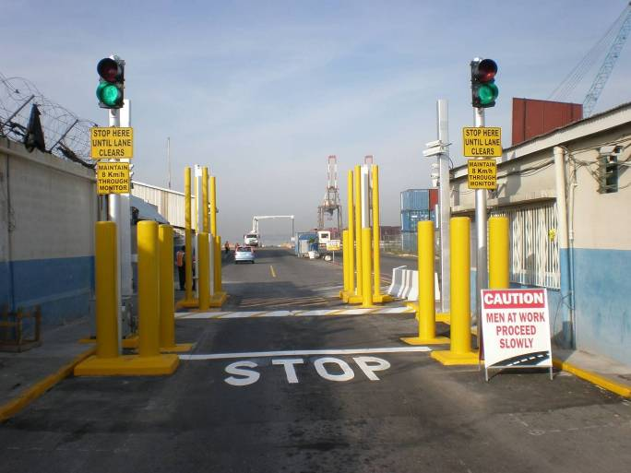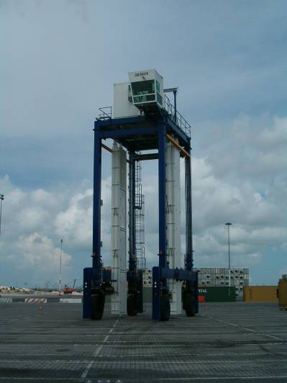
(a)
(b)
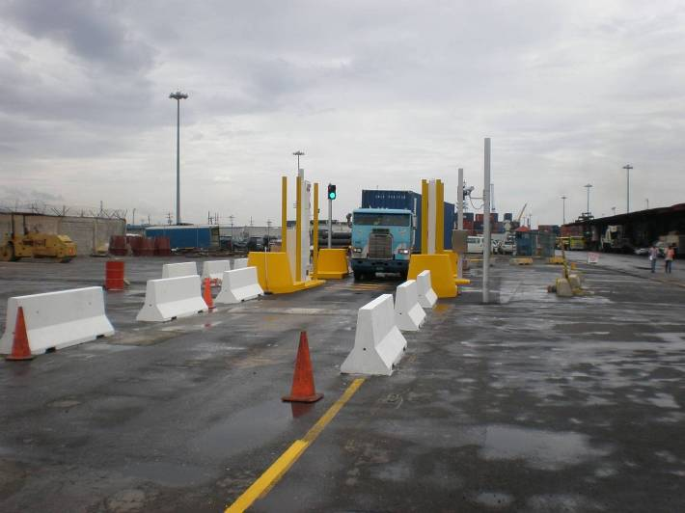
(c)

The “Alarm Details” section of the Jamaica Customs’ Central Alarm Station (CAS) report indicated that a total of 888 alarms were detected between August 2009 to August 2010; 67 secondary inspections were further conducted from these alarms, of which, four alarms required tertiary inspection which uncovered 3 radioactive sources and one imported vehicle radioactively contaminated. Figure 2 highlights the standard procedure from alarm detection, through to a secondary inspection and finally a tertiary inspection by technical personnel. Table 2 provides details on the frequency of alarms since the start of the initiative in 2009. The CAS events overview report indicates that naturally occurring radioactive materials (NORMs) accounted for 64% of the alarms detected and less than 1% of the alarms (Real Alarms) were of orphaned sources once used in industry and found among scrap for international transport, from 2009 to 2010.

Figure2. Secondary Inspection Process Leading up to a Tertiary Inspection
ALARM
SCAN CONTAINER AGAIN

Release? Investigate? Detain?
STANADARD OPERATING PROCEDURES AND OFFSITE TECHNICAL SUPPORT BY ICENS (TERTIARY INSPECTION)
Manifest information
Innocent Alarm?
False Alarm?
Illicit Alarm?

NEUTRON or NEUTRON- GAMMA
Gamma

Table 2 Number of Alarms derived from the CAS Events Overview Report by Alarm Disposition Types from 2009 to 2010
Alarm Dispositions Types | Number of Alarms | Frequency (%)
Innocent Alarm-NORM | 567 | 63.85
Innocent Alarm-Legal Source | 2 | 0.23
Innocent Alarm-Medical isotope | 1 | 0.11
Alarm/Tamper/Fault-Maintenance, Training or Test | 27 | 3.04
Real Alarm-Other | 6 | 0.68
Other | 12 | 1.35
False alarms | 273 | 30.74
Total | 888 | 100.00

Approximately 68,487 containers entered the KWL from 2009 to 2010. All import/export containers in Jamaica are now screened for radioactive material content by the RPMs at the KWL. There are no estimates however of the number of containers screened by the Kingston Container Terminal (KCT), who acquired a “straddle carrier” radiation detection system in 2012 primarily for transhipment operations.

JAMAICA’S CHALLENGES HIGHLIGHTED BY THE INITIATIVE

- Capacity building deficiencies exist
- Lack of a dedicated nuclear forensics infrastructure aid by traditional forensics
- Lack of a national management strategy for emergencies, and safety and security relevant events involving nuclear and other radioactive sources
- National repository issues for radioactive sources out of control; for radioactive waste management
- Introduction of the “Megaports” Initiative in a developing State (Jamaica) further revealed the gaps and the implications from not having a proper regulatory framework
- Radioactive materials and sources out of regulatory control are being uncovered in scrap metal and imported trade
- Lack of a State System of Accounting and Control (SSAC) for radioactive sources exist
- A comprehensive legislative framework for safety and security of nuclear and other radioactive materials

With these challenges in mind and the philosophy that the responsibility of nuclear security rests entirely with each individual Member State, Jamaica has taken steps to be a part of the IAEA’s illicit trafficking database and to finalize an Integrated Nuclear Security Support Plan (INSSP). We await legislation concerning nuclear and other radioactive materials in line with international legal instruments and IAEA guidelines.

REFERENCES

- Uslu I., Issues in the Management of Orphan Sources. Education Faculty, Selçuk University, Meram, Konya, Turkey. Paper presented at the IAEA’s Safety and security of Radioactive Sources: Towards a Global System for the Continuous Control of Sources throughout Their Life Cycle, Proceedings of an International Conference, Bordeaux 27 June-1 July 2005.

- International Atomic Energy Agency, Strengthening Control over Radioactive Sources in Authorized Use and Regaining Control over Orphan Sources: National Strategies, IAEA-TECDOC-1388, IAEA, Vienna, 2004.

- International Atomic Energy Agency, IAEA. Illicit Trafficking and Other Unauthorized Activities involving Nuclear and Radioactive Materials, Fact Sheet, 2006.

- U.S. Department of Energy, Megaports Initiative Scrap Metal Briefing: Presented by Christine Bent, Country Manager, Office of Second Line of Defense, Megaports Initiative November 2009.

- Hill C., Director OSHE, Jamaica Customs, Government of Jamaica, personal communication, January 2010.

