Use of micro-Raman spectrometry for nuclear forensics

# F. Pointurier, O. Marie

CEA, DAM, DIF, F-91297 Arpajon, France

**Abstract**. Thanks to its ability to carry out structural identification of small–size objects, Micro-Raman spectrometry (MRS) is a potentially interesting tool for nuclear forensics. In this communication, application of Raman spectrometry to the fast and non–destructive determination of the chemical composition of various uranium compounds will be presented and discussed. Analysis by MRS can be carried out to minute amounts of samples and to mixtures of various uranium species. Moreover, MRS can be coupled to a scanning electron microscope (SEM) thanks to a coupling device. This interface was designed to obtain topographical information (by SEM imaging), elemental composition (by EDX), and chemical information (by MRS) from the same spot without sample transfer. Different examples of analysis by MRS or SEM–MRS coupling of relevant samples for nuclear forensics will be shown.

# Introduction

Raman spectroscopy (RS) is nowadays largely used in chemistry, biology and material science. It allows a remote, fast, very sensitive to slight structural changes, and almost non-destructive identification of chemical species and of their symmetry in a low amount of material. This technique is particularly of interest in the case of a potentially toxic or radioactive sample, of unknown origin, even of irregular shape. Moreover, several authors [1–12] demonstrated that several uranium compounds can be detected and distinguished from one another by using MRS. They also identified specific Raman bands for several uranium compounds relevant for the nuclear industry, even if most of these studies were carried out on significant amounts of materials (in the 100s of mg to the g range) as single crystals or powdered materials. However, several authors demonstrated that Micro–Raman spectrometry (MRS) is suitable for the analysis of individual microscopic objects, with a better spatial resolution (till ~1 μm) than other microanalysis techniques like micro–infrared spectroscopy (typically 20–400 μm) and micro–X-ray–fluorescence (50–3000 μm).

So, Raman spectrometry is well suited for nuclear forensics analysis, because samples are nuclear or radioactive, and non-destructive analysis must be conducted to allow applying several analytical techniques on the same sample to achieve a complete expertise. More specifically, MRS local micro–analysis capability is potentially interesting in three cases:

1. Micrometric particles are identified in the inner or outer surfaces of the container and/or packaging of the bulk seized nuclear material. These particles may be of the same composition of the bulk nuclear material (contamination) but they can also be of different composition and so bring additional information about origin of the bulk nuclear material.
2. The seized sample is a mixture of several compounds. In such a case, a bulk analysis provides only averaged information. Micro–analysis at the scale of the single particle is therefore necessary to identify each individual components of the mixture and to increase probabilities to identify origin of the whole sample or of its components.
3. The seized sample itself is a very small one, and contains only minute amounts of material. This small amount of material may have to be divided in several sub–samples for different kind of analysis, possibly carried out by different laboratories (among which destructive analytical techniques like mass spectrometry). Therefore, quantity of material in sub–samples may be too low for other structural analysis techniques.

Since 2006, CEA trace analysis laboratories in Bruyères–le–Châtel (France) are equipped with a MRS and, since 2008, with a coupling device between a SEM and the MRS. This device allows performing in–SEM Raman analysis for particles which are too small to be efficiently analyzed by MRS after location by SEM and relocation inside the MRS measurement chamber. Studies are in progress at CEA to exploit capabilities of these instruments for both safeguards and nuclear forensics [13–14]. In this paper, a few potential applications of MRS and of SEM-MRS coupling to samples deemed relevant for nuclear forensics are described and discussed.

# Materials and instruments

## Micro-Raman spectrometer

## The MRS used in this study (‘InVia’, Renishaw, UK) is equipped with two lasers of different wavelengths: 514 nm (green) with a power of 50mW and a 785 nm (red) with a power of 300 mW. Most of the uranium compounds are colored and fluorescent, which allow choosing the laser that minimizes fluorescence for each U compound, although the 785 nm usually allows obtaining the best signal–to–noise ratios. The most appropriate substrates for both sampling particulate material and carrying out MRS analyses proved to be commercially available sticky carbon disks covered with glue (Agar, Oxford Instruments, Saclay, France). Before analyzing samples, it is necessary to calibrate the detector with respect to the wave numbers and to check the alignment of mirrors and holographic gratings. For this, a pure silicone sample is systematically analyzed to check the position (520±1 cm−1), resolution (<5 cm−1) and intensity of the main Raman band of silicone. Laser powers are carefully optimized as lower powers do not provide enough sensitivity for micrometric targets whereas higher powers may lead to a quick thermal decomposition of the particle. Generally, powers are set to 1% of the maximal value for the 514 nm–laser (i.e. ~0.5 mW) and to 0.1% of the maximal value for the 785 nm–laser (i.e. ~0.3 mW). Analyses are generally relatively fast with typical measurement times of a few minutes. Spectral range is generally 100 cm−1 to 2000 cm−1.

## SEM

Two SEM are used to identify and locate U-bearing particles prior to the MRS analyses: a ‘XL–30 ESEM’ (FEI, the Netherlands) and a ‘Quanta 3D FEG’ (FEI, the Netherlands). Both of these instruments are equipped with an EDX analyzer and software for automated detection and location of particles (Eastern Analytical SPRL, Stevelot, Belgium). This software, called ‘gunshot residue’ (GSR), detects automatically particles whose average atomic number is above a given threshold (usually 20 to 25). In addition, the ‘Quanta 3D FEG’ is equipped with a WDX analyzer and a Focused Ion Beam (FIB) device. U-bearing particles deposited on a 1–inch diameter disk can be detected within ~8 hours. Particles as small as ~1 and ~0.5 µm are detected with respectively the ‘XL 30’ and ‘Quanta 3D FEG’ instruments. Then, the disks are transferred to the MRS.

## SEM–MRS coupling

The SEM–MRS device (‘SEM–SCA’, Renishaw Ltd.) was designed to obtain topographical information (by SEM imaging), elemental composition (by EDX), and chemical information (by MRS) from the same spot without sample transfer. The laser beam is transferred inside the SEM measurement chamber through a mono–mode optical fiber inside a retractable arm. Raman scattering signals are transferred to the Raman charge–coupled device (CCD) detector through the same optical fiber. The retractable arm is inserted between the BSE detector and the SEM sample holder and is positioned just ahead of the sample. The Raman scattering signal is transmitted back to the MRS following exactly the same path, through the optical fiber, and is finally directed to the CCD detector of the MRS. Particles at the disk’s surface can be simultaneously viewed on the one hand with the CCD camera of the MRS thanks to a mirror attached to the retractable arm and, on the other hand, with the SE detector of the SEM. Both views are available on two separate screens. The illumination due to the laser beam can also be observed on the view provided by the CCD camera. The image of the laser beam should appear exactly in the center of the crosshairs. The spot sizes of both 514 and 785nm laser beams are less than 2 μm.

## Samples

Different types of particulate materials were used for the experiments described in this paper. Small amounts of U compounds, namely U3O8, UO4·*x*H2O, UO3, UO2, UO2F2, and UF4 produced by Areva (Pierrelatte, France), were collected with adhesive carbon disks from bulk materials (each disk containing only one compound). These materials are not reference materials, although their bulk composition is reportedly well characterized and guaranteed by the producer. Particle size distributions were large, but only particles in the size range of a few μm to a few tens of μm were studied. Raman bands regarded as the characteristic bands of a given U compound are the ones that are reproducibly observed for all particles.

Pu dioxide particles were produced by VTT Technical Research Center of Finland from certified reference material #136 solution (Pu isotopic standard, New Brunswick Laboratory, Argonne, IL, USA) using an atomizer system after chemical separation of Am [15]. The highest density of the size distribution of the particles obtained from 312 particles was in the range of 0.7−0.8 μm. The isotopic composition of Pu and U and the amount of Am were estimated by mass spectrometry techniques [15]. MRS analysis was carried out to determine the chemical form of the Pu. Particles were deposited on a glassy carbon disk. Prior to Raman analysis, 12 particles were identified as Pu–containing particles and located by SEM using EDX detector and GSR software. Sizes of these particles are typically between 1 and 2 µm.

Particles from U–Ore Concentrate (UOC) samples (commonly referred to as ‘yellow cakes’) of various origins were deposited by JRC/ITU (Joint European Research Center / Institute for TransUranium elements, Karlsruhe, Germany) on glassy carbon disks using the ‘vacuum impactor’ device specially designed by the Japan Atomic Energy Agency for this purpose. Particle size distributions are variable from one material to the other. Sizes of the analyzed particles range from 5 to 60 µm, although most of them are between 10 and 20 µm.

# Methodologies

## SEM to MRS relocation method

To relocate the particles located beforehand by SEM inside the MRS's measurement chamber, a relocation method based on the identification of landmarks on the sample holder and on suitable calculations was applied. Landmarks (see Fig. 1) are given features on two copper grids currently used in transmission electron microscopy (TEM) or –more recently– platinum crosses drawn by means of the focused ion beam device available on the ‘Quanta 3D FEG’ SEM. Two copper grids are glued or two crosses are engraved randomly on both extremities on the disks on which the particles are deposited. The coordinates of a particle inside the MRS are calculated using rather straightforward arithmetical operations since the positions of landmarks both inside the SEM and the MRS and the position of the particle inside the SEM with respect to the internal reference systems of each instrument are known. However, relocation methods, even with more than two marks, are not precise enough for analyzing particles smaller than ~3–4 µm because these U particles cannot be recognized (and distinguished from non–U particles) with the CCD device of the MRS. Therefore, the laser cannot be enough precisely focused on the particle.

 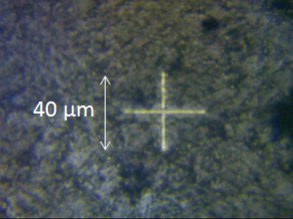

Fig. 1. Left: example of landmark chosen on TEM copper grid: the landmark is at the internal corner of the square immediately on the right above the upper extremity of the “A” letter. Right: example of cross–shaped platinum deposition used as a landmark.

## In-SEM Raman analysis

As the retractable arm is inserted between the sample and the Back-Scattered Electron (BSE) detector, the latter cannot be used when the retractable arm is inserted. So, neither the BSE detector nor the GSR software can be used when the SEM–MRS coupling is active. Therefore, U particles are observed with the Secondary Electron (SE) detector. Particles at the disk’s surface are simultaneously viewed on two separate screens, on the one hand with the CCD camera of the MRS thanks to a mirror attached to the retractable arm and, on the other hand, with the SE detector of the SEM. The illumination due to the laser beam is observed on the view provided by the CCD camera. To carry out a Raman analysis on µm–size particles, it is necessary to determine the position of the impact of the laser beam at the disk’s surface on the SEM image with the greatest accuracy, better than a few hundredths of nanometer. However, an issue for in–SEM Raman analysis is the existing shift between the centers of the SEM and MRS images. For this, a precise landmark, clearly recognizable both with the CCD camera and with the SE detector, for instance a recognizable particle or a specific feature on a TEM grid, must be brought to the exact center of the crosshairs of the CCD image. The corresponding position of the landmark on the SEM image is therefore noted as the real position of the laser beam when focused on the disk. The shift between the centers of the CCD and SE images can be as high as 20 μm. Moreover, this shift may vary from one part of the disk to the other and must be determined frequently. It should be noted that the same magnitude (×500) must be applied for both SEM (SE detector) and Raman (CCD camera) images.

It should be noted that a signal loss by a factor of ~25 is observed when performing Raman analysis on U particles using the SEM–MRS coupling with respect to the MRS alone. Although the background is also reduced by a factor of ~5, the net signal–to–noise ratio obtained with the SEM–MRS coupling is lower by roughly one order of magnitude than that of the stand-alone MRS.

Lastly, as mentioned previously, U compounds are very sensitive to high laser beam intensities. The compromise between a too low laser power (no detected signal) and a too high laser power (destruction of the particle) may be harder to obtain with SEM–MRS coupling than with the stand–alone MRS, because analyzed particles contains a very low amount of material (on the order of a few picograms for a 1 μm particle). For in–SEM Raman analysis, the powers of both lasers are attenuated thanks to attenuation filters designed to transmit 0.3%, 1%, 3%, 10%, 25%, 50%, and 100% of the incident laser light (no 1% and 3% filters are available in the case of the 514 nm–laser), respectively. However, the actual transmission of these filters can be somewhat different from the theoretical values.

# Examples of results

## Particles of various U oxides

The different U oxides used in the nuclear industry (UO2, UO3, U3O8, UO4∙*x*H2O) cannot be reliably distinguished by SEM. Moreover, other usual analytical techniques (like XRF) require larger amounts (milligram range) and are therefore not applicable to µm–size particles. To ensure the applicability of MRS to identify relevant U compounds contained in particles coming from ‘real–life’ samples, particles of each U oxide species deposited on graphite disks were analyzed by stand–alone MRS (particles from 5 µm to tens of µm) and by SEM–MRS coupling (particles as small as 2–3 µm).

The key result is that all U oxide compounds can be systematically distinguished at the particle’s level, by stand–alone MRS [13]. For each U oxide, specific Raman bands were reproducibly observed, for several tens of particles of each species (see Table 1). Moreover, most of these bands match published values, even if other authors analyzed higher amounts of materials. Observed differences between observed and published data, for UO3 and –to a lesser extent– for U3O8, can be explained by existence of several phases for these compounds.

However, analysis of ‘real–life’ samples, for which U particles of known composition are mixed with ‘environmental dust’ (mineral organic and particles) proves to be much more difficult. Until known, characteristic bands observed without environmental dust are not recovered when environmental dust is added. This phenomenon is currently not explained. However, this drawback is less important in the case of nuclear forensic samples (i.e. mainly made of nuclear material) than for typical safeguard samples (i.e. ‘swipes’) for which environmental dust is generally largely dominant.

Table 1. Main Raman bands observed for U oxides particles with the stand–alone MRS.

|  |  |
| --- | --- |
| U compounds | Main Raman bands (cm-1) |
| UO2 | 445 (s), 1150 (w) |
| U3O8 | 351 (m), 412 (s), 487 (m), 810 (s) |
| UO3 | 845 (s), 1052 (w) |
| UO4∙*x*H2O | 823 (s), 867 (m) |

s = strong intensity, m = medium intensity, w = weak intensity

When analysis is carried out by means of the SEM–MRS coupling, typical Raman bands of the studied U oxide species were also successfully observed for particles collected with sticky carbon tapes, although in–SEM Raman spectra are of poorer quality than stand–alone MRS spectra [14]. However, only UO2 and UO3 compounds are correctly identified for most of the particles when particles are deposited on glassy graphite disks.

Regarding the minimal size of analyzed particles using SEM–MRS coupling, Raman analyses of particles smaller ~2 µm proves to be very difficult: many attempts must be carried out before obtaining characteristic Raman bands. This size limitation is due to the extremely low amount of material available (and consequently to the very low Raman scattering obtained), to the difficulty to focus exactly the laser beam (whose diameter is larger than 1 μm) on the particle, and, lastly, to the high probability to ‘burn’ the particle by a too high laser emission. Nevertheless, in some cases, UO2, UO3, U3O8, and UO4 *x*(H2O) particles with sizes between 1 and 2 μm were successfully analyzed. However, analysis of U particles smaller than 1 μm, which may be the physical limit for application of in–SEM Raman analysis to such small objects, was impossible [14].

## UO2F2 particles

In nuclear forensic cases, one can imagine that it can be of interest to identify fluorinated U compounds in particles, either in a ‘side–sample’ (i.e. particles in packaging, containers, etc.) or in a mix of different compounds. SEM and SIMS [16] allows identifying compounds whose major elemental constituents are U, O and F, but not to distinguish, for instance, between UF4 and UO2F2. Again, MRS analysis carried out on particles from bulk nuclear material of known stoichiometric composition (UF4 and UO2F2). Characteristic reproducible Raman spectra were obtained for both of these compounds [13]. In the case of UO2F2, a strong intensity band, also observed [1,5,17,18] or predicted [19] by other authors, was systematically detected at 867 cm-1 in analyzed particles. UF4 is reportedly very difficult to analyze by Raman spectrometry because this compound is highly fluorescent and easily degraded by laser emission. To our knowledge Krasser and Nürnberg [20] were the only authors which successfully observed Raman bands for UF4 thanks to a special optical arrangement of the sample to secure a tolerable noise level permitting unequivocal identifications of the Raman bands. Spectra obtained at CEA for UF4 particles were obviously different from the ones of UO2F2, although Raman bands mentioned by Krasser and Nürnberg were not observed. Obtained spectra have in common a very high background and a single and very broad band whose location depends on the laser wavelength, respectively at ~300 cm-1 with the 785 nm–laser and at ~900 cm-1 with the 514 nm–laser. These broad bands are possibly composed of several bands, with close wavenumbers and relatively poor resolutions. The weak band weak band at 915 cm-1 previously reported by Pidduck at al. [1] and Pointurier et al. [13] for UF4 was most probably due to anhydrous UO2F2 [5]. Be that as it may, MRS allows identifying and distinguishing UF4 and UO2F2 at the particle’s level. However, a relatively long observation of the UO2F2 particle by SEM should be avoided as electron beam bombardment apparently leads to a structural degradation of the particle which prevents further MRS analysis [21].

## Pu oxide particles

In the past decades, a few cases of seizures of small amounts of Pu nuclear material were reported. In such cases, knowledge of the chemical form of the Pu compound, in the bulk material but also at the particle’s level, is very useful. Data about Raman bands of Pu oxide compounds is extremely scarce. In the present study, the produced particles were deposited on an adhesive carbon disk for SEM observation [15]. Twelve Pu particles were located by SEM equipped with EDX spectrometry. The micro-Raman analysis was performed for these 12 particles using specifically the SEM−MRS coupling. All particles had nearly spherical geometry with diameter between 1.4 and 2.4 μm. The laser used was the 514 nm one, the laser power was set to ~0.25 mW (attenuation of 0.5%) and analysis duration was 120 s. The integrated peak area was in the range of 9000−17300 counts. A single band was observed in the range of 474.9−476.4 cm−1 with a bandwidth in the range of 23.3−28.9 cm−1 [15]. This is consistent with the band observed by Begun et al. [22] at 478 cm−1 with a 514 nm–laser, a power of 100 mW and attributed to polycrystalline PuO2. Therefore, the particles were identified as PuO2. One typical example of the micro-Raman spectra measured and the corresponding electronic image are given in Fig. 2.

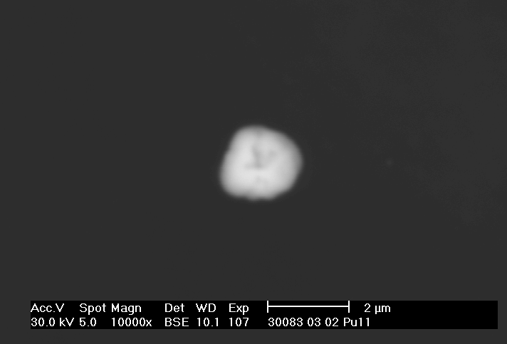 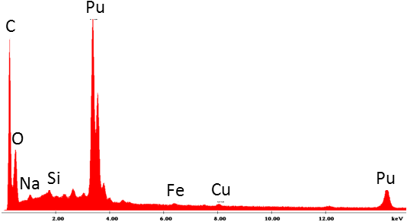

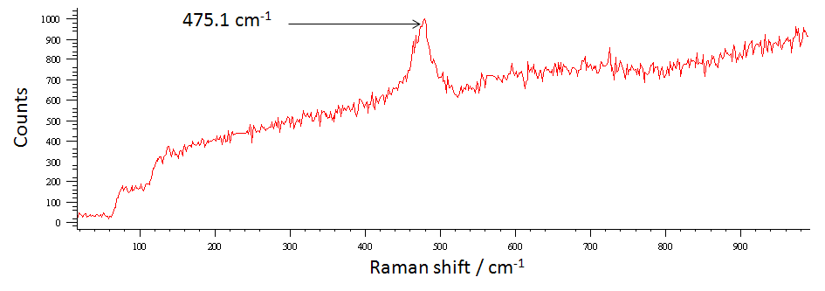

Fig. 2. Typical example of a Pu oxide particle (‘particle #07’) analyzed by SEM–MRS coupling: electronic image (top, left), EDX spectrum (top, right) and Raman spectrum (bottom).

## UOC particles

In the frame of collaboration between CEA and JRC/ITU, 10 particles from 13 different UOCs of various origins were analyzed both by SEM/EDX and MRS. Data treatment (background subtraction, curve fitting, peak identification and integration, etc.) was carried out with the ‘Wire 3.4’ software. Particle sizes ranged from ~5 to ~60 µm. Only the 785 nm–laser was used and focused on particles with the ×50 lens. Depending on sample’s band intensities and fluorescence background, laser attenuation was 0.1% or 1%, and spectrum acquisition time was 10×10 s or 10×60 s. Spectra were measured between 100 and 2000 cm–1, so as to detect peaks related to the U compound itself (100–900 cm–1 region) and peaks related to anions (sulfates, carbonates, nitrates, etc.) present as impurities in the UOCs (900–2000 cm–1 region). Preliminary results are promising: Raman spectra are quite reproducible between particles from the same sample (see Fig. 3), although for some UOCs two or three types of spectra are obtained, and, most of all, typical spectra from different UOCs show significant differences. This suggests that various UOCs could be distinguished and identified based on their Raman spectra. However, more measurements must be carried out and results will be compared with the ones obtained by JRC/ITU with other types of Raman spectrometers on larger amounts of the same UOCs [23]. This work will be the subject of a future article.

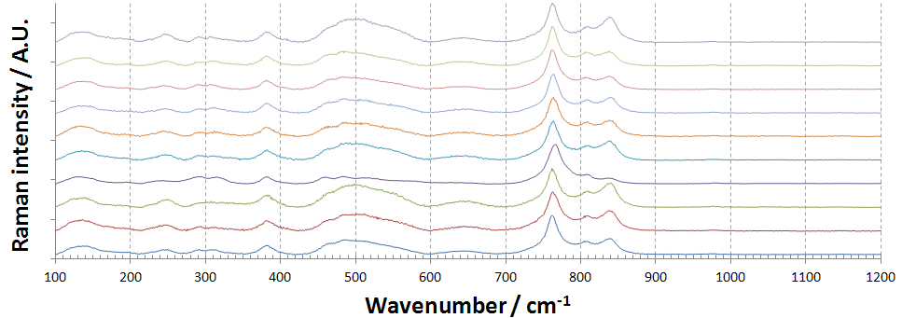

Fig. 3. Background–corrected and normalized spectra for 10 particles of the UOC ‘Union Carbide’. Three main reproducible bands attributable to uranyl ion (UO22+) stretching are observed for the 10 analyzed particles: 763±1 cm-1, 809±1 cm-1 and 839±1 cm-1.

# Conclusions

The few examples described in this paper show that micro–Raman spectrometry is of potential interest for nuclear forensics analysis. This technique can be obviously applied to ‘bulk’ seized samples but, thanks to its capability to analyze micrometric objects, is also relevant in some specific cases: i) when micrometric actinide particles of interest are identified in the inner or outer surfaces of the container and/or packaging of the bulk seized nuclear material; ii) when the seized sample is a mixture of several compounds which must be identified individually by analysis at the scale of the single particle, and iii) when the seized sample contains only minute amounts of material. In such cases, the most usual U compounds in the nuclear industry, as well as Pu dioxide, can be identified in µm–size particles, provided that only limited amounts of ‘environmental dust’ are also present around the actinide particles. Moreover, work presently implemented both at JRC/ITU and CEA strongly suggests that Raman spectrometry analysis may provide specific signatures for UOCs, even at the particle’s level.

More work has to be done notably to demonstrate feasibility of MRS analysis of U particles available in ‘environmental samples’, for which particles of interest are mixed with environmental dust (cellulose, iron oxides, debris of soils or biota, etc.). Besides, database for U compounds has to be enlarged to all crystalline species of UO3 and U3O8 (significant differences are observed between results published by various authors for these species), and to UOCs.

REFERENCES

[1] PIDDUCK, A.J., HOULTON, M.R., WILLIAMS, G.M., DONOHUE, D.L., A multi-technique approach to environmental particle analysis for nuclear safeguards, IAEA-CN-148/115, Proceedings of the Symposium on International Safeguards, Vienna, Austria 16–20 (October 2008) 781–789.

[2] KIPS, R., HOULTON, M.R., LEENAERS, A., MARIE, O., PIDDUCK, A.J., POINTURIER, F., STEFANIAK, E., TAYLOR, P.D.P., VAN DEN BERGUE, S., VAN ESPEN, P., WELLUM, R., The analysis of fluorine in uranium oxyfluoride particles as an indicator for particle ageing, Spectrochim. Acta Part B **64** (2009) 199–207.

[3] MELLINI, M., RICCOBONO, F., Chemical and mineralogical transformations caused by weathering in anti-tank DU penetrators (“the silver bullets”) discharged during the Kosovo war, Chemosphere **60** (2005) 1246–1252.

[4] ALLEN, G.C., BUTLER, I.S., TUAN, N.A., Characterisation of uranium oxides by micro- Raman spectroscopy, J. Nucl. Mat. 144 (1987) 17–19. F. Pointurier, O. Marie / Spectrochimica Acta Part B **65** (2010) 797–804 803

[5] ARMSTRONG, D.P., JARABEK, R.J., Micro-Raman spectroscopy of selected solids, W.H. Fletcher, Appl. Spectrosc. **43** (1989) 461–468.

[6] BUTLER, I.S., ALLEN, G.C., TUAN, N.A., Micro-Raman spectrum of triuranium octoxide, U3O8, Appl. Spectrosc. **42** (1988) 901–902.

[7] ROEPER, D.F., CHIDAMBARAM, D., HALADA, G.P., CLAYTON, C.R., Development of an environmentally friendly protective coating for the depleted uranium — 0.75 wt.% titanium alloy. Part IV. Vibrational spectroscopy of the coating, Electrochimica Acta **51** (2006) 4815–4820.

[8] AMME, M., RENKER, B., SCHMID, B., FETH, M.P., BERTAGNOLLI, H., DÖBELLIN, W., Raman microspectrometric identification of corrosion products formed on UO2 nuclear fuel during leaching experiments, J. Nucl. Mat. **306** (2002) 202–212.

[9] MANARA, D., RENKER, B., Raman spectra of stoichiometric and hyperstoichiometric uranium dioxide, J. Nucl. Mat. **321** (2003) 233–237.

[10] STEFANIAK, E.A., ALSECZ, A., SAJO, I.E., WOROBIEC, A., MATHÉ, Z., TÖRÖK, S., VAN GRIEKEN, R., Recognition of uranium oxides in soil particulate matter by means of μ-Raman spectrometry, J. Nucl. Mat. **381** (2008) 278–283.

[11] PODOR, R., Raman spectra of the actinide-bearing monazites, Eur. J. Mineral. **7** (1995) 1353–1360.

[12] GRAVES, P.R., Raman microprobe spectroscopy of uranium dioxide single crystals and ion implanted polycrystals, Appl. Spectrosc. **44** (1990) 1665–1667.

[13] POINTURIER, F., MARIE, O., Identification of the chemical forms of uranium compounds in micrometer-size particles by means of micro-Raman spectrometry and scanning electron microscope, Spectrochimica Acta Part B **65** (2010) 797–804.

[14] POINTURIER, F., MARIE, O., Use of micro-Raman spectrometry coupled with scanning electron microscopy to determine the chemical form of uranium compounds in micrometer-size particles, J. Raman Spectrosc. **44** (2013) 1753–1759.

[15] SHINONAGA, T., DONOHUE, D., AIGNER, H., BÜRGER, S., KLOSE, D., KÄRKELÄ, T., ZILLIACUS, R., AUVINEN, A., MARIE, O., POINTURIER, F., Production and Characterization of Plutonium Dioxide Particles as a Quality Control Material for Safeguards Purposes, Anal. Chem. **84** (2012) 2638−2646.

[16] Fauré, A.L., Rodriguez, C., Marie, O., Aupiais, J., Pointurier, F., Detection of traces of fluorine in micrometer sized uranium bearing particles using SIMS, J. Anal. Atom. Spectrom. **29** (2014) 145–151.

[17] KIPS, R., PIDDUCK, A.J., HOULTON, M.R., LEENAERS, A., MACE, J.D., MARIE, O., POINTURIER, F., STEFANIAK, E.A., TAYLOR, P.D.P., VAN DEN BERGHE, S., VAN ESPEN, P., VAN GRIEKEN, R., WELLUM, R., Determination of fluorine in uranium oxyfluoride particles as an indicator of particle age, Spectromchim. Acta B**64** (2009) 199–207.

[18] Kips, R., Kristo, M., Hutcheon, I., Progress report March–October 2009, Study of Chemical Changes in Uranium Oxyfluoride Particles, Progress Report, LLNL–TR–420742 (November, 25, 2009).

[19] OHWADA, K., Uranium–fluorine lattice vibration of uranyl fluoride, J. Inorg. Nucl. Chem., **33** (1971) 1615–1623.

[20] Krasser, W., Nürnberg, H.W., Vibrational spectra and force constants of uranium tetrafluoride, Spectrochim. Acta **62A** (1970) 1059–1062.

[21] Stefaniak, E.A., Pointurier, F., Marie, O., Truyens, J., Aregbe, Y., In-SEM Raman microspectroscopy coupled with EDX – a case study of uranium reference particles, Analyst **139** (2014) 668–675.

[22] Begun, G. M., Haire, R. G., Wilmarth, W. R., Peterson, J. R. J., Raman spectra of some actinide dioxides and of EuF2, Less-Common Met. **162** (1990) 129−133.

[23] Ho Mer Lin, D., Manara, D., Varga, Z., Berlizov, A., Fanghänel, T., Mayer, K., Applicability of Raman spectroscopy as a tool in nuclear forensics for analysis of uranium ore concentrates, Radiochim. Acta **101** (2013) 779–784.