LLNL-TR-775785

Analysis of a Uranium Ore Concentrate Sample Interdicted in Durban, South Africa
(FSC 14-1-1)

L. E. Borg¹, Z. Dai¹, G. R. Eppich¹, B. K. Esser¹, A. M. Gaffney¹, V. G. Genetti¹, P. M. Grant¹, J. J. Hancke², I. D. Hutcheon¹, T. M. Kayzar¹, G. L. Klunder¹, K. B. Knight¹, M. J. Kristo¹, R. E. Lindvall¹, N. E. Marks¹, R. Mogafe², K. J. Moody¹, A. Nelwamondo², C. E. Ramon¹, E. C. Ramon¹, M. Robel¹, S. K. Roberts¹, K. C. Schorzman¹, M. A. Sharp¹, M. J. Singleton¹, R. W. Williams¹

¹Lawrence Livermore National Laboratory, Livermore, CA 94551
² South Africa Nuclear Energy Corporation, Pretoria, South Africa

4 July 2014
Revised 10 December 2014

Abstract
We provide a concise summary of the analyses of a 1 kg uranium-rich sample seized in Durban, South Africa on 15 November 2013. Results are presented for compound identification, U assay, trace element abundances, Sr, Pb, U and Pu isotope compositions and model age. The sample is a fine-grained mixture of two common uranium compounds – ammonium uranyl fluoride and a hydrated uranium-ammonium oxide. The uranium isotope composition indicates the material is depleted in ²³⁵U relative to natural uranium, consistent with the initial NDA measurements performed by the Nuclear Energy Corporation of South Africa (NECSA). A comparison of the analytical results for this sample with data in the NNSA Uranium Sourcing Database failed to find a match, indicating the sample was not produced from a source or at a facility represented in the database. The presence of ²³⁶U and trace Pu point to the use of recycled (irradiated) uranium. Calculations of the performance of a graphite moderated reactor using natural uranium fuel suggest the characteristics of the Durban sample are consistent with the tails derived from fuel from a graphite moderated reactor irradiated to a burn-up of 1.6 GWD/MTU and used as the feedstock for an enrichment cascade producing uranium enriched in ²³⁵U to between 2 and 10%. The uranium isotope composition of the Durban sample is similar to that of commercial uranium-rich reagents.

Introduction
This report documents the analysis of a 1 kg uranium-rich sample seized by South African police in Durban, South Africa on 15 November 2013. The sample was initially analyzed by NECSA using non-destructive methods and determined to have an isotopic composition depleted in ²³⁵U with a ²³⁵U abundance of 0.32% compared to the value of 0.72% for natural uranium. In December 2013, the U.S. State Department and Department of Energy and the South African Department of International Relations and Co-operatives organized transportation of a ~10g aliquot of the sample to Lawrence Livermore National Laboratory (LLNL) on for a comprehensive nuclear forensic analysis. The results of these analyses are presented herein.

Analytical Methods
Shortly after the sample was received from Necsa, the entire sample was transferred to a plastic container and analyzed in the LLNL gamma-ray counting facility for 5 days. Following this analysis, ~1g was removed for analysis and split into aliquots. The analytical procedure began with XRD analyses, followed by analyses for compound identification, morphology, U concentration, trace element abundances, Sr, Pb U and Pu isotopes and age.
The phase composition was determined by X-ray diffraction (XRD). The samples were analyzed on a Bruker AXS D8 ADVANCE X-ray diffractometer equipped with a LynxEye 1-dimentional linear Si strip detector; DIFFRACplus Evaluation package Release 2009 software was used for data analysis. Morphology was characterized with an FEI Inspect FE-SEM equipped with a Kevex EDS x-ray system. A visible/NIR spectrometer (Analytical Spectral Devices, Inc.) equipped with three detectors that spanned consecutive spectral regions: 350 – 1000 nm (Vis+), 1000 – 1800 nm (NIR1), and 1800 – 2500 nm (NIR2) was used for optical spectroscopy. Trace element abundances were measured with a TherData reduction and analysis were performed using the Unscrambler X ver. 10.1 (CAMO Software AS). Trace element abundances were determined using a ThermoScientific ICAP-Q ICP-MS, while the U concentration was measured by Davies-Gray titration. Sr isotope compositions were measured following chemical separation by thermal ionization mass spectrometry (TIMS, ThermoScientific Triton), while Pb, U and Pu isotope composition were measured using mass spectrometry after dissolution in HNO₃/HF using high-resolution multi-collector inductively coupled plasma-mass spectrometry (MC-ICP-MS, Nu Plasma). The time since the sample was last chemically reprocessed (model age) was determined using the ²³⁴U – ²³⁰Th chronometer.

Abundances of Radionuclides
Following the 5-day gamma-ray count, the abundances of radionuclides were determined using GAMANAL. Only the isotopes of uranium were detected and results are shown in table 1.
Table 1. Radionuclide abundances in the Durban uranium oxide.
Radionuclide | Concentration (at. %)¹ | Concentration (atoms)
⁹⁵Zr |  | <1.23 x 10⁷
¹⁰⁶Ru |  | <1.85 x 10⁹
¹²⁵Sb |  | <3.69 x 10⁸
¹³⁷Cs |  | <1.85 x 10⁹
¹⁴⁴Ce |  | <3.69 x 10⁸
¹⁵⁵Eu |  | <3.69 x 10⁸
²³⁴U | (1.020 ± 0.20) x 10⁻³
²³⁵U | 0.333 ± 0.001
²³⁸U | 99.67 ± 0.20
1. Uncertainties are 2 standard deviations

Phase composition
The analytical results are shown in Table 2. The analyses demonstrate that the sample is a mixture of ammonium uranyl fluoride plus three hydrated uranium-ammonium oxide phases differing in the relative abundances of NH₃ and UO₃.

Table 2 – Analytical x-ray diffraction results.
Ammonium Uranium Fluoride | (NH₄)₂UF₆
Uranium Oxide Ammonia Hydrate | 2UO₃·NH₃·3H₂O
Ammonium Uranium Oxide Hydrate | UO₃·NH₃·H₂O
Ammonia Uranium Oxide Hydrate | UO₃·zNH₃·xH₂O

Optical Spectroscopy

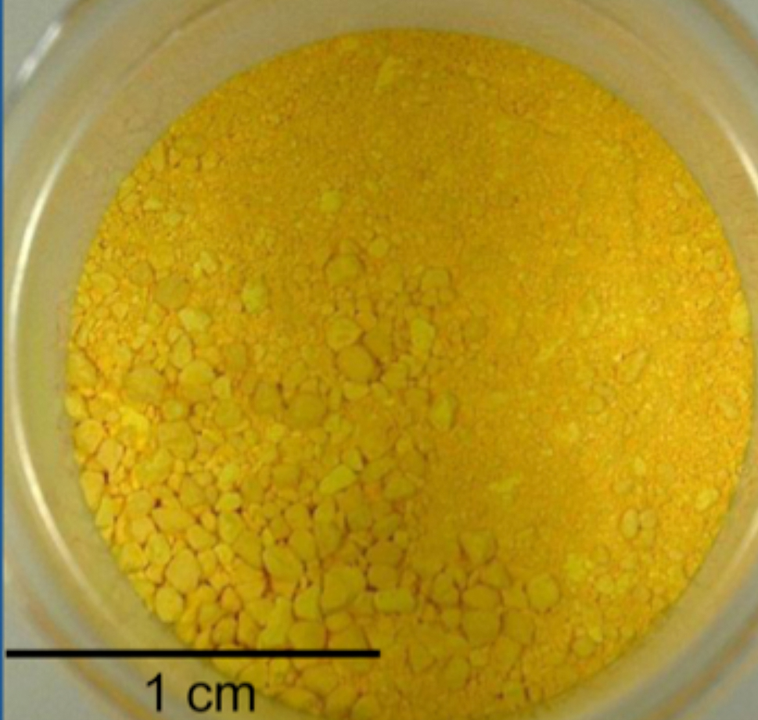
Figure 1. While light photograph of FSC 14-1-1.
The sample is a fine-grained powder as shown in the white light photo in Figure 1. Vis/NIR reflectance spectroscopy provided a rapid non-destructive evaluation of the phases present in the Durban sample. The inhomogeneity inferred from the visual appearance was confirmed with the spectral measurements. The sample appears to have been produced by the NH₃ process with a relatively low drying temperature of between 85º and 150º C. Some lighter colored particles may have experienced a different temperature and/or may have come from a different location in the furnace or from a different batch but appear to have been produced by same process. Based on a comparison of the spectra for the Durban sample with samples in the Uranium

Sourcing Database, the Durban material is primarily ammonium uranate with one of the following the general formulae: (NH₄)₂U₂O₇, UO3·xH2O·yNH₃, or UO₂(OH)₂·xH2O·yNH₃ (Klunder et al., 2013).

Morphology
SEM/EDS reveals the sample is a fine-grained aggregate of tabular to anhedral grains raging in size from <0.2 to 1 μm; thin platelets are particularly abundant. No correlation between chemical composition and morphology was observed. A number of small aggregates 5-10 μm in size, composed of multiple fine grains are present (Figs. 2, 3).
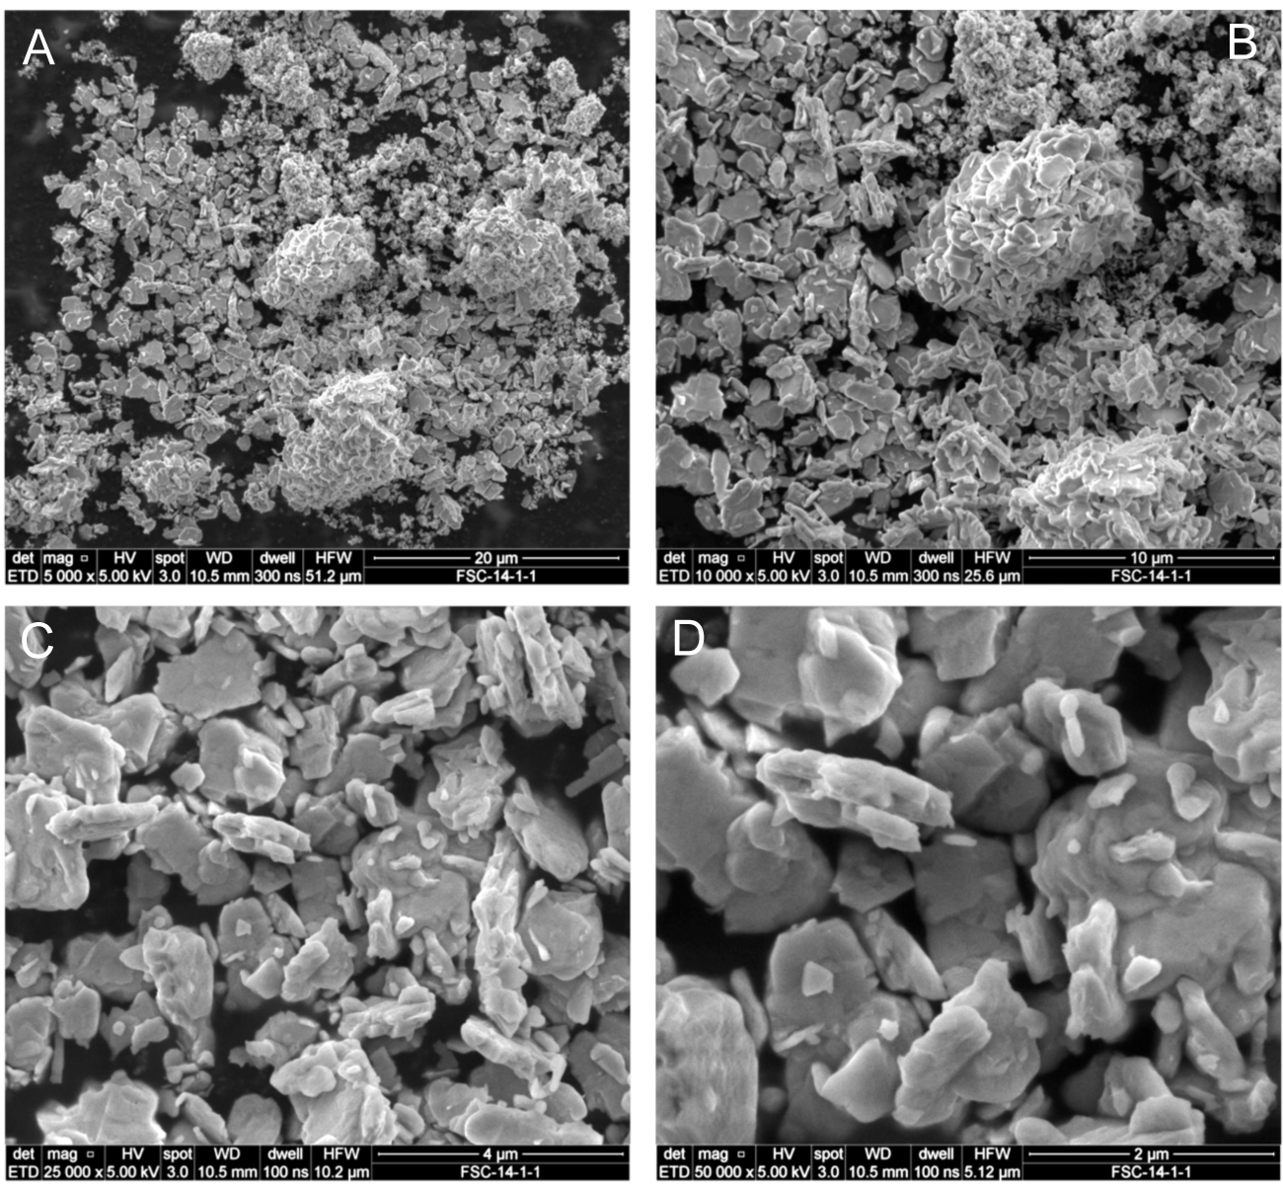
Fig. 2. SEM secondary electron photomicrographs showing characteristic morphologies of FSC 14-1-1. (A) Dispersed particles; scale bar is 20 μm. (B) Close up of aggregate composed of dispersed individual grains and clumps of grains; scale bar is 10 μm. (C, D); Close-up views o individual grains showing varied morphologies; scale bars are 4 and 2 μm, respectively.

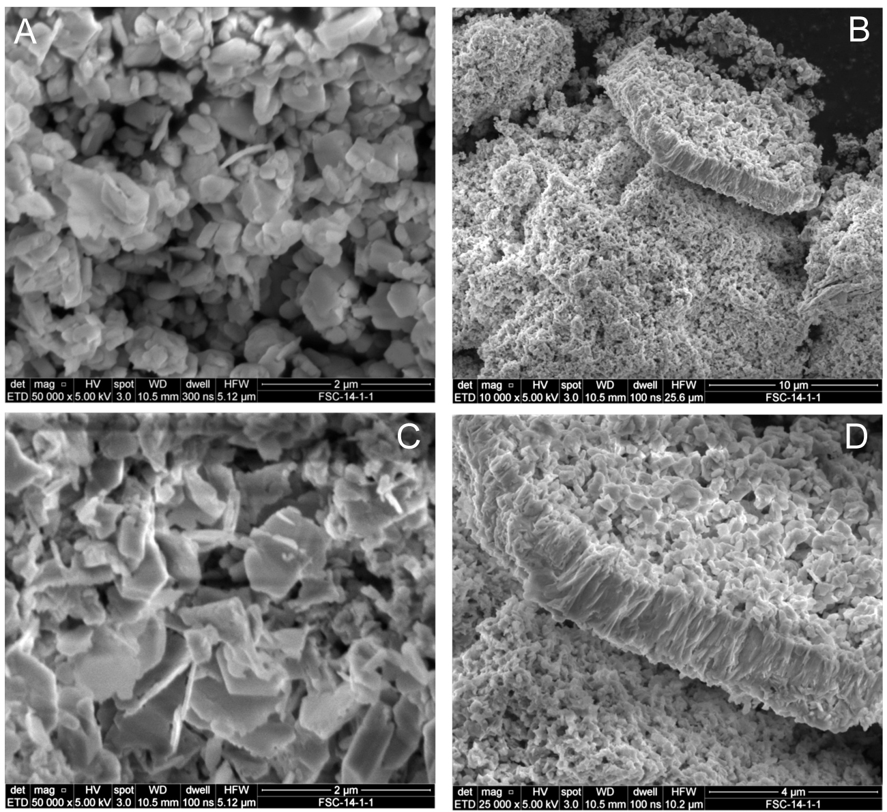
Fig. 3. SEM secondary electron photomicrographs showing characteristic morphologies of the Durban sample. (A) Dispersed particles; scale bar is 2 μm. (B, D) Views of platelets composed of particle aggregates; scale bars are 10 and 4μm, respectively; (C) Close-up views of top surface of platelet shown in (B). Individual grains exhibiting varied morphologies are apparent; scale bar is 2 μm.

Trace Element Abundances and U Assay
Trace elements abundances and U content were determined on separate aliquots of the dissolved sample; results are summarized in table 3. The trace element abundances are unremarkable other than the unusually high abundance of Cs (156 μg/g). The total impurity content of ~400 μg/g is low and more characteristic of a laboratory chemical rather than an industrial product (unless directly converted from UF₆).

Table 3. Trace elements abundances and U content.
Element | Technique | unit | Avg. (n=3) | uncertainty | L_{c}^{1,2}
Be | ICP-MS | μ | 0.008 | 0.004 | 0.0025
B | ICP-MS | μ | 3 | 8 | 0.42
Na | ICP-MS | μ | 34.4 | 1.8 | 9
Mg | ICP-MS | μ | 1.3 | 1.3 | 0.6
Al | ICP-MS | μ | 8 | 2 | 1.2
Si | XRF | μ | <270 |  | 267
P | XRF | μ | <200 |  | 200
S | XRF | μ | <175 |  | 172
Cl | XRF | μ | <125 |  | 123
K | ICP-MS | μ | 90 | 30 | 14
Ca | ICP-MS | μ | 38 | 14 | 30
Sc | ICP-MS | μ | 0.28 | 0.16 | 0.026
Ti | ICP-MS | μ | 0.9 | 0.2 | 0.21
V | ICP-MS | μ | 0.23 | 0.03 | 0.0022
Cr | ICP-MS | μ | 8 | 3 | 0.2
Mn | ICP-MS | μ | 0.8 | 0.2 | 0.019
Fe | ICP-MS | μ | 100 | 30 | 3.3
Co | ICP-MS | μ | 0.36 | 0.04 | 0.002
Ni | ICP-MS | μ | 3 | 2 | 0.1
Cu | ICP-MS | μ | 0.78 | 0.16 | 0.05
Zn | ICP-MS | μ | 2.8 | 1.8 | 0.7
Ga | ICP-MS | μ | 0.009 | 0.002 | 0.00061
Ge | ICP-MS | μ | 0.023 | 0.02 | 0.005
As | ICP-MS | μ | 0.55 | 0.04 | 0.0016
Se | ICP-MS | μ | 12 | 0.5 | 0.4
Br | XRF | μ | <80 |  | 80
Rb | ICP-MS | μ | 0.088 | 0.005 | 0.014
Sr | ICP-MS | μ | 0.27 | 0.05 | 0.04
Y | ICP-MS | μ | 0.0026 | 0.0005 | 0.00022
Zr | ICP-MS | μ | 0.11 | 0.06 | 0.008
Nb | ICP-MS | μ | 0.113 | 0.009 | 0.00029
Mo | ICP-MS | μ | 18.8 | 0.9 | 0.01
Ru | ICP-MS | μ | 0.0007 | 0.0009 | 0.00022
Rh | ICP-MS | μ | 0.00028 | 0.00015 | 0.00011
Pd | ICP-MS | μ | 0.0011 | 0.001 | 0.0003
Ag | ICP-MS | μ | 0.23 | 0.03 | 0.006
Cd | ICP-MS | μ | 3.08 | 0.19 | 0.0019
Sn | ICP-MS | μ | 0.49 | 0.04 | 0.033
Sb | ICP-MS | μ | 2.12 | 0.14 | 0.003
Te | ICP-MS | μ | 0.86 | 0.13 | 0.006
Cs | ICP-MS | μ | 156 | 12 | 0.0041
Ba | ICP-MS | μ | 3 | 0.2 | 0.04
La | ICP-MS | μ | 8.9 | 0.5 | 0.0028
Ce | ICP-MS | μ | 0.061 | 0.003 | 0.0004
Pr | ICP-MS | μ | 0.0017 | 0.0006 | 0.00009
Nd | ICP-MS | μ | 0.005 | 0.002 | 0.00023
Sm | ICP-MS | μ | 0.0012 | 0.0007 | 0.00038
Eu | ICP-MS | μ | 0.0005 | 0.00016 | 0.00008
Gd | ICP-MS | μ | 0.0021 | 0.0006 | 0.00033
Tb | ICP-MS | μ | 0.00006 | 0.00018 | 0.000034
Dy | ICP-MS | μ | 0.0005 | 0.0007 | 0.0001
Ho | ICP-MS | μ | 0.00014 | 0.00008 | 0.000038
Er | ICP-MS | μ | 0.0005 | 0.0005 | 0.00016
Tm | ICP-MS | μ | 0.00011 | 0.00006 | 0.000019
Yb | ICP-MS | μ | 0.0005 | 0.0003 | 0.00013
Lu | ICP-MS | μ | 0.00012 | 0.00006 | 0.000025
Hf | ICP-MS | μ | 0.0017 | 0.0013 | 0.00054
Ta | ICP-MS | μ | 0.0009 | 0.0005 | 0.00007
W | ICP-MS | μ | 0.22 | 0.02 | 0.0015
Re | ICP-MS | μ | 0.0005 | 0.0002 | 0.000208
Ir | ICP-MS | μ | 0.0003 | 0.0005 | 0.0003
Pt | ICP-MS | μ | 0.0004 | 0.0007 | 0.0003
Tl | ICP-MS | μ | 0.298 | 0.015 | 0.00021
Pb | ICP-MS | μ | 7.6 | 0.5 | 0.007
Bi | ICP-MS | μ | 0.12 | 0.02 | 0.03
Th | MC-ICP-MS | μ | 0.170 | 0.018 | 0.0006
U | D-G | g/g (%) | 74.9 | 0.5
¹Limit of detection
²The units of the L_{c} values correspond to column 2.

Sr, Pb, U and Pu Isotope compositions and Age
The Sr, Pb and U isotope compositions were determined by MC-ICP-MS on chemically purified aliquots of the sample. The data are shown in tables 3-6 and Fig. 4. The uranium isotope composition indicates the Durban material is depleted in ²³⁵U compared to natural uranium, while the elevated ²³⁶U content indicates the parent material was irradiated in a nuclear reactor. The U-isotope composition of the Durban material was compared to soil samples from LLNL Site 300, where the U.S. conducts high explosive tests of materials containing depleted uranium. The U-isotope composition of Site 300 soils reflects mixing between U.S. depleted uranium from the tests and natural uranium from soil (Esser et al., 2002); no match was found. The Sr and Pb isotope compositions of the Durban sample and a variety of UOC samples are depicted in an isotope correlation diagram (Fig. 4). The data confirm the absence of a match between the Durban sample and any of the UOC samples in the U-Sourcing Database. The time since the sample was last chemically processed (model age) was determined using the ²³⁴U – ²³⁰Th chronometer; the model age is 30.9 ± 0.4 years, corresponding to a production date of 30 April 1982 with an uncertainty of 130 days. The model age assumes complete separation of Th and U during chemical processing and represents an upper limit to the actual time of production.

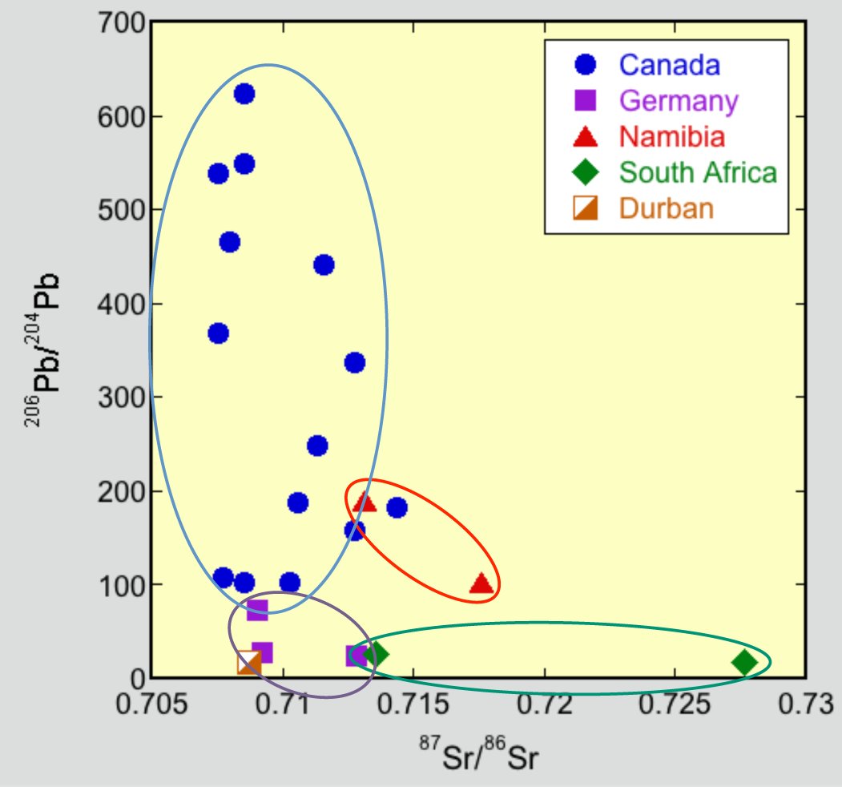
Fig. 4. Isotope correlation diagram showing Sr and Pb isotope compositions of the Durban sample compared to UOC from Germany, Namibia, South Africa and Canada; data for the UOC samples are taken from the Uranium Sourcing Database (Robel et al., 2011). The lack of a match for the Durban sample with UOC from the database is apparent.
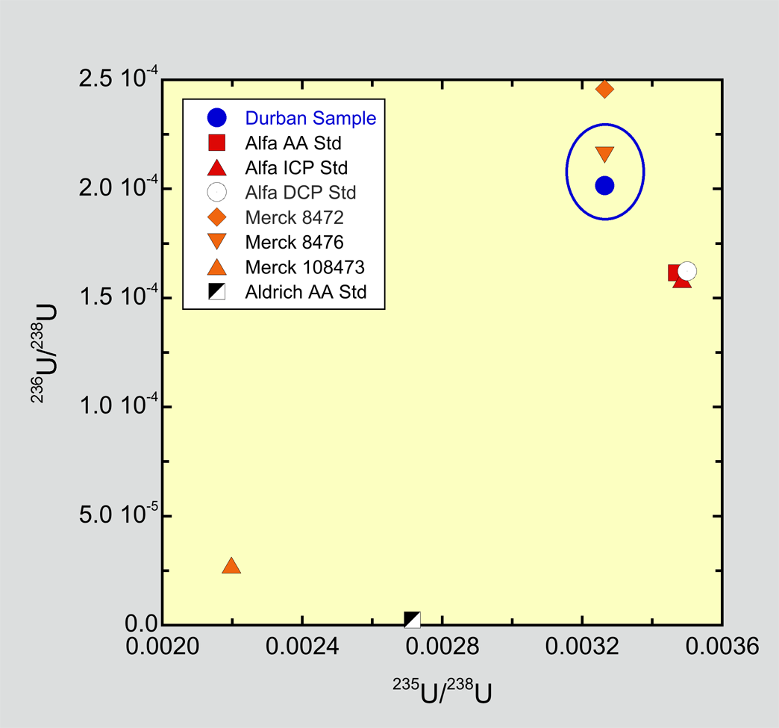
Fig. 5. Uranium 3-isotope plot showing ²³⁶U/²³⁸U and ²³⁵U/²³⁵U ratios for the Durban sample compared to values of several commercial uranium reagents; data from Richter et al. (1999). The composition of the Durban sample is similar to that of Merck 8476, a uranyl nitrate solution. The common depletion in ²³⁵U compared to natural uranium, suggests all of the samples are a by-product of enriched uranium produced for the nuclear power industry.

Table 4. Sr Isotope Composition
Sample | ⁸⁷Sr/⁸⁶Sr | 2σ | k | ⁸⁴Sr/⁸⁸Sr | 2σ | k
FSC-14-1-1-B | 0.708699 | 0.000040 | 2 | 0.056536 | 0.000026 | 2

Table 5. Pb Isotope Composition
Sample | Pb (ng/g) | ²⁰⁸Pb/²⁰⁴Pb | 2σ | k | ²⁰⁷Pb/²⁰⁴Pb | 2σ | k | ²⁰⁶Pb/²⁰⁴Pb | 2σ | k
1-B | 552 | 37.849 | 0.023 | 2 | 15.6088 | 0.0076 | 2 | 18.0630 | 0.0086 | 2
1-B¹ | 676 | 37.848 | 0.022 | 2 | 15.6090 | 0.0076 | 2 | 18.0633 | 0.0086 | 2
¹Duplicate analysis.

Table 6. U Isotope Composition
Isotope | Abundance (atom %) | Uncertainty
²³⁴U | 0.0021107 | 0.0000072
²³⁵U | 0.31963 | 0.00024
²³⁶U | 0.018592 | 0.000070
²³⁸U | 99.6597 | 0.0020

Table 7. Pu Abundance and Isotope Composition
Sample | Pu (pg/g) | 2σ | k | ²⁴⁰Pu/²³⁹Pu | 2σ | k
1-B | 9.69 | 0.67 | 2 | 0.0719 | 0.0037 | 2

Reactor Models
To explore potential sources of the Durban sample, we modeled the performance of a graphite moderated, natural uranium (NU) fueled reactor using the MAGNOX reactor model included in the Origen-ARP component of SCALE 6.1 (Bowman and Cook, 2000). NU fuel irradiated for ~100 days to a burnup of 1.6 GWD/MTU would have a ²⁴⁰Pu content of ~14% at discharge. Assuming this fuel was then used as feedstock for an enrichment cascade producing ²³⁵U enriched to 2%, we used the ORNL MSTAR program to calculate the U isotopic composition of tails from the cascade. The calculated values, ²³⁴U /²³⁵U = 0.009 and ²³⁶U /²³⁵U = 0.04, agree reasonably well with the measured U-isotope composition of the Durban sample. Increasing the enrichment in ²³⁵U in the calculation to 10% also yields a ²³⁶U/²³⁵U ratio similar to the observed value but predicts a ²³⁵U abundance that is ~5% too low.

Summary
A U-rich sample interdicted in Durban, South Africa is a fine-grained mixture of two common uranium compounds – ammonium uranyl fluoride and a hydrated uranium-ammonium oxide. The presence of ²³⁶U and trace Pu point to the use of recycled (irradiated) uranium and the low trace element abundances and depletion in ²³⁵U relative to natural uranium suggest the material originated as a by-product of enriched uranium produced for the nuclear power industry. A comparison of the properties of the Durban sample with samples contained in the Uranium Sourcing Database using principal components analysis, partial least squares discriminant analysis and the iDAVE search engine failed to produce a match, suggesting the material was produced from a source and at a facility not represented in the database. Natural uranium fuel irradiated in a graphite moderated reactor for ~100 days and then used as feed for an enrichment cascade to produce low enriched uranium would generate tails having ²³⁴U and ²³⁶U contents in reasonable agreement with values measured in the Durban sample. Legitimate commerce in depleted uranium is worldwide and depleted UF₆ can be converted to any uranium compound, depending on the end use, making it difficult to identify the source of the Durban sample.

Acknowledgement: We thank M. Penkin for valuable discussions. This work performed under the auspices of the U.S. Department of Energy by Lawrence Livermore National Laboratory under Contract DE-AC52-07NA27344; LLNL-TR-650596. Work supported by NNSA Confidence Building Measures Program.

References
Bowman, S.M. and Leal, L.C. (2000) Origen-ARP: automatic rapid process for spent fuel depletion, decay and source term analysis, ORNL Technical Report, http://web.ornl.gov/sci/scale/pubs/orignarp.pdf.
Esser, B., Williams, R.W. and Taffett, M. (2002) Isotopic Characterization of Depleted Uranium in Contaminated Soils and Groundwaters, Amer. Chem. Soc. Annual Meeting.
Klunder, G.L., Plaue, J.W., Spackman, P.E., Grant, P.M., Lindvall, R.E. and Hutcheon, I.D. (2013) Application of Visible/Near-Infrared Reflectance Spectroscopy to Uranium Ore Concentrates for Nuclear Forensic Analysis and Attribution, Appl. Spectros. 67, 1049-1056.
Richter, S., Alonso, A., Wellum, R. and Taylor P.D.P (1999) The isotopic composition of commercially available uranium chemical reagents, Jour. Anal. Atom. Spectr. 14, 889-891.
Robel, M., Hutcheon, I.D., Kristo, M.J. and Lindvall, R.E. (2011) The uranium sourcing database project: a comprehensive international nuclear forensics collaboration from ore to attribution, Inst. Nucl. Mats. Mgmt. 52nd Annual Meeting, LLNL-CONF-486157.

