Measurement of sulphur isotopic ratio for the nuclear forensic investigation of uranium ore concentrates (yellow cakes)

Zsolt Vargaª, Sun-Ho Han^{a,b}, Judit Krajkoª, Maria Walleniusª, Kyuseok Song^{b}, Klaus Mayerª

ª European Commission,
Joint Research Centre,
Institute for Transuranium Elements
Postfach 2340, 76125
Karlsruhe, Germany

^{b} Korea Atomic Energy Research Institute,
Daejeon, 305-353,
Republic of Korea

Abstract. A novel method has been developed for the measurement of the n(³⁴S)/n(³²S) isotope ratio in uranium ore concentrate (yellow cake) samples for the origin assessment in nuclear forensics. The leachable sulphate is separated and pre-concentrated by anion exchange separation followed by the n(³⁴S)/n(³²S) ratio measurement using multi-collector inductively coupled plasma mass spectrometry. The method was validated by the measurement of standard reference materials (IAEA-S-2, IAEA-S-3 and IAEA-S-4) and the δ³⁴S value could be determined with an expanded uncertainty between 0.45‰ and 1.9‰ expressed with a coverage factor of 2. The method was then applied for the analysis of uranium ore concentrates of world-wide origin. In the studied materials distinct n(³⁴S)/n(³²S)isotope ratios could be observed, which can be a promising signature for the nuclear forensic investigations to identify the source of unknown nuclear materials. By the investigation of the sulphur isotope ratio variation during UOC production from ore to U₃O₈ product it was shown that process reagents have radical effect on the n(³⁴S)/n(³²S), thus the sulphur isotope ratio is in most cases a process-related signature.

1. Introduction

As an answer to the illicit trafficking of nuclear materials in the 1990s a new scientific topic has emerged, commonly referred to now as nuclear forensics [1]. The aim of the nuclear forensic investigations is to identify the hazard and origin of the confiscated or found nuclear materials and ultimately strengthen security measures and prevent nuclear terrorism thereafter. Over the last few years several signatures of nuclear materials have been investigated and developed to establish the links between the measurable parameters of the unknown material in question and the source of the nuclear materials. These measurable parameters or signatures include e.g. elemental or anionic impurities, isotopic composition, structural analysis, morphology and age determination [1-6]. This complex dataset can give information about the source of uranium ore or feed materials, process and the production facility.

Among the other signatures the natural sulphur isotope variation also gives a possibility to discriminate samples of different origin. The sulphur isotope abundance shows relatively high variation in nature due to the large relative mass difference between its isotopes, the variety of chemical forms and the widespread occurrences in nature [7].

The sulphur variation is generally expressed as the amount ratio of n(³⁴S)/n(³²S) of the two principal sulphur isotopes relative to the IAEA V-CDT (Vienna Cañon Diablo Troilite meteorite) standard in parts per thousand (permil, ‰) [8]. The δ³⁴S values of samples relative to the V-CDT scale in ‰ are calculated using the following equation:

(1)

where (³⁴S/³²S)_{sample} and (³⁴S/³²S)_{V-CDT} are the n(³⁴S)/n(³²S) of ratio of sample and IAEA V-CDT standard, respectively. The (³⁴S/³²S)_{V-CDT} is defined as 0.0441626 ± 0.0000078 (k = 2) [9, 10].

Typically, natural materials with oxidized sulphur have δ³⁴S values between +5 ‰ and +25 ‰, while for materials with reduced sulphur it ranges between -5 ‰ and +15 ‰ [11]. The sulphur isotope ratio in uranium ore deposits is also reported to exhibit large variation, such as in the sandstone-type uranium deposits of the Colorado Plateau and Wyoming (-20.5 to -17.8 ‰) or in the uranium roll-type deposit in South Texas, USA (-25 to -40 ‰). However, as the sulphur content in the nuclear material derives not only from the feedstock (ore), but is also introduced into the process stream as process chemical (e.g. as H₂SO₄ with an approximate δ³⁴S value of -5 to +15 ‰), its contribution to the final δ³⁴S value in the product has to be considered. Therefore, it is expected that sulphur isotopic composition can be indicative both for the process (chemicals used) and the ore type depending on the hydrometallurgical production route.

In order to investigate if the sulphur isotopic composition is a meaningful signature in nuclear forensics, a novel method has been developed and validated for the measurement of n(³⁴S)/n(³²S) isotope ratio in uranium ore concentrates (yellow cakes) [11]. The developed ion exchange separation method effectively separates and pre-concentrates sulphate from uranium and the possibly interfering matrix components, such as cations. The measurement was performed by multi-collector inductively coupled plasma mass spectrometry. The applicability of the sulphur isotope ratio as a possible signature for nuclear forensics was tested by the measurement of several UOCs of world-wide origin, and also its variation was investigated during the UOC production from uranium ore to U₃O₈.

2. Experimental

2.1. Instrumentation

A NuPlasma™ (NU Instruments, Oxford, United Kingdom) double-focusing multi-collector inductively coupled mass spectrometer (MC-ICP-MS), equipped with 11 Faraday collectors and 3 discrete dynode electrode multipliers was used for the sulphur isotope ratio measurements. The instrument was operated at low mass resolution mode (R = 300). The samples were introduced into the plasma using a low-flow Teflon microconcentric nebulizer operated in a self-aspirating mode in combination with a desolvation unit (DSN-100, NU Instruments, Oxford, United Kingdom).

The anion (sulphate) measurements were performed by ion chromatography (Advanced Compact IC 861, Metrohm, Switzerland). The ion chromatograph is equipped with a chemical suppressor (Module MSM II) and a conductivity detector. The separation of sulphate was carried out using an anion exchange column (METROSEP A supp 5, 150 × 4.0 mm I.D.) preceded with a guard column (METROSEP Anion Dual 1, 50 × 4.6 mm I.D.).

2.2. Reagents and materials

For dilutions ultra-pure water was used (UHQ System, USF Elga, Germany). Suprapur grade nitric acid (Merck, Darmstadt, Germany) was used for the sample preparation. All other reagents used were of analytical grade. To prevent anionic contamination during the measurement, all lab ware was washed three times with ultra-pure water, dried in a laminar flow bench and stored in clean zipped bags. New and cleaned labware was used for each sample.

To validate the developed method, sulphur isotope ratio certified reference materials purchased from the International Atomic Energy Agency (IAEA) were used. For the analysis approximately 80 mg of the IAEA standards (S-1, S-2, S-3, S-4) were weighed into a screw-cap Teflon vial and dissolved in 5 mL of nitric acid while heating to 95 °C on a hotplate for 6 hours. After cooling to room temperature, sulphate concentrations in these stock solutions were measured by ion chromatography (IC). These stock solutions were subsequently diluted to 2 μg mL⁻¹ (expressed as sulphur) in 1% HNO₃ for the sulphur isotope ratio measurement.

A total of 18 uranium ore concentrates originating from different mines were included in this study. The chemical compositions of the investigated uranium ore concentrates vary depending on the milling process applied in the different facilities. The samples investigated for the variation of sulphur isotope ratio variation during UOC production were obtained from an undisclosed UOC production facility. There the UOC production is carried out in the following five stages:

(a) Sulphuric acid leaching of the uranium ore
(b) Ion exchange separation
(c) Solvent extraction
(d) ADU precipitation using ammonia
(e) Calcination to U₃O₈

One production batch was followed during the UOC production, and samples were taken from the various stages. The sampled materials are assumed to be representative of the investigated single UOC production batch.

2.3. Separation of sulphate by ion exchange

100 – 300 mg of sample depending on the sulphur concentration was taken and 10 mL ultra-pure water was added in pre-cleaned plastic bottle. The samples were leached for 24 hours at room temperature and filtered with pre-rinsed 0.45 μm cellulose acetate syringe filters (Nalgene, USA) before the ion exchange separation.

For the separation of SO₄²⁻ from the leaching solution anion exchange resin (AG 1-X4, Cl⁻ form, 100 – 200 mesh, Bio-Rad Laboratories, USA) was applied. New column was used for every sample to avoid the risk of cross-contamination. For the column preparation, 1 mL of the resin was placed in a poly-prep column (0.8 x 4 cm, Bio-Rad Laboratories, USA) and porous polyethylene frit (120 μm pore size, Reichelt Chemietechnik Heidelberg, Germany) was placed on the top to avoid mixing. Before use, the resin was converted into nitrate form by elution with 10 mL of 3 M HNO3 and pre-conditioned with 10 mL of 0.03 M HNO₃. The flow rate for the resin column was about 0.6-0.7 mL min⁻¹. Before loading, the resin was conditioned again with 10 mL of 0.03 M HNO₃. After loading, the resin was washed with 10 mL of 0.03 M HNO₃ and subsequently SO₄²⁻ was eluted using 3 mL of 0.3 M HNO₃. An aliquot was taken for the recovery measurement of SO₄²⁻ by ion chromatography. Further details can be found elsewhere [11].

2.4. Measurement of ³⁴S/³²S by MC-ICP-MS

During the sulphur isotope ratio ICP-MS analysis dominantly two types of isobaric interferences need to be taken into account to achieve accurate results: doubly charged metals ions (e.g. ⁶⁴Ni²⁺, ⁶⁴Zn²⁺ or ⁶⁸Zn²⁺) and oxide/hydrate molecular ions (e.g. ¹⁶O₂⁺, ¹H¹⁶O₂⁺ or ¹⁶O¹⁸O⁺). Doubly charged isobaric interferences can be efficiently removed by using a prior chemical separation by the ion exchange process. On the other hand, the significant interferences by oxygen and hydrogen containing polyatomic ions cannot be eliminated using only chemical separation. In our method the oxide and hydrate species were eliminated by the application of a desolvation system. The background intensities for 1% HNO₃ solution at m/z = 32 and m/z = 34 were about 0.2 V and 0.006 V, respectively. In comparison, the intensities of 2 μg mL⁻¹ S standard were 4 V and 0.19 V at m/z = 32 and m/z = 34, respectively. The contribution of blank for a 2 μg mL⁻¹ S solution is estimated to be approximately 5%. As the blank intensity and the instrumental mass discrimination can change during the measurement sequence, a blank1–standard–blank2–sample bracketing procedure was used for the measurements. To correct for mass discrimination, the IAEA-S-1 standard was used, and 1% HNO₃ solution was used for background correction. The sulphur concentration of the standards and samples for the MC-ICP-MS measurement was adjusted to approximately 2 μg mL⁻¹ by dilution with 1% HNO₃. For the IAEA-S-4 and the separated uranium samples, Ag standard solution was added to obtain a final Ag concentration of 27 μg mL⁻¹ (equivalent to 4:1 molar ratio of Ag⁺/SO₄²⁻). It was found that sulphur can be lost via the applied desolvation system coupled to the MC-ICP-MS, which can be overcome by adding Ag⁺ to the measured sample. This approach also provides matching the sample to the bracketing standard, thus assures accurate results [11].

2.5. Data evaluation

The measured raw intensities were corrected for the background using the preceding blank sample. Then the obtained net ³⁴S/³²S isotope ratio of the sample was corrected for the instrumental mass discrimination using the bracketing IAEA-S-1 standard (external standardisation). For the correction the ³⁴S/³²S isotope abundance ratio of the IAEA-S-1 is 0.0441493 ± 0.0000080 (k = 2) used [8]. Finally, the δ³⁴S values related to the V-CDT scale were calculated using Equation (1). Three replicates were measured for each sample. For the estimation of the measurement uncertainty the ISO GUM (Guide to the Expression of Uncertainty in Measurements) approach was adapted. The calculation was performed with the GUM Workbench software. The model developed was based on Equation (1), taking into account the uncertainty contributions from the measured n(³⁴S)/n(³²S) isotope ratios of the IAEA-S-1 bracketing standard and the sample, the isotope abundance ratio of the IAEA-S-1 (0.0441493 ± 0.0000080, k = 2), and the uncertainty of the assigned V-CDT δ³⁴S value (0.0441626 ± 0.0000078, k = 2) [8]. All uncertainties are reported as expanded uncertainties (U) with a coverage factor k = 2.

3. Results and discussion

3.1.The n( ³⁴S)/n(³²S) ratio in nuclear materials

The developed method was applied for the measurement of uranium ore concentrates. The n(³⁴S)/n(³²S) results are collected in Table I and shown in Figure 1 together with the sulphate concentrations measured by ion chromatography [11]. Clear differences in the δ³⁴S values of the uranium ore concentrates can be observed. As the δ³⁴S value differs in several cases from the reported average δ³⁴S value of sulphuric acid (-5 to +15 ‰), it suggests that the sulphur content of the uranium ore can significantly contribute to the sulphur content of the final product, thus the measured δ³⁴S value is indicative of the uranium ore. Since the δ³⁴S values of several samples from different origin overlap, the sulphur isotopic composition can be used only as a comparative signature for the origin assessment, i.e. to use the parameter to verify or exclude of an assumed (declared) origin of a nuclear material by the measurement of a comparison sample. Moreover, in a few cases the δ³⁴S values can indicate a predictive nature: the El Mesquite, Crow Butte and US Mobile samples are milled by in-situ leaching from sandstone-type deposit using carbonate lixiviant, followed by ion exchange separation. As sulphuric acid is not used in these processes in high amount compared to other metallurgical processes (e.g. acidic leaching with H₂SO₄, or use of H₂SO₄ for the solvent extraction purification), and the sulphide minerals associated with sandstone-type uranium have significantly low δ³⁴S values, we can assume that the low δ³⁴S value together with the low sulphate content can be a useful predictive signature for uranium ore concentrates produced by in-situ leaching from sedimentary sandstone-type deposits, which are one of the major sources for uranium production (approximately 18% of world uranium resources).

Table I. δ³⁴S_{VCDT}(‰) values for various uranium ore concentrate samples (n = 2). Uncertainties are expressed as expanded uncertainties with a coverage factor of 2

Uranium ore concentrate sample | δ³⁴S(‰) | SO₄²⁻ concentration (μg/g)
Gunnar (Canada) | 16.3 ± 1.4 | 2136
Rabbit Lake (Canada) | 14.9 ± 2.0 | 3529
Madawaska (Canada) | 2.3 ± 2.0 | 4958
Queensland (Australia) | -0.8 ± 1.2 | 5150
Olympic Dam (Australia) | 16.0 ± 1.2 | 43206
Stanrock (Canada) | 1.1 ± 1.1 | 47780
El Mesquite (USA) | -15.4 ± 1.2 | 1268
US Mobile (USA) | -10.3 ± 1.2 | 230
Shirley Basin (USA) | 4.2 ± 2.0 | 36530
Crow Butte (USA) | -12.3 ± 2.1 | 2115
Yeelirrie (Australia) | 15.0 ± 1.5 | 4402
Dyno (Canada) | 18.3 ± 2.0 | 1710
Eldorado (Canada) | 0.8 ± 1.5 | 16445
Rössing (Namibia) | 10.4 ± 0.9 | 4675
Palabora (South Africa) | 7.2 ± 1.6 | 410
Arlit (Niger) | 12.5 ± 1.7 | 190
McArthur River (Canada) | 8.6 ± 1.1 | 20053
Mounana (Gabon) | 11.0 ± 0.9 | 11793

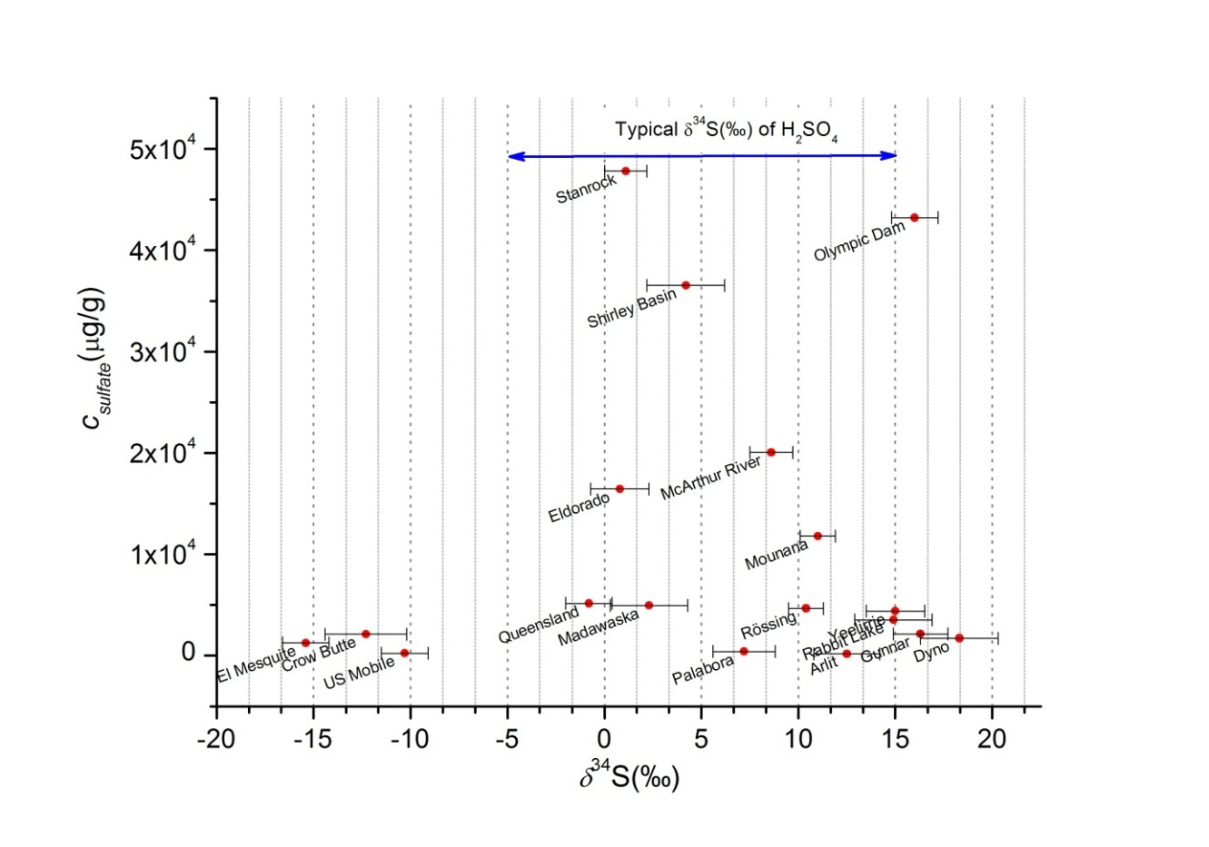
FIG. 1. Distribution of δ³⁴S_{VCDT}(‰) and sulphate concentration of the analysed uranium ore concentrates. The relative combined standard uncertainty of the sulphate determination by ion chromatography is less than 10%.

3.2. Variation of n(³⁴S)/n(³²S) ratio in UOC production

The developed method was applied for the measurement of intermediate products in the course of a uranium ore concentrate production. In the undisclosed facility UOC is produced in the following way: in the first stage the uranium ore is leached with sulphuric acid, then the leachate is purified by ion exchange, then solvent extraction. Uranium is precipitated using ammonia, the resulted ammonium uranate (AU) is calcined to U₃O₈ as the final product. The material flow was sampled at each stage, the sulphur concentration and the n(³⁴S)/n(³²S) was measured with the method described before.

The sulphur concentrations and n(³⁴S)/n(³²S) results are shown in Fig. 2. Knowing that sulphur is added in high amount to the process flow in various forms (e.g. as H₂SO₄ for leaching and ion exchange elution or as Na₂SO₄ solution during solvent extraction for back-extraction) it is obvious that the sulphur contribution from process reagents is high. The sulphur concentration of the investigated samples is significantly higher at the ion exchange and solvent extraction stages (second and third stage, respectively) than in the ore leachate (first stage) (Fig. 2), which means that the contribution of sulphur from the process chemicals is increasing. After the solvent extraction purification the sulphur as impurity is gradually removed during the AU precipitation and calcination. In these stages the n(³⁴S)/n(³²S) does not change, since no reagents with high sulphur content is added to the material process flow.

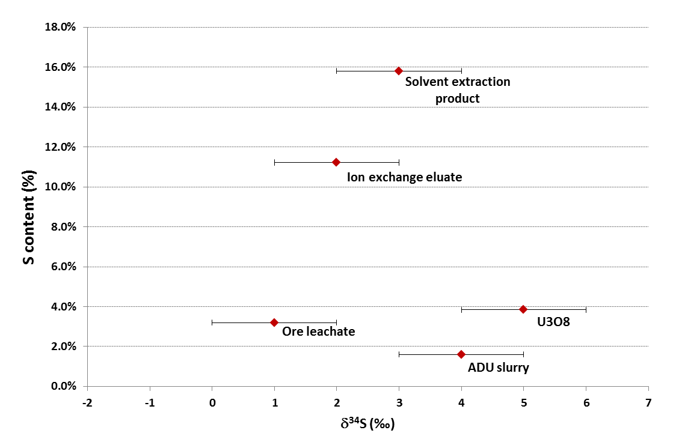
FIG. 2. Distribution of δ³⁴S_{VCDT}(‰) and sulphate concentration of the samples during a uranium ore concentrate production.

4. Conclusions

A novel method has been developed and validated for the measurement of n(³⁴S)/n(³²S) isotope ratio in uranium ore concentrates (yellow cakes). The ion exchange separation method effectively separates and pre-concentrates sulphate from uranium and the possibly interfering matrix components, such as cations. Determination of n(³⁴S)/n(³²S) ratio in uranium ore concentrates of world-wide origin showed significant differences between the samples. This variation can be exploited to differentiate samples of different origin, for instance to verify or exclude a declared origin. Moreover, as the n(³⁴S)/n(³²S) ratio can be indicative of the feed ore used for the production in several instances, the uranium ore deposit type can be identified, which can make this signature highly valuable to provide clues on the provenance of unknown nuclear materials, and thus trace them back to their source. Further studies are on-going to reveal further correlations between the δ³⁴S value in the ore concentrate and the deposit type (geolocation), to investigate the variation of n(³⁴S)/n(³²S) ratio during the UOC production and the effect of process reagent on the n(³⁴S)/n(³²S) value.

REFERENCES

[1] Mayer, K., et al., Nuclear forensic science: Correlating measurable material parameters to the history of nuclear material, Chem. Rev. 113 (2013) 884.
[2] Mayer, K., et al., Nuclear forensics - a methodology providing clues on the origin of illicitly trafficked nuclear materials, Analyst, 130 (2005) 433.
[3] Varga, Z., et al., Analysis of Uranium Ore Concentrates for Origin Assessment, Radiochim. Acta 1 (2011) 1.
[4] Keegan, E., et al., Attribution of uranium ore concentrates using elemental and anionic data, Appl. Geochem. 27 (2012) 1600.
[5] Schwantes, J.M., et al., Nuclear archeology in a bottle: Evidence of pre-trinity U.S. weapons activities from a waste burial site, Anal. Chem. 81 (2009) 1297-1306.
[6] Kristo, M.J., Tumey, S.J., The state of nuclear forensics, Nucl. Instrum. Meth. Phys. Res. B 294 (2013) 656.
[7] Thode, H.G., Sulphur Isotopes in Nature and the Environment: An Overview, in: H.R. Krouse, V.A. Grinenko (Eds.) Stable Isotopes in the Assessment of Natural and Anthropogenic Sulphur in the Environment, John Wiley & Sons, New York (1991).
[8] Ding, T., et al., Calibrated sulfur isotope abundance ratios three IAEA sulfur isotope reference materials and V-CDT with a reassessment of the atomic weight of sulfur, Geochim. Cosmochim. Acta 65 15 (2001) 2433.
[9] Ding, T., et al., Preparation of two synthetic isotope mixtures for the calibration of isotope amount ratio measurements of sulfur, International Journal of Mass Spectrometry, 197 1-3 (2000) 131-137.
[10] Coplen, T.B., et al., Isotope-abundance variations of selected elements (IUPAC technical report), Pure Appl. Chem. 74 10 (2002) 1987.
[11] Han, S.H., et al., Measurement of the sulphur isotope ratio (34S/32S) in uranium ore concentrates (yellow cakes) for origin assessment, J. Anal. At. Spectrom. 28 12 (2013) 1919.

