Proof of Principle for the Preparation and validation of an uranium age dating reference material

Z. Vargaª, K. Mayerª, A. Hubert^{b}, I. Hutcheon^{c}, W. Kinman^{d}, M. Kristo^{c}, F. Pointurier^{b}, K. Spencer^{d}, F. Stanley^{d}, R. Steiner^{d}, L. Tandon^{d}, R. Williams^{c}

ª European Commission,
Joint Research Centre,
Institute for Transuranium Elements
P.O. Box 2340 76125
Karlsruhe, Germany

^{b} CEA, DAM, DIF,
F91297 Arpajon, France

^{c} Lawrence Livermore National Laboratory,
7000 East Avenue,
Livermore, CA, USA 94550

^{d} Los Alamos National Laboratory,
P.O. Box 1663,
Los Alamos, NM, USA 87545

Abstract. The present paper discusses the outcome of a joint effort of expert nuclear forensic laboratories in the area of age dating of uranium. Completely separated uranium materials of known production date were distributed among the laboratories, and the samples were dated according to the routine laboratory procedures. The measurement results were in fairly good agreement with one another and also with the known production date, thus strongly underlining that the concept for preparing such age dating reference material is valid and a useful and appropriate certified reference material can be produced applying this methodology. The detailed knowledge of the laboratory procedures used for measuring the age of the sample allows to identify possible improvements in the current protocols and to develop the best practice for uranium age dating in the future. The availability of age dating reference materials as well as the evolvement of the age dating best-practice protocol will increase the relevance and applicability of age dating as part of the tool-kit available for nuclear forensic investigations.

1. Introduction

If nuclear materials are diverted and afterwards interdicted, detailed investigation is required to identify the possible origin, intended use and hazard related to the material. Such analysis, which is now commonly referred to as nuclear forensics, involve the comprehensive physical, chemical and isotopic measurements (e.g. physical dimensions, crystal structure, radioactive and stable chemical impurities, classical forensic analysis) as well as the interpretation of these measured parameters [1-3]. Based on this complex information, the assumed origin of the material can be verified or for an unknown material the provenance can be identified with high reliability.

Numerous characteristics (so-called signatures) of the material can be used for such purpose, such as the isotopic composition of U, Pb or Sr, elemental impurities, trace-level radionuclide content, crystal structure or anionic residues. Besides these parameters the elapsed time (commonly referred to as the "age" of the material) since the last chemical purification of the material can also be measured for radioactive (nuclear) materials. This unique possibility is based on exploiting the presence and decay of the long-lived radionuclide (usually uranium or plutonium as major component in case of nuclear materials): in the course of the production the radionuclide is chemically purified from the impurities, including also its radioactive decay products. After production, the radioactive progenies start to grow-in again in the material. Assuming that the parent-daughter separation was complete, the elapsed time since the last separation, thus the production date, can be calculated according to the decay equations after the measurement of the parent-daughter ratio in the sample. This age value enables either to identify the origin of the unknown sample or to verify the source of the feed material. In contrast to most other characteristics used in nuclear forensics, the production date of the material is a predictive signature, thus it does not require comparison samples for origin assessment. This feature makes the production date one of the most prominent signatures for attribution.

However, in order to put the obtained results on a more solid scientific or legally defensible foundation, dedicated reference materials are required. In consequence, an emerging need for such materials has been recently expressed by the community involved in national or international nuclear security programs.

Our major objective was the preparation and validation of a uranium-based reference material, which can be applied for the validation of age measurements based on the ²³⁰Th/²³⁴U chronometer. The material was prepared from high-purity uranium solutions with various uranium enrichments by completely separating the thorium decay product [4]. By this means, the production date is very precisely known (with an uncertainty of less than about 5 hours). In contrast to other methods of producing age dating reference materials , this approach does not require measuring the age of the final material and thus deriving a certified production date, because, if all conditions are fulfilled (completeness of separation, long-term stability, closed system), the ²³⁰Th present in the material will solely depend on the radioactive decay laws. Therefore, the material prepared can be used as a primary standard for age dating of uranium materials.

The aim of the present collaboration is two-fold: firstly, to prove the applicability of this methodology for the preparation of a uranium age dating reference material by the independent measurement of expert laboratories. Since the validation requires the measurement of the ²³⁰Th decay product at very low level from the freshly separated material, state-of-the-art instruments and well-established techniques are required. Secondly, this joint effort enables the identification of the best methodologies (best practices) for uranium age dating. The availability of age dating reference materials will help validate current and future age dating protocols, leading to a more robust source of nuclear forensic signatures and a legally defensible basis for the use of age dating results in nuclear forensics investigations. Validation of these methods will increase their relevance and applicability as part of the tool-kit available for nuclear forensics investigations.

2. Preparation of the materials

The material was prepared from uranium after complete separation of thorium decay products (zeroing the initial daughter nuclide concentration) at a well-known time and allowing the ingrowth of the daughter nuclides.

The preparation of the material is described in details elsewhere [4]. The materials used were high-purity uranium-oxide samples dissolved in nitric acid. Three uranium materials with different uranium enrichments were prepared: natural uranium (0.71% ²³⁵U abundance), low-enriched uranium (LEU, approximately 4% ²³⁵U abundance) and a highly-enriched uranium material (HEU, ²³⁵U abundance is about 70%). The dissolved uranium samples were purified with three consecutive extraction chromatographic separations in order to completely remove the ²³⁰Th decay product. The final thorium purification of the material took place on 19 July 2011. The purified uranium solutions were aliquoted into screw-capped PFA vials right after the uranium purification and sample homogenization. Approximately 30 mg U was placed into each vial, and then they were evaporated to dryness right after its preparation to avoid loss of Th by adsorption.

The separation efficiency of Th was determined by gamma spectrometric measurement and by the addition of ²³²Th to the starting material and its re-measurement following the chemical separations. A total separation factor of approximately 3 × 10⁷ was achieved, which corresponds to a ²³⁰Th/²³⁴U ratio in the final reference material of 10⁻¹¹ – 10⁻¹³ at the time of preparation. Therefore, the residual ²³⁰Th is negligible compared to the ingrowth thereafter (corresponds to less than a few hours’ expressed as time), and the amount of ²³⁰Th in the material is then solely the function of the ²³⁴U amount. The number of atoms of ²³⁰Th can be derived from the decay equations:

(1)

where N_{Th-230} and N_{U-234} are the number of atoms of ²³⁰Th and ²³⁴U in the sample, respectively, λ_{Th-230} and λ_{U-234} are the decay constants of ²³⁰Th and ²³⁴U, respectively, and t is the elapsed time since the separation of the material.

3. Reported results from the participating laboratories

Aliquots of the prepared samples were shipped to the participating expert nuclear forensic laboratories, where the production dates of the materials were determined according to their routine procedures. The participating laboratories in this study were Lawrence Livermore National Laboratory (USA), two laboratories from the Los Alamos National Laboratory (USA), DIF of CEA (France) and EC JRC Institute for Transuranium Elements (European Commission). It should be noted, though, that the analytical determination of the production date by measuring the parent/daughter ratio is fairly challenging because the time span between the preparation and the measurement (approximately 2.5 years) is very small compared to the half-life of the parent nuclide ²³⁴U (245 000 years). In consequence, only minute quantities of daughter nuclide ²³⁰Th will grow in and have to be separated and accurately quantified. The reported age results are shown in Figs 1-3.

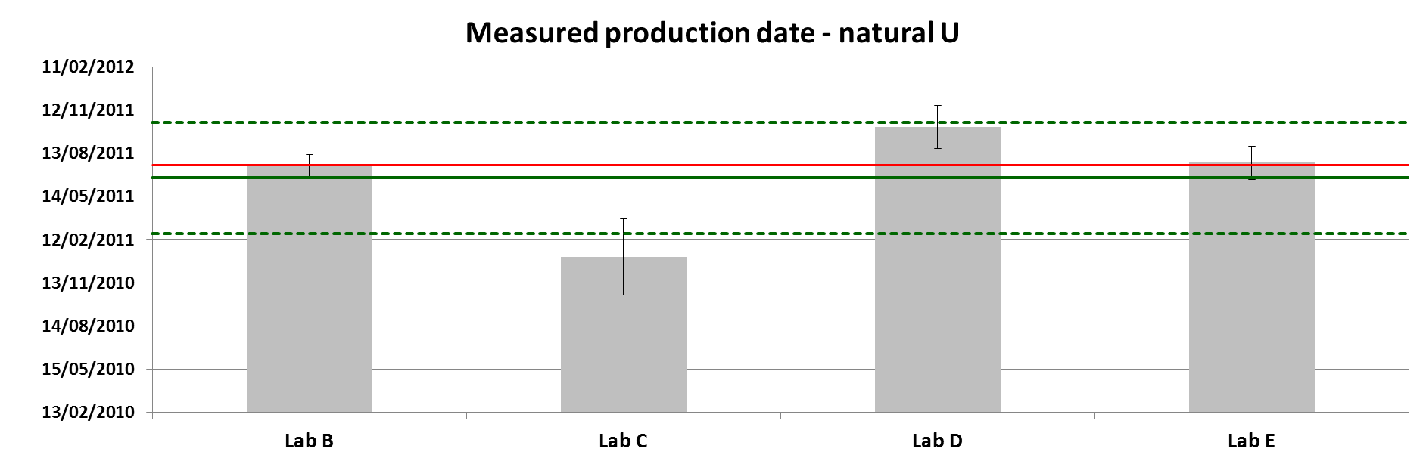
FIG. 1. Reported production dates for the natural uranium sample. Red line: known production date (19 July 2011); Green line: average of the reported dates with the confidence interval expressed as one standard deviation of the reported dates (dotted lines).

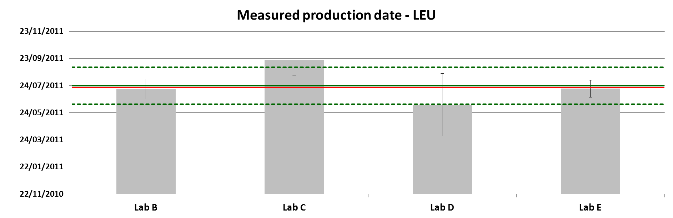
FIG. 2. Reported production dates for the low-enriched uranium sample. Red line: known production date (19 July 2011); Green line: average of the reported dates with the confidence interval expressed as one standard deviation of the reported dates (dotted lines).
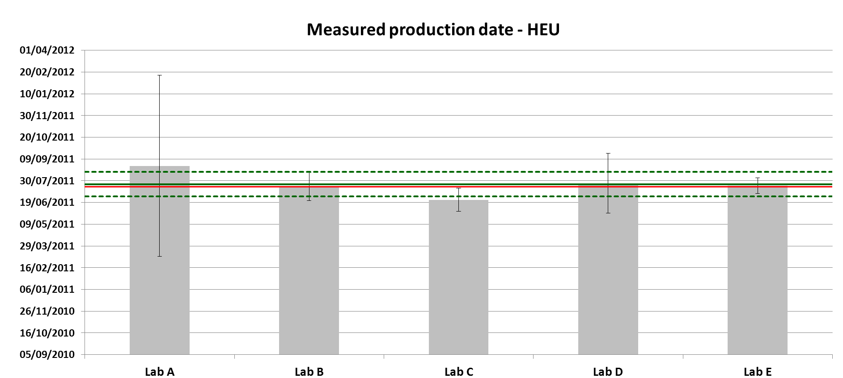
FIG. 3. Reported production dates for the highly-enriched uranium sample. Red line: known production date (19 July 2011); Green line: average of the reported dates with the confidence interval expressed as one standard deviation of the reported dates (dotted lines).

The reported average production dates for the natural, LEU and HEU samples are 21/06/2011 (with an uncertainty of 117 days at k = 2), 23/07/2014 (with an uncertainty of 42 days at k = 2) and 23/07/2011 (with an uncertainty of 23 days at k = 2), respectively. For all samples the reported averages are in good agreement with the known production date of 19/07/2014 within measurement uncertainty. The differences between the known production dates and the reported average production dates for the natural, LEU and HEU samples are 27.2 days, 4.7 days and 4.5 days, respectively. As no significant or systematic bias could be identified between the known and reported values of all three materials, the methodology for such uranium age dating reference material is expected to be applicable, which is an additional confirmation of the earlier study [4]. All the reported production dates of the individual laboratories overlap with the average results even at 1-sigma level.

However, if one compares the individual laboratory results, significant differences can be observed. While all reported individual HEU age results overlap with one another, in case of the LEU and natural uranium samples the reported individual results from the laboratories are significantly different (Figs 1-3). This difference is much higher for the natural uranium sample than for the LEU material, which is in correlation of the ²³⁴U content (and therefore with the amount of ²³⁰Th progeny). As the difference is possibly not related to the reference material properties (e.g. inhomogeneity between the items), it is assumed to the consequence of the difficulties in the measurement of the trace-level ²³⁰Th. In case of the natural uranium and LEU samples the corrections for the trace-level ²³⁰Th measurement are more significant than for the HEU material, thus more detailed studies and investigations are necessary to develop more robust procedures in the participating laboratories. By sharing the details of the existing methodologies, the possible inappropriate steps in the procedures can be rectified (Table I and II). By this means the approaches can be harmonized and the best practices for age dating measurements can be developed.

Table I. Analytical measurement methodologies of the participating laboratories

 | Lab A | Lab B | Lab C | Lab D | Lab E
Sample preparation
Sample taking, subsampling or sample pre-treatment | Sample was dissolved and aliquots were taken for U/Pa and U/Th analysis | Sample dissolved in original sample vials and transferred with rinses into weighed vial | Sample was dissolved in original vial prior to splitting | Total sample was dissolved in the original Teflon vial without splitting. | Total sample was dissolved in the original PFA vial without splitting/transfer.
Dissolution conditions (e.g. type of acid, temperature, labware type) | HCl UP, heated to 90°C overnight | 4 M HNO₃ + 0.05 M HF, into 30 mL PFA vial for primary solution, warmed on low temperature hotplate and ultrasonicated | Dissolved in heated acid (80-90 ºC) for ~ 1 hour and allowed to equilibrate overnight prior to use. | 24 hour closed vessel digestion on hotplate at 90˚C in 8M HNO₃ (Optima HNO3 + triple distilled H2O) | Subboiled ccHNO₃ (3 ml to 30 mg U), heated to 90 ºC for 1 hour
Uranium analysis
Measurement technique and instrument type | TIMS (Triton) | Static multi-collection on NuPlasma MC-ICPMS. U-isotopic composition measured first on un-spiked aliquots. U IDMS on separate spiked aliquot from secondary diluton | TE TIMS- VG Sector 54 | Multi-collector TIMS U isotopic analysis | TIMS, MTE-TIMS (Triton) and ICP-MS (Element2)
²³⁴U quantification method | Isotope dilution with ²³³U | IDMS using ²³³U spike. | Isotope Dilution | Isotope dilution on Element 2 ICP-MS + U isotopic composition by MC-TIMS | Isotope dilution
Sample amount used for U analysis | 1.2 µg done in triplicate | 0.4-0.6 µg U | 3 mg | 500 ng for U isotopic, 5 ng for U IDMS measurement | 5 mg, done in duplicate
Thorium analysis
Measurement technique and instrument type | ICP-MS (Element XR) | Peak jumping on secondary electron multiplier (229-230), NuPlasma MC-ICPMS | Ion Counting TIMS- Isotopx Isoprobe T | Isotope dilution on Element 2 | ICP-MS (Element2)
Thorium chemical separation method | Ion chromatography (AG1X8), single step | Three step: anion exchange, TEVA extraction, anion exchange | Ion Chromatography (Lewatit MP5080) | Anion exchange x 3 (2 8M HNO3 columns then 1- 9M HCl column) | Extraction chromatography (TEVA), single step
²³⁰Th quantification method | Isotope dilution | Isotope dilution | Isotope Dilution | Isotope dilution | Isotope dilution
Standards (calibrants) applied, manufacturer | ²²⁹Th (AEA Technology) | NBL U010 used for mass bias correction. | NBL ²²⁹Th | NIST SRM 4342A ²³⁰Th radioactivity solution | Custom-made natural ²³²Th (certified as weight fraction (Spex Certiprep Inc.)
Sample amount used for Th separation | 1.2 µg done in triplicate | 2.25 to 4.52 milligram U. | 27 mg | 1-3 mg, three replicates of each sample except natural U sample. | 1 mg, three replicates are done
Mass bias/mass fractionation factor for Th measurement (if applied) | Exponential law correction with IRMM183 (U standard) in bracketing | 0.99309 (²³⁰Th/²²⁹Th) determined from U standards during analytical session. | None applied as not enough data to quantify | NBL CRM-U010 measured by ICP-MS | Using uranium with CRM U010
Detector efficiency/gain measurement for Th | None (single collector ICP-MS) | N/A – peak jumping on same detector. |  | None | None (single collector ICP-MS)
Abundance sensitivity measurement (if applied) | None measurement of ²²⁹Th/²³⁰Th; no significant amount of ²³²Th | None. | Not applied. WARP used | Measured ²³⁶U in NIST U-960 (natural U) as a monitor of peak tailing. No correction applied. Measured ²³²Th signals < 1e6 cps for all samples, natural U samples with comparable ²³⁸U signals exhibited negligible tailing. | Used on ²³⁰Th/²³²Th ratio with natural uranium with ²³⁶U abundance less than 10⁻⁹, linear correction
Typical absolute method blank | Below 1 fg | (4-5)×10⁶ atoms ²³⁰Th | 85 fg of ²³⁰Th | 10-30 fg ²³⁰Th | 30 fg of ²³⁰Th
Quality control sample used | IRMM-184 (U standard) | Table Mountain Latite, secular equilibrium standard for spike calibration check. | U-630 U and Th Fractions | IRMM-035 | IRMM-035

Table II. Age dating calculation procedures of the participating laboratories

Age calculation
²³⁴U half-life used | 245 250 ± 490 years (k=2)  (Cheng et al.,2000 [5]) | 245250 ± 490 years  (Cheng et al., 2000 [5]) | 245500 ± 545 (k=1), from IAEA Live Chart | 245,250 ± 490 years at 2σ (Cheng et al., 2000 [5]) | 245500 ± 600 (k=1), from Decay Data Evaluation Project (DDEP) [6]
²³⁰Th half-life used | 75690 ± 230 years (k=2)  (Cheng et al., 2000 [5]) | 75690 ± 230 years  (Cheng et al., 2000 [5]) | 75400 ± 300 (k=1), from IAEA Live Chart | 75690 ± 230 years at 2σ (Cheng et al., 2000 [5]) | 75380 ± 300 (k=1), from Decay Data Evaluation Project (DDEP) [6]
Quality control sample used | NBS100 | None | U 630 from NBL | NBL CRM-125A and NBL CRM-U630 | Self-prepared completely separated U with known production date
Software used for calculation | Excel spread sheet | Excel | GUM Workbench Pro | Excel based LANL developed software | GUM Workbench
Approach used for uncertainty calculation | Error propagation | BIPM Guide |  | Estimates of uncertainty are standard deviations on internal independent observations propagated in quadrature with a coverage factor of two | BIPM Guide
Major uncertainty components | ²²⁹Th concentration of the tracer and counting statistic of ²²⁹Th and ²³⁰Th. | - ²³⁰Th measurement (²²⁹Th spike calibration – Th standard uncertainty)  - ²³⁴U measurement (²³³U spike calibration)  - ²³⁴U half-life  - Mass bias corrections | Measured ²²⁹Th/²³⁰Th ratio, ²²⁹Th and ²³³U concentration of the standard. | Measured ²³⁰Th/²²⁹Th ratio, ²³⁰Th and ²³³U concentration of isotope dilution standards, mass bias correction factors (NBL CRM U-010) | Measured ²³⁰Th/²³⁰Th ratio, ²³²Th and ²³³U concentration of the standards, mass bias correction factors

4. Conclusions

Based on the results we can conclude that the production methodology is a valid approach to obtain a measureable and fit-for-purpose uranium age dating reference material. The average reported production date results are in good agreement with the known production date. The reported individual laboratory values for the HEU sample (containing higher amounts of ²³⁰Th) are in agreement with one another within measurement uncertainty. However, for the natural uranium and LEU samples more pronounced differences could be observed. This reflects the enormous challenges associated with age dating of such young material, particularly when the sample size is fairly small. Thus, further efforts are required to improve existing methodologies for the lowest enriched and/or most recently-produced materials.

REFERENCES

[1] Mayer, K., et al., Nuclear forensic science: Correlating measurable material parameters to the history of nuclear material, Chem. Rev. 113 (2013) 884.
[2] Kristo, M.J., Tumey, S.J., The state of nuclear forensics, Nucl. Instrum. Meth. Phys. Res. 294 (2013) 656.
[3] Tandon, L., et al., Nuclear, chemical, and physical characterization of nuclear materials, J. Radioanal. Nucl. Chem. 276 (2008) 467.
[4] Varga, Z., et al., Development and validation of a methodology for uranium radiochronometry reference material preparation, Anal. Chim. Acta 718 (2012) 25.
[5] Cheng, H., et al., The half-lives of uranium-234 and thorium-230, Chem. Geol. 169 (2000) 17.
[6] DDEP, Monographie BIPM-5 - "Table of Radionuclides", http://www.nucleide.org/DDEP.htm, accessed on 17 March 2014 (2014)

