First Certified Uranium Reference Material for the production date in Nuclear Forensics

C. Venchiarutti^{a*}, Z. Varga^{b}, A. Nicholl^{b}, S. Richterª, J. Krajko^{b}, R. Jakopicª, K. Mayer^{b} and Y. Aregbeª

ª European Commission, Joint Research Centre (JRC),
Institute for Reference Materials and Measurements (IRMM),
Retieseweg 111, B-2440 Geel
^{b} European Commission, Joint Research Centre (JRC),
Institute for Transuranium Elements,
P.O. Box 2340, 76125 Karlsruhe, Germany

Abstract. In order to support research in Nuclear Forensics, the European Commission - Joint Research Centre Institute for Reference Materials and Measurements in Geel (IRMM, Belgium) and the EC-JRC Institute for Transuranium Elements in Karlsruhe (ITU, Germany) joined efforts to produce the first ever uranium reference material certified for the production date. IRMM-1000 has been prepared from a low-enriched uranium solution after complete separation of thorium decay products at a well-known time. Such a CRM is indispensable to establish the accurate age of a nuclear material using validated mass spectrometric or radiometric methods. This paper describes the preparation of IRMM-1000 and first steps towards the certification of this reference material, as certified for the production date based on the ²³⁰Th/²³⁴U radiochronometer. The IRMM-1000 was produced in compliance with ISO Guide 34 and will be available beginning of 2015 in units of two sizes, 20 mg for mass spectrometric methods and 50 mg for radiometric methods.

- Introduction
Nuclear forensics is a relatively young science, which develops and applies thorough, interpretative and comparative (radio-) analytical methodologies to investigate the origin and intended use of nuclear or other radioactive material intercepted from illicit trafficking. The parameters to be investigated are inherent to the material and range from isotopic composition, microstructure, chemical impurities to decay products [1-3].
Among these parameters, the elapsed time since the production of the material, commonly referred to as the "age" of the material, is measured for nuclear materials. Indeed, during its production, the nuclear material is chemically purified from impurities, which includes the removal of radioactive decay products or daughter nuclides (typically decay products from U and Pu for nuclear materials), thereby "zeroing" the initial amount of daughter nuclides in the nuclear material at the time of separation. Therefore, assuming that the parent–daughter separation was complete and allowing the ingrowth of the daughter nuclides in the sample, the elapsed time since the last separation (i.e. the age of the material) can be determined by measuring the parent-daughter ratio later in the sample, according to the equations of radioactive decay [4-5].

Unlike other characteristic parameters, this age of the material- i.e. the time elapsed since the last chemical separation of the daughter nuclides from the mother radionuclide - does not require comparison samples or reference data for interpretation. It is a self-explaining parameter and supports without ambiguity the identification of the origin of unknown material or helps to verify the source of intercepted nuclear material. However, up to now, no certified reference material exists for validation of measurement procedures to determine accurately the age or the production date of a nuclear material. "Age determination" has been based so far on historical data, archives and on the determination of the aforementioned combined parameters for the characterisation of nuclear material.

As a consequence, the European Commission - Joint Research Centre Institute for Reference Materials and Measurements, IRMM in Geel (Belgium) and the EC-JRC Institute for Transuranium Elements, ITU in Karlsruhe (Germany) joined efforts to produce the first ever uranium reference material certified for the production date (IRMM-1000) to answer the emerging need expressed by communities involved in national or international nuclear forensics, security and safeguards programmes for such a reference material [2-3]. Reference materials are a prerequisite for method validation. Such validated methods in combination with correct propagation of uncertainties are required when characterising intercepted nuclear material, establish its origin, and identify perpetrators and their network as well as providing evidence to bring them to justice [6].

Two parent/daughter pairs are generally used to determine the age of a highly enriched uranium material: ²³⁴U/²³⁰Th and ²³⁵U/²³¹Pa [7-8]. However, the lack of a suitable isotopic tracer and the challenging processing currently prevent a broader application of the ²³⁵U/²³¹Pa isotope ratio as an efficient chronometer for U-age dating. Another constraint on the use of these radiochronometers is the low concentration of daughter products, and therefore it requires a very sensitive measurement technique such as Thermal Ionisation Mass Spectrometry (TIMS) or High-Resolution Inductively Coupled Plasma Mass Spectrometry (ICP-MS) [7-8].

In this paper, we describe first the production of this reference material from low-enriched uranium after the complete separation of the ²³⁰Th decay product from its mother nuclide ²³⁴U, thereby using the ²³⁴U/²³⁰Th as radiochronometer for the determination of the production date. Then, we present the characterisation and homogeneity study carried out according to ISO Guide 34 and ISO 17025 to establish the reference value (i.e. the production date) and its uncertainty (according to ISO/IEC Guide 98-3) towards final certification and distribution as IRMM-1000.

- Principle of uranium age-dating
The age of a uranium material can be calculated from the ratio of the measured ²³⁰Th and ²³⁴U amount contents. Consequently, for the confirmation and homogeneity studies carried out in the context of the certification of the IRMM-1000, as presented in the next sections, the 'target value' was the age of the material estimated from the measurements of the thorium and uranium amount contents in the uranium reference material at a certain time.
The method used to determine the two concentrations is based on Isotope Dilution Mass Spectrometry (IDMS). In IDMS, a known amount of an isotope (ideally not present in the sample) of the element of interest, called spike or tracer, is introduced in the sample and the ratio of the blend is then measured [9]. Therefore, for the ²³⁰Th determination a ²³²Th spike was used and for ²³⁴U, a ²³³U spike was added to the uranium fractions.
The simplified IDMS equation used to calculate the amount content of the analyte in the sample is then expressed as follows:
Equation 1
Where R_{X} is the amount ratio in the unknown sample, R_{Y} the amount ratio in the spike, R_{B} the amount ratio in the blend (spiked sample), m_{X} and m_{Y} are respectively the masses (in g) of unknown sample and of spike used for the measurement and C (Spike, Y) is the amount content of the spike.
That, for instance, gives the following equation for the ²³⁰Th determination, with R_{X}, R_{Y}, R_{B} equal to the amount ratio n(²³⁰Th)/n(²³²Th) in the sample, spike and blend respectively:
Equation 2
Note that to determine the production date/time of last purification of the daughter radionuclide from the parent nuclide, the following assumptions are made: firstly, that there is disequilibrium between the two radionuclides, secondly that the daughter nuclides have been completely removed after the last separation (as assessed by the separation factor) and thirdly, a closed system is assumed with a constant content of the parent nuclide (i.e. no variation in the ²³⁴U content in the time frame of the analysis). Therefore, based on these assumptions the equations of the radioactive decay can be simplified and the age can be then determined using the measured amount ratio of n(²³⁰Th)/n(²³⁴U) in the sample and the following equation [8, 10]:
Equation 3
where t is the age of the uranium sample (in years), λ²³⁴U and λ²³⁰Th are the respective decay constants of ²³⁴U and ²³⁰Th based on their half-lives (T_{1/2}= 245.5 (1.2)·10³ a and T_{1/2}= 75.38 (0.3) ·10³ a, k = 2, respectively [11]) with $\text{λ}\text{= ln2/}{\text{T}}_{1/2}$.
The amount contents of Th and U and the final age are traceable to the SI and their combined standard uncertainties were determined by identifying and quantifying the sources of uncertainties for IDMS according to the ISO/BIPM Guide to the Expression of Uncertainty in Measurement (GUM).

- Selection of material, preparation and characterisation
The uranium age dating reference material IRMM-1000 was prepared from a mixture of low-enriched uranium dioxide pellets of three different origin: one natural uranium (from Sweden) and two slightly enriched uranium (at ~ 6% from Kazakhstan and at ~ 3% from Germany), resulting in a relative mass fraction m(²³⁵U)/m(U) of 3.6% in the base material. The mother solution used for the separation contained about 20 g of uranium in 3 M HNO₃, from which an aliquot containing about 6 gram of uranium was used to produce the reference material.
Most of the instrumental methods and analytical procedures for the preparation and purification of a uranium reference material (using TEVA resin) and associated γ- and ICP-MS measurements have been fully described in [8] for a (highly enriched) uranium-based radiochronometry reference material. Therefore, the methodology is only briefly described here and the preparation steps and measurements are highlighted when different from the method used in [8], hence relevant for the production of the IRMM-1000.
Note that one chemical separation of the uranium material requires a full day of laboratory work from the evaporation of the sample, subsequent dissolution and weighing, the chromatography to separate Th from U with intermediate γ-spectrometric measurements of the recovered fractions, and finally evaporation of the sample [8].
The separation of the thorium from the slightly enriched uranium bulk matrix was done by extraction chromatographic separation applying TEVA resin, in a "sandwiched-column" containing silica-gel, thereby allowing as well the protactinium separation from the uranium material. However, the certified production date of IRMM-1000 has been established after complete separation of thorium decay products, there is no guaranteed complete separation from the Pa daughter. This means that when using the Pa/U chronometer, the certified reference value of IRMM-1000 can be used as indicative value.
The separation was carried out in four consecutive separation steps, and for each step the solution was divided into 16 aliquots and loaded on 16 separate extraction chromatography columns (Fig.1).
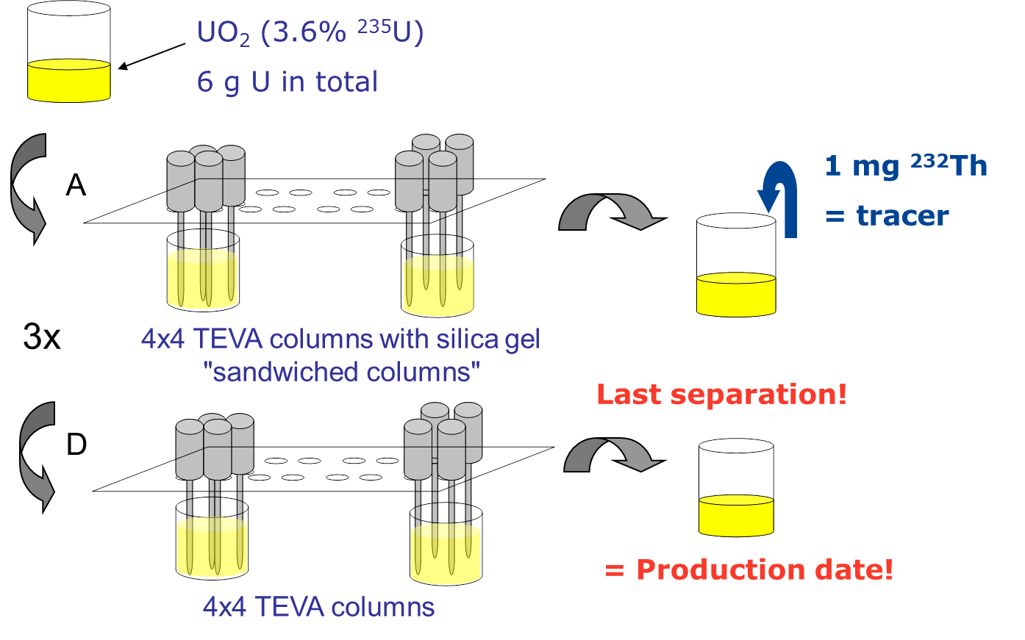
Figure 1 Four-step chemical separation using TEVA resin of the thorium from the uranium base material to ensure efficient Th removal from the uranium matrix (U/Th separation factor > 10⁷).
In order to ensure homogeneity of the sample throughout the whole process, the uranium eluates from the sixteen columns were combined after each separation step, measured by γ-spectrometry and evaporated overnight.
As the final separation factor and uranium recovery are very important to determine the thorium/uranium separation efficiency (i.e. the completeness of the U/Th separation) and quantify the effective recovery of uranium, measurements of the recovered U fractions (four batches A, B, C and D) were performed using γ-spectrometry between each of the chemical separation using the well-resolved γ-peaks of the short-lived ²³⁴Th (T_{1/2}= 24.1 days) and the ²³⁵U (at 185.7 keV) respectively [7].
Moreover, a natural ²³²Th tracer (1 mg of a Custom Claritas Standard with a total Th concentration of 1000 ± 5μg/g, k=2) was added to the solution before the second chemical separation in order to determine later on by ICP-MS the residual thorium in the reference material after the last chemical separation (Fig.1). Then, the procedure of chromatography, weighing and γ-spectrometry was repeated as described above.
The fourth and last chemical separation corresponding to the "production date", i.e. the reference value of the material, was carefully recorded as dd/mm/yyyy and time. After this separation, the final purified solution was aliquoted into cleaned PFA vials: altogether 108 units containing about 20 mg of uranium and 53 units containing about 50 mg of uranium were prepared. The aliquots were evaporated and kept in solid form in the capped and sealed vials.
Table 1 summarises the results obtained from the different γ-measurements (between each separation and after the final separation) for the uranium recoveries using the ²³⁵U and separation factors using the ²³⁴Th. These results (Table 1) proved that the 'target value' was reached, with an overall U recovery of 83.7% ± 0.3% (relative standard uncertainty) and a cumulative U/Th separation factor (i.e resulting from the four successive separations) better than 2.77 × 10⁷ ± 0.93 × 10⁷ (standard uncertainty) attesting of the effective/quantitative recovery of uranium in the final reference material and of the efficiency of the separation of Th from the uranium material.
The completeness of the removal of thorium from the initial uranium material was further confirmed by the measurements of the Th amount content and isotope ratio by mass spectrometry using ICP-MS and the ²³²Th tracer that had been added to the uranium sample after the first separation. Based on this measurement, the final (cumulative) U/Th separation factor was found to be higher than 1.81× 10⁷, but still fulfilling the 'target value' with thorium in the purified solution being less than 0.01 μg/g uranium.
Note that other impurities in the final U material were measured as well by the ITU Analytical Services but were identified to be insignificant for the determination of the age.
Table 1 Summary of the uranium recoveries (based on γ-peak of ²³⁵U) and separation factors based on γ-peak of ²³⁴Th and on ICP-MS measurements of the total Th (traced with ²³²Th) for each of the four chemical separations and total separation factors (cumulative, i.e. from steps 1 to 4). Reported uncertainties are standard uncertainties.
Separation steps | U recoveries (²³⁵U) | SF from Th/U | SF from total Th
1 | 95.0 ± 0.4 % | 714 ± 126 | 714 ± 126ª
2 | 94.9 ± 0.4 % | 22 ± 4
3 | 96.2 ± 0.5 % | 24 ± 4 | 25366
4 | 94.4 ± 0.4 % | 75 ± 12
Cumulative | 83.7 ± 0.3 % | 2.8x10⁷ ± 0.9x10⁷ | 1.8x10⁷
ª Note that for the first step no separation factor can be calculated based on ²³²Th since it is only introduced in the sample after the first step. It is therefore assumed to be equal to the separation factor based on the γ-determination of the U/Th ratio.
Based on the cumulative U/Th separation factor (Table 1) and the known initial n(²³⁰Th)/n(²³⁴U) amount ratio in the uranium base material, any residual amount of ²³⁰Th present after the last chemical separation can be estimated. This can be done from measurements by ICP-MS of the n(²³⁰Th)/n(²³⁴U) amount ratio in the purified uranium material directly after the last separation, but the amount of ²³⁰Th is often too close to the detection limit to be accurately measured. Therefore, by applying Eq. 3, the residual ²³⁰Th in the reference material can be expressed as a time and was found to be less than 1.3 hours in IRMM-1000.
Finally, the uncertainty on the production date of our uranium age-dating reference material includes the uncertainty on the date of the last chemical separation (i.e. the time interval bracketing the exact time of the last elution of Th from the U material ) and the uncertainty coming from the residual thorium measured in the final purified uranium material. The elution of thorium lasting about 3 hours, the uncertainty on the last elution time of the Th from the U material was estimated to be 1.5 hours in order to account for the whole thorium elution time. Finally, the combined standard uncertainty inherent to the production of the reference material was estimated to be 0.08 days (k=1).

- Confirmation measurements of the certified reference value
After ingrowth of Th in the U reference material confirmation measurements were carried out following ISO Guide 34 to assess if the measured age corresponded to the known production date. This confirmation step consisted of the analysis of 6 randomly selected 20 mg out of the 161 IRMM-1000 units. The 6 randomly selected 20 mg units (referred as A, B, C, D, E, F) were first dissolved. The expected U concentration in these samples was ~ 10 mg/ml of total U and should correspond to an amount of ~ 1 pg of ²³⁰Th per sample 7 months after the production of IRMM-1000. Subsequently, aliquots were prepared gravimetrically and by dilutions from the 2 ml dissolved samples in order to measure the U isotopic composition using TIMS, the U concentrations by ICP-MS (and the thorium isotope ratios and concentrations with ICP-MS. For the isotope dilution measurements, a ²³³U spike was used to determine the uranium amount content, whereas two different natural Th spikes (²³²Th) were used to determine the thorium amount content [8]. With each of the 6 units, a procedural blank (using 2 ml concentrated HNO₃) and an unspiked sample were prepared as well. Procedural blanks were measured before each measurement series and amount contents in the samples were corrected for the respective bracketing blanks. The unspiked samples were measured with each corresponding measurement series in order to establish R_{X,} in the IDMS equation (Eq. 2).
After evaporation, the thorium and uranium fractions were recovered in 4% HNO₃ to be measured with the double-focusing magnetic sector ICP-MS, Element 2. The detailed mass spectrometric parameters and corrections applied for the measurements of the n(²³⁰Th)/n(²³²Th) and n(²³⁴U)/n(²³³U) amount ratios are described in [8].
Based on the ²³⁰Th and ²³⁴U amount contents determined by IDMS applying Eq. 1-3, the ages from the six selected units and their associated expanded uncertainties (k=2) were calculated according to ISO/BIPM using the GUM Workbench Software [12]. The calculated age values reported in Fig.2 were then compared with the known elapsed time between the production of the reference material and the last chemical separation carried out for this study. The date of the separation of the first batch A was taken as the reference date hereafter referred to as the "known age". Since the reference value, i.e. the exact production date of IRMM-1000, cannot be revealed yet, the age values, calculated in days, are presented in this study normalised to the known age (Fig.2).
A good agreement of the calculated ages per single units, the average age and the known age was established (Fig.2); successfully confirming the completeness of the separation of the thorium from the uranium during the production of the uranium reference material. Note that the associated uncertainty of the known age (Fig.2) combines the uncertainty on the production date as given in the previous section, i.e. 0.08 days (k=1), and the uncertainty of the reference time of the Th/U separation for this study and is therefore of 0.21 days (k=2). Finally, the uncertainties on the calculated ages take into account the performed replicate measurements (standard deviation), thereby resulting in an expanded uncertainty of 4.6 days (k=2) on the calculated average age.
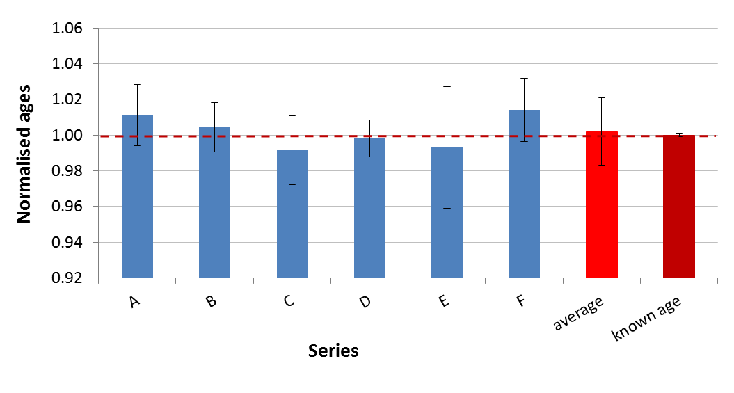
Figure 2 Final ages obtained for the 6 units selected for the characterisation study (blue), their average (red) and the known age based on the reference value (burgundy) with their expanded uncertainties (k=2).The age values are here normalised to the known age.

- Homogeneity study
The homogeneity study took place about 14 months after the production of the reference material. For the homogeneity test, 10 units (5 of 20 mg and 5 of 50 mg uranium units) were randomly selected among the whole batch of IRMM-1000. The 20 mg uranium samples were referenced from A to E and the 50 mg uranium samples from F to H.
The randomly selected units of 20 mg and 50 mg uranium, in dry form, were first dissolved and subsequently the same measurement procedures were applied as for the confirmation measurements described in the previous section. All together 10 units/series of 3 replicates were prepared together with an unspiked sample with each series and 8 procedural blanks, resulting in a total number of 48 samples to be measured for the homogeneity study.
The chemical separations were performed for each aliquot at consecutive dates. Therefore, the separation for the first series of samples is considered as the reference date for the comparison of the final results. The thorium fractions were measured with HR-ICP-MS in a randomised order as follows: I, D, B, J, C, H, F, G, A, E.
Applying Eq 1-3 on the determined ²³⁰Th and ²³⁴U amount contents, the 30 ages for the selected units and their associated expanded uncertainties (k=2) were calculated according to ISO/BIPM using the GUM Workbench Software [12]. The results from the homogeneity study for the calculated ages per selected unit (10 values) are presented in Fig. 3 in the chronological order of the ICP-MS measurements. The overlap of the average age value with the known age, as well as with all the individual age values confirmed the homogeneity of the complete IRMM-1000 batch.
The final evaluation of the homogeneity was carried out using an ANOVA Single Factor analysis (analysis of variance) on the 30 age values (3 Th replicates x 10 units). No trend was observed in the results related to the chronological order of the analysis and measurements (Fig.3).
The ANOVA analysis allows the separation of the method variation (s_{wb}) from the experimental averages over the replicates measured in one unit to obtain an estimation for the real variation between units (s_{bb}). The relative standard uncertainty for method repeatability (s_{wb}) was 0.43%. The absolute expanded uncertainty resulting from the homogeneity study was 7.8 days (k=2). This uncertainty will be the major component of the expanded uncertainty of the reference value of IRMM-1000.
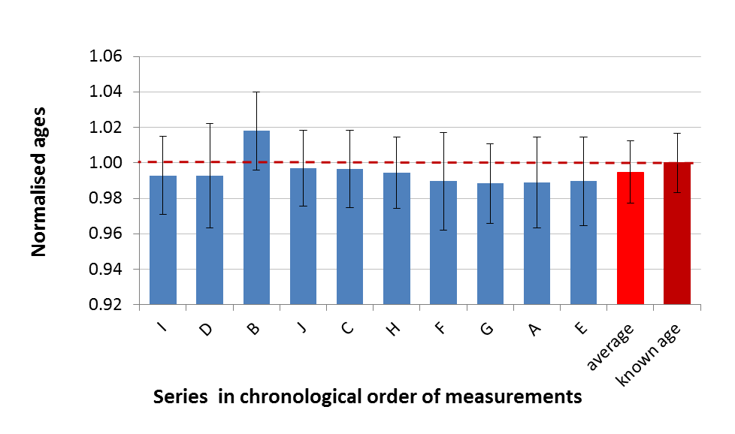
Figure 3 Calculated ages obtained for the 10 units selected for the homogeneity study (blue), their average (red) and the known age based on the reference value (burgundy) with their expanded uncertainties (k=2). The age values are here normalised to the known age.

- Conclusion

Combining the complementary capabilities of two JRC institutes enables the conception, preparation and certification of the first ever uranium reference material certified for its production date. The release of this new reference material, IRMM-1000 responds to a demand expressed by the Nuclear Forensics International Technical Working Group (ITWG) and laboratories in the field. The results from the verification and homogeneity studies both confirmed the completeness of the chemical separation of thorium from uranium in IRMM-1000, and were fully consistent with the date of last chemical separation. Moreover, these two studies demonstrated the accurate characterisation of this material and the reference value as it will be given on the reference material certificate in dd/mm/yyyy ± days (k=2).
This new reference material is certified for the production date in uranium age-dating and can be used in applications such as nuclear forensics, security and safeguards using the ²³⁴U/²³⁰Th parent/daughter pair. Prior to the release of IRMM-1000, first the long-term stability study needs to be finalised during summer 2014 and secondly the result reporting for the Regular European Inter-laboratory Measurement Evaluation Programme (REIMEP-22) called "U Age Dating - Determination of the production date of a uranium certified test sample" and based on this material needs to be closed [13]. The certified reference material IRMM-1000 should be available in 2015.

References
[1] Mayer, K., Wallenius M., et al., Nuclear Forensics: A methodology applicable to Nuclear Security and to Non-Proliferation. Journal of Physics: Conference Series 312- 062003 (2011). doi:10.1088/1742-6596/312/6/062003
[2] Mayer K., Security: Expand nuclear forensics. Nature, 503, 461-462 (2013).
[3] Mayer, K., Wallenius, M., Varga, Z., Nuclear Forensic Science: Correlating Measurable Material Parameters to the History of Nuclear Material. Chemical Reviews, 113, 884 (2013).
[4] Wallenius M., Morgenstern A, Nicholl, A.; Fiedler R., Apostolidis C., Mayer K., Age determination of highly enriched uranium. IAEA-SM-367/5/07.
[5] Varga, Z., Suranyi G., Production date determination of uranium-oxide materials by inductively coupled plasma mass spectrometry. Analytica Chimica Acta, 599, 16-23 (2007).
[6] Pommé S., Jerome S.M., Venchiarutti C., Uncertainty propagation in nuclear forensics. Journal of Applied Radiation and Isotopes, 89C, 58-64 (2014).
[7] Morgenstern A., Apostolidis C., Mayer K., Wallenius M., Uranium age determination: separation and analysis of ²³⁰Th and ²³¹Pa. IAEA-CN-98/27P
[8] Varga, Z., Nicholl, A.; Wallenius, M.; Mayer, K.., Development and validation of a methodology for uranium radiochronometry reference material preparation. Analytica Chimica Acta, 718, 25-31 (2012).
[9] De Bievre P., Peiser H.S., Basic equations and uncertainties in isotope-dilution mass spectrometry for traceability to SI of values obtained by this primary method. Fresenius, Journal of Analytical Chemistry, 359, 523-525 (1997).
[10] Lamont S.P., Hall G., Uranium age determination by measuring the ²³⁰Th/²³⁴U ratio. Journal of Radioanalytical and Nuclear Chemistry, 264, 423-427 (2005).
[11] DDEP, 2004-2013. Table of radionuclides. Monographie BIPM-5, BIPM, Sèvres, website: ohttp://www.nucleide.org/DDEP_WG/DDEPdata.htm4.
[12] Programme GUM work bench 2.4 (Metrodata, GmbH, Weil am Rhein, Germany, 2009).
[13] https://ec.europa.eu/jrc/en/interlaboratory-comparison/reimep-22

