Nuclear Forensics Expertise Development: Transferring Knowledge to the Next Generation
S.K. Connelly, W.B. Daitch

Domestic Nuclear Detection Office
U.S. Department Of Homeland Security
Washington, DC, 20005, USA

Abstract. Since 2008, the National Nuclear Forensics Expertise Development Program (NNFEDP) has served as the comprehensive U.S. Government effort to grow and sustain the uniquely qualified technical expertise required to execute the nation’s nuclear forensics mission. The NNFEDP has created a vibrant academic pathway over the past six years from undergraduate to post-doctorate study in nuclear and geochemical sciences directly relevant to nuclear forensics, supporting over 300 students and faculty in partnership with 11 U.S. National Laboratories and 23 universities. Through its fellowship, scholarship, junior faculty, and education development initiatives, the program links next generation scientists with technical experts at the Laboratories for practical research experiences and individual mentoring to facilitate critical knowledge transfer and to establish a seamless pipeline from academia into an attractive career in nuclear forensics. The NNFEDP provides an active and practical example of how to transfer and sustain nuclear forensics knowledge and expertise to the next generation of scientists – a major challenge facing the international nuclear security community today.

1. Introduction

The National Nuclear Forensics Expertise Development Program (NNFEDP) serves as the comprehensive U.S. Government (USG) effort to grow and sustain the uniquely qualified technical expertise required to execute the nation’s nuclear forensics mission. The U.S. Department of Homeland Security (DHS) launched the NNFEDP in 2008, and President Obama supported the effort when he signed the Nuclear Forensics and Attribution Act into law in 2010 [1]. The primary program objective is to create a vibrant and enduring academic pathway from undergraduate to post-doctorate study in nuclear and geochemical sciences directly relevant to nuclear forensics, including radiochemistry, geochemistry, nuclear physics, nuclear engineering, materials science, and analytical chemistry. Through its fellowship, scholarship, junior faculty, and education development initiatives, the NNFEDP links next generation scientists with technical experts at the U.S. Department of Energy (DOE) National Laboratories for practical research experiences and individual mentoring to facilitate critical knowledge transfer and to establish a seamless pipeline from academia into an attractive career in nuclear forensics.

Over the past six years, the NNFEDP has supported over 300 students and faculty in partnership with 11 U.S. National Laboratories and 23 universities. This program provides an active and practical example of how to transfer and sustain nuclear forensics knowledge and expertise to the next generation – a major challenge facing the global nuclear security community today.

2. The Workforce Challenge and the U.S. Approach

In the early 2000s, a number of expert groups published studies recognizing that the cadre of experienced nuclear forensics experts at U.S. National Laboratories and in academia had been rapidly diminishing since the end of the Cold War, and the outlook for replacing them was grim. A 2004 DOE National Science Foundation Nuclear Science Advisory Committee report assessed that within ten years, “more than three quarters of the workforce in nuclear engineering and at the National Laboratories will reach retirement age” [4]. At the same time, the decline in U.S. academic programs in technical areas directly relevant to nuclear forensics, such as radio- and nuclear chemistry, had reached alarmingly low levels. Few universities still offered graduate programs in radiochemistry, and in most of these, only one faculty member remained. By 2008, the total number of Ph.Ds. awarded nationwide had decreased to fewer than six per year. The National Academy of Sciences, a Joint Working Group of the American Association for the Advancement of Science and the American Physical Society, and the U.S. Government Accountability Office all highlighted these gaps as a crisis and recommended they be addressed in a swift, targeted manner [2, 3, 5].

In the face of a dire situation both at the National Laboratories and in academia, the USG established the NNFEDP to reverse declining trends and develop the next generation of nuclear forensic scientists in the United States. The NNFEDP promotes an interdisciplinary approach emphasizing collaboration among students, academic departments, universities, and National Laboratories. It is unique compared to broader science and technology federal education programs in its deliberately narrow focus on addressing highly specific, identified technical needs within the nuclear forensics field. All efforts are integrated, aligned, and inextricably linked to USG nuclear forensics priorities, projects, and the cadre of expert nuclear scientists at the National Laboratories. This is accomplished through one-on-one mentoring, practical internships, and focused collaborative applied research.

3. Establishing an Academic Pathway to a Nuclear Forensics Career

Key components of this holistic program aim to create a seamless pipeline from academia into a career in nuclear forensics at the national level [Fig. 1]. NNFEDP initiatives include graduate and undergraduate scholarships, fellowships, internships and mentoring, post-doctoral fellowships, and university and junior faculty awards for studies and research in nuclear forensics-related disciplines.

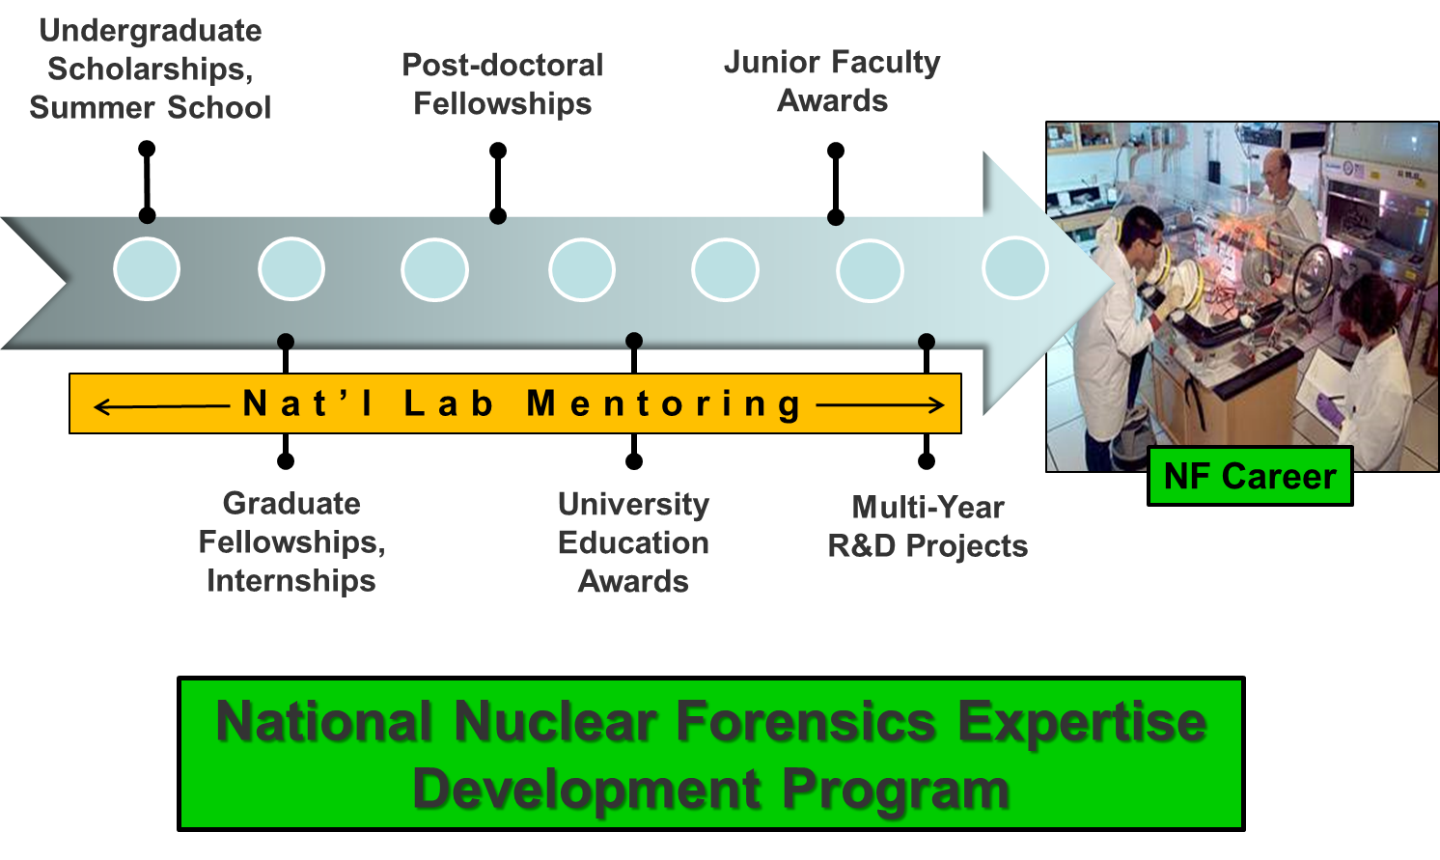

FIG. 1. Illustration of the NNFEDP: key components from the undergraduate through the post-doctoral level create a seamless pipeline from academia into a career in nuclear forensics at the national level.

3.1 Undergraduate Initiatives

The NNFEDP undergraduate-level programs are designed to introduce undergraduate students to the field of nuclear forensics as a viable career path, increase the number of qualified undergraduates pursuing graduate studies in technical fields related to nuclear forensics, develop enduring relationships between the students and National Laboratories, and foster collaborations between university partners and laboratory staff conducting nuclear forensics research. NNFEDP addresses these objectives through two primary initiatives.

3.1.1 Nuclear Forensics Undergraduate Scholarship Program

The Nuclear Forensics Undergraduate Scholarship Program aims to introduce outstanding physics, chemistry, and nuclear engineering undergraduates to nuclear forensics-related research sponsored by the USG at the National Laboratories. Participants gain hands-on experience through a nine-to-12-week summer research practicum under the guidance of a senior laboratory mentor and a university faculty advisor. Following the completion of the practicum, scholars produce a scientific report and deliver oral presentations of their research to the broader nuclear forensics community, including technical and policy experts from academia, the National Laboratories, and the Federal Government, as well as their peers.

3.1.2 Nuclear Forensics Undergraduate Summer School

The Nuclear Forensics Undergraduate Summer School provides a comprehensive, experimental, hands-on training curriculum in topics essential to nuclear forensics as a means of attracting students to pursue graduate studies in related technical fields. Students participate in a four- to six-week program, hosted by a partnership of universities and National Laboratories, that comprises a series of lectures, laboratory experiments, National Laboratory field trips, and practical exercises. The focus of this program is to introduce students to the technical and practical aspects of nuclear forensics, while providing them with a fundamental understanding of the underlying science necessary to comprehend the subject matter. The Summer School recruits undergraduate students from chemistry, physics, geology, and materials science departments at research universities across the nation, with the host school and laboratory field trip rotating each year.

3.2 Graduate Initiatives

The NNFEDP graduate-level programs encourage students to pursue advanced degrees in radiochemistry and other nuclear forensics-related disciplines and encourage universities to invest in these types of academic programs. The main objective at the graduate level is to meet the near-term USG milestone of adding 35 new Ph.D. scientists into the nuclear forensics field by 2018. The NNFEDP implements two primary initiatives in this area.

3.1.1 Nuclear Forensics Graduate Fellowship Program

As a key component of the broader NNFEDP, the Nuclear Forensics Graduate Fellowship Program enables students to gain unique, hands-on experience through laboratory practicums and close interaction with technical and policy experts throughout the nuclear forensics community. The program encourages these students to seek advanced education in technical areas related to nuclear forensics and provides incentives for universities to invest in and further develop radiochemistry and other related academic programs.

Fellowship appointments provide tuition and a 12-month stipend at an approved university, renewable for up to 60 months, for outstanding graduate students pursuing doctoral degrees in nuclear, geochemical, and related scientific disciplines. Universities selected to participate in the program have demonstrated a commitment to building a sustainable academic program in these core disciplines. Fellows must earn their degrees with a consistently high level of academic standing and complete at least two ten-week-minimum practicums at a National Laboratory or federal agency conducting nuclear forensics research. Upon graduation, fellows must serve for two years in a post-doctoral or other staff position at a National Laboratory or federal agency in a nuclear forensics-related area. Ultimately, this program gives highly motivated students an exceptional opportunity to apply their knowledge to enhance U.S. national security.

3.1.2 Glen T. Seaborg Institute Nuclear Science Summer Internship Program

The USG also sponsors graduate and outstanding undergraduate students as interns at Lawrence Livermore National Laboratory and Los Alamos National Laboratory each summer through the well-established Glen T. Seaborg Institute Nuclear Science Summer Internship Program. Most interns are graduate students with expertise in nuclear engineering, radiochemistry, math, physics, and the earth sciences. The Seaborg Institute facilitates student research in a variety of different areas; however, NNFEDP students work on projects directly related to nuclear forensics. Interns also have the opportunity to participate in a seminar series at their respective laboratories to interact with their peers and more senior experts and to learn about important topics in the nuclear sciences.

3.3 Post-Graduate Initiatives

The NNFEDP Post-Doctoral Fellowship Program encourages recent Ph.D. graduates with relevant technical expertise to enter the forensics workforce and provides a career track for nuclear forensics graduate fellows. During these three-year appointments, post-docs work on nuclear forensics research projects at a National Laboratory and have the opportunity to engage with experts across the USG nuclear forensics community. The ultimate goal is to help facilitate the successful transition of these fellows at the end of their appointments to permanent staff positions at the National Laboratories.

3.4 University Initiatives

3.4.1 Nuclear Forensics Education Award Program

The Nuclear Forensics Education Award Program is designed to encourage universities to develop interdisciplinary programs in partnership with the National Laboratories. This program provides cost-shared grants, renewable for up to three years, to colleges and universities to support educational programs in analytical, geological, and radiochemistry, nuclear physics and engineering, and materials science. To ensure university commitment, an annual cost-share agreement of 50 percent matching funds is required from the institution receiving an award. Universities may use the award to develop nuclear forensics curriculum and research programs that complement ongoing research at the national laboratories, construct on-campus laboratory facilities for forensics-related work, enhance faculty member qualifications or hire new faculty, sponsor students, and/or make other improvements that align with USG mission priorities.

3.4.2 Nuclear Forensics Junior Faculty Award Program

The objective of the Nuclear Forensics Junior Faculty Award Program is to provide universities with an incentive to recruit, promote, and retain highly qualified personnel to teach within nuclear forensics-related degree programs and to contribute to associated research at universities. These awards are renewable for up to three years and can be used to support faculty salaries, facilitate research projects, purchase equipment, and provide travel to National Laboratories for technical collaboration. The award recipient must be in a tenure-track position and meet the definition of a “junior faculty member” (someone with less than six years of experience at the time of application). Partial matching funds from the university are encouraged and demonstrated collaboration with a National Laboratory is a key component of this program.

3.4.3 Nuclear Forensics Minority Serving Institution Collaboration Award Program

The Nuclear Forensics Minority Serving Institution Collaboration Award Program serves to strengthen the engineering and science programs at Minority Serving Institutions located throughout the United States and to enhance the partnerships between these institutions and other U.S. universities with established academic programs in scientific disciplines relevant to nuclear forensics. These three-year awards can be used to support faculty salaries, student scholarships and fellowships, travel, laboratory and equipment improvements, coursework, and other collaborative academic activities with university and national laboratory partners. The overarching goal of this program is to help meet USG needs for a diverse and highly trained workforce in priority technical areas for nuclear forensics research and development.

3.5 Mentoring

The Graduate and Undergraduate Mentoring Assistance Programs enable mid-to-senior-level staff scientists at U.S. laboratories to mentor students in collaboration with university professors. These programs provide dedicated funding for one-on-one mentoring, which includes training, assistance with the design, execution, and publishing of research projects, and interaction with the student’s faculty advisor and home university. The impact of this support has also extended into the development of special lectures and courses in nuclear forensics-related topics at universities, thus benefiting upper-level undergraduate and graduate students more broadly in addition to individual mentees. Scientist-student mentoring is a multi-year responsibility that helps to build a long-term collaboration among the National Laboratories, universities, and next generation of experts that is critically important to facilitating a seamless pipeline from academia into a nuclear forensics career and transferring expert knowledge to the next generation of scientists.

4. Real Progress

In close collaboration with 11 National Laboratories, the NNFEDP has supported over 300 students and faculty and 23 universities since its inception in 2008. Twenty-one students are currently pursuing their Ph.D.’s through the Nuclear Forensics Graduate Fellowship Program, along with 13 post-doctoral fellows who are at the laboratories conducting research under preeminent nuclear forensics experts. Eighteen graduates of these two programs have already entered the nuclear forensics workforce at U.S. National Laboratories and federal agencies, with four post-doctoral fellows transitioning to permanent positions at the labs in the first half of 2014 alone. Undergraduate initiatives are proving to be an effective tool for recruiting future Ph.D. candidates, with 15 new undergraduate participants each year. NNFEDP education award programs have directly sponsored nuclear forensics-related curriculum development and research partnerships at 13 universities around the country, including support to eight tenure-track junior faculty members. These university initiatives are having a broad impact in increasing the awareness and knowledge base of the next generation, with an increase of more than 50 percent since 2009 in the number of nuclear forensics-related courses and the number of students enrolled in those courses at universities with awards.

5. Continual Assessment

The USG continually evaluates the state of the workforce within the National Laboratory system relative to the U.S. nuclear forensics mission requirements in order to appropriately scale and scope the NNFEDP. In addition, DHS chairs a Nuclear Forensics Expertise Development Committee in order to ensure whole-of-government integration and participation in nuclear forensics expertise development activities. The Committee provides a forum to plan, coordinate, and execute joint program initiatives, avoiding duplication, leveraging funding, and ensuring robust national support and unity of effort. Participants include DHS, DOE, and the U.S. Departments of Defense and Justice.

6. Summary

The United States is steadily accomplishing its goal to grow and sustain the uniquely qualified technical expertise required to execute the nation’s nuclear forensics mission through the implementation of the NNFEDP. The range of initiatives spanning the undergraduate to the post-doctoral level has created a pathway for students from academia to a career in nuclear forensics. Eighteen new Ph.D. scientists have now transitioned from the expertise pipeline into full-time positions in the USG nuclear forensics workforce, as the NNFEDP steadily progresses toward the near-term milestone of adding 35 new Ph.D. scientists into the field by 2018. More broadly, this program is reinvigorating the nuclear science academic community at universities across the United States – providing the strong foundation in core scientific disciplines that is needed to educate the next generation of nuclear forensics experts and enhancing the overall U.S. capacity for critical technical research. The NNFEDP is a key component in ensuring an enduring and robust nuclear forensics capability that will continue to contribute to both national and international efforts to prevent nuclear terrorism.

References

[1] 111th U.S. CONGRESS, Nuclear Forensics and Attribution Act (Public Law 111-140), Washington, DC (2010).

[2] JOINT WORKING GROUP OF THE AMERICAN ASSOCIATION FOR THE ADVANCEMENT OF SCIENCE and the AMERICAN PHYSICAL SOCIETY, Nuclear Forensics: Role, State of the Art, and Program Needs, AAAS Publication Services, United States (2008).

[3] NATIONAL RESEARCH COUNCIL, Nuclear Forensics: A Capability at Risk (Abbreviated Version), The National Academies Press, Washington, DC (2010).

[4] U.S. DEPARTMENT OF ENERGY and NATIONAL SCIENCE FOUNDATION NUCLEAR SCIENCE ADVISORY COMMITTEE, Education in Nuclear Science: A Status Report and Recommendations for the Beginning of the 21st Century, U.S. Department of Energy and National Science Foundation (2004).

[5] U.S. GOVERNMENT ACCOUNTABILITY OFFICE, Nuclear Forensics: Comprehensive Interagency Plan Needed to Address Human Capital Issues, U.S. Government Accountability Office, Washington, DC (2009).

