Development of Nuclear Forensics Capabilities in Japan
N. Shinohara, Y. Kimura, K. Sato, N. Toda, Y. Shinoda, Y. Funatake, M. Watahiki, Y. Kuno
Japan Atomic Energy Agency, Integrated Support Center for Nuclear Nonproliferation and Nuclear Security (ISCN), Tokai, Ibaraki 319-1195 Japan

Abstract: According to the IAEA technical guidance for nuclear forensics (NF) starting from incident response and going to sampling, distribution, analysis and finally interpretation in illicit trafficking of nuclear and other radioactive materials [1], NF laboratory has to enable the identification of unique characteristics in the seized materials, to provide investigative leads and support prosecution outcomes and then to enhance State security. Japan Atomic Energy Agency (JAEA) has started the development of analytical techniques for establishment of the NF laboratory with responsibilities to accomplish the analytical techniques such as isotope ratio measurement, impurity measurement, particle analysis, uranium age determination, and development of a prototype national NF library against illicit trafficking of nuclear and radiological materials. In this paper, capabilities of the NF technologies in Japan are presented in order to share our experience with international NF community. Need to establish international cooperation regime on realistic NF approach is also discussed.

1. Introduction
In accordance with Japan’s national statement at the Washington Nuclear Security Summit (2010), development of technology related to measurement and detection of nuclear material and nuclear forensics (NF) has been started based on international cooperation for the contribution to the identification of the sources of the nuclear material illicitly trafficked or used in terrorist attacks. Japan has made increased contributions to the international community by establishing these technologies with more precise and accurate capabilities in detection and forensics within an approximate three year time frame and sharing the fruits of these new technologies with the international community.
According to IAEA reports and other security documents, the threat of nuclear terrorism is still increasing. From the point of view of security and maintenance of public peace in Japan, the domestic technologies against illicit trafficking of nuclear material and radioactive substances must be established for criminal specification and prosecution. When illicit trafficking of nuclear material happens in a third-country in future, there is possibility that the nuclear material is suspected to be stolen in Japan because we have various nuclear facilities and multiplex nuclear materials. Japan’s own technology for NF should be retained in order to keep reliance of our nuclear activities.
Japan Atomic Energy Agency (JAEA) has engaged in research and development activities of NF for strengthening nuclear security. The JAEA implements joint researches with the US including uranium age dating measurements, characterization of nuclear fuel for forensics purposes, and establishment of a proto-type national NF library. Analytical methods for measurement of isotopic abundance and impurity in nuclear material are also developed to identify its source and determine the point of its origin and routes of transit. In this paper, capabilities of the NF technologies in Japan are presented in order to share our experience with international NF community. Need to establish international cooperation regime on realistic NF approach is also discussed.
2. Development of nuclear forensics technologies
Fundamental technologies for NF have been developed from 2011 to 2013 at JAEA, where the objects to be analysed are isotopic abundances of nuclear material by means of Thermal Ionization Mass Spectrometry (TIMS), abundance of impurity contained in the nuclear material by Inductively Coupled Plasma-Mass Spectrometry (ICP-MS), particle image by Scanning Electron Microscope (SEM) and/or Transmission Electron Microscope (TEM), and uranium age determination. National NF library is under construction by collecting several kinds of data and analysing various uranium samples as an NF database.
Actual uranium samples have been measured by the methods mentioned above. Isotopic abundance of an imported yellow cake was analysed by TIMS and the result is shown in TABLE I. High reliability of the isotopic abundance measurement has been accomplished by analysing the NBL standard materials of CRM U050 and U500, where their relative standard deviations (1 RSD) are 0.022% and 0.030%, respectively. Particle image of the same sample measured by SEM is given in FIGURE. 1. Specific future of the image can be observed from this figure, which is very useful information as an NF evidence.

TABLE I: ISOTOPIC ABUNDANCE OF A URANIUM SAMPLE (YELLOW CAKE).*
Sample No | ²³⁴U (%) | ²³⁵U (%) | ²³⁸U (%)
1 | 0.00576 | 0.7206 | 99.2736
2 | 0.00527 | 0.7206 | 99.2742
3 | 0.00565 | 0.7199 | 99.2744
4 | 0.00545 | 0.7202 | 99.2744
5 | 0.00547 | 0.7207 | 99.2739
Mean Value | 0.00552 | 0.7204 | 99.2741
1 SD | 0.00019 | 0.0003 | 0.0004
* Five specimens from one sample were measured for uncertainty evaluation.
Impurity analyses were carried out for five samples of natural, depleted and enriched uranium by ion exchange separation and ICP-MS measurement and the result is shown in FIG. 2. The contents of impurity elements are quite different among the samples, because the points of their origins and routes of transit are varied.
The age of nuclear material is essential information to identify the source of the material, and ²³⁴U-²³⁰Th chronometer is widely applied to NF. We conducted procedure exchange and inter-laboratory comparison exercise on uranium age dating between Department of Energy (DOE) of US and JAEA, where the same NBL standard materials of CRM U050 were independently analysed. The analysis of age determination on uranium oxide standard was already performed and the time of its purification can be estimated to be July 31 of 1957 from the JAEA’s result. Inter-comparison with other laboratory’s results is now in progress [2].
The JAEA has developed a prototype system of National Nuclear Forensics Library (NNFL) based on the data related to nuclear materials and other radioactive materials possessed at the JAEA facilities. A concept building of the database for NNFL was almost completed with its basic system of data handling. The data gathering on the nuclear materials at JAEA has been continued. The present prototype system will be transferred to the future national responsible authority as a real NNFL which will support the nuclear security activities in Japan. The JAEA participated in the first international table top exercise of NNFL “Galaxy Serpent,” held by the International Technical Working Group (ITWG) as a part of our NNFL development project [3]. FIGURE 3 shows an isotope correlation plot in order to evaluate the seizure. The seized material (green) strongly associated with the PWR-2 reactor (blue). Status of our NNFL development will be also presented in this IAEA Conference [4].

3. Nuclear Forensics Capabilities in Japan
In the Statement of Principles committed to the participants in the Global Initiative to Combat Nuclear Terrorism (GICNT), they implement eight principles on a voluntary basis: One of the principles is “Improve capabilities of participants to search for, confiscate, and establish safe control over unlawfully held nuclear or other radioactive materials and substances or devices using them.” In view of the importance of nuclear security and international impetus to construction of NF regime, the pertinent agencies in Japan (Nuclear Regulation Authority, National Police Agency, Japan Coast Guard, Ministry of Foreign Affairs, Ministry of Finance Japan, Ministry of Education, Culture, Sports, Science and Technology, Ministry of Defense, and so on) must cooperate with one another. It is necessary to organize Japan’s own system for NF by establishing a national NF laboratory and collaborating with traditional forensics which targets the evidences of finger prints, DNS, and so on.

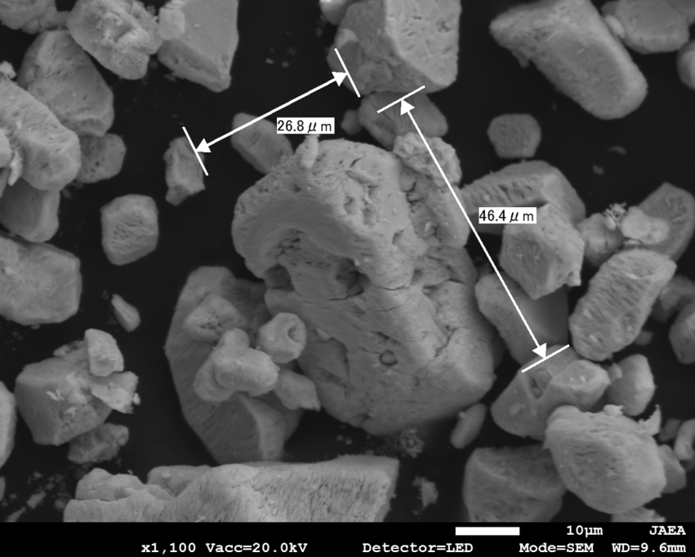
FIG. 1. Particle image of the yellow cake observed by SEM.

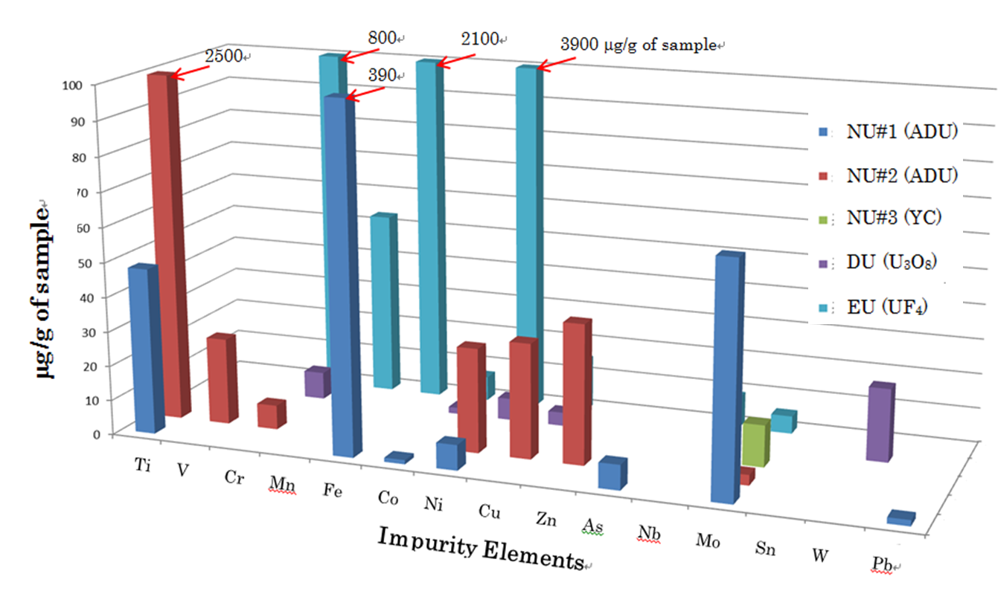
FIG. 2. Impurities contained in the uranium samples.

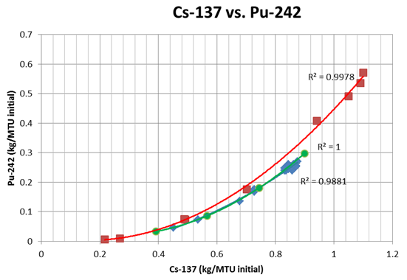
FIG. 3. Isotope correlation plot of ¹³⁷Cs vs. ²⁴²Pu for international table top exercise of NNFL “Galaxy Serpent.” The data of red squares belong to spent fuel of PWR-1, blue squares to PWR-2 and green circle to seizure, respectively.
The NF laboratory consists of analytical and storage facilities for seizure materials and NNFL. The laboratory should have ability to secure the reliabilities of evidence analysis techniques, guarantee of quality to the results analysed as evidence, database and its comparison with evidence. Because the JAEA has developed the fundamental technologies for NF as mentioned above, it is possible for us to take charge of the analysis for nuclear materials as a work of NF laboratory. In the NF analysis of seizure and the database construction of NNFL, the judicial reliability of the data is required on the basis of standardization of the analytical scheme and inter-laboratory round-robin exercises. We enhance our analytical skills for the sake of international progress of the nuclear security.
Exchange of the newest NF information through international cooperation is important for each State, because the NF activity has a global side of criminal investigation. Japan implements joint researches with the US for forensics purposes at the JAEA. The Integrated Support Center for Nuclear Nonproliferation and Nuclear Security (ISCN) under the JAEA has been providing training courses to support domestic and international capacity building for regulators, mainly from Asian countries in cooperation with the IAEA. The IAEA Regional Training Course on Introduction to Nuclear Forensics was hosted by the ISCN in May 2012 and received total 24 participants from ten Asian countries. Japan will continue to promote such coordination and cooperation through the IAEA and other international fora [5].

4. Conclusion
The JAEA has developed fundamental and reliable technologies for NF (Nuclear Forensics) and is now measuring actual uranium samples to make a NF database. A prototype system of NNFL (National Nuclear Forensics Library) is under construction on the basis of international cooperation. The pertinent agencies in Japan must cooperate with one another to organize Japan’s own system for NF by establishing a national NF laboratory. The laboratory should have the reliabilities of evidence analysis techniques, guaranteed quality of the evidence, and database and its comparison with evidence. Another important subject of ours is domestic and international capacity building of nuclear security, especially for Asian countries, in cooperation with the IAEA.

Acknowledgements
The authors would like to express our gratitude to Ms. A. Okubo, Mr. O. Kataoka, and Mr. T. Matsumoto for their support and advice regarding this study. The work presented in this paper has been supported by the Ministry of Education, Culture, Sports, Science, and Technology (MEXT) of Japan

REFERENCES
[1] | IAEA Nuclear Security Series No.2, Nuclear Forensics Support, Technical Guidance, STI/PUB/1241 (2006).
[2] | A. OKUBO et al., to be submitted (2014).
[3] | Y. KIMURA, N. SHINOHARA, Y.FUNATAKE, Lessons Learned from the International Table Top Exercise of National Nuclear Forensics Library at JAEA, Journal of Nuclear Material and Management (in press).
[4] | Y. KIMURA, N. SHINOHARA, Y.FUNATAKE, M. WATAHIKI,Y. KUNO, National Nuclear Forensics Library at Japan Atomic Energy Agency, International Conference on Advances in Nuclear Forensics, IAEA, Vienna (2014).
[5] | NUCLEAR SECURITY SUMMIT 2014, National Progress Report Japan,  http://www.mofa.go.jp/dns/n_s_ne/page18e_000059.html, Hague (2014).

