Extrapolation of Be Erosion Modelling

from JET and PISCES-B to ITER

D.BORODIN^{a,b} J.ROMAZANOV^{b}, S.BREZINSEK^{b}, S.W.LISGO^{c}, R.A.PITTS^{c}, R.P.DOERNER^{d}, D.NISHIJIMA^{d}, I.BORODKINA^{e,b}, A.EKSAEVA^{b}, A.KIRSCHNER^{b}, Ch.LINSMEIER^{b} and JET CONTRIBUTORS*

Email: d.borodin@fz-juelich.de

ªEUROfusion Consortium JET, Culham Science Centre,
Abingdon, OX14 3DB, UK

^{b}Forschungszentrum Jülich GmbH, Institut für Energie- und Klimaforschung - Plasmaphysik,
52425 Jülich, Germany

^{c}ITER Organization,
Route de Vinon-sur-Verdon, CS 90 046, 13067 St. Paul Lez Durance Cedex, France

^{d}CER, University of California at San Diego,
La Jolla, CA 92093-0417, USA

^{e}National Research Nuclear University MEPhI,
31, Kashirskoe sh., 115409, Moscow, RF

Abstract
The extrapolation of the erosion data from the various experiments for ITER demands detailed modelling including impurity transport in the context of 3D wall, magnetic and plasma configuration. ERO is a Monte-Carlo impurity transport and plasma-surface interaction code. It was applied for the ITER beryllium (Be) first wall (FW) life time predictions. After that the same code was significantly improved during its application to both existing fusion-relevant plasma devices allowing operation with Be: the tokamak JET equipped with an ITER-like wall and the linear plasma device PISCES-B. This has allowed testing the sputtering data for beryllium (Be), showing that the “ERO-min” fit based on the large (50%) D surface content is well suitable for plasma-wetted areas. A procedure for calculating the effective sputtering yields for each location along the plasma-facing surface utilizing the semi-analytical approach for the ion trajectories in the surface sheath was recently developed. This approach leads to a significant increase of the effective yields (up to factor 2) in comparison to the earlier simulations. However, the role of other factors like re-deposition, magnetic shadowing and uncertainties in the plasma parameters can also have a strong impact. This ERO application experience has motivated a re-visit of earlier ITER predictions.

INTRODUCTION
Beryllium (Be) erosion is one of the key issues for ITER [1] – the first reactor-scale fusion device, which is designed with a low-Z Be first wall (FW) main chamber. First, erosion during long (~400s) ITER pulses is a critical factor determining the lifetime of the plasma-facing components (PFCs). This includes Be FW PFCs, but also the tungsten (W) ones in the divertor [2], which are eroded partially due to the Be plasma impurity. Secondly, the retention of radioactive tritium (T), which must stay below the safety limit of 1kg for ITER, is largely determined by the co-deposition with eroded and subsequently redeposited Be. Thirdly, the sputtering of W partially caused by Be (see fig. 1b, sec. 2) and following penetration of high-Z W impurity into the core plasma can lead to the confinement deterioration or even to the radiation collapse of the plasma discharge. W sputtering even by small amounts of Be impurity is important because hydrogenic fuel ions often (except for e.g. intra-ELM conditions) have insufficient energy to overcome the threshold. Finally, T-D content dilution also by Be impurity reduces the fusion output. The proper extrapolation of Be data from the few existing plasma devices operating with Be demands detailed numerical modelling. This paper provides an overview of the Be erosion data validation obtained by modelling interpretation [3-6] of mainly spectroscopic measurements in the ITER-Like Wall (ILW) in JET [7, 8] and in the PISCES-B [9] linear plasma device. Also mass loss measurements were simulated for the latter [6]. The key tool with which this is accomplished is the Monte-Carlo (MC) simulation code ERO, including the newly-developed massively parallel ERO2.0 [10, 11]. It simulates the 3D impurity transport and plasma-surface interaction. The described ERO application cases illustrate the process of data validation and uncertainty levels relevant for the predictive modelling of the erosion rates to be expected in ITER [12, 13].
Be sputtering can be characterized by the spectroscopic emission of BeI or BeII as well as by mass loss of the target in PISCES-B. The results of post mortem analysis of FW elements at JET ILW are difficult for interpretation, because, whereas in PISCES-B the plasma exposure conditions can be kept constant, the JET FW is exposed to a large variety of pulses during the experimental campaign. Moreover, conditions during a tokamak pulse typically vary strongly (ramp up/down, ohmic and L/H-mode, further parameter scans for measurements e.g. safety factor q95 or fuelling rate). From the other side, JET has allowed to study the impact of RF-iduced sheaths from the ICRH antennas not available at PISCES- B [12]. The geometries of experiments are essentially different, providing from one side complementary material for benchmark, for instance normal incidence of B-field to the Be target at PISCES-B versus tokamak-typical shallow incidence of B-Field to the JET guard limiter surfaces. From the other side the modelling interpretation, in optimal way with the same code, is of importance to summarize and extrapolate this data for ITER [13].
The main uncertainties are typically attributed to the plasma parameters (both measured and simulated) [11] and the accuracy or even availability of erosion yield data that for intance include the role of the chemically assisted physical sputtering (CAPS) [14], which significance was demonstrated experimentally in ITER-releavant conditions at JET ILW [15]. Section 3 describes the current status of the data used by ERO.
A significant change in the modelling was caused by the introduction of the semi-analytical model for ion trajectories in the sheath including the consequent implementation of the oblique magnetic fields, surface biasing and RF-sheath effects [16]. Validation at JET and PISCES-B has confirned that the effective yields (explaned in section 2) are generally larger than the ones simulated earlier, for instance for the critical for ITER FW life time case (blanket module 11 – „BM11“) [17, 13]. Section 5 discusses the results of the respective re-visit of the ERO simulations for the BM11 case.
  - Be physical sputtering data importance and validation strategy

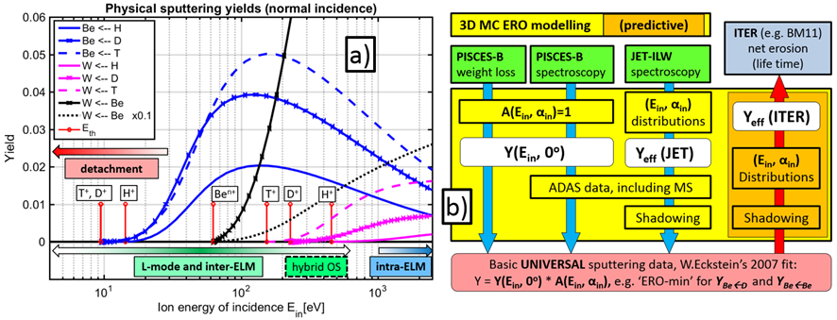
FIG. 1. a) Normal incidence sputtering yields simulated by the SDTrimSP code in the BCA approximation for Be and W sputtering by various hydrogen (fuel) isotope and Be ions. The sputtering thresholds E_{th} are marked by the short vertical red lines. The figure illustrates the important effect of Be impurity for L-mode and inter-ELM sputtering. b) The strategy of ERO application to the various existing fusion-relevant devices: in all cases simulation of the effective sputtering yields Y_{eff} is an essential stage. Moreover the interpretation of the measured data may need additional input, like for instance ADAS data for spectroscopy simulation.
FIG.1a illustrates the role of the physical sputtering of Be. One can see that sputtering thresholds for Be are relatively low, so it is difficult to supress the main chamber erosion except for strongly detached conditions. However, even in this case some erosion will happen due to energetic atoms produced by charge exchange (CX) with ions coming from the core plasma [11]. In the main JET plasma scenarios foreseen for JET DT operation [8], the diverted pulse magnetic configuration protects the Be main chamber from high fluxes leading to Be impurity concentration in the order of just about 1%. Due to the low Z, this does not pose strong radiation or self-sputtering issue. Nevertheless, Be ions can be responsible for a large and even dominant contribution to the W sputtering in a large variety of DT scenario relevant conditions. Sputtering by Be ions is of importance because the W sputtering by H/D/T is often (except for the high temperature hybrid scenario) suppressed excluding inter-ELM due to its high ion impact energy threshold [2]. It should be noted that FIG.1a is based on the SDTrimSP code calculations [19], which may have large uncertainties at small impact energies characteristic for Be sputtering threshold. The possible influence of molecular effects is discussed in the next section.
ERO tracks the impurity particles e.g. Be, using the plasma background (BG) as an input. However, the most significant part of the erosion is caused not just by the Be atoms or molecules starting from the PFC included into the simulation box, but rather by the D plasma impact and its intrinsic impurity content with a significant fraction of Be⁴⁺ coming from the core. The erosion by these background species is treated based on the effective sputtering yields obtained by the averaging of the basic sputtering data (discussed in sec. 3, “ERO-min”) with the appropriate distributions of the ion energies E_{in} and angles α on impact:
Y^{eff}(η, T_{e})=<Y(E_{in}, α)> = <Y(0, α)* A(E_{in}, α)>, (1)
where η is the local surface angle with magnetic field B, T_{e} is the local electron temperature at the sheath entrance and A(E_{in}, α) is the angular part of the sputtering yield. In general, more parameters can affect Y^{eff}. However, for the considered JET and ITER cases it is assumed to be just a 2D function of (η, T_{e}); while for PISCES-B [6] Y^{eff} it is a function of T_{e} and the surface biasing (deliberate voltage applied to the target). The angular part in (1) is discussed in [4]; it comes from the BCA simulations [19] and its discussion is out of the scope of the present paper.
The local statistics of sputtering ion impact energies and angles obviously vary along the PFC surfaces. It depends on the ion charge and mass, local surface shape, electrostatic and magnetic fields magnitude direction, ion density and temperature, ion velocity before they enter the magnetic sheath etc. This necessitates to consider effective yields for various locations and, moreover, for different devices. The application of ERO to PISCES-B has revealed that the pure numerical procedure used earlier leads to certain issues. An improved semi-analytical approach for treating the ion trajectories in the surface sheath (just before sputtering ions impact on the surface, where they are accelerated in the electrostatic field rapidly rising towards the surface), has been developed [16]. It was successfully tested including the normal (PISCES-B) and oblique (JET ILW) angles of B-field to the surface, surface biasing, RF-induced sheaths and other game-changing parameters. FIG.1b illustrates the work flow of ERO simulations for existing devices, which allow validating the basic sputtering data discussed in the following section. The predictive simulations for ITER are done in a similar way, however in the reversed order.

Basic sputtering data used in the simulations
The sputtering yield dependence on the angle of the sputtering species at which they fall to the surface can be factorized [4] as an “angular part” (see (1) below). The normal incidence part of the yield (FIG.2a) is often at the focus of the data validation efforts at various devices. However, due to large scattering of the experimental data, which are partially explainable by the difficulty of measurement interpretation (angular part is often neglected despite its significance, see FIG.2b), ERO utilizes fits based on the combination of the binary-collision approximation (BCA) [19] and molecular dynamics (MD) [14] simulated points. The “ERO-max” fit is based on simulations for pure Be surface (it is close to earlier BCA simulations [4]) and for the “ERO-min” 50% D content is assumed. The latter was proved to be well suitable for the plasma-wetted areas by ERO interpretive simulations for JET-ILW and PISCES-B. A large D content is also observed by the post mortem analysis of Be samples exposed to D plasma [20], in particular for Be-deposits (up to 70%). The concentrations up to 40% just due to the implantation are reported as well [20]. “ERO-min” is also well in line (fig. 1) with the most recent and sophisticated MD simulations coupled with the object kinetic Monte-Carlo (OKMC), which allows treatment of additional processes like outgassing [14]. In all simulations discussed in the present paper we use the “ERO-min” fit.
MD-OKMC simulations [14] are very demanding on the CPU power. This constrains the number of ion impacts with the surface simulated and leads to large statistical errors [18]. The MD-OKMC yields have a maximum at E_{in}~100eV though BCA yields reach maximum at larger impact energies. MD simulations allow following the Be that was sputtered as molecules (mostly BeD according to MD-OKMC [14]) and separate the pure physical sputtering (PhSp) from the chemically assisted one (CAPS), whereas BCA neglects most chemical effects.
To get a feeling about the surface temperature T_{surf} effect on the PhSp to CAPS relation, the MD-OKMC points relevant for the parameter range characteristic for JET-ILW experiment [15] (points at E_{in}<40eV and T_{surf}<400K are excluded) were used to produce a linear fit for the PhSp fraction in the total yield: PhSp/(PhSp+CAPS) (FIG.3a). The CAPS suppression at T_{surf}=820K was ensured by the fitting procedure. Surprisingly, such simple approach allows reproducing the decay of CAPS observed in [15] by shape and T_{surf} scale (FIG.3b). The absolute CAPS fraction at low temperatures is about ~30% of the total in comparison to ~50% in the experiment.
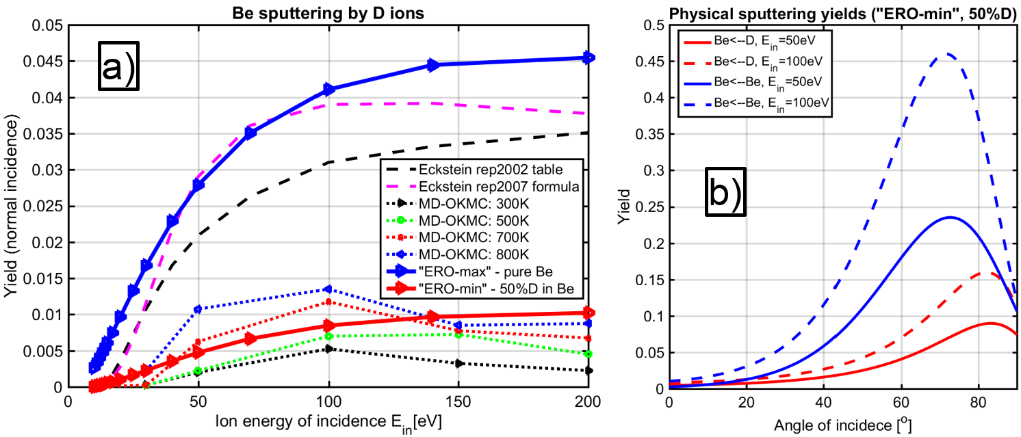
FIG. 2. a) The normal incidence sputtering yields systematically used by ERO for ITER, JET, PISCES-B:“ERO-min” and “ERO-max” as well as various BCA (2002, 2007 [4]) and MD-OKMC [6] simulations. The latter data has very large statistical scattering which is not plotted here, but discussed in [18]. b) Angular dependence of “ERO-min” sputtering yields for D⁺ ion impact (red) and Be self-sputtering (blue) for 2 energies of impact characteristic for usual electron energies at the JET or ITER FW limiter tips of about 10-20eV.
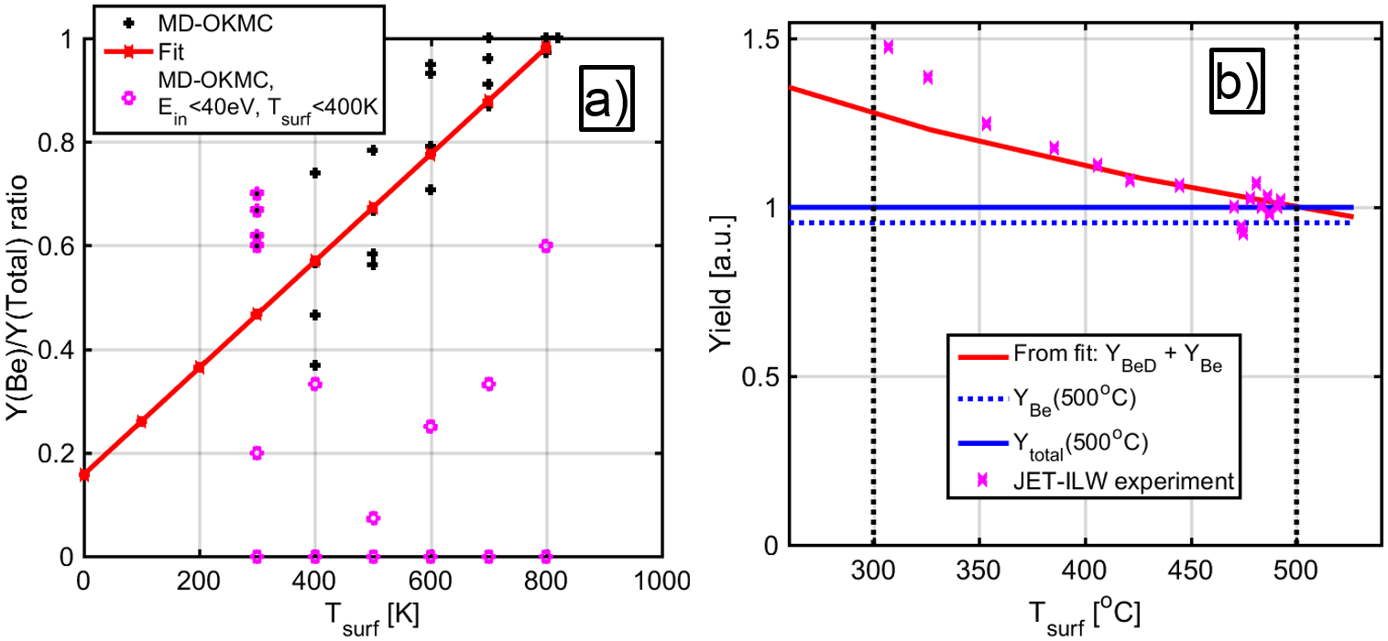
FIG. 3. a) A linear fit for the Be yield to total yield ratio for the MD-OKMC data [6]. The points at low T_{e} and E_{in} are excluded. b) The fit [18] allows to reproduce the general behaviour (right) of the total erosion observed during JET-ILW experiment [15].

LessONS LEARNED froM SIMULATIONS for JET ILW and PISCES-B
The basic physical sputtering in the form of fits (1) was validated during application to various experiments. For instance a dedicated Be erosion experiment was carried out at the JET ILW [3]. The limiter plasmas were deliberately shifted towards the inner wall (IW) causing untypically high erosion. The passive spectroscopy in the sightline directed to the IW guard limiter made of solid Be allows to characterize the erosion by the line-of-sight (LOS) integrated spectroscopy. One of the validation approaches is to use the S/XB method [22] to obtain the experimental yields and to compare those with the effective yields Y_{eff} simulated by ERO (FIG.4a). These simulations were repeated several times as the ERO code and the underlying data (e.g. plasma parameters mapping) were improving. The most significant change is due to the introduction into ERO of the improved approach for the surface sheath [16], which has caused a revision of the effective sputtering yields as illustrated by FIG.4b. Note, that these yields are not directly comparable with the ones in FIG.4a, which are averaged along the limiter surface inside the LOS observation spot. FIG.4a is coming from the most up-to-date ERO2.0 simulations [11], which allow to take into account the self-sputtering in the self-consistent way. However, the effective yields ( It should also be noted that other validation approaches, for instance simulation of 2D overview camera images or heat patterns on the JET wall obtained by the IR cameras were also successfully applied and have confirmed the reasonability of the modelling results (see [10, 11] for details).
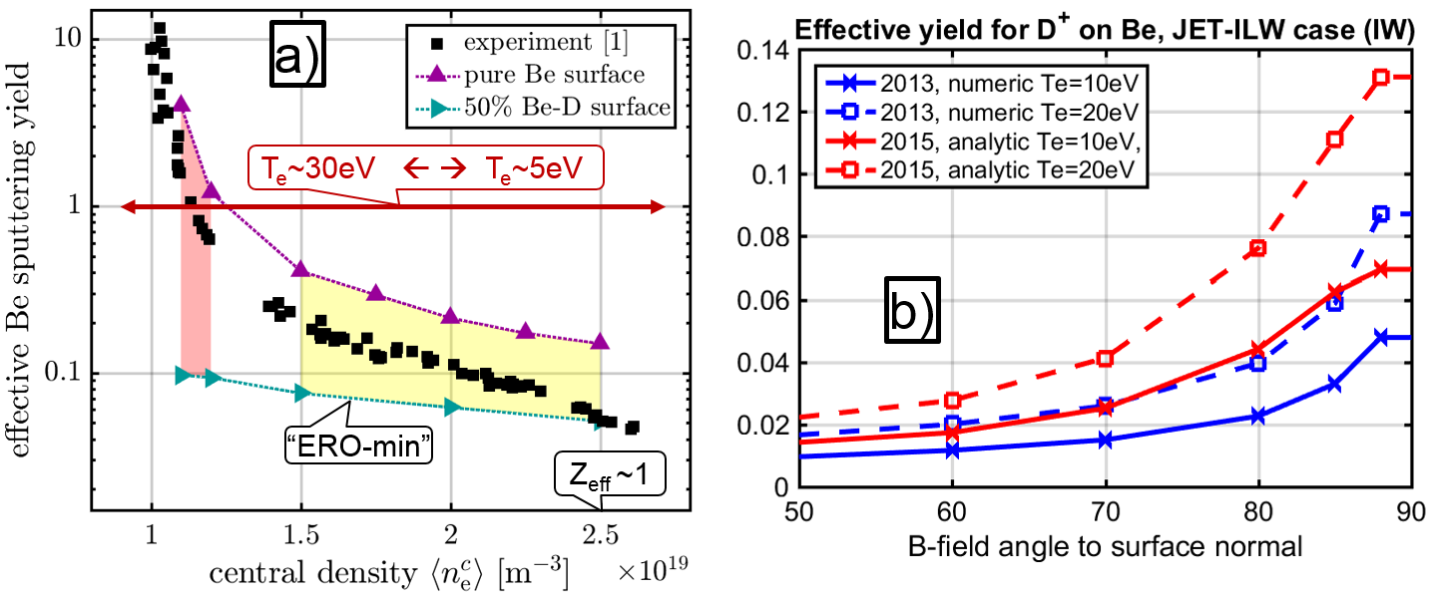
FIG. 4. a) Effective sputtering yields measured during the dedicated experiment [3] at the ILW and simulated by ERO. At low densities and high T_{e} the self-sputtering plays a very strong role. On the right side of the plot, in pure D plasmas as confirmed by Z_{eff} measurement “ERO-min” fit matches well with the measurements. b) The effective sputtering yields used in the works [3, 4] “2013, numeric” and after implementation of the semi-analytic sheath approach [5, 10, 11] “2015, analytic”.
The ERO simulations for PISCES-B are well in line with the JET ILW results. Moreover, the most recent work [6] confirms the theory [23] that the lower than predicted by the SDTrimSP [19] (similar to “ERO-min” for Be surface implanted with 50%D) for pure material sputtering yields are typical for other light species like e.g. He. The continuous plasma operation, the possibility to vary the surface biasing and have experiments with pure He plasma, thus, without CAPS has helped to check and improve many features of the ERO code, for instance the angle distribution of the sputtered species. ERO spectroscopy model and data were significantly improved and now capable of tracking the metastable state in BeI, which was proved to be of importance for proper reproducing of the triplet to singlet BeI line ratios near the Be target surface.

The RE-VISIT of ITER “BM11” LIFE TIME pREDICTIONs
The new ERO simulations [18] assume exactly the same geometry of the critical FW element BM11, plasma parameters, magnetic configuration and shadowing pattern resulting from it as in [13]. The plasma configuration and parameters are for the baseline Q=10 ITER discharges [10]. The main difference to the earlier (2011) simulations are the effective sputtering yields depicted in fig. 5 and discussed below. The point of maximal erosion to the left from the left ridge of the BM11 has remained approximately at the same location (more details see in [18]). So, the same toroidal profile as in [13] can be used to study the erosion/deposition balance.
In 2011, the dedicated ERO preliminary runs for D⁺ and Be ions were utilized to obtain the (E_{in}, α) distributions. However, later on this approach was substituted by the semi-analytical approach [16], which uses CPU power more efficiently and free of numerical issues due to strong sheath E-field gradients. The new effective sputtering yields (FIG.5), which have motivated the re-visit, were obtained in the frame of the very same procedure, which was applied earlier in ERO simulations for JET and PISCES-B (only the energy distribution of sputtering ions matters for the latter). The main difference is for Y_{eff}^{BeD} (FIG.5a) reaching a factor ~2 for large inclinations of the PFC surface with the B-field, thus at toroidal boundaries of BM11, which shape is depicted in FIG.6b (B is nearly parallel to the surface at the ridges). Larger inclination also leads to a higher plasma ion flux determining the gross erosion maximum location (fig. 3b).
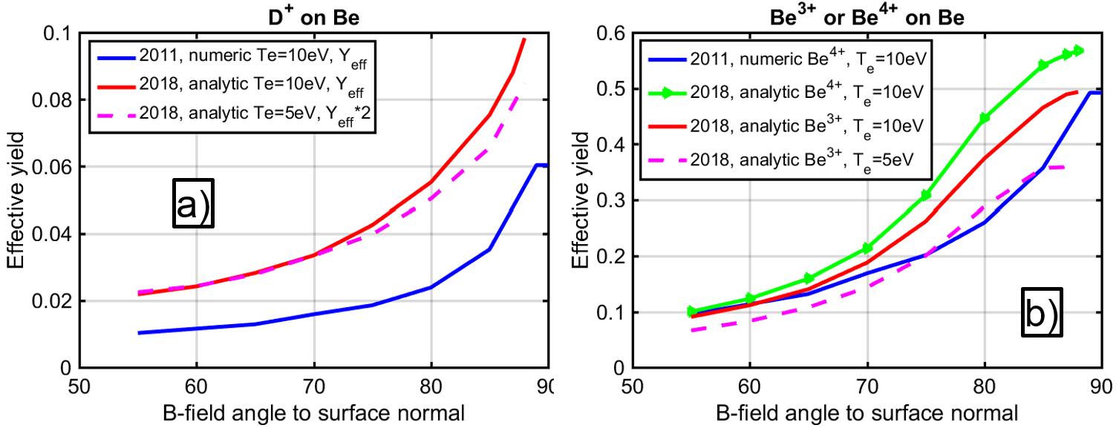
FIG. 5. The effective sputtering yields for Be by D⁺ ions (a) and Be ions (b) simulated using the semi-analytical sheath approach [5] and pure numerical procedure used in 2011. T_{e}=5eV curve for D⁺ ion impact (left plot 5a) is multiplied by 2 to simplify the shape comparison with the T_{e}=10eV.

FIG.6a shows the net erosion toroidal profiles extracted from the ERO simulations using Y_{eff} based on the “ERO-min” fit. The Y(E_{in}, α) are averaged by distributions of E_{in}, α obtained using the semi-analytical approach for the trajectories in the surface sheath. The role of CAPS (section 3) is neglected. The role of self-sputtering is treated based on the assumed concertation of Be³⁺ (1% or 2%) or Be⁴⁺ (1%) ions in the plasma flux to the surface. The thick blue curve reproduces the 2011 ERO predictions [13] except for the insignificant artefacts at the boundary cells in the old run (the related code bug was fixed). The new yields lead to factor ~2 increase of the net erosion at the point of its maximum near the left ridge. Remarkably, the re-visited erosion close to the right ridge is about the same value as near the left ridge, though in earlier runs it was significantly lower. Both absolute and qualitative changes in net erosion are mainly determined by the new Y_{eff}.
The Be plasma impurity in the range of a few percent leads to a decrease of the net erosion. FIG.6b based on the same ERO runs as FIG.6a is useful to understand the balance between the erosion and deposition. At larger Be impurity concentration the erosion is increased due to the larger yields for the self-sputtering compared to the lighter D⁺ ions. However, the D⁺ sputtering flux decreases according to the electroneutrality condition:

n_{e} = 1*n(D⁺) +3*n(Be³⁺ ) + 4*n(Be⁴⁺ ) + . . . (2)

Note, that a single Be⁴⁺ ion is equivalent to 4 D⁺ ions in the sputtering flux, however the self-sputtering yields are typically significantly larger. At the end due to the latter the gross erosion slightly increases with growing impurity content, however this increase of erosion is over-compensated by the increase of the deposition from the BG plasma. The reflection of Be is negligible. The resulting net erosion, gross erosion and deposition profiles are different including the maxima position.
Obviously, the erosion of Be PFCs including BM11 is one of the main factors determining the Be concentration in the plasma. The self-consistent runs including the whole of ITER FW and its volume are possible only using the new ERO2.0 [11]. It takes into account the realistic 3D wall geometry based on the technical drawings. Also, it utilizes a more advanced approach for the extrapolation of the edge plasma profile beyong the wall contour determined by the poloidal BM ridges facing the plasma.
The CAPS discussed in sec. 2 can further increase the Be PFC gross erosion up to 30%-50%, however this process strongly decreases at large T_{surf}. This process is clearly proportional to the D⁺ ion flux, thus, the places where CAPS will be most significant should also be relatively hot due to the heat loads, which may reduce the CAPS. Many parameters for CAPS are uncertain: the yields including the dependence on angles and energies of the sputtering ions, the type and initial angular distributions of released atoms or molecules. The erosion, increased due to CAPS contribution, may be partially compensated by the increased Be plasma concentration and thus, re-deposition. One can expect that CAPS will not have too dramatic impact on the ITER FW life time. From the other side, the decay of BeD and other Be-containing molecules in the plasma will cause significantly different transport, which may have impact on Be migration and D (T) co-deposition. The reaction data for the Be_{x}D_{y} molecule dissociation and ionization in plasma are scarce and uncertain, only 3 reactions are implemented into ERO and validated [24] by application to PISCES-B.
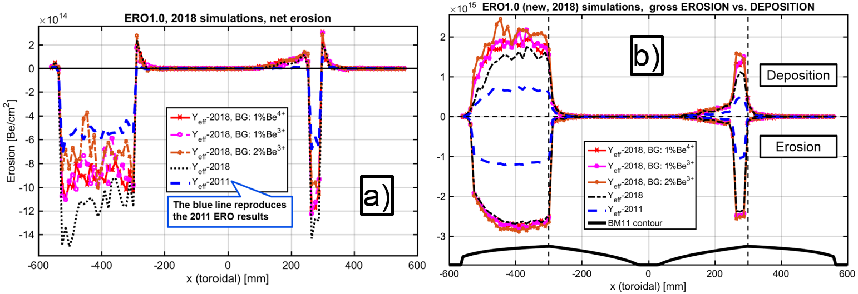
FIG. 6. The re-visited [18] ERO simulations for ITER “BM11” case [13] assuming various effective sputtering yields Yeff and intrinsic Be impurity concentrations. a) Net erosion; b) erosion and deposition for the very same ERO runs plotted separately together with the BM11 toroidal contour (dashed lines show the ridge positions).
Using the recent ERO experience and improved code infrastructure, it was shown that plasma parameters and shadowing patterns on the BM11 surfaces should be corrected. For instance, a significantly lower n_{e} will lead to a decrease of erosion. The more detailed 2D mapping of the plasma parameters has revealed that the T_{e} at sheath entrance will not be constant at T_{e}=10eV along the BM11 surface as in the 2011 ERO runs and the current simulations, but may be ~3-5eV lower at certain locations. FIG.5a contains the effective yields for T_{e}=5eV, which can be significantly, up to factor ~2, lower than for 10eV.
Sputtering by the CX plasma ions [11, 12] is a dominant effect in the shadowed areas. Including this effect will also affect Be re-deposition.

summary and Conclusions
The paper presents an overview of the plasma-surface interaction and impurity transport ERO application to the Be erosion experiments at the existing ITER-relevant plasma devices and explains the strategy of the extrapolation of the obtained knowledge for ITER. This work presents a re-visit of the ERO code simulations [13] motivated by the update of the effective sputtering yields due to the semi-analytic approach for ion trajectories in the surface magnetic sheath [16].
The paper gives also a status of the currently available sputtering data, including the validated at JET and PISCES-B “ERO-min” fit and the most recent MD-OKMC simulations. The role of CAPS is discussed, including a fit allowing to reproduce to a certain extent the JET-ILW experiment [15] on the CAPS suppression by the surface temperature carried out at JET ILW.
The increased effective yields lead to the increase by factor ~2 of the net erosion in relation to the one predicted in 2011. As always, such predictions are dependent to zero order on the assumptions made for the background plasma conditions (ITER baseline Q=10 pulses), which are currently not verified by measurements for ITER. The erosion near the right ridge of BM11 in new ERO runs is stronger than earlier and comparable to the one near the left ridge. Be plasma impurity leads predominantly to deposition, which decreases the net erosion, thus the simulations neglecting the Be plasma content give just the minimal estimate for the ITER life time assuming that BM11 is the most critical PFC.
It is not right, however, to see this work as a correction to the ITER life time predictions [13], because it considers an improvement for just one of the competing factors, out of many which may have an impact. In general:
• Self-consistent treatment of self-sputtering by Be impurity [11] (unlike an assumed concentration in the BG plasma) will lead to more reliable estimates for Be impurity content and charge as well as Be re-deposition.
• CAPS will contribute to the erosion, moreover it will lead to somewhat different transport of dissociating Be-D radicals. Deposition of molecular species can also be different from Be ions.
• More detailed extrapolation of the plasma parameters, refined shadowing patterns and inclusion of the erosion due to the CX ion flux are necessary.
• PFC surface morphology, e.g. roughness, can have a comparable effect of factor ~2-3 on the effective yields [25].
Therefore, this work prepares and motivates a more profound re-visit of the ITER predictions based on global modelling, including the whole FW and vessel volume, using the recently available ERO2.0 code [11].
ACKNOWLEDGEMENTS
The authors are thankful to E.Safi and K.Nordlund for ongoing studies of Be physical and chemically assisted sputtering based on MD simulations.
This work has been carried out within the framework of the EUROfusion Consortium and has received funding from the Euratom research and training programme 2014-2018 under grant agreement No 633053. The views and opinions expressed herein do not necessarily reflect those of the European Commission
References
- PITTS, R.A. et al., Plasma Phys. Control. Fusion 47 (2005) B303–B322
- S.Brezinsek et al., this conference
- BORODIN, D. et al., JNM 438 (2013), S267-S271
- BORODIN, D. et al., Phys. Scr. T 159, 014057 (2014).
- BORODIN, D. et al., Nuclear Materials and Energy 9 (2016) 604–609
- BORODIN, D. et al., Nuclear Materials and Energy 12 (2017) 1157–1162
- MATTEWS, G. F. et al., 2011 Phys. Scr. T145 014001
- JOFFRIN, E. et al., this conference
- DOERNER, R.P. et. al., Journal of Nuclear Materials 438 (2013) S272–S275
- ROMAZANOV, J. et al., 2017 Phys. Scr. (2017) 014018
- ROMAZANOV, J. et al., invited at PSI-2018 conference, paper submitted to Nuclear Materials and Energy.
- LASA, A. et al., 2018 Nucl. Fusion 58 016046
- BORODIN, D. et al., 2011 Phys. Scr. T145 14008
- SAFI, E. et al., J. Phys. D: Appl. Phys. 50 (2017) 204003
- BREZINSEK, S. et al., Nucl. Fusion 54 (2014) 103001
- BORODKINA, I. et al., Nuclear Materials and Energy 12 (2017) 341–345
- CARPENTIER, S. et al., Journal of Nuclear Materials 415 (2011) S165–S169
- BORODIN, D. et al., PSI-2018 conference, paper submitted to Nuclear Materials and Energy.
- ECKSTEIN, W., 2007, Top. Appl. Phys. 110 33–187
- DE TEMMERMAN, G. et al, Nucl. Fusion 48 (2008) 075008
- LISGO, S.W. et al., Journal of Nuclear Materials 438 (2013) S580–S584.
- POSPIESZCZYK, A. et al., J. Phys. B: At. Mol. Opt. Phys. 43 (2010) 144017
- DOERNER, R.P., Scripta Materialia 143 (2018) 137–141
- Björkas, C. et al., 2013 Plasma Phys. Control. Fusion 55 074004
- EKSAEVA, A. et al., PSI-2018 conference, paper submitted to Nuclear Materials and Energy.

*See the author list of “X. Litaudon et al 2017 Nucl. Fusion 57 102001”

