# plasma Termination by Excess pellet fueling and impurities in tj-II, LHD and Wendelstein 7-x

A.Dinklage1,2*, K.J. McCarthy3, C. Suzuki4, N. Tamura4, Th. Wegner1, H. Yamada4,5, J. Baldzuhn1, B. Buttenschön1, H. Damm1, P. Drewelow1, G. Fuchert1, H. Kasahara4, D. Maier6, J. Miyazawa4, G. Motojima4, T. Oishi4, T. Sunn Pedersen1,2, R. Sakamoto4, R.C. Wolf1,7, D. Zhang1, the W7-X Team, the LHD Experiment Group and the TJ-II Team

1Max-Planck-Insitut für Plasmaphysik

Greifswald, Germany

*Email: [dinklage@ipp.mpg.de](mailto:dinklage@ipp.mpg.de)

2E.-M.-Arndt Universität Greifswald, Greifswald, Germany

3CIEMAT, Madrid, Spain

4National Institute for Fusion Science, National Institutes of Natural Sciences, Toki, Japan

5Tokyo University, Tokyo, Japan

6Universität Greifswald, Greifswald, Germany

7Technische Universität Berlin, Berlin, Germany

**Abstract**

Plasma terminating events due to excess pellet fueling and impurity injection is studied in LHD, W7-X and TJ-II. Time scales for these events range from values of a decimal fraction of typical energy confinement times to the order of the energy confinement time. The leading mechanism of energy loss appears to be radiation revealing similarities to radiation collapses when a radiative density limit is approached. Differently to tokamaks, the capability of helical devices to provide magnetic confinement in vacuum (i.e. without large inductive plasma currents) gives rise to the observation of plasma recovery even after some energy confinement times. Time-scales and the dynamics of recovery for close to marginal termination indicates some robustness in the response of helical devices to large unintended perturbations.

# INTRODUCTION

It appears to be self-evident that the unintended termination of plasma operation could lead to safety relevant interruptions in potential fusion reactors. Potential causes may be due to plasma stability or sorts of ‘external events’, e.g. the release of material from plasma facing components due to mechanical fatigue. Sudden termination of plasma operation accompanied by a release of particles and energy is an aspect that enters material requirements in terms of power loads, localization, forces (e.g. by fast breakdown of plasma currents). In tokamaks, such events may lead to disruptions or thermal quenches. As one of the main findings in this paper, stellarators appear to have the potential for the recovery of plasmas close to marginal termination. While unintended plasma termination is unpredictable in general, operating present experiments may deliver the basis for validated models predicting the impact of plasma termination. The latter serves for defining safety margins and the reliability of which appears to be important input for licensing procedures. The identification of potential recovery (and thereby the exclusion of *false positives*) after an unexpected event in a stellarator may also serve for more robust control schemes in reactor scale experiments.

A broader study of plasma termination, however, is lacking for helical devices and this paper is intended to provide an initial overview of unintended plasma termination in the large helical device (LHD), Wendelstein 7-X (W7-X) and TJ-II. Radiative collapses frequently observed in discharges with highly-radiating edge and scrape-off layer (SOL) regions, however, are not covered in this study but will be reported elsewhere in the context of radiative density limits [1]. While disruptions are not expected in (currentless) stellarator/heliotron operation, thermal quenches are certainly to be illuminated for reactor scale stellarators and heliotrons as well. Being not a subject of this study, but relevant to the introduced motivation, very recently, observations on W7-X showed fast loss of plasma energy when large and broadly distributed (in excess to expected boot-strap currents) current drive was applied on plasmas in W7-X.

As an initial systematic study on plasma termination in large stellarators and heliotrons, benefit is taken from the fact that both W7-X and the LHD, are sufficiently large to address key questions for potential helical fusion reactors since their size allows to study plasmas at low collisionality. Both devices are equipped with superconducting coils to achieve true long-pulse operation. Complementary aspects are delivered from experiments in TJ-II. The methods employed in this study rely on the analysis of waveforms of temporally varying data and the spatio-temporal evolution after large amounts of fueling pellets or impurities are injected into the helical plasma. This approach allows the quantification of perturbative material and variations reveal the level of injected matter allowing the recovery to stable plasma operation. This study will provide a documentation of selected cases of plasma termination in different devices and a comparison of typical time scales. The paper gives further introduction of the devices compared in this study and discusses plasma termination due to excess fueling and excess impurity injection by tracer-encapsulated impurity pellets (TESPEL) or laser blow-off (LBO).

## Survey of Devices

Employing different helical confinement concepts in comparative studies takes benefit from a larger configuration space and potential effects of plasma volume or the structure of the magnetic field [2]. The devices include in this study vary in both aspects.

The large helical device (LHD) [3] is a heliotron equipped with super-conducting coils starting operation in 1998 in Toki (Japan). The nominal major plasma radius is R = 3.75 m, the minor radius a = 0.6 m (both varying when the magnetic field structure is changed at typical fields up to 2.9T). LHD is equipped with 23 MW of heating power from neutral beam injection, 2.5 MW from ECRH and 3MW of ICRH. LHD plasmas show electron temperature up to 4keV and electron densities up to 1.2 x 1021m-3 (the latter in the super-dense core regime but at low temperatures) and bulk ion temperatures of up to 10keV. It is noted that specific values of all aforementioned parameters are subject to the discharge scenario (as for the W7-X and TJ-II below). LHD is equipped with a pellet injector delivering fuelling pellets [4] and tracer encapsulated solid pellets (TESPEL) [5]. Excess injection of both was observed to ruminate the plasma operation (cf. Sec. 3.1 and 3.2).

Wendelstein 7-X (W7-X) is a supercondcuting HELIAS (helical axis advanced stellarator) with a major radius of R = 5.5.m and typical minor radius of a = 0.5 m. W7-X started operation in 2015 in Greifswald (Germany) [6] and is equipped with about 7 MW electron cyclotron resonance heating (ECRH). W7-X is equipped with a pellet injection system [7] and a laser blow-off diagnostics [8].

TJ-II is a heliac operated since 1997 in Madrid (Spain) [9]. The device has a major radius of R = 1.5 m and an average minor radius of a < 0.22 m. It is equipped with ECRH and neutral beam injection heating (NBI). With ECRH the plasma density cut-off is 1.7x1019 m-3. A fuelling pellet injection system was commissioned in 2014 [10]. More recently the pellet injector was temporally equipped with a TESPEL tracer-loaded pellet system [11].

## experimental Findings

### Fuelling pellet injection on LHD

LHD is equipped with a 20 barrel solid hydrogen injector [12] delivering high fuelling rates even adjustable to terminate the plasmas. An example of the plasma response close to termination is shown in Fig. 1. The evolution of measure electron temperature, density and pressure profiles from Thomson scattering measurement on LHD. The evolution of the profiles at t=6.05s and t = 6.10s indicate the plasma response due to two hydrogen pellets injected at t=6.038s and 6.071s (N=1.5×1021 particles each). Timing and size of the pellets in the shot series (other shots not shown) has been varied and the shown case is an example of close to marginal sustainment of the plasma long (>800ms) after pellet injection.

The time-slice at t=6.20s shows a strong decrease of the electron pressure (with small measured temperatures and densities) to values below the detection limits of the Thomson scattering system. In the course of the discharge (t=6.70s), however, density profiles even leading to positive electron pressure gradients are observable in the detection range of the Thomson scattering. Therefore, even with the mentioned caveats, the measurements give clear evidence that a plasma almost terminated by fueling pellets can recover on confinement time scales (~100ms). This conclusion is supported from the inspection of the visible light detected from a video camera. The characteristic structure of bright seams changes strongly in phases with small central electron temperature Te(0). The same phenomenology has been reported as a *temperature hole* [13].

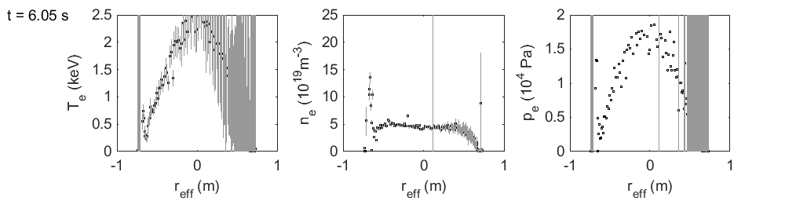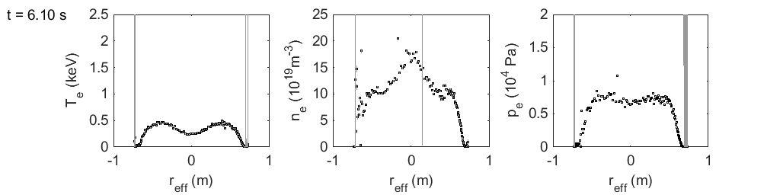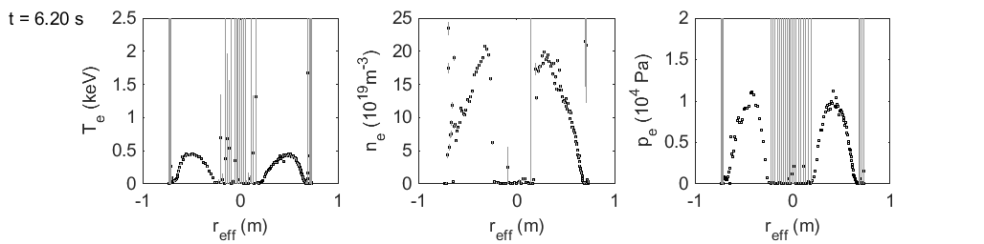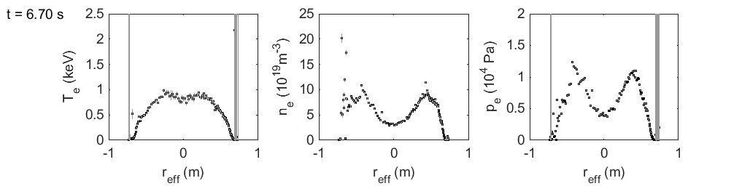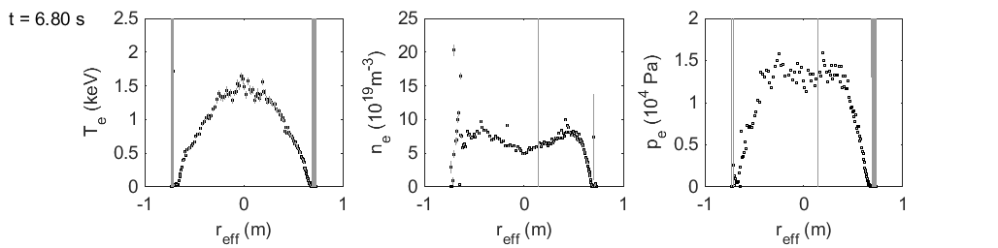

*FIG. 1. Time evolution of electron temperature (left), density (middle) and pressure (right column) after pellet injection in LHD close to the operational density limit (from Thomson scattering). Pellets are injected at t= 6.038, 6.0719 s.*

### TESPEL injection on LHD

An example for the plasma response due to a Gd impurity embedded in polystyrene pellets (TESPEL) is shown in FIG. 2. The comparison shows the plasma response well after two TESPEL injections in different discharges (cases are slightly different in terms of the encapsulated Gd impurity tracer). Both discharges receive about almost the same amount of Gd atoms but are slightly different in terms of retained impurity atoms. This is reflected by the radiated power in the phase after TESPEL injection. Also after the phase of decay, the radiated power is higher than before TESPEL injection potentially indicating that a fraction of the impurities are retained. For the TESPEL injection in discharge #107489 ((2.04 ± 0.30) ×1017 Gd atoms, red in FIG. 2), the radiated power appears to be slightly larger (also in stationary conditions are). The density appears to be visibly larger but is very similar for both cases. The central electron temperature is a little smaller than that in #107488 ((1.98 ± 0.30) ×1017 Gd atoms, balck waveforms in #107488).



*FIG. 2. Waveforms of heating power Pheat, plasma stored energy Wp, central electron temperature Te(0), mean density <ne> and radiated power in response to Gd impurity pellets. Shot #107488 (black) receives a TESPEL with 1.98*±0.30*×1017 particles, shot #107489 with 2.04*±0.30*×1017 Gd atoms. The TESPEL is injected at t = 3.8 s.*

Plasma response leading to termination or recovery is induced when the heating power is decreased. For #107488 (black), the heating power goes from 10 to 5 MW at ~ 4.6 s leading to a cooling of the plasma visible in the electron temperature. There is almost no response of the radiated power Prad. Somewhat delayed, the radiated power increases after a dead-time of ~120 ms significantly leading to additional radiative cooling of the plasma (while the density stays virtually unaffected). The change of plasma energy dWp/dt is about 1.5 MW in this period which is significantly higher than the radiated power. Shortly before the central temperature measurements gets to vanishing temperatures, a short recovery of the plasma heating is suspected to stabilize the electron temperature which is not measurable for about 500 ms. The temperature profiles (not shown here) resemble the temperature hole feature [14] as reported for the fuelling pellet cases. Te(0) increases again after the heating power steps up but with a dead-time ~100 ms. During periods of temperature holes, Te(0) = 0, the diamagnetic loop still measures plasma energies around 150 kJ indicating the hollow plasma pressure even with Te(0) = 0. A full recovery of the plasma temperature is observed when the heating power is increased from 5 to about 14 MW and the temperature profiles appear as being filled up eventually leading to peaked temperature profiles.

For the second discharge #107489 (red in Fig. 2), the plasma also decays when the heating power is switched down. The loss of plasma energy is about dWp/dt ~ 3.3 MW during the decay lasting around 150 ms. As for this case the plasma radiation increases to values up to ~3 MW. Both loss figures get much closer to the values of the heating power thus indicating that the discharge #107489 is much more affected by radiation and other losses than #107488. It is noted the increase of radiated power occurs when the central electron temperature falls below ~1 keV. Differently to #107488, the plasma energy is still not stabilizing in the period with vanishing central temperature (Te(0) = 0 ) but is decaying further to show a collapse also in the plasma density within 50 ms at the end of the discharge. The specific time of the collapse coincides with a tripping of the plasma heating to vanishing heating power. Even a large increase of heating power after the short tripping does not lead to a recovery of the plasma as in shot #107488. It is concluded that the difference in retained Gd atoms from the TESPEL leads to the observed differences.

### Plasma termination by LBO in Wendelstein 7-X

FIG. 3 shows an example of plasma termination on W7-X after massive tungsten injection by laser blow-off (with LBO pulses at 20 Hz starting at 23.64s (pulse separation 0.05s), some tenth milligrams of tungsten in each LBO pulse). The energy decay is dominantly through cooling of the plasma. The electron temperature decays about a factor of two faster than a typical energy confinement time (~100ms), while the plasma density remains almost constant (even slightly increasing). Since the density does not decrease, this observation provides evidence that energy losses are due to plasma radiation. Transport processes lead to cooling of the plasma and allowing a deeper penetration of the impurities released by LBO. For the power balance, however, transport induced losses appear to play a subordinate role. The plasma is finally terminated along with a strong increase of radiation and an increase of iron impurity lines (not shown). The overall mechanism could not be revealed and appears to be complicated. Possible reasons could be an overall cooling of the plasma and may indicate additional influx of impurities due to enhanced plasma wall interaction.



*FIG. 3. Waveforms of heating power, diamagentic energy, electron density, electron temperature, and radiated power (from different plasma regions) after massive tungsten laser blow-off at 23.640, 23.645 and 23.650 s.*

The specific spatio-temporal dynamics of the electron temperatures (measured by multi-channel electron-cyclotron emission radiometry (ECE) shown in Fig. 3) indicate local radiation effects. The innermost channel (ECE_12) indicates a longer cooling period. This is also supported from the bolometer detecting the core region of the plasma. The temperature dependence of the cooling rate (due to the abundance of ionization stages of impurities) could be mechanism leading to the different decay times in the plasma region. Likewise, spatial dependencies are indicated in the LHD TESPEL case from the increasing radiation when the plasma cools down below an apparent recombination threshold.

## **Plasma termination by fueling pellets and TESPEL in TJ-II**

1. **b)**

**c)****d)**

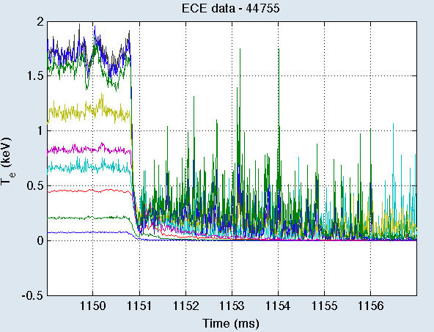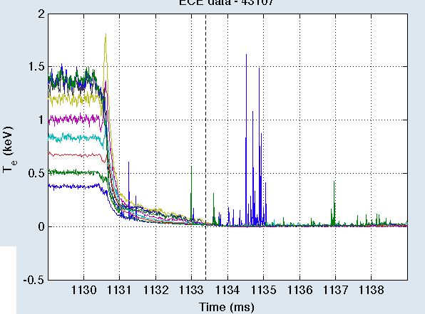

*FIG. 4. Plasma termination on TJ-II: waveforms of mean density, electron temperature, plasma energy and radiative power losses (top).Waveforms from a multichannel ECE radiometer. (bottom). (a) and (c) show the response to a fueling pellet, (b) and (d) show the response to a TESPEL.*

In TJ-II, the injection of a large cryogenic pellet (>1.5x1019 H) into an on-axis ECRH discharge leads to rapid plasma termination. This is seen in Fig. 4 where the plasma experiences a collapse with rapid energy loss (<10 ms) after pellet entry into the plasma. During this process radiation drops rapidly and a weak glow remains thereafter. Similarly, if a sufficiently large TESPEL (C8H8) is injected into the target discharge a comparable plasma termination occurs. For both situations, pellet injection induces an abrupt increase in plasma electron density from 5x1018 m-3 to >1019 m-3 followed by a slower steady increase towards cut-off (Ñe >1.4x1019m-3). In such cases no plasma recovery is observed, rather a cold dense plasma remains but is never reignited.

### Plasma recovery after TESPEL injection in TJ-II

In contrast, in some instances, plasma recovery is found in TJ-II after a large TESPEL injection. Such a recovery is observed in Fig. 5, where a polystyrene pellet with sulphur tracer, C8H8(S), is injected into an off-axis ECRH discharge (at r/a = 0.34). In this case, the initial post-injection rise in electron density is smaller than in Fig. 4, this being followed by a subsequent steady increase up to cut-off. This smaller abrupt density increase can be understood by considering that a large fraction of pellet electrons are carried by the carbon and sulphur atoms, resulting in a slow Ñe rise after pellet ablation as ionization continues during several milliseconds to C+6 and S+13[15]. This also results in a slower plasma energy decrease which falls to ~50% of the pre-injection value when the discharges reaches cut-off. From Thomson Scattering profiles taken before and after injection, it is seen that the plasma core does not cool completely (Fig. 5), rather a dense, but not cold, plasma column remains in its core. Finally, after several ten milliseconds of continued ECRH injection into the plasma, whose density remains high but below cut-off, it partially reignites with plasma energy increasing above pre-injection levels.

1. **(b)**



*FIG. 5. (a) Waveforms of line-averaged electron density, central electron temperature, plasma energy and plasma radiation. (b) Electron density and temperature profiles from Thomson scattering during plasma decay compared to profiles from a reference discharge without TESPEL.*

# discussion and SUmmary

1. TABLE 1. CHARACTERIZATION OF PARTICLE INJECTION LEADING TO PLASMA TERMINATION

|  |  |  |  |
| --- | --- | --- | --- |
| Device | Case | injected material | decay time |
| LHD | Excess fuelling | H2 | order of (100ms) |
|  | TESPEL | Gd | ~150ms |
| W7-X | Excess LBO | W | ~50ms |
| TJ-II | Excess fueling | H2 | <5 ms |
|  | TESPEL | C8H8 | < 5 ms |

1. The systematic comparison of plasma terminating events by cryogenic pellets, induced impurity injection or changes of the heating in stellarators and heliotrons gives evidence that the observed termination takes place on a time scale somewhat smaller than the energy confinement time. The cases investigated here are characterized by plasma cooling by large radiated power due to excess fueling or impurity injection.

Cases comparing TESPEL injection close to marginal termination with slightly higher core radiation indicate that the cooling rate in relation to the heating power (Prad ~> Pheat) along with the number of radiating particles defines threshold conditions for the plasma collapse. Subsequent increase of the heating power was observed to lead to plasma recovery for the TESPEL injection. The crucial role of plasma radiation is supported with the effect of tungsten radiation on W7-X collapses. Close to marginal termination, LHD shows very clearly the beneficial effect of confinement of the vacuum field which gives rise to transient plasmas with cold regions in the center but may recover after typically 1s. It is to be investigated if temperature holes due to fueling pellet injection recover when the absorbed heating power is increasing during the recovery to go to lower Prad/Pheat ratios.

1. Typical time scales of plasma terminating events were found to be fractions of the energy confinement time and were related to radiated power from injected impurities (and thus the number of radiating particles). The observed time scales are some orders of magnitude larger than MHD time scales and appear to lead to relaxed requirements for plasma facing materials than required for fast terminating events. Recent observation of plasma termination in the course of changes of an intended change of the rational transform by electron cyclotron current drive [16], however, indicate that fast terminations can be intentionally induced by broadly applied current drive. These findings will be reported elsewhere.
2. In conclusion, the multi-machine comparison of plasma terminating events in this paper indicate that the vacuum confinement of stellarators and heliotrons differently to tokamaks has a benign impact in plasma terminating events due to excess material injection showing even the capability of helical currentless confinement devices for plasma recovery if exposed to not too high particle influx. These findings appear to be relevant to the discussion of unintended exposure of material to a fusion plasma.

ACKNOWLEDGEMENTS

This work has been conducted under auspices of the IEA Technology Collaboration Programme on the Stellarator-Heliotron Concept.

This work has been carried out within the framework of the EUROfusion Consortium and has received funding from the Euratom research and training programme 2014-2018 under grant agreement No 633053. The views and opinions expressed herein do not necessarily reflect those of the European Commission. CS and NT acknowledge supports by the JSPS KAKENHI (Grant Nos. 23360415, 15H03759, and 15H04234), a fundamental budgetary support (Nos. ULHH012 and ULHH017), the Program for Enhancing Research Collaboration (UFEX105), the Young Researchers Supporting Program (UFEX106) of the National Institute for Fusion Science, the NIFS/NINS under Strategic International Research Exchange Promotion Program (UFEX402), and the NINS program of Promoting Research by Networking among Institutions (Grant No.01411702). KJM acknowledge support from MINECO (FIS2017-89326-F).

References

1. FUCHERT G., et al., Increasing the density in W7-X: benefits and limitation (this conference).
2. DINKLAGE A.,. et al., Nucl. Fusion **53** (2013) 063002.
3. KOMORI A., et al., Fusion Sci. Technol. **58** (2010) 1.
4. SAKAMOTO R.., et al., Nucl. Fusion **52** (2012) 083006.
5. SUDO S., TAMURA N., Rev. Sci. Instrum. **83** (2012) 023503.
6. KLINGER T., et al., Plasma Phys. Contr. Fusion **59** (2017) 014018.
7. DIBON M., Entwicklung und Verbesserung eines Blower-Gun Pellet Injektors für die Anwendung in thermonuklearen Fusionsanlagen (in German), Master Thesis, Technical University Munich (2014).
8. WEGNER, Th., et al., Rev. Sci. Instrum. **89** (2018) 073505.
9. CASTEJON, F., et al., Nucl. Fusion **57** (2017) 102022.
10. McCARTHY, K.J., et al., Nucl. Fusion **57** (2017) 056039.
11. TAMURA, N., et al., Rev. Sci. Instrum. **87** (2016) 11D619.
12. SAKAMOTO, R., et al., Rev. Sci. Instrum **84** (2013) 083504.
13. MIYAZAWA, J., et al., Nucl. Fusion **48** (2008) 015003.
14. SUZUKI, C., et al., Plasma Phys. Control. Fusion **59** (2017) 014009.
15. McCARTHY, K. J., et al., Europhys. Lett. **120** (2017) 25001.
16. KLINGER, T., et al., Overview of first W7-X high-performance operation with island divertor, this conference