REINFORCING NUCLEAR SAFEGUARDS

EFFECTIVENESS THROUGH COOPERATION

LEONARDO PARDO, GUSTAVO DIAZ, STELLA BONET DURAN
Nuclear Regulatory Authority of Argentina
Buenos Aires, Argentine
Email: lpardo@arn.gob.ar

SONIA FERNANDEZ MORENO, LUIS MACHADO DA SILVA
Brazilian-Argentine Agency for Accounting and Control of Nuclear Materials
Rio de Janeiro, Brazil

MALIK DERROUGH, ALTA BROODRYK
International Atomic Energy Agency
Wien, Austria

Abstract

The Brazilian-Argentine Agency for Accounting and Control of Nuclear Materials (ABACC) was created on July 1991, within the Agreement between the Republic of Argentina and the Federative Republic of Brazil for the Exclusively Peaceful Use of Nuclear Energy (Bilateral Agreement). In December 1991, the Quadripartite Agreement was signed between the Republic of Argentina, the Federative Republic of Brazil, the Brazilian-Argentine Agency for Accounting and Control of Nuclear Materials (ABACC) and the International Atomic Energy Agency (IAEA) for the Application of Safeguards in both countries. Since the signature of the Quadripartite Agreement, the application of safeguards in Argentina has made great progress, mostly based on the cooperation activities. ABACC, IAEA and the Nuclear Regulatory Authority of Argentina (ARN), which is the responsible organization for the safeguards activities within the country, work in close association to strengthen the safeguards implementation. This cooperative based scheme has proven to be a fundamental pillar in safeguards, improving the effectiveness of its application in the country and in the region. The paper describes the application of safeguards in Argentina, the improvements implemented in the recent years, the incorporation of new technologies to meet technical safeguards objectives in a more efficient manner, the test of new techniques like the 2D-Laser curtain barrier, and the development of new methodologies such as the ABACC-Cristallini method for UF₆ sampling. A status of the ongoing cooperation activities and future challenges are also presented.

INTRODUCTION
In the 1980s and 1990s, the Argentine Republic (hereinafter referred to as Argentina) and the Federative Republic of Brazil (hereinafter referred to as Brazil) devised a regional integration process inclusive of their nuclear sector. Intense dialogue and confidence building mechanisms led to the arrangement of a regional safeguards system encompassing all nuclear materials and activities in Argentina and Brazil. In July 1991, the “Agreement for the Exclusively Peaceful Use of Nuclear Energy”, known as “Bilateral Agreement”, was signed and committed both countries to exclusively use nuclear energy for peaceful purposes. It also created a regional safeguards verification arrangement, and subsequently, the Brazilian-Argentine Agency for Accounting and Control of Nuclear Materials (ABACC) as administrator of said arrangement. Two important aspects of this agreement include inter-agency cooperation and mutual verification of nuclear materials, with the final objective being verification of the peaceful uses of nuclear energy.
ABACC is an international organization with a regional scope and singular characteristics. Its mandate is to apply its verification system, the “Common System of Accounting and Control of Nuclear Materials” (the SCCC), with the objective to verify that nuclear material in all nuclear activities in the Parties’ regime are not diverted to purposes prohibited by the Bilateral Agreement.
Immediately following signature of the Bilateral Agreement, Argentina and Brazil subscribed to a comprehensive safeguards agreement based on the IAEA model INFCIRC/153 on the 13 December 1991 with ABACC as an intermediary and the SCCC as a fundamental component. This is recognized as the “Agreement between the Republic of Argentina, the Federative Republic of Brazil, the Brazilian-Argentine Agency for Accounting and Control of Nuclear Materials and the International Atomic Energy Agency for the Application of Safeguards” and known as the “Quadripartite Agreement”. This agreement satisfies the requirement of states party to the Treaty on the Non-Proliferation of Nuclear Weapons (“the NPT”) and the Treaty for the Prohibition of Nuclear Weapons on Latin America and the Caribbean (“the Tlatelolco Treaty”) to conclude a comprehensive safeguards agreement with the IAEA.
A fundamental characteristic of the Quadripartite Agreement is the promotion of cooperation among all the parties to achieve and maintain the effective and efficient application of safeguards. As such, the agreement contains clear guidance on cooperation between Parties, and specifically, between ABACC and the IAEA. Cooperation is of utmost importance as it is an essential mechanism for ensuring satisfactory implementation of safeguards and coordination of IAEA and ABACC safeguards activities. In this framework, the introduction of new technologies and concepts is an incessant objective for ensuring the effectiveness and robustness of the safeguards approach. The accomplishments of this approach with a focus on cooperation activities performed by the IAEA, ABACC and Argentina towards improving the implementation of safeguards in specific nuclear facilities are described hereafter.

Argentinean Nuclear Fuel Cycle
The fuel cycle developed by Argentina includes a broad spectrum of activities that includes small research & development facilities and labs, production plants , research reactors and nuclear power plants.. Among their most relevant facilities are:

- Two nuclear power plants in operation and one nuclear power plant undergoing a life extension programme with associated dry spent fuel storage facilities
- One small modular reactor (SMR), the CAREM 25, under construction
- Five research reactors; one of which is exclusively dedicated to the production and supply of radioisotopes for medicine and industrial applications
- One open pool research reactor under construction with unique characteristics to the region

One of the main production activities is the manufacturing of different types of fuel elements used in sub-critical, critical and nuclear power reactors and the purification and conversion of natural and enriched uranium Currently, the construction of a new uranium conversion plant located in the north of the country is underway.
There are also smaller facilities and locations outside facilities (LOFs) that support the Argentine nuclear sector, including R&D laboratories in uranium enrichment techniques, waste management, analytical tests, and storage.
The safeguards measures in place in Argentina are commensurate to the magnitude of its nuclear activities and requires due cooperation between the IAEA, ABACC and Nuclear Regulatory Authority of Argentina (ARN), while minimizing intrusiveness in the normal operation of nuclear facilities.

COOPERATION
Enhancing cooperation is instrumental to the implementation of efficient and effective safeguards and is an essential objective of all Parties party to the Quadripartite Agreement. Accordingly, the IAEA, Argentina and ABACC have jointly developed the following novel tools, concepts and approaches aimed at optimizing verification efforts while maintaining or improving safeguards effectiveness:

3.1. Unattended monitoring system for spent fuel transfers at the Embalse Nuclear Power Plant

Embalse Nuclear Power Plant (NPP) is a pressurized heavy water reactor (PHWR). This single unit CANDU-6 reactor has a gross output of 648 MWe, began commercial operation in 1984 and is an on-load refueling reactor. In addition to producing electricity, Embalse is also used to produce Cobalt-60, a radioisotope used in medical and industrial applications.
Dry storage at Embalse was commissioned in 1993 to manage the demand for spent fuel storage through the operative life of the facility (Fig.1). Of note, the process implemented requires spent fuel bundles to remain in wet storage for a minimum of six years in order to facilitate adequate thermal cooling and radioactive decay based on system design requirements.
Historically, spent fuel transfers to difficult access storage silos had been resource intensive for both the IAEA and ABACC as the approach required the presence of inspectors throughout the campaign. To improve the efficiency and effectiveness of verification activities, an unattended monitoring system (UMS) was developed, constructed and installed (Fig. 2). The UMS uses surveillance, containment and non-destructive measures designed to maintain continuity of knowledge (CoK) of spent fuel during the entire transfer process, and as such, alleviates the need for IAEA and ABACC inspectors to be constantly present during transfer campaigns.
To ensure safeguards effectiveness, all diversion scenarios were analyzed and all safeguards systems were designed to cover all possible pathways through the combination of Non-destructive Assay (NDA) measurements, remote monitoring and containment measures. Accordingly, joint use procedures were written to ensure facility operators, State authorities and international inspectors work in a coordinated manner while in the field.
In order to achieve a high level of confidence of the nuclear material involved in transfers during a material balance period, unannounced inspections (UIs) are performed on a random basis for verification at strategic points in order to confirm the validity of the activities declared by the facility operator through mailbox declarations; to verify the performance of the UMS and deter tampering with the system; and to perform verification activities required by the operational status of the facility.
The development and approval of UMS required extensive negotiation and coordination with the IAEA, ABACC and ARN on one side and ARN and facility operators on the other side. To ensure the best possible results, parties used a two-step approach. First, good performance and reliability of the UMS from a technical perspective was established. Second, a field trial was conducted to test aspects of the procedure, in particular those applicable during UIs such as the entrance procedures for ABACC and IAEA inspectors and the time required to perform all safeguards activities foreseen in the procedure.
This two-step approval process was successful and the UMS system is now routinely used at Embalse NPP. Despite the complexity of the system the built in redundancy mechanisms implemented has allowed both safeguards agencies, the IAEA and ABACC, to draw positive conclusions with high confidence.

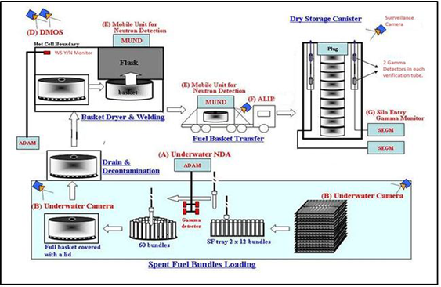

Fig. 1. Embalse Dry Storage Fig. 2. Embalse Unattended monitoring system

3.2. Dry storage at Atucha I Nuclear Power Plant - 2D laser curtain barrier

Atucha I NPP is a Siemens-KWU on-load refueling power reactor with a gross electrical power output of 363 MWe. It uses slightly enriched uranium (0.85% concentration of the isotope U-235) for fuel and heavy water as the coolant and moderator. It has been in operation since 1974 and is the first nuclear power plant commissioned in Latin America.
A new dry storage system for spent fuel assemblies is under construction at Atucha I NPP site (Fig. 3). This design differs from that used at Embalse NPP given the unique design of Atucha’s fuel assemblies such that each fuel assembly has 37 active bars with a length of 5.3 m. The dry storage is composed of 316 silos with each silo containing a canister for nine fuel assemblies. One important difference from the safeguards viewpoint in reference to the dry storage used at Embalse NPP is that the dry storage has been designed as an extension of the house building of the reactor´s spent fuel ponds. The safeguards approach under discussion prioritizes the CoK of the nuclear material being transferred as the re-verification of fuel assemblies following placement into the silos proves difficult. CoK is maintained based on solid and reliable technology, adequate backup systems and concise procedures. Consideration was also given to reducing the presence of inspectors to the extent possible as a result of the relatively high expected anticipated dose rates.

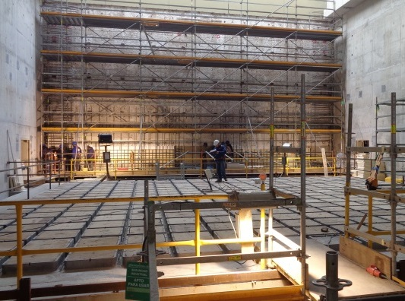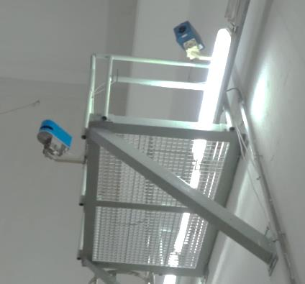

Fig. 3. Atucha Dry Storage Building Fig. 4. Laser Curtain Field Trial

As one of the main elements of the safeguards approach, the IAEA floated the idea of a laser system that would monitor the movement of canisters into each silo in the form of a Laser Curtain for Containment (LCCT) system (Fig.4). The LCCT is being developed by the IAEA with the technical assistance of the European Commission’s Joint Research Center in Ispra and with support of ABACC and Argentina under its member state support programme. Before the system can be authorized for safeguards use, a series of extensive field tests under real conditions must be conducted. For this purpose, Argentina has made two of its facilities available for testing. If successful, the LCCT will not only have applications in Argentina but possibly in other facilities around the world. Based on the data collected during the tests carried thus far, the system is a promising technology for midterm deployment.

3.3. Conversion facilities – SNRI

The Uranium Conversion Plant (DIOXITEK) is a commercial plant for the production of natural uranium (NU) dioxide from uranium ore concentrate (UOC) and the recycling of NU and low enriched uranium (LEU) The LEU contains less than 1% enriched uranium and contains scrap powder and pellets introduced through the recycling process. The UO2 powder produced at DIOXITEK is transferred to the Fuel Fabrication Plant (CONUAR), where fuel elements and bundles for Atucha I, Atucha II and Embalse NPPs are manufactured. On a non-routine basis, campaigns for the recovery of uranium from scrap material received from CONUAR are carried out.
Verification of nuclear material received through transfers is an integral part of any safeguards approach based on material accountancy. To achieve a high level of confidence for transfers into and out of the conversion facility, short notice random inspections (SNRIs) have been selected as a tool for the verification of nuclear material involved in transfers, including the verification of the nuclear material at the starting point of safeguards. SNRIs allow for full verification coverage of the nuclear material flow while employing reduced inspectorate resources.
The SNRI regime was first introduced in Argentina in 2007 at their fuel fabrication plant and again in 2018 at their conversion facility for the verification of nuclear material involved in facility-to-facility transfers.
In support of SNRIs, a near real-time accountancy method, referred to as the “mailbox” concept, was introduced and requires the facility operator to make daily declarations on the flow of nuclear material, production, receipts and shipments. To validate the reporting of all items, the SNRI approach utilizes the residence time concept (retention), which requires every item to remain available for verification for a defined period of time in case ABACC and/or the IAEA trigger an SNRI.
The SNRI procedure was successfully verified during a trial carried out in 2017. The findings and lessons learned led to improvements in the procedure, mailbox scope and other elements of the procedure being implemented during routine implementation.

3.4. Uranium hexafluoride sampling methodology – ABACC / Cristallini

The currently accepted industry procedure for sampling uranium hexafluoride (UF₆) in gaseous phase from process lines at enrichment facilities is via desublimation occurring inside a metal sampling cylinder cooled with liquid nitrogen or via a fluorothene P-10 type tube (Fig.5).
Dr. Cristallini developed a new UF₆ sampling method, the “ABACC-Cristallini UF₆ Sampling Method” for U-235 enrichment determination. This method collects UF₆ (gaseous phase) by adsorption in alumina (Al₂O₃) in the form of uranyl fluoride (UO₂F₂) (solid). This method also uses a fluorothene P-10 type tube containing alumina pellets (Fig. 6) to adsorb and hydrolyze UF₆ directly during the sampling process and has been extensively tested by ABACC in Argentinian and Brazilian laboratories. This novel method is advantageous to current methods as ensures greater flexibly in meeting current nuclear material transport regulations, results can be obtained with lower residual material at facilities and requires simpler treatment of the sample.
The IAEA submitted a task proposal for this project to Argentina and Brazil under the scope of the technical cooperation programme, “Develop and implement techniques for determination of new chemical and physical attributes for strengthening safeguards verification using nuclear material samples,” in the IAEA Department of Safeguards Long-Term R&D Plan, 2012-2023. ABACC is the coordinating organization for the project.
The sampling procedure has been validated; meaning, its applicability to sample UF₆ from isotope enrichment facilities or storage cylinders is confirmed. The following steps were followed to develop the procedure: demonstration of the principle method; conclusion of a feasibility study in a research enrichment facility; an international inter-laboratory comparison of isotope amount ratio measurement results; and operational validation in an isotope enrichment facility. The written procedure has also been assessed by several experts and is ready for review by the American Society for Testing Materials (ASTM).

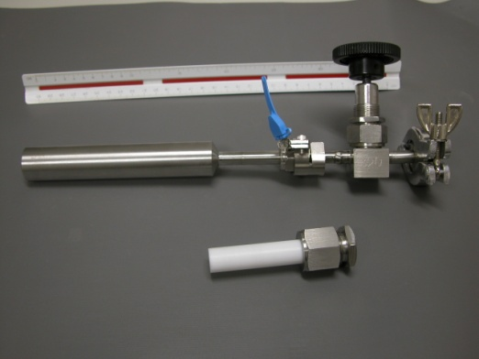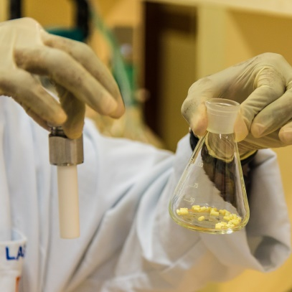

Fig. 5. Croft Sample Bottle vs fluorothene P-10 Fig. 6. Alumina Pellets with hydrolysed UF₆

3.5. Ultrasonic seals system for Atucha I NPP ponds

Through an ABACC led joint technical project, with technical assistance provided by Joint Research Centre (JRC)_in Ispra, a containment tool, focusing on the application of ultrasonic seals technologies, for Atucha I NPP spent fuel pools, was developed and is currently being tested. The main objective of this project was the evaluation of the technique to the application of safeguards measures to contain irradiated fuels stored at a two layers spent fuel pool. Currently, the verification activities are time consuming and show difficulties for second layer access. Final system vulnerability tests are underway to confirm the tool’s robustness for its application at Atucha I power reactor spent fuel pools.

FUTURE WORK
On the medium term the IAEA, ABACC and ARN have started design information exchange related to the following projects:

- Uranium Conversion facility at Formosa province
- A prototype of the CAREM Small modular reactor of Argentinean design
- Research reactor RA-10

For these projects, the construction phase is underway and the applications of safeguards measures are under analysis.

CONCLUSIONS
The Quadripartite Agreement calls for States parties, ABACC and the IAEA to co-operate in facilitating the implementation of the safeguards provided for by the agreement. It also specifies that ABACC and the IAEA shall avoid unnecessary duplication of safeguards activities amongst other obligations and guidance.
The identification, testing and use of novel technologies and methods and the development of new approaches are essential to the reliable and efficient implementation of safeguards. This is especially important when addressing new facilities and processes. The IAEA, Argentina and ABACC continue to work together to improve the nuclear safeguards verification schemes applied to nuclear material during all fuel cycle activities occurring in Argentina.
References

- Agreement between the Republic of Argentina and the Federative Republic of Brazil for the Exclusively Peaceful Use of Nuclear Energy, INFCIRC/395, Mexico (1991)
- Agreement of 13 December 1991 between the Republic of Argentina, the Federative Republic of Brazil, the Brazilian-Argentine Agency for Accounting and Control of Nuclear Materials and the International Atomic Energy Agency for the Application of Safeguards, INFCIRC/435, Vienna (1994).
- BONINO A., RENHA G., FERNANDEZ MORENO S., MACHADO L., LITTMANN F., WISHARD B., VIGILE S., PARDO L., “Use of Ultrasonic Sealing System as a Containment System at Spent Fuel Storage”, 39th Annual Meeting ESARDA Symposium 2017, Jülich/Düsseldorf (2017)
- MACHADO L., FERNANDEZ MORENO S., RENHA G., BONINO A., PARDO L., DIAZ. G., “Experience in unattended monitoring systems applied to PHWR reactors in Argentina – Progress Achieved”, 58th INMM, Palm Desert, USA (2017)
- ESTEBAN A., GAUTIER E., MACHADO da SILVA L., FERNÁNDEZ MORENO S., RENHA G., DIAS F. PEREIRA de OLIVEIRA O., AMARAGGI D., MASON P., SORIANO M., CROATTO P., ZULEGER E., GIAQUINTO J., HEXEL C., VERCOUTER T., PAREDES-PAREDES E., ISNARD H., RICHTER S., Qualification for Safeguards Purposes of UF₆ Sampling using Alumina – Results of the Evaluation Campaign of ABACC-Cristallini Method”, 58th INMM, Palm Desert, USA (2017)
[6] CRISTALLINI O., ESTEBAN A., GAUTIER E., MACHADO da SILVA L., FERNÁNDEZ MORENO S., RENHA G., BONINO A., ALMEIDA S., PEREIRA de OLIVEIRA O., LLACER C., PARDO L., DIAS F., GALDOZ E., AMARAGGI D., MASON P., “Qualification for Safeguards of the Sampling of UF₆ using Alumina – ABACC-Cristallini Method – Progress Achieved” , 56th INMM, USA (2015)

Agreement between the Republic of Argentina and the Federative Republic of Brazil for the Exclusively Peaceful Use of Nuclear Energy (published at the IAEA website as INFCIRC/395 on 26 November 1991), known as the Bilateral Agreement.
Agreement of 13 December 1991 between the Republic of Argentina, the Federative Republic of Brazil, the Brazilian-Argentine Agency for Accounting and Control of Nuclear Materials and the International Atomic Energy Agency for the Application of Safeguards (published at the IAEA website as INFCIRC/435).
Dr. Osvaldo Cristallini, renowned Argentine radio-chemist, has developed the “ABACC-Cristallini” method for UF₆ sampling.

