Guidelines for the Application of EURATOM / IAEA Safeguards for Small Holders of Nuclear Materials from Romania

Irene POPOVICI

Safeguards, Physical Protection and Mining Section
Nuclear Fuel Cycle Division
National Commission for Nuclear Activities Control
Government of Romania

Blvd. Libertatii, no. 14, Bucharest, Romania

GUIDELINES FOR THE APPLICATION OF THE EURATOM / IAEA SAFEGUARDS FOR SMALL HOLDERS OF NUCLEAR MATERIALS FROM ROMANIA

~ WRMZ - ROMANIAN NATIONAL LOFs MBA ~

In the case of Romanian National LOFs MBA (WRMZ), the National Commission of Nuclear Activities Control (CNCAN) acts as the nuclear operator. The obligations of the nuclear operator are to maintain a reliable nuclear material accountancy and control system for the entire MBA, prevent the diversion of the nuclear materials from their intended and declared uses, fulfilling all the reporting requirements to EURATOM concerning nuclear safeguards and to prepare for and provide assistance to nuclear safeguards inspections.
Based on the provision of European Unions Safeguards legislation and Romanian Law no. 111/1996, republished, with subsequent amendments and additions. CNCAN has issued a Guidelines document for application of safeguards to the small holders of nuclear materials in Romania. The Guidelines describe how the small holders of nuclear materials should undertake safeguards activities in Romania in accordance with the requirements of EURATOM/IAEA/CNCAN. The Guidelines are applied by all small holders of nuclear materials in Romania in:
- Provide safeguards in all the small holder activities involving nuclear materials;
- Ensuring an appropriate communication interface between Romanian small holder of nuclear materials and CNCAN in order to fulfill the deadlines and the corresponding quality control of all safeguards requirements assumed by Romania through membership of the European Union, namely requirements under the Treaty establishing the European Atomic Energy Community, and
- Provide a framework for the small holders of nuclear materials to allow the best conditions for the safeguards inspections performed by the EURATOM / IAEA / CNCAN inspectors.
In addition, the Guidelines describe the measures that the licensee must take to ensure the physical protection of radioactive sources, radiological equipment and chemical compounds containing nuclear materials.

- Introduction

The safe deployment of nuclear activities in Romania is provided by Law no. 111/1996. The Law was republished based on the provisions of Article II of Law no. 63/2006 for the amendment and addition and was modified and completed by the Law no. 378/2013.
The competent national authority in the nuclear field, which has responsibilities of regulation, authorization and control as stipulated in this Law, is National Commission for Nuclear Activities Control (CNCAN).

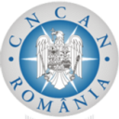
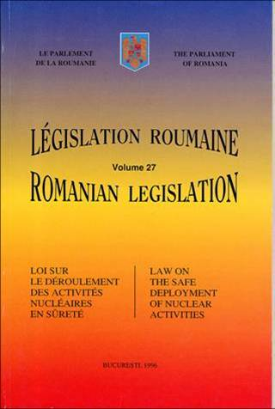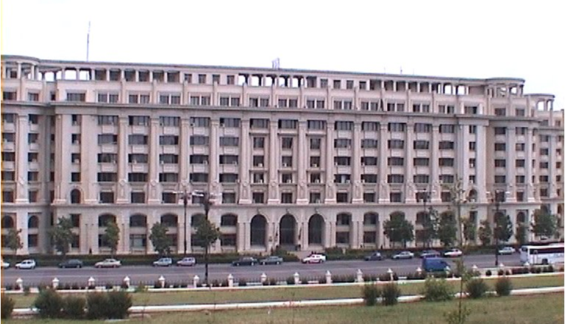

Romania ratified in 08 March 1972 the Agreement for Application of Safeguards in connection with the Treaty on the Non-proliferation of Nuclear Weapons, agreement that committed our country to „accept safeguards on all raw materials and on all special fissile products in all peaceful nuclear activities deployed on its territory”; (Decret no. 394/1972).

ROMANIA was for many years under traditional safeguards (TS) and has developed in good conditions this type of nuclear safeguards.
The legal framework was Law no.100/2000 ( INFCIRC/180) for ratification of the Protocol between Romania and International Atomic Energy Agency (IAEA) additional to the Agreement between the Socialist Republic of Romania Government and IAEA as part of the Treaty on the non-proliferation of nuclear weapons.
After TS ROMANIA had the opportunity to improve the performance and quality of the safeguards activity and increase the accountancy and control of nuclear material by passing to Integrated Safeguards (IS).
The passing was not made in the same time at all the facilities. The passing was made facility with facility .
In this conditions the aid of IAEA and CNCAN was very important to analyse and review each step and to conclude about the magnitude of the implementations difficulties, limits and conditions at each facility.
In 11 June 2007 Romania adhere to the IAEA and EURATOM Agreement for the Application of Safeguards (INFCIRC/193) in connection with the Treaty on the Non-proliferation of Nuclear Weapons.
Starting with 1 ^{st} of May 2010 Romania implemented Safeguards Agreement between IAEA, EURATOM and Romania (INFCIRC/193) and the Additional Protocol.
Romania confirmed its intention not to make use of the possibilities offered in paragraph 6 of Annex III of the AP.
CNCAN is the main contact point with the European Commission and is responsible for the implementation of AP in Romania.
According to the art. 2c) provisions of the Nuclear Law shall apply to production, sitting and construction, supply, leasing, transfer, handling, possession, processing, treatment, use, temporary storage or final disposal, transport, transit, import and export of radiological installations, nuclear and radioactive materials, including nuclear fuel, radioactive waste and ionizing radiation generating devices.
With regards to the small holders of nuclear materials, the Romanian legislation takes into account the following safeguards objectives:
- Establishing provisions governing the possession, use, transfer, import and export of nuclear materials;
- Ensuring the implementation of the safeguards system for accountancy and control of nuclear materials:
- Ensuring that all nuclear materials are reported under the provisions of the Safeguards Agreement;
- Ensuring that all nuclear activities are declared under the provisions of the Additional Protocol;
- Developing and implementing nuclear material accounting and control procedures at all small holders of nuclear materials;
- Ensuring training for safeguards staff at all small holders.

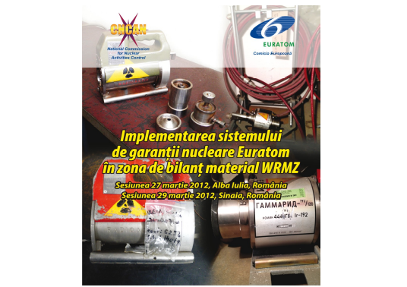

- Romania MBAs

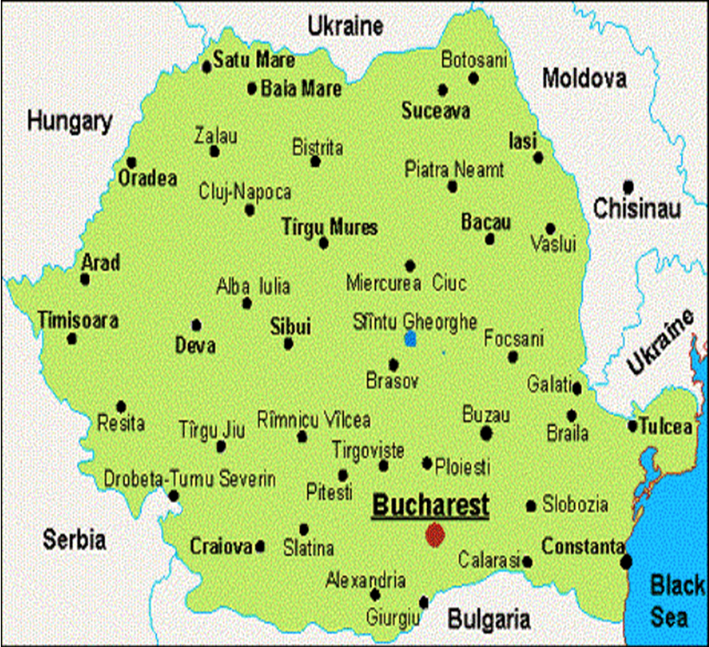

CNCAN and subordinated facilities Flow-chart

WRMA (RO-A) – National Institute for Physics and Nuclear Engineering “Horia Hulubei”, Măgurele;
WRMC (RO-C1) – Nuclear Power Plant Unit 1, Cernavodă;
WRMD (RO-D) – Nuclear Fuel Plant Pitești;
WRME (RO-E) – Institute for Nuclear Research, Pitești;
WRMF (RO-F) - Powder Plant, Feldioara;
WRMG (RO-G) – Interim Spent Fuel Dry Storage, Cernavodă;
WRMH (RO-H) - Nuclear Power Plant Unit 2, Cernavodă;
WRMZ (RO-Z) – Miscellaneous Locations (LOF).

- EURATOM Safeguards

Starting with 1 ^{st} of May 2010 the safeguards legal framework for Romania is:

    - Treaty establishing the European Atomic Energy Community (EURATOM);
    - Commission Regulation (EURATOM) no. 302/2005 of 8 February 2005 on the application of EURATOM safeguards;
    - Commission Recommendation of 11 February 2009 on the implementation of a nuclear material accountancy and control system by operators of nuclear installations (2009/120/EURATOM);
    - Agreement Between the Kingdom of Belgium, the Kingdom of Denmark, the Federal Republic of Germany, Ireland, the Italian Republic, the Grand Duchy of Luxembourg, the Kingdom of the Netherlands, the European Atomic Energy Community and the International Atomic Energy Agency in Implementation of Article III, (1) and (4) of the Treaty on the Non – Proliferation of Nuclear Weapons, approved by the Romanian Parliament through the Law no. 185/2007;
    - Protocol Additional to the Agreement Between the Republic of Austria, the Kingdom of Belgium, the Kingdom of Denmark, the Republic of Finland, the Federal Republic of Germany, the Hellenic Republic, Ireland, the Italian Republic, the Grand Duchy of Luxembourg, the Kingdom of the Netherlands, the Portuguese Republic, the Kingdom of Spain, the Kingdom of Sweden, the European Atomic Energy Community and the International Atomic Energy Agency in Implementation of Article III, (1) and (4) of the Treaty on the Non – Proliferation of Nuclear Weapons, approved by the Romanian Parliament through the Law no. 185/2007;
    - Arrangements for the implementation and information flow for the Additional Protocol in Romania – OJ L 67/1 of 13/3/1999;
    - National legislation.

Regulation 302/2005 Reporting Responsibilities:

CNCAN Send a copy of the report Nuclear installations

WRMZ – Romania National LOFs MBA WRMA, WRMC, WRMD,WRME,
WRMG, WRMF, WRMH
  - ICR, MBR, PIL - ICR, MBR, PIL
  - Special Reports - Special Reports
  - Internal transfers of nuclear materials - Internal transfers of nuclear
materials
  - Import / Export of nuclear materials - Import / Export of nuclear materials

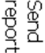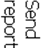
EURATOM

CNCAN centralized all information on basic technical characteristics (BTC) of small nuclear holders relevant in terms of the nuclear safeguards and submit monthly reports to the EURATOM and EURATOM send all reports received from CNCAN to the IAEA

Before Romania joined the European Union, the movement of nuclear material in the material balance area RO-Z (which has become WRMZ after Romania's accession to the EU) was characterised by the following features which, after the accession, generated difficulties in identifying the totality of small holders of nuclear material from the point of view of safeguards control:

Depleted uranium used in making containers for the radiological protection (shielding) of sealed sources of ionizing radiation used for non-destructive testing in industrial activities:
- the quantities of depleted uranium used to manufacture the shielding of non-destructive control facilities were imported from the Soviet Union during 1960-1980 and were exempted from the safeguards control of the International Atomic Energy Agency (IAEA), according to Romania's claims in that period. At that time, the exemption from safeguards control, was interpreted as implying that the strict and detailed control of the movement of the non-destructive control equipment having components made of depleted uranium was not necessary, while the control of this equipment was performed only in terms of its importance to radiological safety. As a consequence, the majority of licenses issued by CNCAN before 2005 for the possession and use of non-destructive control equipment with shielding of depleted uranium, do not contain information on the quantity of depleted uranium in the biological shielding.
- under strict safeguards controls were only the quantities of depleted uranium in biological protective shields of non-destructive control equipment procured through import.

Chemical compounds containing uranium and thorium imported as chemical reagents or for didactic purposes:
Prior to 1970, many industrial enterprises with chemical laboratories and many schools (colleges, universities) imported small quantities of chemical compounds (nitrates, acetates of uranium and thorium, etc.) as chemical reagents or for use in the education process (e.g. in university laboratories). The legislation in force at that time did not contain provisions on the mandatory placement of small quantities of chemical reagents containing uranium and thorium under the safeguards control.
Meanwhile, most of the foreign trade enterprises which imported chemical reagents containing uranium and thorium have been liquidated, making it virtually impossible to reconstruct the full list of beneficiaries of such imports.

Economic and social factors
The overall economic and social context of Romania in the first years after 1989:
In the process of rapid transition to market economy, a large number of economic entities possessing non-destructive control equipment with depleted uranium shielding or small amounts of chemical reagents containing uranium or thorium were divided, liquidated, reorganized or privatized, having as an immediate effect the difficulty of maintaining the dialogue between CNCAN and legal owners of these materials. Also, in the process of rapid transition to market economy in the period after 1989, entities holding such materials have made redundant a lot of their staff, including the persons responsible for the management of nuclear materials management.

Factors related to the management of the regulatory control exercised by CNCAN that contributed to the identified non-conformities:
- The fluctuation of CNCAN staffing lead to frequent changes of the persons actually involved in the implementation of Safeguards in the RO-Z material balance, now WRMZ after EU accession (6 people in the last 10 years, each no more than 1-3 years);
- For the past 10 years, there has been only one person at a time having detailed knowledge of the implementation of safeguards in the RO-Z, now WRMZ, material balance area, with the capability to prepare safeguards reports for WRMZ – there was no second person assigned to fulfill these duties in case the first person was unavailable;
- The safeguards inspections performed were insufficient to cover all the small holders of nuclear materials (more than 100 small holders located throughout Romania) since practically only one person was actually involved in the implementation of Safeguards in the material balance area WRMZ;
- The designated CNCAN inspector involved in the implementation of safeguards in the material balance area WRMZ participated in the safeguards training courses organized by EURATOM only sporadically;
- There has been insufficient and inadequate cooperation among the personnel involved in the implementation of safeguards in the actual material balance area WRMZ, within the Safeguards, Transport and Physical Protection Unit and the personnel working in the Ionizing Radiation Division (directly involved in the authorization of the non-destructive equipment with depleted uranium shield, from radiation protection point of view).
- There have been no guidelines developed by CNCAN for small holders of nuclear material for the documentation, management, control and reporting of nuclear material by CNCAN in order to implement the safeguards;
- There was no procedure developed by CNCAN for preparing PIT, PIV and safeguards reports for WRMZ.
Based on the provision of European Unions Safeguards legislation and Romanian Law no. 111/1996, republished, with subsequent amendments and additions. CNCAN has issued a Guidelines document for application of safeguards to the small holders of nuclear materials in Romania. The Guidelines describe how the small holders of nuclear materials should undertake safeguards activities in Romania in accordance with the requirements of EURATOM/IAEA/CNCAN. The Guidelines are applied by all small holders of nuclear materials in Romania in:
- Provide safeguards in all the small holder activities involving nuclear materials;
- Ensuring an appropriate communication interface between Romanian small holder of nuclear materials and CNCAN in order to fulfill the deadlines and the corresponding quality control of all safeguards requirements assumed by Romania through membership of the European Union, namely requirements under the Treaty establishing the European Atomic Energy Community, and
- Provide a framework for the small holders of nuclear materials to allow the best conditions for the safeguards inspections performed by the EURATOM / IAEA / CNCAN inspectors.

The guidelines content the followings:
- responsabilities of nuclear materials small holders management:
  - Establish and develop the safeguards system;
  - Officially represent of the legal entity, holding the holder, transfer, intra-community transfer, import and export license of nuclear material in relation to CNCAN, EURATOM and the IAEA on the safeguards point of view;
  - Designate a person within the licensee to act as safeguards responsible;
  - Require CNCAN approval for designating the safeguards responsible;
  - Provide a rapidly communication channel with CNCAN for the safeguards responsible;
  - Provide technical support and prompt access for EURATOM, IAEA and CNCAN inspectors in the areas where the nuclear materials are;
  - Establish and maintain through the safeguards responsible the primary evidence of all nuclear materials in their possession and to order the preparation and submission deadlines for all safeguards reports;
  - Provide financial support for the safeguards responsible in order to attend to the regular training sessions conducted by CNCAN;

- responsabilities of the safeguards responsable:
  - Complete and update the Movement Register of Nuclear Materials;
  - Prepare appropriate labels and label all nuclear materials;
  - Prepare and update the inventory list of items (LAI) for all locations where they are held nuclear materials, radiological installations or equipment containing nuclear material;
  - Develop and submit by fax or e-mail a notification accompanied by a copy of the transport document (notice accompanying the consignment) for any movement of nuclear material from the places of holding;
  - Notify CNCAN about the intended to transfer, intra – community transfer, import and export of nuclear materials at least six months before the intended date of making the transfer, intra-community transfer , import and export and carry out the transfer, intra-Community transfer, import and export only after requesting and obtaining the appropriate authorization from CNCAN;
  - Put promptly to the EURATOM, IAEA CNCAN inspectors the inventory list of nuclear materials held, the register of evidence and movement of nuclear materials, transport documents, authorizations CNCAN for possess, use, transfer, intra-community transfer, export, import and any other document required;
  - Develop and submit to CNCAN, annual, until November 15, Plan of the nuclear activities and movements of nuclear material which will held in the following year;
  - Properly archive all documents in connection with safeguards and keep them at least for 10 years.

- PREPARATION OF THE PHYSICAL INVENTORY TAKING (PIT)

All activities to be carried out by nuclear materials small holder to ensure the following conditions in order to achieve the physical inventory of nuclear material (PIV) by EURATOM, IAEA, CNCAN safeguards inspectors are:
- Prompt access for IAEA, EURATOM and CNCAN inspectors in any location where nuclear material is held;
- Rapidly and easily physical identification to all nuclear material held;
- Rapidly checking of all documents on which there were made movements of nuclear material;
- Rapidly verifying of the physical and scripted inventory of the owned nuclear materials;
- Small holders of nuclear materials will sent to CNCAN, at the required deadline, the information and documents required for the preparation of the annual physical inventory for material balance area WRMZ.

- NUCLEAR MATERIALS MOVEMENTS FROM / IN WRMZ MATERIAL BALANCE AREA

- CNCAN issues holding authorization for each location from WRMZ and export / import / transfer / intra-community transfer authorization between WRMZ and other material balance areas;
- Any movement (input / output) of nuclear material in a material balance area to another material balance area requires to obtain an import / transfer / export / intra-community transfer authorization, as appropriate, in accordance with art. 2 c) and Art. 8 of Law no. 111/1996, republished, with subsequent amendments and the provisions of the Safeguards Norms.
- Guidelines present all types of movements and documents required for movement of nuclear materials.

Legislative provisions for suppliers of nuclear material
Companies supplying nuclear materials will provide the intermediation delivery from the manufacturer only to the beneficiaries from Romania who requested and obtained from CNCAN transfer / import / export / intra-community transfer authorization of nuclear material, as appropriate;
- Upon completion of the delivery intermediation activity in Romania to the beneficiaries, the providers will deliver the following documents:
- Minutes of handover of nuclear material or equipment containing nuclear material with registration number, signed and stamped by both the supplier and the recipient;
- Certificate of conformity;
- Transport documents;
- The customs declaration;

- Additional Protocol Declaration for WRMZ MBA

• Declaration of Additional Protocol for WRMZ material balance area shall be made once a year, according to Article 2a (iii) of the Additional Protocol to the Safeguards Agreement, and includes a general description of each building on each site, including its use and, if this is not apparent from the description, its contents. The description shall include a map of the site;

• Safeguards Officer for the WRMZ material balance area will prepare and submit the letters with the information that small holders of nuclear materials should send to CNCAN for the preparation of the Declaration of Additional Protocol between 1 to 15 February of the current year;

• Small holders of nuclear material shall submit the information for the previous
year this year as CNCAN letter required until 05 March of the current year.

- Physichal Protection OF THE NUCLEAR MATERIALS FROM WRMZ MATERIAL BALANCE AREA

The main measures that the licensee must take to ensure the physical protection of radioactive sources and radiological equipment containing nuclear materials are:
a) Radioactive sources / radiological equipment containing nuclear materials will be stored in - a room where they will take all measures to safe storage (room equipped with suitable closures for access door and barred windows, into the room will be allowed only to persons authorized under access procedure, the existence of visual and acoustic alarm systems, movement sensors, if applicable);
b) Strict records of nuclear materials / radiological equipment containing nuclear materials held by the company / institution, and periodic physical inventory of nuclear / radiological equipment containing nuclear materials (monthly or quarterly);
c) Strict evidence of the movement of nuclear materials / radiological equipment containing nuclear materials held by the company / institution (register of movements);
d) Strict records of persons who possess keys or access cards to the nuclear materials / radiological equipment containing nuclear materials storage and taking action to control and safekeeping of keys / access cards;

