# IDENTIFICATION OF IRRADIATED FOODS WITH

# ELECTRON SPIN RESONANCE (ESR) SPECTROCSOPY

C.T.T. ZAW

Ministry of Education

Nay Pyi Taw, Myanmar

Email: cho1980@gmail.com

L.L. OO, S.M. AUNG

Ministry of Education

Nay Pyi Taw, Myanmar

**Abstract**

Food irradiation uses electromagnetic radiation and is controlled by many identification methods according to the contents in foods. Currently there are ten methods used to identify the irradiated foods and electron spin resonance (ESR) spectroscopy is one of these methods to identify the irradiated food containing bone, cellulose and crystalline sugar. The present work was to detect the un-irradiated and irradiated wheat, rice and chickpea powder, study the ESR intensity with respect to the absorbed dose, and fading of ESR signal with time. As the radiation source, industrial type 5 MeV, 15 kW electron beam accelerator was applied and three grain flour was irradiated with the dose; 1, 1.5, 2.1, 2.6 and 3.2 kGy. The optical absorbance of B3 Windose film dosimeters was measured at 552 nm with GEX (Spectronic Genesys-20) spectrophotometer for absorbed dose measurement. ESR measurements were carried out using an ESR spectrometer (magnettech, MS 400). Free radicals generated by irradiation gave typical signal in the ESR spectrum for irradiation identification. In present study, irradiated samples showed strong ESR signals centered at g = 2.006, where un-irradiated samples had weak signals. And ESR intensity increased linearly with absorbed dose in most of the cases. The fading of ESR intensity of the samples stored at room temperature was studied over storage period of 4 weeks. Following one week after irradiation, ESR intensity decreased significantly with storage time.

## INTRODUCTION

Food irradiation uses electromagnetic radiation of energy levels sufficient to cause disinfestations or decontamination of treated product without causing induced radioactivity. An ideal detection method of irradiated food should measure a specific radiation effect, proportional to the dose and should not be affected by processing parameters and storage conditions or length of time between irradiation processing and analysis. In 1993, the European Commission gave a mandate to the European Committee for Standardization (CEN) to standardize irradiated food detection methods [1].

Ten methods used to identify irradiated foods are: GC analysis of hydrocarbons (EN 1784:2003) for detection of irradiated food containing fat; GC/MS analysis of 2-Alkylcyclobutanones (EN 1785:2003) for detection of irradiated food containing fat; ESR spectroscopy (EN 1786:1996) for detection of irradiated food containing bone; ESR spectroscopy (EN 1787:2000) for detection of irradiated food containing cellulose; Thermo luminescence (EN 1788:2001) for detection of irradiated food from which silicate minerals can be isolated; ESR spectroscopy (EN 13708:2001) for detection of irradiated food containing crystalline sugar; (EN 13751:2002) for detection of irradiated food using photo-stimulated luminescence; screening method (EN 13783:2001) for detection of irradiated food using direct epi-fluorescent filter technique/aerobic plate count (DEFT/APC); screening method (EN 13784:2001) - DNA comet assay for the detection of irradiated foodstuffs; microbiological screening for irradiated food using LAL/GNB procedures (EN 14569:2004) [4].

Electron paramagnetic/spin resonance (ESR) spectroscopy is a spectroscopic technique that permits the detection of unpaired electrons originating from radicals, including those induced by irradiation or from paramagnetic ions in an applied external magnetic field [3].Electron spin resonance is a simple, fast and sensitive technique for irradiation detection in various foods. Free radicals generated by irradiation are trapped in bones, shells or other hard or cellulosic parts of the foods. These free radicals give typical signal, in the ESR spectrum that can be potentially applied for irradiation identification [2]. The intensity of the signal obtained increases with the concentration of the paramagnetic compounds and thus with the applied dose. Detection of irradiated bone sample is typically possible above a dose of approximately 0.5 kGy, covering the majority of commercial applications. Detection of irradiated food containing cellulose: pistachio nuts, paprika powder and fresh strawberries have been validated for doses of 2 kGy, 5 kGy and 1.5 kGy respectively [4]. The present work is to detect and identify the un-irradiated and irradiated wheat, rice and chickpea powder by using the electron spin resonance (ESR) spectrometer; investigate ESR intensity variation with respect to absorbed dose and fading of ESR signal with storage time.

## MATERIALS AND METHOD

### Sample and Irradiation

Three kinds of grains; wheat, rice and chickpea powder were purchased from the local market in India. Each 100 grams of samples were packed in polyethylene bags for irradiation and control. The samples were irradiated with the dose; 1, 1.5, 2.1, 2.6 and 3.2 kGy by using 5 MeV, 15 kW electron beam accelerator at Isotope and Radiation Application Division, BARC, India. After irradiation the samples were stored at room temperature for further studies.

### Dosimeters

B3 Windose film dosimeters were used for absorbed dose measurement. They were placed on the dummy material and irradiated together with the samples. The optical absorbance of the dosimeters was measured at 552 nm with GEX (Spectronic Genesys-20) spectrophotometer. B3 dosimeters have been calibrated using reference standard alanine dosimeters.

### ESR Spectroscopy

ESR measurements were carried out using an ESR spectrometer (magnettech, MS 400). The ESR quartz tube (2 mm diameter, 12 cm long) containing about 3 g of each sample was adjusted to a fixed position. Then, the operating parameters were adjusted and the signals were recorded at the position shown in Table 1. All ESR spectra were recorded at the X-band (9.43 GHz) and the measurement was carried out at room temperature.

TABLE 1. PARAMETERS USED IN ESR OPERATION

|  |  |  |  |  |
| --- | --- | --- | --- | --- |
| Specifications | Parameters | Wheat | Samples  Rice | Chickpea |
| Microwave | Power (mW)  MW atten: dB  Frequency (GHz) | 10  10  9.43 | 20  7  9.43 | 10  10  9.43 |
| Magnetic field  Modulation  Gain (Amplitude)  Sweep time (s) | Centre field (G)  Sweep width (G)  Frequency (kHz)  Amplitude (mG) | 3365.99  47.42  100  4000  3  12 | 3359.61  47.42  100  7000  5  20 | 3359.61  99.15  100  7000  9  20 |

## RESULTS AND DISCUSSION

### ESR Spectra of un-irradiated and irradiated foods

The measurement was started following day after irradiation and continued weekly. Irradiated samples showed strong and symmetric ESR signals centered at g=2.006, as un-irradiated samples had weak signals. The results are similar to the previous reports by [1] and the ESR signals for un-irradiated and irradiated samples can be distinguished easily. Fig. 1 shows the ESR spectra of wheat at doses range 1 to 3.2 kGy. Fig. 2 and 3 show the ESR spectra of rice and chickpea powder for control and irradiated samples respectively.

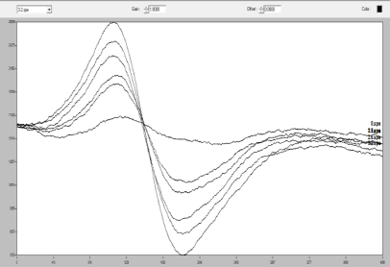 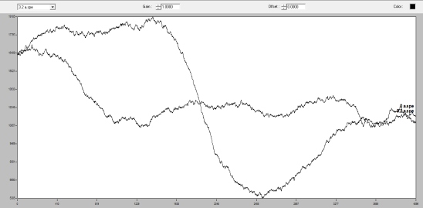 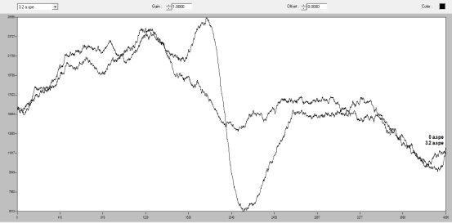

(b)

(c)

(a)

*FIG. 1. ESR spectra of (a) wheat (0, 1, 1.5, 2.1, 3.2 kGy) middle to up/down; (b) rice and (c) chickpea (0, 3.2 kGy) middle and up/down*

### Variation of Intensity with Absorbed Dose

The amplitude of each curve was analysed by using the Aer’ede application system. The response curves show that amplitude increased with the absorbed dose. ESR intensity changed as a function of absorbed dose but nothing changed in the spectral pattern, as reported [1].

*FIG. 2. Variation of ESR signal intensity with absorbed dose for wheat, rice and chickpea*

Meanwhile, the amplitude of signals of wheat and rice samples varied more linearly with absorbed dose than chickpea sample. Moreover, the viscosity of chickpea affected the measurement which could be done only for four points. The linear function for the data of each sample is expressed in figures.

### Fading of ESR signal with storage time

The effects of storage period after irradiation of samples were investigated. The samples were stored at room temperature for 4 weeks and their fading was measured weekly. For this experiment, irradiated samples with the dose of 3.2 kGy were analysed. Starting one week after irradiation, ESR intensity decreased significantly through 4 weeks.

*FIG. 3. Variation of ESR signal intensity with storage period*

## cONCLUSION

Electron beam accelerator is widely used for different purposes: food preservation, sterilization of medical products, waste water treatment and modification of the properties of industrial products. Food irradiation is controlled by many identification methods according to the contents in foods. Currently there are ten methods used to identify irradiated foods and electron spin resonance (ESR) spectroscopy is one of these methods to identify the irradiated food containing bone, cellulose and crystalline sugar. In this study three grain samples were irradiated with the doses 1, 1.5, 2.1, 2.6 and 3.2 kGy by using 5 MeV, 15 kW, ILU electron beam accelerator in order to detect the samples before and after irradiation. Identification of irradiation was determined by using ESR spectroscopy which is a quick method to identify. However, ESR signals usually fade with the storage time. The present work is concluded that ESR method can identify the un-irradiated and irradiated samples. Irradiated samples showed strong ESR signals centered at g = 2.006 where un-irradiated samples had weak signals at the same position. And ESR intensity increased with absorbed dose more linearly in wheat and rice than chickpea. The fading of ESR intensity of the samples stored at room temperature was studied over storage period of 4 weeks. Following one week after irradiation, ESR intensity decreased steadily with storage time for all three samples.

ACKNOWLEDGEMENTS

We express sincere gratitude to Mr. K.S.S. Sarma, Head, Isotope and Radiation Application Division, BARC for his permission and support to do the entire experiments by using the ILU electron beam accelerator and ESR spectrometer. And we are deeply grateful to Dr. P.G. Benny for his expertise, hands-on experience along the experiments and whole-hearted encouragement for doing this work. Moreover, we want to send special thanks to the staff in electron beam processing (EBPS) section for their co-operation and supporting along the experiments. We gratefully acknowledge the Centre for International Co-operation in Science (CICS), India for supporting the financial assistance under the “India Science and Research Fellowship” programme to conduct the experiments. Especially, we wish to send appreciation from heart to Ministry of Education, Myanmar for giving permission to carry out the extensive studies in India.

References

1. SUDPRASERT, W., MONTHONWATTANA, S., VITITTHEERANON, A., “Identification of irradiated rice noodles by electron spin resonance spectroscopy,” Radiation Measurement, 47 (2012)640-643.
2. KHAWAR, A., BHATTI, I, A., NAKAMURA, H., “ESR detection of wheat flour before and after irradiation”, Asian Journal of Chemistry, 23 (2011).
3. JOON-HO, K., SHAHBAZ, H. M., JAE-UN, A., “Advanced electron spin paramagnetic resonance spectroscopy for the identification of irradiated food’, (2014).
4. DEL MASTRO, N. L., “Detection of irradiated food”, LASLANS symposium, integration of nuclear technologies in Latin America, (2009).
5. MAGNETTECH operation hints for the miniscope, MS100-MS300, <http://www.magnettech.de>.