Potential Nano-Fe/Ca/CaO Composite Enabled Environmental Remediation Technologies for Radioactive Waste

Srinivasa Reddy Mallampati,¹* Yoshiharu Mitoma,² Cristian Simion³

¹Department of Civil and Environmental Engineering, University of Ulsan, Ulsan 680-749,
Republic of Korea
²Department of Environmental Sciences, Prefectural University of Hiroshima, Shobara, Japan
³Politehnica University of Bucharest, Department of Organic Chemistry, Bucharest, Romania
*Corresponding Author: Phone/Fax:+82-52259-1412/2629; Email address: srireddys@ulsan.ac.kr

Abstract. Radioactive cesium (¹³⁷Cs) contaminated soil obtained from Fukushima was treated with nano-Fe/Ca/CaO/[PO4], approximately 27.3 wt% of magnetic and 72.75% of non-magnetic soil fractions were separated. The highest amount of entrapped ¹³⁷Cs was found in the lowest weight of the magnetically separated soil fraction (i.e., 80% in 27.3% of treated soil). Results show that ¹³⁷Cs either in the magnetic or non-magnetic soil fractions was 100% immobilized. While, ¹³⁷Cs contaminated fly ash (containing an initial 14,040 Bq kg⁻¹ ¹³⁷Cs concentration) obtained from burning wastes from Fukushima were reduced to 3,583 Bq kg⁻¹ after treatment with nanometallic Ca/CaO methanol suspension. Furthermore, both soil/ash content and eluted solution concentrations of ¹³⁷Cs were much lower than the Japanese Ministry of the Environment regulatory limit of 8,000 Bq kg⁻¹ and 150 Bq L⁻¹ respectively. The nano-Fe/Ca/CaO/[PO₄] enabled treatment can be considered as environmental remediation of radioactive waste.

Key Words: Radioactive cesium; Nano-Fe/Ca/CaO composite; Remediation; Contaminated soil/fly ash.

Introduction
In Japan, the major environmental concern on the radioactive cesium (¹³⁷Cs) deposition and its contamination due to the emission from the Fukushima Daiichi Nuclear Power Plant showed up after a massive quake on March 11, 2011. Many fallout of ¹³⁷Cs generated a large amount of various wastes (soil, water, ash, sediment/wide range of concentration). Fukushima prefecture exceed the government’s safe limit of 2500 Bq/kg of cesium¹³⁷ in soil. According to the Japan science ministry about 8 percent of the country’s land has been contaminated with levels higher than 10,000 Bq/m² of cesium¹³⁷ a threshold that Japan’s science ministry defines as affected by a nuclear accident [1,2]. On the other hand, by the end of March 2012, incineration ash containing 100,000 to 140,000 becquerels per kilogram (Bq kg⁻¹) of (¹³⁷Cs) was recorded. High levels of ¹³⁷Cs are also present in incineration ash from normal garbage [3,4]. Temporary disposal sites for incinerated ash containing ¹³⁷Cs are rapidly filling up. No alternative landfills are available. During and after the 30 years it takes for ¹³⁷Cs to decay by half, each time it rains, ¹³⁷Cs deposited will be washed down to where people live [4]. Therefore, the ¹³⁷Cs extraction and immobilization in contaminated soil/ash is recognized to be one of the most difficult problem solved by taking advantage of suitable technologies [1-4]. For radiological contamination, the separations of interest may be the removal of the radioactive species from its host matrix (i.e., an extraction), or it may involve processes such as fixation or stabilization, in which the radioactive material is separated from any mobilization and/or transport pathways so that the risk it poses is reduced or eliminated altogether by preventing it from being made available to a receptor [1-4]. In recent years, nanotechnology has risen to the forefront and the new properties and enhanced reactivities offered by nanomaterials may offer a new, low-cost paradigm to solving complex environmental and engineering problems [1-4]. This study assessed the synthesis and application of nano-Fe/Ca/CaO composite/ nanometallic Ca/CaO methanol suspension for use as a separation/extraction and immobilizing treatment of ¹³⁷Cs contaminated soil/fly ash.
Materials and methods
  - Soil sample and fly ash collection and nano-Fe/Ca/CaO and nanometallic Ca/CaO methanol suspension preparation

Radioactive Cs, contaminated soil samples collected from areas affected by the Fukushima Daiichi NPP accident. On the other hand, radioactive cesium (¹³⁷Cs) contaminated fly ash samples were collected from disaster stricken area of Iwaki city, Fukushima prefecture, and were used as such for treatment experiments. Nano-Fe/Ca/CaO/Nano-Ca/CaO (dry system) systems were prepared respectively by a ball milling process [2,3]. The suspension of nanometallic Ca/CaO methanol was prepared by magnetic stirring the mixture of 10 g nanometallic Ca/CaO and 50 g methanol for 30 min. After stirring, the samples were kept for 10 minutes to settle and the supernatant of methanol suspension contains nanometallic Ca/CaO (about 25-30%) (nMCaS) was separated and used for treatment experiments.

  - Radioactive cesium (¹³⁷Cs) contaminated soil and fly ash treatment
Radioactive cesium (¹³⁷Cs) contaminated soil samples (10 g) were mixed with 0.5 g nano-Fe/Ca/CaO, or 0.5 g NaH₂PO₄ ([PO₄]). These mixtures were ground in a 500 mL ceramic tumbling mill, along with 10 ceramic balls (10-mm diameter) for 2 h at 100–150 rpm in open atmosphere. After the treatment, the samples were analyzed and compared with the untreated soil samples. The magnetic and non-magnetic soil fractions were separated easily through a balance of magnetic forces and gravity. On the other hand, about 1 g of ¹³⁷Cs contaminated fly ash and 3 g of extraction solvent (i.e. nMCaS) were thoroughly mixed for 4 h at 200 rpm followed by filtered through a 0.45 μm membrane filter. The total ¹³⁷Cs concentrations in extracted solutions and/or soil/fly ash residues were measured using a high-purity germanium detector with gamma-ray spectrometry (GMX-20P4-70; Seiko EG & G), according to the standard Ministry of Education, Culture, Sports, Science & Technology Japan (MEXT) method [2,3].

- Results and discussion
  - Radioactive cesium (¹³⁷Cs) contaminated soil treatment
Once the principal steps for the ¹³³Cs immobilization/separation process using artificially contaminated soil with ¹³³Cs have been established (Fig. 1a), the procedure was applied to actual soil samples contaminated with ¹³⁷Cs obtained from Fukushima prefecture, the region most affected by emitted radionuclides. The treatment process is presented as a simplified flowchart in (Fig. 1b). The initial radioactive cesium (¹³⁷Cs) concentration in contaminated soil was 6,201 Bq kg⁻¹. The radioactive cesium concentrations in various soil size fractions were measured. As presented in Table 1, a high concentration of ¹³⁷Cs was found in the fine fraction of soil (i.e. <0.125 mm size 4446 Bq kg−1 and >7 mm size contains only 436 Bq kg−1), which corresponds to about 40 wt% (i.e., 0.5 to < 0.125 mm size) fine fraction of soil contained about 67% of total radioactive cesium (¹³⁷Cs) [3]. Any isotope of cesium, whether radioactive or stable, will preferentially adhere to the surfaces of soil and other organic particles. After treatment with nano-Fe/Ca/CaO/[PO₄], the sum of ¹³⁷Cs allocations among the magnetic and non-magnetic soil fractions were, respectively, 5,419 and 1,438 Bq kg⁻¹ (much lower than the regulatory limit of 8,000 Bq kg⁻¹ established by the Japanese Ministry of the Environment) [3]. The best results were obtained using the nano-Fe/Ca/CaO/[PO₄] dispersed mixture, where approximately one-fifth of the contaminated soil, containing approximately 88.1% of the amount of Cs, was magnetically separable. Cs, either in the magnetic or non-magnetic soil fractions, was immobilized completely because no leaching was detected. This method concentrates radio-isotopes into a smaller volume of insoluble material that is easy to store.
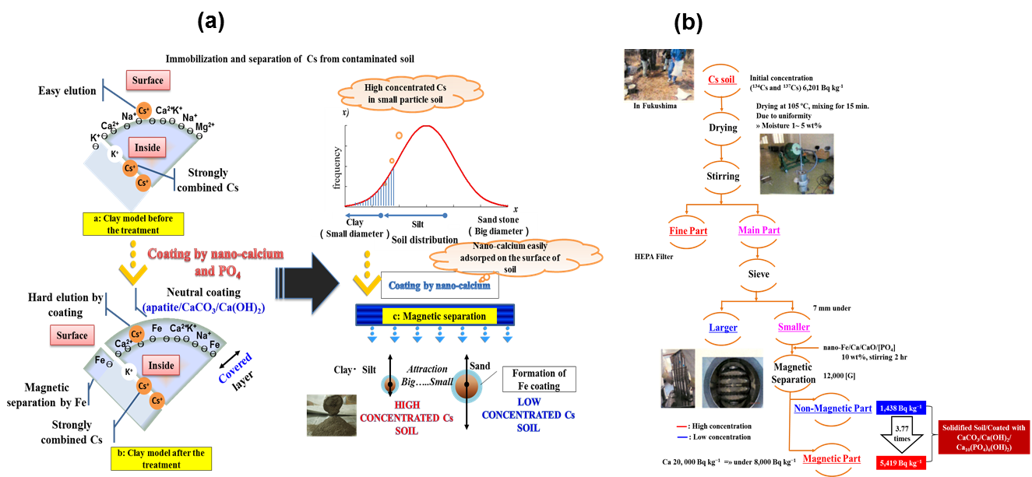
FIG. 1. A possible pathway for separation/immobilization of (a) stable cesium (¹³³Cs) and (b) radioactive cesium (¹³⁷Cs) with the nano-Fe/Ca/CaO/[PO₄] treatment [3].

TABLE 1. Radioactive cesium concentrations in various soil size fractions
Soil size (mm) | Soil ratio (Wt%) | ¹³⁷Cs
Soil size (mm) | Soil ratio (Wt%) | Concentration  (Bq kg−1) | Soil Ratio (Bq %)
>7 | 4.8 | 436 | 0.7
02-7 | 8.6 | 724 | 3.3
2-0.5 | 46.6 | 1227 | 30.1
0.5-0.25 | 17.1 | 1893 | 17.8
0.25-0.125 | 10.5 | 3187 | 18.3
<0.125 | 12.4 | 4446 | 30.8
Total | 100 |  | 100

3.4. Removal and immobilization of radioactive cesium (¹³⁷Cs) in fly ash

Once established the principal steps for the ¹³³Cs removal/immobilization process using artificially contaminated fly ash with ¹³³Cs (Fig. 3a), the present methodology applied to actual radioactive cesium (¹³⁷Cs) contaminated fly ash obtained from a municipal waste incinerator from Fukushima prefecture, the region most affected by radionuclides emitted after the Fukushima Dai-ichi Nuclear Power Plant accident. The first extraction of ¹³⁷Cs from fly ash was carried out using methanol to remove the large amount of ¹³⁷Cs followed by the second step treatment of fly ash with n-MCaS to further remove the residual (¹³⁷Cs), i.e. trapped inside the fly ash particles. During the process, the dispersed mixture of nano-Ca/CaO is act as a sealing agent for fly ash particles that facilitate the filling of channels and pores created by methanol. The process is presented as a simplified flowchart in (Fig. 3b). Thus, from an initial concentration 14,040 Bq kg⁻¹ in the Fukushima area fly ash, after the 1st methanol extraction, the remaining total ¹³⁴Cs and ¹³⁷Cs concentration was only 3,583 Bq kg⁻¹, representing 74.5% removal efficiency. After the 2nd extraction with n-MCaS, elution test conducted on the treated fly ash gave only 100 Bq L⁻¹ total ¹³⁴Cs and ¹³⁷Cs, a lower value than the regulatory limit of 8,000 Bq kg⁻¹ and 150 Bq L⁻¹, respectively, established by the Japanese Ministry of the Environment. This study demonstrates that nanometallic Ca/CaO methanol suspension extraction effectively extracted and immobilized radioactive cesium from contaminated fly ash [2]. These results suggested that nanometallic Ca/CaO methanol suspension extraction can be regarded as a sustainable remedial strategy for extraction and immobilization of ¹³⁴Cs and ¹³⁷Cs from actual contaminated fly ash.
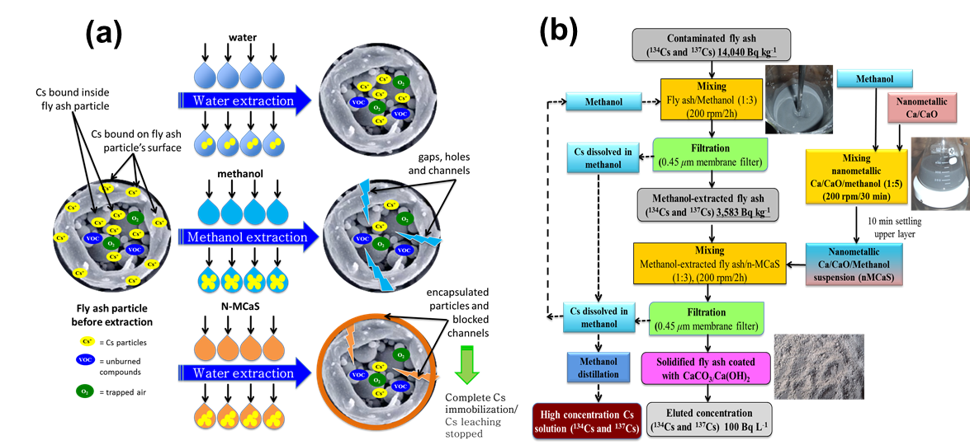
FIG. 3. Schematic representation of possible mechanisms determining the (a) Stable cesium (¹³³Cs) (b) radioactive cesium (¹³⁴Cs and ¹³⁷Cs) extraction and immobilization in contaminated fly ash with n-MCaS extraction [2].

4. Conclusions
In this study, nano-Fe/Ca/CaO composite has act as a promising agent for simultaneous removal and immobilization of radioactive cesium (¹³⁷Cs) from contaminated soil/fly ash. The highest amount of entrapped ¹³⁷Cs was found in the lowest weight of the magnetically separated soil fraction (i.e., 80% in 27.3% of treated soil). Both soil/ash content and eluted solution concentrations of ¹³⁷Cs were much lower than the Japanese Ministry of the Environment regulatory limit of 8,000 Bq kg⁻¹ and 150 Bq L⁻¹ respectively. These results suggest that simple treatment with nano-Fe/Ca/CaO/[PO4]/ nanometallic Ca/CaO methanol suspension is a highly potential amendment for the remediation of radioactive cesium-contaminated soil/fly ash.

Acknowledgment
We are thankful to National Research Foundation of Korea (NRF) and Japan Society for the Promotion of Science (JSPS), for providing financial support for this study through the collaborative research project (2016K2A2A4003740).
Reference
[1] Mallampati et al., “High immobilization of soil cesium using ball milling with nano-metallic Ca/CaO/NaH₂PO₄: implications for the remediation of radioactive soils”, Environ. Chem. Lett. 10 (2012) 207.
[2] Mallampati et al., “Preferential removal and immobilization of stable and radioactivecesium in contaminated fly ash with nanometallic Ca/CaO methanolsuspension”, J. Hazard. Mater. 279 (2014) 59.
[3] Mallampati et al., “Solvent-free synthesis and application of nano-Fe/Ca/CaO/[PO4] composite for dual separation and immobilization of stable and radioactive cesium in contaminated soils”. J. Hazard. Mater. 297 (2015) 82.
[4] Mallampati et al., “Dynamic immobilization of simulated radionuclide 133Cs in soil by
thermal treatment/vitrification with nanometallic Ca/CaO composites”, J. Environ. Radio. 139 (2015) 124.

