**Exploring spectroscopic and morphological data as new signatures for uranium ore concentrates**

D. Ho Mer Lin1,4, D. Manara1, Z. Varga1, L. Fongaro1, A. Nicholl1,

M. Ernstberger1, A. Berlizov2, P. Lindqvist-Reis3, T. Fanghänel1 and K. Mayer1

1European Commission,

Joint Research Centre,

Institute for Transuranium Elements,

P.O. Box 2340, 76125 Karlsruhe, Germany

2International Atomic Energy Agency,

Vienna International Centre,

P.O. Box 100, 1400 Vienna, Austria

3Institute of Nuclear Waste Disposal,

P.O. Box 3640, 76021 Karlsruhe, Germany

4DSO National Laboratories,

20 Science Park Drive, Singapore 118230

**Abstract.** Raman spectroscopy and morphological parameters obtained from Scanning Electron Microscopy (SEM) combined with image analysis, of uranium ore concentrates (UOCs) were studied and assessed as possible signatures for nuclear forensic applications. Raman spectra and morphological data were subsequently treated separately with principal component analysis. The complementary use of infrared and Raman data adds value to the interpretation and shed reasonable doubts regarding the true composition of UOCs such as ammonium diuranate/uranyl hydroxide that resulted from overlapping clusters in PCA analysis of 95 samples. PCA analysis of 30 parameters relating to shapes and sizes of 17 UOC samples is a potential signature for origin assessment indicative of the process.

# 1. Introduction

As a relatively young discipline emerging from the needs to tackle illicit trafficking [1-4], nuclear forensic science continues to develop with interest in the investigation of new signatures or fingerprints to complement or improve its existing multi-faceted analysis. *Signatures* or *fingerprints*, in this sense refer to physical, chemical, isotopic characteristics associated with the nuclear materials that could potentially identify their origin, should the material be lost and subsequently found. The eventual attribution of material can subsequently lead to legal prosecution and henceforth, the studying and understanding of nuclear materials clearly plays a pivotal role in the entire process.

Originating from the early stages of the nuclear fuel cycle, *uranium ore concentrates (UOCs)* or *yellow cakes* are intermediate products as a result of mining and milling of uranium ore. These precursors of nuclear fuel are often traded in large quantities, due to ease of access compared to enriched samples and therefore, diversions or thefts are real. Three cases involving UOCs had been published [5-7]. What is noteworthy is the fact that these yellow cakes have different compositions depending on their processing history and it is therefore necessary to differentiate or distinguish them from each other. After uranium is leached from the ore, purification and concentration of uranium are followed and subsequently, the yellow cakes are produced by precipitation. The use of precipitating reagents such as ammonium hydroxide, hydrogen peroxide, sodium hydroxide, ammonium carbonate, magnesium hydroxide/magnesium oxide will lead to the formation of ammonium diuranate, uranyl peroxide, sodium diuranate, ammonium uranyl carbonate, uranyl hydroxide, respectively. The choice of the precipitating reagents is based on the type of ore plus economics and environment factors. After the precipitation, these powders have a characteristic pale/bright yellow, orange or light brown colour. They are further subjected to drying and calcination to remove water and volatile components [8]. At temperatures of ~450 °C, another UOC known as UO3 with a bright orange colour is produced. Further increment in temperatures to ~700 °C will lead to the formation of a dark green/black powder of U3O8 [9], also known collectively as yellow cake. These UOCs are further subjected to conversion whereby UF4 and UO2 products are also subsequently formed. These non-UOCs are also included in this study.

In view of developing signatures of UOCs for nuclear forensics purposes in answering questions such as '**what** is the material?', '**How** it was produced?', '**Where** did it come from?', there have been numerous studies published on the applicability of analyzing various aspects associated with the yellow cakes. These includes composition of major constituents including U isotopes [10, 11], minor constituents such as Th [12], Pb [13-15], Sr [14] and S isotopes [16], trace elements [10, 13, 15, 17-19], non-volatile organics [20] and anionic impurities [19, 21, 22]. The application of 228Th/232Th to the determination of production dates of 'found' impure yellow cake has been demonstrated [5, 12]. These techniques typically require very sensitive and precise measurements and are often fulfilled with the use of inductively coupled plasma mass spectrometry (ICP-MS) or thermal ionization mass spectrometry (TIMS). More recently, there have also been reports on the use of spectroscopic techniques such as infrared (IR) spectroscopy [22], near infrared reflectance spectroscopy [23, 24] and laser-induced breakdown spectroscopy (LIBS) [25] for the measurement of UOCs for origin assessment.

In this paper, we explored the feasibility of using Raman spectroscopy as a tool for nuclear forensics application. The phenomenon of light interaction with molecules typically gives rise to certain interaction between the light and material such as absorption, reflection, elastic and inelastic scattering. Raman spectroscopy is based on the inelastic light scattering to obtain information from molecular vibrations (Fig. 1). This technique is of interest owing to its non-destructive nature, ability to measure all states of matter and solution and through containment system like glass (thus hazardous/unknown substances can be probed in a safe way). Therefore, hardly any sample preparation is needed thus rapid analysis is possible. The miniaturization of Raman spectrometers has also played a critical role leading to several field applications especially in cultural heritage [26, 27], forensic [28, 29], defence and homeland security [28, 30]. A hand-held Raman on loan from International Atomic Energy Agency (IAEA) is also featured in this paper where the usefulness/performance of this instrument is briefly highlighted.

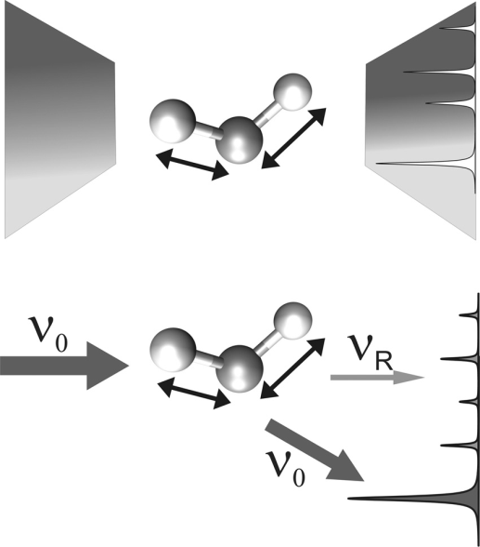

*Fig. 1: Concepts of Raman scattering (ν0 being the incident laser line; νR (thin arrow) corresponds to inelastic scattering/ the Raman lines; ν0 (thick arrow) corresponds to elastic scattering/ the Rayleigh lines [**31**]*

A less explored signature but nonetheless an important aspect of studying uranium ore concentrates, is the correlation between their respective morphological characteristics and the processing or production history. In the context of this paper, morphology refers to the sizes and shapes of particles. Reports of such investigations can be found in some references, where factors affecting the precipitation behaviour such as temperature, pH, rate of addition of reagents are varied and the consequent change in morphology are monitored by various automated techniques [32, 33].

However, none of the above mentioned have worked on actual industrial UOCs or report the morphology of these samples. This task is also made more challenging due to the presence of impurities that can influence the morphology as well as the lack of complete information regarding production processes.

In addition to the applicability of Raman spectroscopy, in this paper, the feasibility of studying the morphology of some UOCs using scanning electron microscopy (SEM) and image analysis are also explored and discussed. SEM has the added advantage of allowing direct observations of size and shape simultaneously compared to other automated techniques such as particle size analyser based on diffraction, sedimentation etc. It is also readily available in the nuclear forensics laboratory since it is necessary to study the physical appearance as well as to obtain chemical composition of unknown material, with the help of energy dispersive spectrometry.

Finally, with the eventual goal of assessing the strengths and limitations of Raman spectroscopy and morphological parameters as signatures for nuclear forensics, *principal component analysis* *(PCA)* is used to provide an overview of the data. Observations of clusters, patterns, trends or outliers often results from the analysis. PCA also reveals relationships between the observations and the variables and among the variables themselves. PCA does it by finding new relationships between variables and presenting them differently without modifying the data. In so doing, the number of variables needed to present the data is also drastically reduced [34].

# 2. Experimental

2.1. Investigated material

A total of 89 industrial UOC samples from various mining/milling facilities in the world were analyzed using Raman spectrometer as summarized in chapter 2.2. These UOCs have different compositions such as ammonium diuranate (ADU), sodium diuranate (SDU), uranyl peroxide (UO4), uranyl hydroxide (UH) or UO2(OH)2, ammonium uranyl carbonate (AUC), UO3 or U3O8. Six samples of AUC, ADU, SDU, UO4 and UO2(OH)2 were synthesized in our laboratory [35]. All powder samples were pressed into pellet using a hydraulic press that made handling of the sample easier and this also reduced the risk of contamination. In addition, a nuclear grade UO2 fuel pellet was also measured.

17 industrial UOC samples were randomly selected for morphological assessment. Tiny amount of powder were placed in a mortar crusher and grinded in analytical grade ethanol. The gentle grinding is aimed to disintegrate large agglomerates. A small portion of the sample solution was pipetted onto aluminium disk holder with membrane filter. All samples were coated with 10 nm Au to increase conductivity.

2.2. Instrumentation

*2.2.1. Raman spectrometers*

A bench-top model of Raman spectrometer known as Senterra from Brukers® (available in the Institute for Nuclear Waste Disposal, Karlsruhe, Germany) was mainly used in this study. All 95 samples were analysed using Senterra while selected samples were analysed with two other Raman spectrometers. One of them is a hand-held spectrometer, FirstDefender|RM from Ahura Scientific® (from IAEA) and the other, a laboratory spectrometer, T64000 from HORIBA Jobin Yvon® (available in Institute for Transuranium Elements).

*2.2.2. Infrared spectrometer*

Fourier Transform Infrared (FT-IR) measurements were performed using Perkin Elmer System 2000 spectrometer from Perkin Elmer Ltd, Beaconsfield, UK), the details can be found elsewhere [22].

*2.2.3. Scanning Electron Microscopy and Image Analysis*

SEM of the model VEGA-TESCAN from Oxford instruments was used for taking images. For most samples, 2-5 images of 2560x2320 µm were acquired and the Image-Pro Analyzer 3D software v. 7.0 (Media Cybernetics, Inc., USA) with a pre-recorder macro was used to carry out the image analysis resulting in an output of 30 parameters describing shapes and sizes of the particles. A total of 65 images from 17 samples were analysed.

2.3. Data evaluation software

A PLS Toolbox version 7.5.2 (Eigenvectors Research, Inc., USA) for Matlab version 8.1 (The Matworks Inc, Natick, MA, USA) software was used for the multi-variate data analysis (PCA). Various pre-processing methods were used for Raman data (baseline correction, normalize, smoothing) and for image analysis (autoscale).

# 3. Results and Discussions

3.1. Raman spectroscopy

*3.1.1. Spectral interpretation*

Fig. 2 shows examples of the Raman spectra taken from four industrial UOCs with the hand-held device. In general, the spectrum is divided into three regions as these vibrations have different origins. Region I (900-250 cm-1) containing the most intense peak(s) is due to symmetric stretch of UO22+, known to be in the region of 750-900 cm-1 [36]. The small peaks found in region II (1200-900 cm-1) have been attributed to process related impurities (which were verified by comparison with laboratory synthesized yellow cake) by spiking with the impurities in question [35]. These anionic impurities are often sulphates, nitrates and carbonates that are used in mining/milling processes. The observation and identification of such impurities in UOCs using Raman spectroscopy were firstly reported by us. Region III (2500-1200 cm-1) has been associated with non-Raman effects and was in fact observed as electronic transitions with the use of different wavelength lasers. The full details can be found in reference [35].



*Fig. 2: Raman spectra of four industrial UOCs obtained by hand-held Raman spectrometer*

*3.1.2. Comparison of figure of merits in the analysis of UOCs by three dispersive spectrometers*

It is pertinent to note that most of these UOCs fluoresce when higher frequency lasers such as 514.5 or 532 nm are used. Often, cracks and burnt marks could be observed after measurements and good quality spectra were difficult to obtain. Near-infrared laser, or red laser (785, 752.5 and 647.1 nm) sufficed in producing good quality spectra although at the expense of sensitivity, since Raman signals are proportional to ν4 where ν is frequency. Figures of merit such as sensitivity and signal-to-noise ratio (defined according to [37]) and the detection capabilities of the three spectrometers are briefly featured in this paper. Table 1 denotes the overall performance in measuring five different UOCs, UO2 powder and a nuclear grade UO2 fuel pellet. The latter was analysed so that it could be compared to the UO2 powder.

There are immediately a few observations from Table I that shall be summarized here. In general, Senterra and T64000 can analyse all the UOCs as well as UO2 powder and pellet. However, hand-held Raman cannot measure dark powder such as UO2 and U3O8 due to preferential absorption of light and poor reflective surfaces on a macroscopic scale. This is in contrast to the fuel pellet where a signal was picked up, thus highlighting the importance of surface optical properties in such an instance. These dark powdered samples (due to calcinations) could still be measured by Senterra and T64000, but with two orders of magnitude lower in intensity compared to other uncalcined UOCs. This also affects the detection of trace level impurities in such samples by Raman spectroscopy with more details found in reference [37].

Table I. Comparison of sensitivity, signal to noise ratio and the ability to detect characteristic bands and impurities present in measured compounds among the three spectrometers [37]. Calculated values were further normalised within each figure of merit for better readability.

|  |  |  |  |  |  |  |  |  |
| --- | --- | --- | --- | --- | --- | --- | --- | --- |
|  | | Type of compound | | | | | | |
| **Figures of merit** | | Ammonium diuranate | Sodium diuranate | UO2 powder | UO2 pellet | U3O8 | Uranyl hydroxide | Uranyl peroxide |
| **Sensitivity** | *Portable[1]* | 17.5 | 18.6 | - | 1.2 | - | 19.3 | 22.3 |
| *Senterra[2]* | 36.8 | ***100.0*** | 0.3 | 2.4 | 0.4 | 16.8 | 45.3 |
| *T64000[3]* | 1.9 | 3.4 | 0.007 | 0.04 | 0.03 | 0.3 | 0.2 |
| **Signal-to- noise ratio** | *Portable* | 31.2 | 24.6 | - | 10.9 | - | 15.5 | 12.8 |
| *Senterra* | 47.3 | ***100.0*** | 2.7 | 19.2 | 4.8 | 59.4 | 31.9 |
| *T64000* | 56.4 | 28.4 | 0.9 | 2.8 | 1.6 | 8.0 | 23.7 |
| **Detection capability (based on characteristic bands)** | *Portable* | √ | √ | X | √ | X | √ | √ |
| *Senterra* | √ | √ | √ | √ | √ | √ | √ |
| *T64000* | √ | √ | √ | √ | √ | √ | √ |
| **Ability to detect impurities[4]** | *Portable* | √ | MP | NA | NA | X | √ | MP |
| *Senterra* | √ | MP | NA | NA | X | √ | MP |
| *T64000* | √ | MP | NA | NA | X | √ | MP |

MP: Most probable; NA: Not applicable (impurities were not observed)

*3.1.3. Library database in hand-held Raman spectrometer*

Given that the hand-held Raman spectrometer is equipped with an existing and customizable library, more than 40 spectra of measurable UOCs and the spectra of fuel pellet were stored in the spectrometer. This is a huge advantage of deploying Raman spectrometer as it allows real-time identification of unknown substances on top of its simple operation. The samples were tested as 'unknowns' to verify the matching accuracy of the detection algorithms. The details of this study can be found in a separate proceeding [38].

*3.1.4. PCA analysis of Raman spectra*

As seen in Fig. 3A (full circles), clusters or groups with similar composition such as UO4, U3O8, SDU, UF4 and AUC could be observed. However, UOCs such as ADU and UH (dotted circles) were found to overlap with each other. The corresponding loading plot is shown in Fig. 3B. Three principal components (PCs) could explain 75 % of the variance in the dataset. The clustering of supposedly different composition of ADU and UH is addressed in the following section with the use of infrared data to complement the Raman data.

*3.2. Infrared spectroscopy*

It is known that infrared spectroscopy based on absorption is generally more sensitive technique than Raman spectroscopy (scattering is 1010 times less probable than absorption) [39]. The data taken by FTIR for the same UOCs had been measured and the results were published [22]. Therefore, it is logical to use IR as a basis of comparison to verify the composition of UOCs. Fig. 4 depicts two pairs of industrial samples and laboratory synthesized ADU and UH. It is evident that given the observations of N-H bands (~3150 cm-1 and ~1400 cm-1) of ADU (samples El Dorado, Delft, ADU) in IR, these supposedly Raman active bands [40] are not observed (data not shown here) due to a weaker response of near IR lasers (785 nm) and charge-coupled device (CCD) detectors. The use of lower laser wavelength (532 nm) with higher sensitivity, was unfortunately too energetic to be used for these UOC samples [37].

In addition, the Raman bands of North Span (ADU) and Delft (UH), El Dorado (ADU) and Alligator (UH) samples are highly similar within the pair. This explains why the clusters of ADU and UH (Fig. 3) are overlapping. On the other hand, the IR spectra of the respective pairs are rather different from each other and the ratios of the O-H/N-H bands of both ADUs are completely different from each other. From the qualitative perspective, the varying ratios of O-H/N-H bands could suggest that the compositions of ADUs are varied. Therefore, a sample classified as ADU (such as Delft) could be in fact a mixed UOC, both an ADU and uranyl hydroxide. It is very often the case where the uranium solution is often adjusted to an optimum pH with NH3, NaOH, lime or MgO before its subsequent precipitation [9]. Using a two-step precipitation, application of lime in the first step is also a way to precipitate impurities [41]. Therefore, it is not unusual for these UOCs to have more than one composition. This is further supported by the IR of pure ADU and uranyl hydroxide (Fig. 5) synthesized in the laboratory by the precipitation of concentrated uranium nitrate solutions with ammonium hydroxide and magnesia respectively without the pre-adjustment of pH [35]. These findings would be investigated further especially in an attempt to verify the true composition of the UOCs.

3.3. Morphological assessment

It is known that the morphology of the final products such as U3O8 or UO2 is influenced by the morphology of initial product such as uncalcined UOC [42].

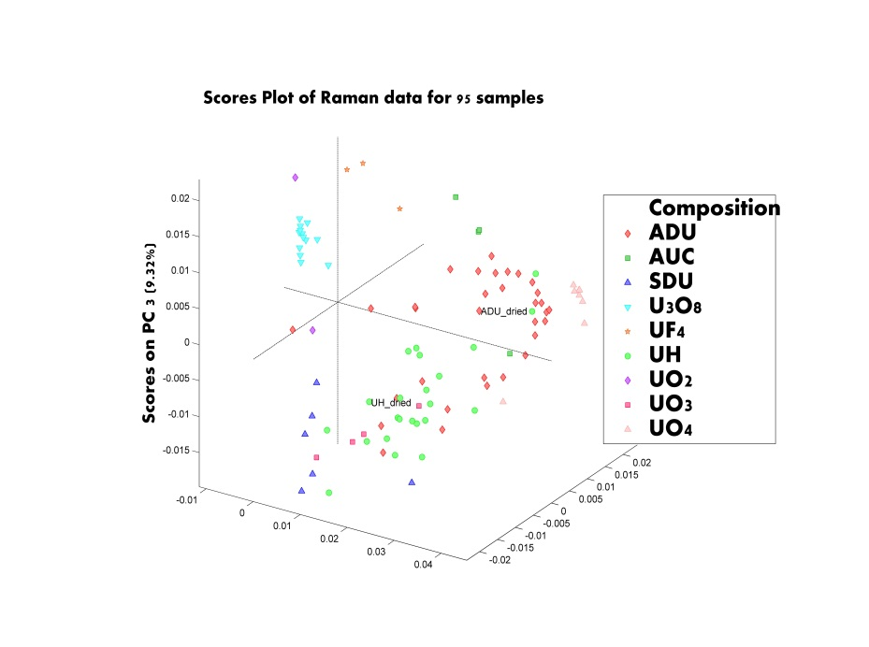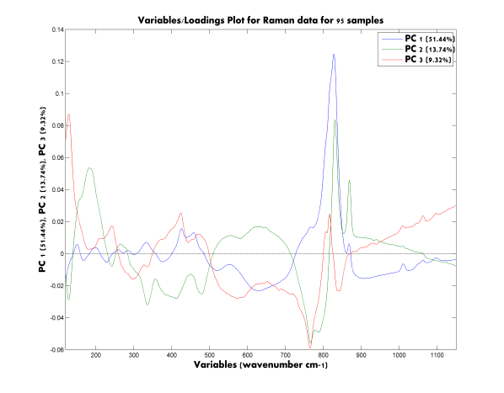

**Scores on PC 2 (13.74 %)**

**Scores on PC 1 (51.44 %)**

B

A

*Fig. 3: A-Score plot revealing clusters of compounds among 95 spectra (95 samples);*

*B- Loading plot of variables*



*Fig. 4: IR and Raman of El Dorado and Alligator samples (A & B); IR and Raman of Delft and North Span samples (C & D); IR and Raman of laboratory synthesized ADU and UO2(OH)2*samples (E & F)

A

B

Key

*Fig. 5: A- Morphology analysis: Score plot of 15 samples; B- Loadings plot of variables*

If this observation is true, it means that morphological parameters can be a potential signature for origin attribution. At the very least, in the scenario of an unknown UOC being analysed, for example, U3O8, its composition can be readily determined by rapid techniques like IR and/ or Raman spectroscopy and subsequently, its morphological parameters assessed complementarily for origin assessment.

Fig. 5 depicts the preliminary PCA graphs of 15 UOC samples (initial graph of 17 samples are not shown) after removing the outliers corresponding to the samples having big variances in the morphology characteristics from the others. There were in total, 30 parameters that were put into the data and subsequently 3 variables were removed to improve the data. Contrary to the observation of clusters among the compounds with similar composition for Raman data (Fig. 3), PCA of morphological data has the opposite effect. Each point on Fig 5A corresponds to a single image taken from the same preparation. As it can be observed, the points are located fairly close to each other with certainly some spread as well. In addition, it can be observed that two pairs of separate clusters of U3O8 and uranyl hydroxides from Key Lake/Rössing and Alligator/Belgian Congo respectively are located far from each other and this appeared to arise from different morphologies. It can also be observed that the use of 2 PCs could already explain 96 % of the variance in the dataset. The loading plot (Fig. 5B) reveals the relationship between 27 parameters (not all are visible) that are related to shape and shape of the particles. The above results are preliminary and needs to be tested with more samples and the repeatability/ reproducibility further assessed. However, it does demonstrate that the method of dispersing UOCs in this study, for SEM analysis appears to work.

# 4. Conclusions

It has been demonstrated that Raman spectroscopy is a useful tool for the measurement of UOCs despite the challenges of fluorescence and weaker Raman effects in comparison to IR. Impurities related to production processes were observed and identified and the exploitation of the complementary nature of both IR and Raman has led to considerable doubts of the true composition of ADUs/uranyl hydroxides especially for samples with mixed composition. This combination would be highly useful in the event of analysing unknown UOC. Raman spectrometers in the form of hand-held, bench-top and laboratory settings were compared, evaluated and the findings added values to the understanding of the differences in measuring different uranium compounds. Preliminary results of morphological data provide a promising outlook as a possible signature for origin assessment.

REFERENCES

1. Mayer, K., M. Wallenius, and I. Ray, *Nuclear forensics- a methodology providing clues on the origin of illicitly trafficked nuclear materials.* Analyst 130 (2005) 433-441.

2. Wallenius, M., K. Mayer, and I. Ray, *Nuclear forensic investigations: Two case studies.* Forensic Science International 156 (2006) 55-62.

3. Mayer, K., M. Wallenius, and T. Fanghänel, *Nuclear forensic science-From cradle to maturity.* Journal of Alloys and Compounds 444-445(2007) 50-56.

4. Wallenius, M., et al., *Nuclear forensic investigations with a focus on plutonium.* Journal of Alloys and Compounds, 444-445(2007) 57-62.

5. Varga, Z., et al., *Analysis of uranium ore concentrates for origin assessment.* Proc. Radiochim. Acta 1 (2011) 1-4.

6. Budinger, P.A., et al., *The Case of the Great Yellow Cake Caper.* Analytical Chemistry 52 (1980) 942A-948A.

7. Keegan, E., et al., *Nuclear forensic analysis of an unknown uranium ore concentrate sample seized in a criminal investigation in Australia.* Forensic Science International 240 (2014)111-121.

8. Hausen, D.M., *Characterizing and classifying uranium yellow cakes: A background.* JOM 50(1998) 45-47.

9. Preez, J.G.H.d., *A review of the industrial processes involving uranium- from the ore to the reactor.* Radiation Protection Dosimetry 26 (1989) 7-13.

10. Keegan, E., et al., *The provenance of Australian uranium ore concentrates by elemental and isotopic analysis.* Applied Geochemistry 23(2008) 765-777.

11. Brennecka, G.A., et al., *Natural variations in uranium isotope ratios of uranium ore concentrates: Understanding the 238U/235U fractionation mechanism.* Earth and Planetary Science Letters 291(2010) 228-233.

12. Varga, Z., et al., *Alternative method for the production date determination of impure uranium ore concentrate samples.* Journal of Radioanalytical and Nuclear Chemistry 290(2011) 485-492.

13. Švedkauskaite-LeGore, J., et al., *Investigation of the isotopic composition of lead and of trace elements concentrations in natural uranium materials as a signature in nuclear forensics*, in *Radiochimica Acta* 95 (2007) 601-605.

14. Varga, Z., et al., *Application of Lead and Strontium Isotope Ratio Measurements for the Origin Assessment of Uranium Ore Concentrates.* Analytical Chemistry 81 (2009) 8327-8334.

15. Švedkauskaitė-LeGore, J., et al., *Investigation of the sample characteristics needed for the determination of the origin of uranium-bearing materials.* Journal of Radioanalytical and Nuclear Chemistry 278(2008) 201-209.

16. Han, S.H. et al., *Measurement of the sulphur isotope ratio (34S/32S) in uranium ore concentrates (yellow cakes) for origin assessment.* Journal of Analytical Atomic Spectrometry 28(2013) 1919-1925.

17. Varga, Z., et al., *Determination of rare-earth elements in uranium-bearing materials by inductively coupled plasma mass spectrometry.* Talanta 80 (2010) 1744-1749.

18. Varga, Z., M. Wallenius, and K. Mayer, *Origin assessment of uranium ore concentrates based on their rare-earth elemental impurity pattern*, Radiochimica Acta98 (2010) 771-778.

19. Keegan, E., et al., *Attribution of uranium ore concentrates using elemental and anionic data.* Applied Geochemistry 27 (2012) 600-1609.

20. Kennedy, A.K., et al., *Non-volatile organic analysis of uranium ore concentrates.* Journal of Radioanalytical and Nuclear Chemistry 296 (2013) 817-821.

21. Badaut, V., M. Wallenius, and K. Mayer, *Anion analysis in uranium ore concentrates by ion chromatography.* Journal of Radioanalytical and Nuclear Chemistry 280 (2009) 57-61.

22. Varga, Z., et al., *Characterization and classification of uranium ore concentrates (yellow cakes) using infrared spectrometry.* Radiochim. Acta 99 (2011) 1-7.

23. Klunder, G.L., et al., *Application of Visible/Near-Infrared Reflectance Spectroscopy to Uranium Ore Concentrates for Nuclear Forensic Analysis and Attribution.* Applied Spectroscopy 67(2013) 1049-1056.

24. Plaue, J.W., et al., *Near infrared reflectance spectroscopy as a process signature in uranium oxides.* Journal of Radioanalytical and Nuclear Chemistry 296 (2013) 551-555.

25. Sirven, J.-B., et al., *Towards the determination of the geographical origin of yellow cake samples by laser-induced breakdown spectroscopy and chemometrics.* Journal of Analytical Atomic Spectrometry 24(2009) 451-459.

26. Lauwers, D., et al., *Characterisation of a portable Raman spectrometer for in situ analysis of art objects.* Spectrochimica Acta Part A: Molecular and Biomolecular Spectroscopy 118(2014) 294-301.

27. Colomban, P., *The on-site/remote Raman analysis with mobile instruments: a review of drawbacks and success in cultural heritage studies and other associated fields.* Journal of Raman Spectroscopy 43 (2012) 1529-1535.

28. Izake, E.L., *Forensic and homeland security applications of modern portable Raman spectroscopy.* Forensic Science International 202 (2010) 1-8.

29. Vítek, P., et al., *Evaluation of portable Raman spectrometer with 1064nm excitation for geological and forensic applications.* Spectrochimica Acta Part A: Molecular and Biomolecular Spectroscopy 86(2012) 320-327.

30. Mogilevsky, G., et al., *Raman Spectroscopy for Homeland Security Applications.* International Journal of Spectroscopy 2012 (2012) 1-12.

31. Siebert, F. and P. Hildebrandt, *Theory of Infrared Absorption and Raman Spectroscopy*, in *Vibrational Spectroscopy in Life Science*, Wiley-VCH Verlag GmbH & Co. KGaA (2008) 11-16.

32. Kim, K.-W., et al., *Effects of the different conditions of uranyl and hydrogen peroxide solutions on the behavior of the uranium peroxide precipitation.* Journal of Hazardous Materials 193 (2011) 52-58.

33. Rajagopal, S., T.P.S. Asari, and C.S.P. Iyer, *Particle size analysis of ammonium uranate prepared by conventional and homogenous methods of precipitation and their corresponding oxides.* Journal of Nuclear Materials 227 (1996) 300-303.

34. Eriksson, L., et al., *Multi- and Megavariate Data Analysis: Principles and Applications*. (2001) Umetrics Academy.

35. Ho, D.M.L., et al., *Applicability of Raman Spectroscopy as a Tool in Nuclear Forensics for Analysis of Uranium Ore Concentrates.* Radiochimica Acta 101(2013) 779-784.

36. Čejka, J., et al., *Raman spectroscopic study of the uranyl carbonate mineral čejkaite and its comparison with synthetic trigonal Na4[UO2(CO3)3].* Journal of Raman Spectroscopy 41(2010) 459-464.

37. Ho, D.M.L., et al., *The use of different dispersive Raman spectrometers for the analysis of uranium compounds.* Vibrational Spectroscopy 73 (2014) 102-110.

38. Berlizov, A., et al. *Assessing Capabilities of Handheld Raman Spectrometer FirstDefender RM for Complementary Access Applications*. in *Esarda 35th Annual Meeting*. (2013) Gruges, Belgium: European Safeguards Research and Development Association.

39. McCreery, R.L., *Raman Spectroscopy for Chemical Analysis*, ed. J.N. Winefordner. 2000, Canada: John Wiley and Sons, Inc

40. Degen, I.A. and G.A. Newman, *Raman spectra of inorganic ions.* Spectrochimica Acta 49A(1993) 859-887.

41. INTERNATIONAL ATOMIC EBERGY AGENCY,Uranium Extraction Technology, Vienna (1993).

42. Choi, C.S., et al., *The influence of AUC powder characteristics on UO2 pellets.* Journal of Nuclear Materials 153 (1988) 148-155.

1. a 785nm
2. 785nm
3. 752.5nm/647.1nm
4. If present at ppm levels