Identification of Unknown Nuclear Material

G. Melanofthalmidou, I. Lantzos, G. Nicolaou

Demokritus University of Thrace, Faculty of Engineering,
Department of Electrical and Computer Engineering,
Laboratory of Nuclear Technology,
Vas. Sofias 12, 67100 Xanthi, Greece

Abstract. An isotopic fingerprinting method has been demonstrated to discriminate spent fuels of the same origin. The method, demonstrated for conceptual and real spent fuels through their isotopic compositions obtained from simulations and Post-Irradiation Examinations, was sensitive enough to resolve spent fuels from: different reactor types, the same reactor but with different charge composition and of the same charge composition but from different reactors. Furthermore, the simulation of spent fuel composition when ²³⁶U is considered in fresh fuel has shown that the inclusion of ²³⁶U does not affect the clustering. Spent fuels have been resolved on the basis of U and Pu or only Pu isotopic composition.

- Introduction
Nuclear forensics is primarily concerned with the timely interception of nuclear material seized away from its designated areas. Identification of the provenance of this material could indicate the trafficking route from its diversion to its interception. Then, appropriate measures could be taken to combat possible future diversions of nuclear material away from designated areas. The objective of this work is to demonstrate a sensitive enough isotopic fingerprinting procedure cluster spent fuels of the same origin [1-6]. The term origin refers to the type of the reactor where the fuel was irradiated and the spent fuel final burnup at the end of irradiation, as well as the composition of the fuel charged to the reactor.

- Materials and methods
Spent fuel/reactor compositions should ideally cover all possible origins. The information can be drawn from Post-Irradiation Examination studies rendering isotopic composition information on the spent fuels. Such spent fuels from PWR and BWR nuclear reactors, which have been considered in this study, are shown in Table 1. The isotopic composition data, given at the End-of-Irradiation of these fuels, have been obtained from Post-Irradiation Examination and are available in the OECD/NEA SFCOMPO databank (http://www.oecdnea.org/sfcompo/Ver.2/Eng/index.html). Alternatively, in the absence of suitable experimental data on U and Pu compositions of spent nuclear fuels, these were simulated for the reactor-commercial nuclear fuel combinations considered (Table 2). These were simulated using the zero-Dimensional isotope generation and depletion code ORIGEN-2.2 [7]. The simulations performed were coupled with burnup-dependent cross-section libraries resembling, as closely as possible, the fuel type and neutron spectrum of irradiation. The composition of spent fuel depends on, and hence reflects, the charge composition of the fuel, its irradiation history and the neutron spectrum, hence carrying information uniquely related to the origin of the fuel.

The discrimination of the spent fuel is based on the use of the uranium and/or plutonium isotopic composition as the forensic signatures. The isotopic ratios considered were in the case of U and/or Pu: ²⁴²Pu/²⁴⁰Pu, ²³⁸Pu/Pu, ²³⁵U/²³⁸U, ²⁴⁰Pu/²³⁹Pu, ²⁴¹Pu/²⁴⁰Pu, ²³⁹Pu/²³⁵U, ²⁴²Pu/²³⁸U. Then, these ratios are compared, using the multivariate statistical technique of factor analysis, in order to cluster on a 3D representation, spent fuel of the same origin, through their similarities and differences in the isotopic compositions [1,2].

Table 1. PWR and BWR UO₂ fuels considered from the SFCOMPO data bank.
Reactor |  | Fresh fuel | Burnup range
name | type | (enrichment in ²³⁵U) | (GWd/tU)
Mihama-3 | PWR | 3.21% | 21 - 32.
Genkai-1 | PWR | 3.415% | 38.1, 38.7
Calvert Cliffs-1 | PWR | 2.453% | 31 - 46
Calvert Cliffs-1 | PWR | 2.72% | 26, 33.17
Calvert Cliffs-1 | PWR | 3.038% | 27 - 44
Monticello | BWR | 1.87% | 44 - 55
Monticello | BWR | 2.14% | 49 - 54
Gundremmingen | BWR | 2.53% | 21 - 25

Table 2. Simulated reactors, fuels and targeted burnup values.
Reactor | Fresh fuel | Burnup range  (GWd/tU)
PWR | 3 - 5% ²³⁵U | 40 - 55
PWR | 3.5% ²³⁵U + Gd  thermal MOX [95% U depleted, 5% Pu*]  MTR high enriched (90 % ²³⁵U)  MTR low enriched (25 % ²³⁵U) | 40 - 55  35 – 50  100 – 300  50 - 100
BWR | UO₂, 2.5 - 4% ²³⁵U  2.75% ²³⁵U + Gd | 20 - 40  20 - 40
CANDU-N | natural U | 4 - 10
CANDU-S | slightly enriched UO₂, 1 - 2% ²³⁵U | 7 - 30
LMFBR | MOX [74% U depleted, 25% Pu*] | 60 - 100
*isotopic vector of plutonium 238:239:240:241:242 was 1.4:55:25.3:13.3:5.

- Results
In Fig. 1a, the ten reactor-spent fuel combinations considered in Table 2, are clustered together on the basis of their similarities in their isotopic composition. Hence, they are clustered together according to the reactor type where the fuels ware irradiated and their charge composition. The fuels are clearly resolved between them. In order to improve the resolution of the graph displayed, the MTR fuels are removed, revealing clearly the U and UGd fuels from the PWR, BWR, LMFBR and CANDU reactors (Fig. 1b).

Spent fuel compositions at EOI were simulated, using the code ORIGEN-2, for PWR and BWR uranium fuels with different charge compositions of ²³⁵U (3% - 5%) and ²³⁶U (0 or 0.6%). The purpose of these simulations was to assess if the inclusion of ²³⁶U in the charge composition of the fresh fuels would affect the clustering of their corresponding spent fuels in the frame of isotopic fingerprinting. The 3D plots, on the basis of the U and Pu isotope ratios, are shown in Figs. 2a & 2b for the PWR and BWR cases given in Table 2 respectively. The inclusion of ²³⁶U does not affect the clustering.
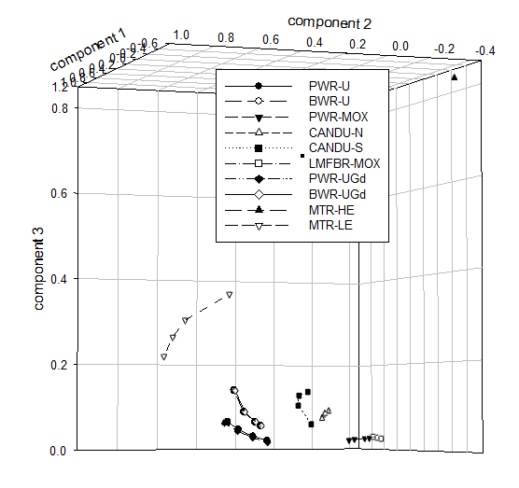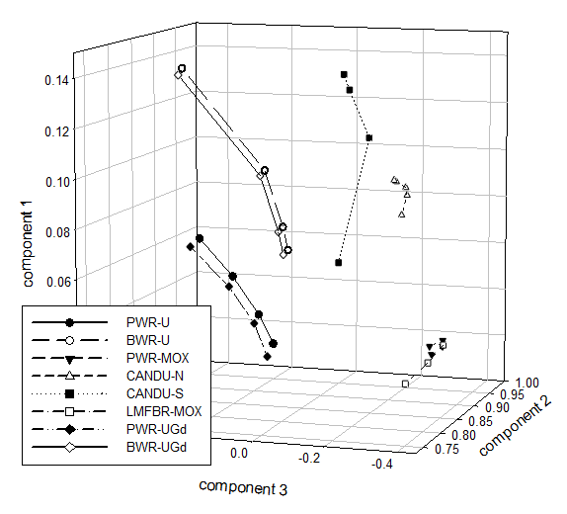
- (b)
FIG. 1. (a) The ten simulated spent fuels clustered on the basis of their U and Pu isotopic composition; (b) enhanced resolution of (a) with the MTR reactor cases removed.

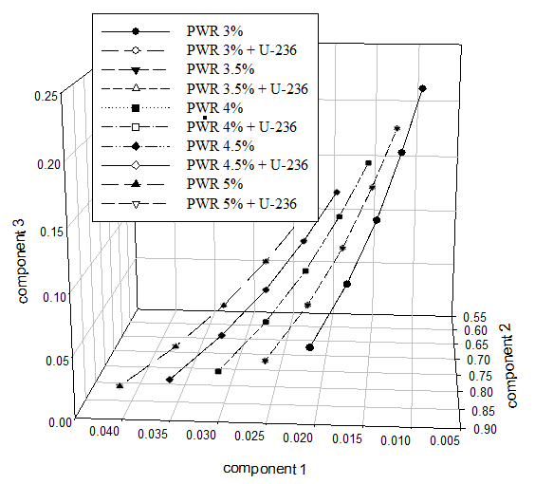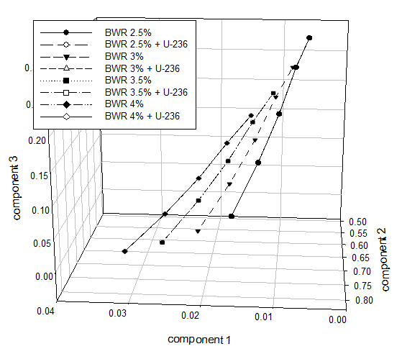
- (b)
FIG. 2. Spent fuel PWR (a) and BWR (b) cases with and without ²³⁶U at charge.

Sensitivity analysis has been carried out on the spent fuels from the SFCOMPO data bank given in Table 1, on the basis of their U and Pu isotopic compositions. The analysis has been carried out in the cases of PWR and BWR reactor/fuel combinations given in Table 1, differentiating well: (1) spent fuels from different reactor types (PWR and BWR), (2) spent fuels of different ²³⁵U enrichments from the same reactor; and (3) spent fuels of similar ²³⁵U enrichments from different reactors. Hence, the 3D plot on the mixing of PWR and BWR spent fuels from the SFCOMPO data bank shows a good discrimination between the fuels (Fig. 3a). Similarly, the sensitivity analysis carried out on the spent fuels from the SFCOMPO data bank (Table 1), on the basis of their Pu compositions has yielded a 3D plot on a mixing of the PWR and BWR spent fuels from the SFCOMPO data bank, showing a good discrimination between the fuels (Fig. 3b). The analysis again has differentiated well: (1) spent fuels from the different reactor types (PWR and BWR), (2) spent fuels of different ²³⁵U enrichments from the same reactor; and (3) spent fuels of similar ²³⁵U enrichments from different reactors.

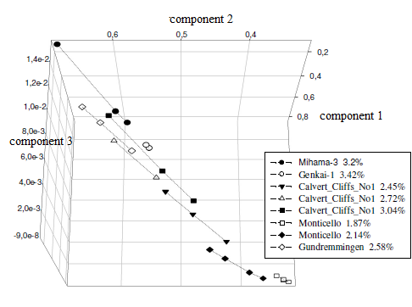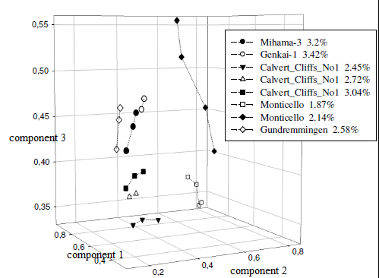
- (b)
FIG. 3. Spent fuel PWR and BWR cases clustered on the basis of U and Pu (a) and Pu (b) isotopic compositions

- Conclusions
The isotopic fingerprinting method was sensitive enough to resolve spent fuels from: different reactor types, the same reactor but with different charge composition and of the same charge composition but from different reactors. This is demonstrated for simulated isotopic compositions of conceptual fuels and also isotopic compositions from the Post-Irradiation Examination of real spent fuels. The simulation of spent fuel composition when ²³⁶U is considered in fresh fuel has resulted in the conclusion that the inclusion of ²³⁶U does not affect the clustering. Spent fuels have been resolved on the basis of U and Pu or only Pu isotopic composition.

Acknowledgements
The International Atomic Energy Agency is gratefully recognized for supporting financially this work under a CRP contract.

REFERENCES
- Nicolaou, G., Determination of the provenance of unknown irradiated nuclear fuel, J. Env. Radioact. 86 (2006) 313.
- Nicolaou, G., Provenance of unknown plutonium material. J. Env. Radioact. 99 (2008) 1708.
- Smith, D.K., et al., Documentation of a model action plan to deter illicit nuclear trafficking, J. Radioanal. Nucl. Chem. 276 (2008) 415.
- Robel, M., Kristo, M.J., Discrimination of source reactor type by multivariate statistical analysis of uranium and plutonium isotopic concentrations in unknown irradiated nuclear fuel material, J. Env. Radioact. 99 (2008) 1789.
- Kristo, M. J., Tumey, S. J., The state of nuclear forensics, Nucl. Instr. Meth. Phys. Res. 294 (2013) 656.
- Fedchenko, V., The Role of Nuclear Forensics in Nuclear Security, Strategic Analysis 38 (2014) 230.
- Croff, A. G., ORIGEN2: A versatile computer code for calculating the nuclide compositions and characteristics of nuclear materials, Nucl. Technol. 62 (1983) 335.

