Radiochronometry by Mass Spectrometry: Improving the Precision and Accuracy of Age-Dating for Nuclear Forensics
Ross Williamsª, Ian Hutcheon ª, Michael Kristo ª, Amy Gaffney ª, Gary Eppich ª, Steven Goldberg ^{b}, Jeffrey Morrison ^{c}, Richard Essex^{d}

ª Lawrence Livermore National Laboratory
Livermore, California USA

^{b} NNSA/NA-45
Washington DC USA

^{c} DNDO/DHS/NTNFC
Washington DC USA

^{d} New Brunswick Laboratory
Argonne, Illinois USA

Abstract. The model-date of a nuclear material is an important signature in a nuclear forensic investigation. Assuming the material is homogeneous, this parameter is fixed and exact, but it may or may not be the same as the purification date. The decay of a radioactive parent to a radioactive or stable daughter is the basis of the radiochronometers that record this model-date. If upon purification, only the parent isotope is present in the material, then the model-date will be the same as the purification date. Otherwise, if any of the daughter isotope remains upon purification, then the model-date will be further in the past. Regardless, it is a fixed and characteristic signature of the material, and will not vary as long as the system remains closed, i.e., there is no post-purification fractionation of parent and daughter. Measurements of the parent-daughter pairs ²³⁴U-²³⁰Th, ²³⁵U-²³¹Pa, ²⁴¹Pu-²⁴¹Am, ¹³⁷Cs-¹³⁷Ba and ⁹⁰Sr-(⁹⁰Y)-⁹⁰Zr can be used to determine the model-dates of a variety of nuclear materials. All of these pairs are measured more precisely by mass spectrometric methods, because, for a given sample, more atoms can be measured by mass spectrometry than decays measured by radiometric methods. State programs have recognized the importance of precise and accurate model-dates as a signature of a nuclear material, and efforts to improve precision and accuracy are being made internationally by national laboratories and institutions charged with developing standards and reference materials. Efforts within the United States include the production of new certified reference materials (U-Th and Cs-Ba radiochronometer standards) and spikes (²²⁹Th, ¹³⁴Ba, ²⁴³Am, ²³⁶Np, ²³³U), and the development of guidance on the interpretation of radiochronometry data. Enhancement of radiochronometric methods and the development of tools needed to improve accuracy and precision are supported collaboratively by the U.S. Department of Homeland Security, U.S. Department of Justice Federal Bureau of Investigation, the U.S. Department of Energy at DOE National Laboratories and U.S. national metrology institutes.
1. Introduction
With their groundbreaking paper, Edwards et al. [1] demonstrated that measurements by mass spectrometry can significantly improve the precision of age-dates of geologic materials using the ²³⁰Th-²³⁴U radiochronometer, relative to measurements of these isotopes by alpha spectrometry. Edwards’ work spurred a renaissance in ²³⁰Th-²³⁴U geochronology, and the development of mass spectrometry methods to measure ²³¹Pa [2,3]. This early work was done by thermal ionization mass spectrometry (TIMS). A good history of this field and an assessment of detection limits for different analytical methods are given in Goldstein and Stirling [4], and analytical improvements continue [5].
As defined in the International vocabulary of metrology [6], precision is “the closeness of agreement between indications or measured quantity values obtained by replicate measurements on the same or similar objects under specified conditions.” It is a measure of the repeatability and the reproducibility [6, 7] of a series of measurements. Within the isotope geochemistry community, internal precision is often used for repeatability, and external precision is used for reproducibility. No distinction is made between these here, and precision describes the closeness of agreement of different measurements. In mass spectrometry, precision is a principal contributor to the uncertainty of the measurement.
Although precise analyses of U and Th, which have relatively high first ionization energies can be made by TIMS (e.g., [8]), most laboratories have transitioned such analyses to inductively coupled plasma source mass spectrometers (ICPMS). Figure 1 illustrates why this is so. The precision calculated in Fig. 1 is based purely on counting statistics (N^{0.5}/N) and assumes the following: one milligram of natural uranium; both daughters were completely removed at time = 0; ICPMS efficiency (ions measured/atoms available) = 1%; TIMS efficiency = 0.1%; counting time = 1 week; and the precision on the measurement of the denominator (the U isotope) for all methods is 0.1%. This figure shows estimates of the theoretical precision for measurement of the daughter/parent ratio that may be obtained by mass spectrometry vs decay counting. This “best case” does not include uncertainties from spike calibration, instrument backgrounds, analytical blanks, instrumental bias or fractionation corrections, and sample/spike ratio measurement. Only when all of these uncertainties are propagated appropriately, can the accuracy of the measurement be assessed, assuming that a “conventional true value” or a best estimate of this can be assigned [7].
Adoption of mass spectrometry for nuclear forensic radiochronometry was somewhat delayed relative to the rapid advances in geochronology, but it was soon recognized that even recently purified uranium, if present in abundance, has easily measured daughter products [9 ,10]. For example, 1 mg of natural uranium, aged only 100 days, has as much ingrown ²³⁰Th as 1 g of average coral that is 100 years old.
2. Radiochronometry for Nuclear Forensics
Equation (1) describes the decay over time of a radioactive parent isotope (N₁) to a radioactive daughter (N₂), when there is no daughter present at the purification time, t(0). Time, t, is positive, measured from that purification time, and λ₁ and λ₂, are the decay constants of the parent and daughter, respectively.
$$N_{2}(t)=\frac{λ_{1}}{\left(λ_{2}-λ_{1}\right)}N_{1}\left(t\right)(1-e^{\left(λ_{1}-λ_{2}\right)t})$$ (1)
This can be solved for t, the age of the material.
$t=\frac{1}{(λ_{1}-λ_{2})}ln\left[1+\frac{R(λ_{1}-λ_{2} )}{λ_{1}}\right]$ (2)
In Eq (2), R is the daughter/parent atomic ratio as measured on, or corrected to, the reference date. The reference date is usually the date when the in-grown daughter was separated from the parent for analysis. Subtracting t from the reference date, one obtains the model-date, denoted this because of the model assumption that there was no daughter present at the purification time. Even if this assumption is not valid and some daughter remained at the purification time, for the relatively long-lived daughters, ²³⁰Th and ²³¹Pa, the model-date will be essentially constant. If the decay constants of the radionuclides are correct, the model-date determined today should be the same as will be determined ten years from now.
Other decay products of radioactive material that might be the subject of nuclear forensic investigation, e.g., ¹³⁷Cs and ⁹⁰Sr, are stable isotopes (¹³⁷Ba and ⁹⁰Zr , respectively) and must be measured by mass spectrometry (e.g., [11]). Equations (1) and (2) simplify.
$N_{2}(t)=N_{1}\left(t\right)(e^{λ_{1}t}-1)$ (3)
$t=\frac{1}{λ_{1}}ln\left[1+R\right]$ (4)
However, in this case, the model assumption that the parent was purified from its daughter completely at t(0) usually does not hold, and correction for this must be made in the numerator of R.
$t=\frac{1}{λ_{1}}ln\left[1+\frac{N_{2}\left(t\right)-N_{2}(0)}{N_{1}(t)}\right]$ (5)
In Eq (5), the number of daughter atoms present in the sample at the time of purification, N₂(0), must be known. For stable isotopes, this can usually be determined through the measurement of other stable isotopes of the daughter element, with the assumption of a normal isotopic abundance at that time.
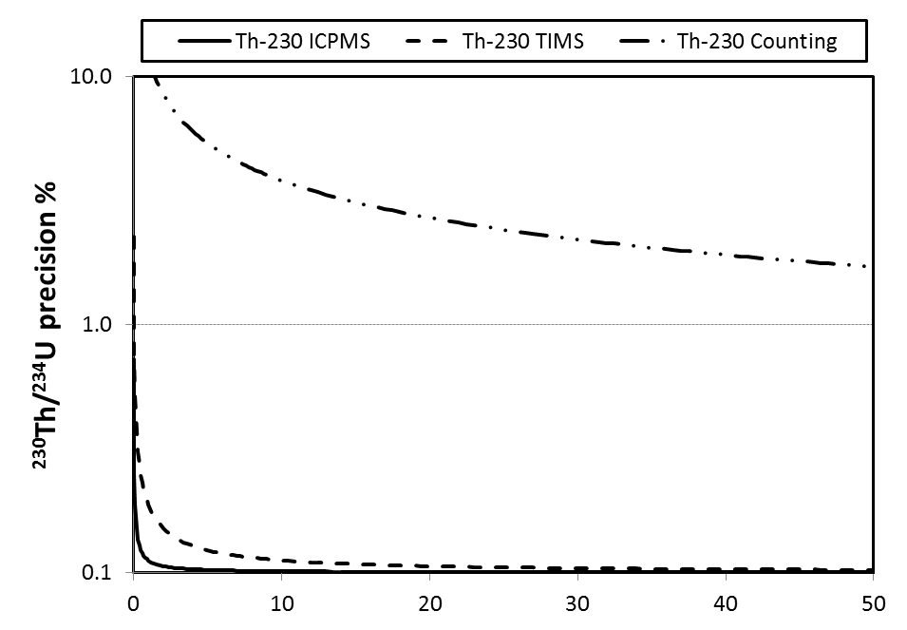
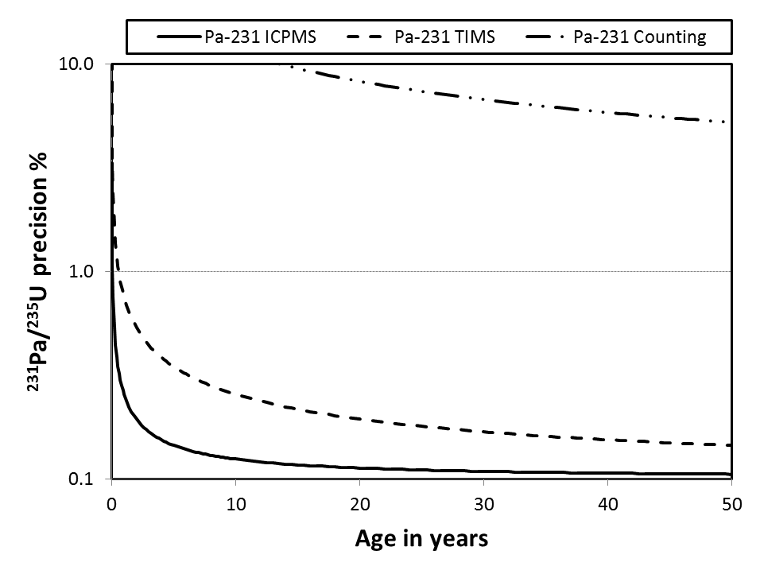
Fig. 1. Age dating 1 mg of natural uranium. Estimated precision, based on counting statistics, on the measurement of the daughter/parent ratios for different analytical methods. See text for assumptions.
3. Improving the Precision of Age-dating
The following is an excerpt from the introduction of NBS Special Publication 260-27, Standard Reference Materials: Uranium Isotopic Standard Reference Materials [12]:
The complete analytical method for any isotopic measurement is divisible into three broad areas; chemistry, instrumentation and mass spectrometric procedure. A prerequisite for an accurate isotopic measurement is an evaluation of the error contributions from these three sources. Since any of these can cause a serious loss of precision and accuracy, equal attention must be given to all phases of the measurement.
While it is possible to measure the daughter/parent ratio in a sample of uranium by ICPMS without chemical purification [9, 13], or even by laser ablation [13, 14], better precision is obtained by the isotope dilution method where the sample is spiked, parent and daughter are separated, and the analyses are made on purified samples [10, 13, 15, 16]. The following discussion assumes this method is used for analysis.
A measure of precision is the relative combined uncertainty of the mass spectrometric analysis. To reduce this uncertainty the following components must be optimized.
3.1 Measurement precision
Age-dating uranium-bearing materials using the isotope dilution method requires separate analyses of both the daughter and parent isotopes. ²²⁹Th and ²³³Pa are used as the spike isotopes for measurement of the daughters. Usually, many measurements of ²³⁰Th/²²⁹Th and ²³¹Pa/²³³Pa are made and the precision of these measurements is a component of the uncertainty on the calculated value for the daughter. This measurement precision depends on the stability of the ion beam and the stability of the instrument response. For TIMS, the beam stability depends on many factors: how much sample is present, its purity, how it is loaded, on what filament, and how the sample is heated to bring it to run conditions. For ICPMS, it depends on, inter alia, the sample introduction system, the gas pressures, the torch position tuning and the RF power supply. The electronics of modern mass spectrometers are remarkably stable, but providing a stable laboratory environment is also important.
If these isotope ratio measurements are made on a multi-collector instrument, it is possible to improve the precision by taking advantage of the simultaneous collection capability to reduce the effects of temporal fluctuations in beam intensity. If both ²³⁰Th and ²²⁹Th are measured on the same ion counting electron multiplier by peak-jumping, and the signal from ²³²Th is measured simultaneously on Faraday cups, then improved precision can be realized by calculation of the ratio according to Eq (6).
$\frac{{}_{ }^{230}{Th}}{{}_{ }^{229}{Th}}={\left(\frac{{}_{ }^{230}{Th}}{{}_{ }^{232}{Th} F1}\right)}_{I}{\left(\frac{{}_{ }^{232}{Th} F2}{{}_{ }^{229}{Th}}\right)}_{II}$ (6)
In this equation, I and II refer to the two static multi-collection cycles. The ²³²Th signal cancels, and the relative Faraday cross-calibration factor F2/F1 (the relative Faraday gain factor) is a well-known value that is determined independently. For a given sample, there may not be sufficient ²³²Th for a Faraday measurement. At LLNL, we have observed that by judicious spiking of the sample with ²³²Th, this analytical method can improve the precision.
Similarly, the parent uranium isotope can be measured more precisely with a multi-collector mass spectrometer. Several options are available depending on the level of ²³⁴U in the sample. For depleted U, U-Nat or LEU, the abundance of ²³⁴U may be insufficient for measurement on a Faraday cup. In this case, ²³⁴U is best measured on an ion-counter. The spike isotope for U analysis, ²³³U, can either be added in sufficient quantity to allow simultaneous collection of ²³³U, ²³⁵U and ²³⁸U on Faraday cups, or added to be sub-equal to ²³⁴U and measured on the same ion-counter, employing a peak-jumping strategy as described above for ²³⁰Th. More commonly, the isotopic composition of the uranium is measured un-spiked to determine the ²³⁴U abundance, and a separate spiked sample is used for the ²³⁴U concentration measurement, putting ²³³U on a Faraday collector [15]. For HEU, simultaneous multi-collection of all U isotopes on Faraday cups is often possible.
It is possible to improve precision with modern instruments by running at high beam intensities and putting ²³⁴U on a Faraday cup or through the use a double-spike, ²³³U-²³⁶U, for these analyses [5]. However, this could compromise detection limits for U-isotopes on an instrument dedicated to low-level analyses for nuclear forensics.
Repeatability is also, in no small way, dependent on the experience of the operator and how they tune the instrument and adjust the ion beam intensities. Following is another quotation from NBS Special Publication 260-27 [12]:
When the operator performs ideally and accomplishes his task, he is merely an appendage of the instrument and does not significantly increase the confidence limits of the measurement. When the operator performs poorly or unsatisfactorily, not only are the confidence limits expanded but the operator is likely to become the limiting factor in the measurement.
When an accomplished art teacher was asked by a student what they must do to learn to draw, the response was: “Well .…, you must draw—draw—draw.” Likewise, in order to make reproducible mass spectrometry analyses from session to session, you must analyze—analyze—analyze.
3.2 Spike calibration
The ²³³U, ²²⁹Th and ²³³Pa spikes used for measurement of the daughter and parent by isotope dilution mass spectrometry (IDMS) should be defined on a molar (or atomic) basis, e.g., atoms ²²⁹Th/g-spike. Of these, only ²³³U certified on a molar basis is available currently from the Institute for Reference Materials and Measurements (IRMM). At present, there is no ²²⁹Th reference material certified on a molar basis, although such standard is in the process of certification at New Brunswick Laboratory (NBL), and is discussed below. A ²²⁹Th radioactivity standard is available from the US National Institute of Standards and Technology (NIST), but for use directly as a spike, the half-life of ²²⁹Th must be used to calculate the spike concentration on a molar basis. Because the uncertainty on the half-life is large, propagation of the uncertainty to the molar concentration is undesirable. Further, there will never be a certified reference material for ²³³Pa due to its short half-life (27 days). This spike is produced either by milking from ²³⁷Np or by neutron irradiation of ²³²Th. It is purified and calibrated on an as-needed basis, and then, only has a useful lifetime of 3-4 months [3, 8, 16].
Nevertheless, most laboratories working in this field have ²³³U and ²²⁹Th spike materials, and the necessary quantity of ²³⁷Np to prepare a ²³³Pa spike. The in-house calibration of these spikes should be made versus standard reference materials that are certified on a molar basis. Such standards may be obtained for uranium and thorium.
A few notes of caution are in order regarding the calibration of ²²⁹Th spikes using ²³²Th standard solutions. The best standards available have expanded uncertainties (k=2) of approximately 0.4%, e.g. NIST SRM 3159. Some vendors of commercial Th solution standards quote expanded uncertainties (k=2) of 0.2% and claim traceability to NIST SRM 3159, which is impossible and erroneous. The NIST certificate clearly states: “When the traceable values of such standards are assigned using this SRM for calibration, the uncertainties assigned to those values must include the uncertainty of the certified value of this SRM, appropriately combined with the uncertainties of all calibration measurements.”
Further, NIST SRM 3159 is not currently available, and it was prepared from thorium oxide which can be problematic due to the highly hygroscopic nature of this material. Many laboratories prepare in-house ²³²Th solutions from thorium metal, which can be weighed accurately with smaller uncertainty and results in improved precision when used for spike calibration.
²³³Pa spike calibration is a special case. A ²³¹Pa standard reference material that can be used for this purpose does not exist at this time. Instead, each laboratory that has developed methods to measure ²³¹Pa by IDMS uses an idiosyncratic approach. However, all approaches have in common the use of ²³¹Pa derived by decay from a known quantity of ²³⁵U. Secular equilibrium “standards” are used most commonly [2, 3, 8, 16], but ²³¹Pa derived from a U-standard of known age is also useful [16]. Even more useful to the nuclear forensic community would be a ²³¹Pa standard reference material certified on a molar basis. This would be a difficult task for the standards institutes, but not an impossible one.
The precision of the analyses required for calibration is affected by the same issues of measurement precision discussed above. These analyses should be fully reproduced several times, that is, mixtures with different spike/standard ratios should be prepared and measured.
3.3 Bias corrections
Corrections for instrumental mass bias (ICPMS), or fractionation (TIMS) rely on stable and reproducible measurement conditions and on analyses of standard reference materials. Both the uncertainties on the isotopic composition of these standards, and the uncertainties of those analyses should be propagated appropriately in the bias corrections.
4. Improving Accuracy
To assess the accuracy of a radiochronometry measurement a best estimate of the true value must be established. Until recently, no certified reference materials for ²³⁰Th-²³⁴U age-dating were available, and accuracy could not be assessed. For an unknown sample subject to nuclear forensic examination this will probably always be the case, because “conventional true values” (see definition B.2.4 in [7]) are unlikely to be assigned. Even so, if a radiochronometry measurement of an unknown is associated with an accurate measurement of a standard with a reference value, a certain transfer of “accuracy” can be inferred, as well as traceability to a national standards base. More plainly, it’s just good quality control and quality assurance practice to analyze such samples.
For ²³⁰Th-²³⁴U age-dating, certified reference materials now exist. In the US, the Domestic Nuclear Detection Office of the Department of Homeland Security National Technical Nuclear Forensics Center (DNDO/DHS/NTNFC) supported the certification of model purification dates for two different uranium materials. The certifications were done by New Brunswick Laboratory and certificates have been issued for NBL CRM U630 and CRM 125-A. CRM U630 is HEU (63% ²³⁵U) U₃O₈ powder, and CRM 125-A is LEU (4% ²³⁵U) UO₂ pellet. These are good surrogates for the type of materials that are likely to be subject to nuclear forensic examination. As such, analyses of these materials by the same methods that are applied to unknowns are the best test of accuracy that can be made.
New radiochronometry standards have also been prepared by the European Commission’s Joint Research Center at the Institute for Transuranium Elements (JRC-ITU) and JRC-IRMM. The strategy for development of these standards was to purify uranium from its daughters, thus establishing a well-known purification date. One of these standards was distributed internationally to laboratories participating in the IRMM’s Regular European Interlaboratory Measurement Evaluation Program (REIMEP-22). More information on these standards will be presented at this conference.
To address the difficulties of ²²⁹Th spike calibrations that are necessary for the measurement of ²³⁰Th, mentioned above, the US Department of Energy’s New Brunswick Laboratory, in collaboration with NIST and supported by the DHS and DOE/NNSA, has developed a new ²²⁹Th standard that will be certified on a molar basis. This solution standard has been calibrated against a high-purity ²³²Th metal standard by mass spectrometry. The certification of this standard is in process.
Other radiochronometry standards and certified spikes for nuclear forensics are being developed in the US with the support of DNDO/DHS/NTNFC. Standards with certified model purification dates are in preparation for the ¹³⁷Cs-¹³⁷Ba radiochronometer, as is a ¹³⁴Ba enriched spike which will enable more precise measurements of ¹³⁷Ba. In collaboration with United Kingdom’s National Physical Laboratory, NIST and NBL are preparing a ²⁴³Am standard for ²⁴¹Am-²⁴¹Pu radiochronometry of samples containing plutonium. Recently, high-purity ²³³U has been recovered from storage at Oak Ridge National Laboratory and efforts are underway to prepare a new standard from this. Efforts are also underway to prepare a ²³⁶Np standard for analyses of ²³⁷Np.
Finally, a four-partner US interagency program has been established known as the Bulk Special Nuclear Materials Analysis Program (BSAP). The partners are the DHS/NTNFC, DOE/NNSA, DOE-IN, and the FBI. Each of these governmental agencies have an interest in the assurance of precise and accurate analyses of nuclear material, and recognize the unique information that radiochronometry of nuclear materials can provide. In support of this interest, a Radiochronometry Guidance document is in preparation for the BSAP which will define terms, summarize state-of-the-art analytical practices, and provide guidelines for the calculation, reporting and interpretation of radiochronometry results.
5. Conclusions
In a nuclear forensic investigation, it is recognized that the model-date of uranium and other nuclear materials is an important signature. This signature is very likely unique and can allow constraints to be placed on the time the material was last purified chemically. Analyses by mass spectrometry provide improved precision on model-dates, and small date/time differences can be seen between materials that may be identical in other respects.
Improving the measurement precision involves improvements to all aspects of the analyses to obtain greater signal/noise and smaller uncertainties. These include improvements to the purification methods used to prepare samples for analysis (e.g., lower blank, with high recovery and purity to eliminate isobaric interferences), to the instrumental analytical methods (the way that samples are introduced or loaded, and the data collection schemes), and to the instruments themselves. Improved precision on model-dates will result from improved determinations of radionuclide decay constants [17], and through the use of standards and spikes with smaller uncertainties.
The accuracy of a radiochronometry model-date, for both radioactive and stable daughter products can only be evaluated through analyses of standard reference materials. A few standards exist, and others are in development, but different materials for a number of radiochronometers are needed.

This work was performed under the auspices of the U.S. Department of Energy by Lawrence Livermore National Laboratory under Contract DE-AC52-07NA27344.
LLNL-CONF-655059

REFERENCES
[1] EDWARDS, R.L., CHEN, J.H., WASSERBURG, G.J., ²³⁸U-²³⁴U-²³⁰Th-²³²Th systematics and the precise measurement of time over the past 500,000 years, Earth Planet. Sci. Lett. 81 (1987) 175-192.
[2] GOLDSTEIN, S.J., MURRELL, M.T., WILLIAMS, R.W., ²³¹Pa and ²³⁰Th chronology of mid-ocean ridge basalts, Earth Planet. Sci. Lett. 115 (1993) 151-159.
[3] PICKETT, D.A., MURRELL, M.T., WILLIAMS, R.W., Determination of femtogram quantities of protactinium in geologic samples by thermal ionization mass spectrometry, Anal. Chem. 66 (1994) 1044-1049.
[4] GOLDSTEIN, S.J., STIRLING, C.H., Techniques for measuring uranium-series nuclides: 1992-2002, Rev. Mineralogy & Geochemistry 52 (2003) 23-57.
[5] CHENG, H. et al., Improvements in ²³⁰Th dating, ²³⁰Th and ²³⁴U half-life values, and U-Th isotopic measurements by multi-collector inductively coupled plasma mass spectrometry, Earth Planet. Sci. Lett. 371-372 (2013) 82-91.
[6] International vocabulary of metrology – Basic and general concepts and associated terms (VIM) 3rd edition, JCGM 200:2012, 2008 version with minor corrections, pp 91.
[7] Evaluation of measurement data− Guide to the expression of uncertainty in measurement, JCGM 100:2008, GUM 1995 with minor corrections, pp 120.
[8] SHEN, C-C. et al., Measurement of attogram quantities of ²³¹Pa in dissolved and particulate fractions of seawater by isotope dilution thermal ionization mass spectrometry, Anal. Chem. 75 (2003) 1075-1079.
[9] WALLENIUS, M., MORGENSTERN, A., APODTOLIDIS, C., MAYER, K., Determination of the age of highly enriched uranium, Anal. Bioanal. Chem. 374 (2002) 379-384, DOI 10.1007/s00216-002-1555-9.
[10] LAMONT, S. P., HALL, G., Uranium age determination by measuring the ²³⁰Th/²³⁴U ratio, J. Radioanal. Nucl. Chem. 264 (2005) 423-427.
[11] STEEB, J.L. et al., Application of mass spectrometric isotope dilution methodology for ⁹⁰Sr age-dating with measurements by thermal-ionization and inductively coupled-plasma mass spectrometry, J. Anal. At. Spectrom. 28 (2013) 1493-1507, DOI: 10.1039/c3ja50136a.
[12] GARNER, E.L., MACHLAN, L.A., SHIELDS, W.R., Uranium Isotopic Standard Reference Materials, NBS Special Publication 260-27 (1971) pp 162.
[13] VARGA, Z., SURANYI, G., Production date determination of uranium-oxide materials by inductively coupled plasma mass spectrometry, Anal. Chim. Acta 599 (2007) 16-23.
[14] VARGA, Z., WALLENIUS, M., MAYER, K., Age determination of uranium samples by inductively coupled mass spectrometry using direct measurement and spectral deconvolution, J. Anal. At. Spectrom. 25 (2010) 1789-1984, DOI: 10.1039/c0ja00048e.
[15] WILLIAMS, R.W., GAFFNEY, A.M., ²³⁰Th-²³⁴U model ages of some uranium standard reference materials, Proc. Radiochim. Acta 1 (2011) 31-35, DOI 10.1524/rcpr.2011.0005.
[16] EPPICH, G.R., WILLIAMS, R.W., GAFFNEY, A.M., SCHORZMAN, K.C., ²³⁵U–²³¹Pa age dating of uranium materials for nuclear forensic investigations, J. Anal. At. Spectrom. 28 (2013) 666-674, DOI: 10.1039/C3JA50041A.
[17] POMME, S., JEROME, S.M., VENCHIARUTTI, C., Uncertainty propagation in nuclear forensics, App. Radiation and Isotopes, 89 (2014) 58-64.

