|  |  |  |
| --- | --- | --- |
| Uranium age dating by gamma spectrometry | | |
|  | | |
|  |  | C. T. Nguyen, J. Zsigrai[1]†, L. Lakosi |
|  |  | Centre for Energy Research, Hungarian Academy of Sciences, Budapest, Hungary |

**Abstract.** For determining the origin of nuclear material out of regulatory control, information on the age of the material seems relevant. A new method for uranium age dating was developed by using high resolution gamma-spectrometry (HRGS) based on determining the daughter/parent activity ratio 214Bi/234U by directly measuring the count rates of the relevant gamma peaks of 214Bi and 234U. The method is non-destructive and does not require the use of reference materials of known ages. It works well first of all for high-enriched and aged material. The least enriched uranium sample dated by HRGS was a 5% enriched oxide material, the age of which was determined as 54 ± 7 y. The youngest sample was a 6.7 ± 0.7 y old metallic U of 90.8% enrichment. In order to extend capabilities and improve sensitivity and accuracy of the method, a higher efficiency (well-type) detector was provided.

1. Introduction

Centre for Energy Research, also as the legal successor of the late Institute of Isotopes (IKI), Budapest, has a comprehensive nuclear forensics analytical capability enabling Hungarian authorities to provide information on the origin and history of nuclear and other radioactive material outside of regulatory control and ensuring effective national and international response. The institute is officially engaged in determining the characteristics of material such as physical form, chemical composition, isotopic composition, nuclear material mass, impurities, date of production, identifying reprocessed uranium, etc. Both NDA and destructive (DA) methods are in use and developed for examining such characteristics. U-bearing materials assayed by NDA and DA methods in Hungary include: Powder (oxide and other U compounds); Certified DU, NU, LEU, HEU reference materials; Seized DU, NU, LEU oxide reactor fuel pellets of CANDU, RBMK, VVER-440, VVER-1000 types; Seized fuel rods (broken), VVR-SM research reactor fuel assemblies, EK-10 fuel rods, Sealed sources; U-ore. Oxide and metallic HEU samples – as unknown materials - provided by the Nuclear Forensics International Technical Working Group (ITWG) for launching Round Robin (RR) exercises are also included.

For identifying the provenance of unknown material, the age of a sample has a unique significance in the nuclear forensic analysis. Although usually provide more sensitive analysis with lower detection limits, destructive (DA) methods (mass spectrometry, α-spectrometry) have certain drawbacks in such activities/applications, namely lack of promptness, sample preparation, need for preservation of evidence. They cannot be used e.g. for items which cannot be dismantled. Among other non-destructive assay (NDA) methods, high resolution gamma-spectrometry (HRGS) has long been routinely used for quantitative assay of U-bearing nuclear materials. No special sample preparation is necessary, whereas assay of some material as a whole is possible, without sampling (e. g. reactor fuel rods). Preservation of evidence can easily be ensured. This is essential for nuclear forensic application, where the materials are evidences in juristic procedure. At the same time destructive methods preserve their traditional role, and combination of different analytical techniques increase the confidence in the results and can help to further narrow down the set of possible origins and intended uses of the investigated materials. In the last years NDA methods used in the institute were complemented by destructive methods as high-resolution mass-spectrometry and scanning electron microscopy (SEM/EDS).

For categorization and characterization, including determination of the origin of nuclear material out of regulatory control, information on the age of the material seems relevant. The daughter/parent ratio as a function of decay time is widely used for determining the age of radioactive samples. The age of a sample is the time elapsed from the last chemical separation of the material. In the case of uranium, age dating is somewhat difficult because the relevant isotopes (234U, 235U, 238U) have very long half-lives, so only small amounts of daughter nuclides could grow in. In contrast, the age of nuclear materials is, at most, merely a few decades, which is very short compared to the long half-lives of the parent isotopes. Therefore, one would expect that the daughter nuclides could only be quantified after destructive chemical separation, followed by mass-spectrometry or alpha-spectrometry. However, it has been demonstrated that the daughter/parent activity ratio for 214Bi/234U can be obtained by directly measuring the count rates of the relevant gamma-ray peaks of 214Bi and 234U by low background HRGS. A new method for uranium age dating was developed by using HRGS based on determining the daughter/parent activity ratio ABi214/AU234 [1, 2]. The method is non-destructive and does not require the use of reference materials of known ages.

The daughter/parent ratio is directly related to the peak ratio technique used widely in gamma spectrometry. By relying on peak ratios, there is no need to know absolute detection efficiencies. Allowing the activity ratio to be determined without use of standards or without determination of geometry-dependent calibration constants, the relative efficiency (intrinsic) calibration method is based on the use of a relative efficiency curve as a function of energy [2, 3]. It is determined from the same spectrum as the measured activity ratios. The analyst determines several gamma intensities from individual U-isotopes, and normalizes the data to a common (relative) efficiency curve which, at the same time, accounts for the attenuation of different energy gamma rays in the absorbers and in the sample as well. The peak ratio method using intrinsic calibration e.g. for U isotope abundance measurements as well as a relative method for mass determination of nuclear materials in the form of pellets and powder are used, based on a standard U calibration set (certified reference material), applying attenuation correction. Among practical applications, we assayed materials whose integrity is to be maintained, thus destructive methods are to be avoided. Such dismountable U-bearing materials like fuel assemblies used in research reactor or a fission ionization chamber containing 235U above 90% abundance cannot even be analyzed by destructive methods at all. These objects may occur in illicit trafficking, too.

1. Principle of uranium age dating

Upon examining illicit nuclear materials, 234Th (24 d half-life) is practically in radioactive equilibrium with its parent 238U in the occurring samples. Thus, determination of the daughter/parent ratio 230Th/234U is the first candidate for age dating of U samples. Indeed, determination of this ratio is the basis of mass spectrometric U dating [4]. Since 230Th does not, however, emit abundant gamma rays, a different daughter isotope was needed to be found for the use of HRGS. Next member of the 234U decay series is 226Ra, without intense gamma emission again, but its short half-life descendants have useful gamma lines, especially 214Bi, whose the 609.3 keV line was appropriate to measure.

The build-up of 230Th after purification of the material and its mass spectroscopic analysis is a first order basis for U age dating. Using the law of radioactive decay, the atom ratio 230Th/234U at time *T* after production of the sample can be calculated with a good approximation as

, (1)

where *λU234* is the decay constant of 234U. The atom ratios *Ni* are expressed in terms of mass *m* and molar mass *M* values. Then the age *T* can be calculated from mass spectrometric measurements.

Considering gamma spectrometry, whereas 234U has well measurable gamma rays, 230Th decays further to 226Ra, which in turn decays to 214Bi through 3 short-lived isotopes. 214Bi has several measurable gamma lines, which may be used for estimating its activity. The time needed for secular equilibrium between 226Ra and 214Bi is about 2 weeks, so it can be assumed that the activities of 226Ra and 214Bi are equal at the time of the measurement. Hence, the activity ratio 214Bi/234U at time *T* after purification/enrichment can be calculated with a good approximation as



, (2)

where the *λi*-s are the respective decay constants. 234U can be detected by its 120.9 keV gamma line. Calculated atom ratio 230Th/234U and the activity ratio 214Bi/234U are plotted as a function of the elapsed time *T* in Fig. 1. The upper curve showing the atom ratio 230Th/234U as a function of the age is relevant for mass spectrometry, whereas the lower one showing the activity ratio 226Ra/234U = 214Bi/234U refers to gamma spectrometric age dating.

Bi-Th-U234-T

*FIG. 1. Atom ratio 230Th/234U and activity ratio 214Bi/234U as functions of the U age*

For determining 214Bi activity, the 609.3 keV gamma line (along with 238U peaks) was recorded by a 150 cm3 coaxial HPGe spectrometer in a low-background iron chamber with a wall thickness of 20 cm. The activity of 234U was measured by observing its gamma peak at 120.9 keV (along with 235U peaks) by planar HPGe detectors under normal laboratory conditions. U gamma spectra are routinely analyzed in the 0-300 keV region by the module MGAU of the advanced Multi-Group-Analysis (MGA) computer code (upgraded, see [5] and references therein), using intrinsic calibration [3], which provides reliable results in the range of 0.05 to 95% 235U abundances. In addition, we developed “manual”procedures as well.

The activity ratio *ABi214/AU234* can be determined in several ways from the gamma spectra of a sample. A reliable method uses a reference material of approximately like age, enrichment, and form, as the investigated sample. Another approach does not require reference materials but uses the absolute efficiency of the detector determined by “point-like” standard sources [1]. That is, the activities of 214Bi and 234U in the sample are measured in an efficiency-calibrated geometry. In an alternate approach, a relative efficiency (intrinsic) calibration is used to determine the activity ratio *ABi214/AU234*, without the use of any standard or reference materials [2]. The method is based on the use of a relative efficiency curve as a function of energy. It is determined from the same spectrum as the measured intensities. The activity ratio can be obtained from the measured intensity ratio, the relative efficiencies taken at the corresponding energies, and from the values of the emission probabilities taken from literature. It means that one determines several gamma intensities from individual U-isotopes, and normalizes the data to a common (relative) efficiency curve which, at the same time, accounts for the attenuation of different energy gamma rays in the absorbers and in the sample as well, provided that a sufficient amount of the investigated material is available (depending on detector efficiency). The relative efficiency calibration is applicable to samples of arbitrary shape and chemical form (e.g. fuel rods).

As a matter of fact, 234U undergoes enrichment/depletion in parallel with 235U. Hence, for lower 235U abundances, the amount of 234U (and therefore of 214Bi) is lower as well, so the corresponding activity is more difficult to measure and the uncertainty caused by the variation of the natural background becomes greater. In addition, a Compton background caused by the peaks of 238U daughters is also present in the spectrum, hindering the evaluation of the 214Bi peaks. A lower limit on the 235U abundance of the material exists that allows determining the age by gamma-spectrometry, depending on the amount and the age of the material, detector efficiency and background level. Using our 150 cm3 coaxial Ge detector in a low-background iron chamber, the age of 5 g of uranium oxide powder of natural isotopic composition could only be measured, if it were about 30 years old, whereas for 90 % enriched HEU the lower bound is around 2 years.

1. Applications and results

The method was discovered and first applied on the occasion of an inter-laboratory comparison organized by ITWG in 2001 (Round Robin Exercise), where a 90 % enriched oxide sample was assayed. Our age result obtained by HRGS was consistent with those of other labs measured by mass spectrometry (Table 1).

**Table I.** Measured ages of RR 2001 samples

|  |  |
| --- | --- |
| ***HRGS*** | ***MS, other labs*** |
| 23 ± 3y | 22.4 ± 0.2y  22.4 ± 1.2y  23.5 ± 0.5y |

The method was tested with 90 % and 36 % 235U-containing samples of ages known as > 41y from records. The measured age of the sample 90% was 43 **±** 2y; that of the sample 36% was found 43 **±** 5y by relative efficiency calibration and 45**±** 4y by determining absolute detector efficiency.

Applications extended to dating low-, medium-, and high-enriched seized and reference samples, HEU oxide powder and metal lumps, HEU and LEU reactor fuel rods, LEU pellet and powder, in the enrichment range of 4.4 to 90%.

Results of a certified reference material (CRM) of 10% 235U content, measured in ITU, Karlsruhe, and in IKI, Budapest, agree well with each other and are consistent with certificate. The result of a CRM of 5 % enrichment was consistent with the certificate. Result of a LEU pellet of 4.4% 235U content was confirmed by LA-ICP-MS.

Research reactor fuel rods (type VVR-SM), enriched to 36%, of known ages as 39, 38, 21, and 6 y were dated as 45±4, 40±3, 29±4, and < 13 y, respectively. A 10% enriched EK-10 fuel rod of age either 39 or 47 y according to records was dated 47±4 y old.

Because of the low activity of 214B in young as well as LEU material, the fluctuation of the natural background due to atmospheric 222Rn, precursor of 214Bi, has a substantial influence on the result. In order to reduce this effect, the sample to be measured was tightly surrounded by polystyrene foam in the iron chamber. In addition, N2 vapour was directed around the sample through a pipe from the cryostat of the detector to drive out the air from its surroundings with the assumption that any possible radon activity in liquid nitrogen has already decayed by the time of the measurement. Systematic control of the 609 keV peak in the background spectrum confirmed this expectation when performing measurements in the iron chamber.

In Table II age data measured for two U metal samples enriched to around 90% 235U, distributed by the ITWG for the following Round Robin Exercise (2010) are shown. One can see that results are consistent and the deviation is systematic between the ages of the two samples.

**Table II**. Age dating results of the HEU metal RR samples

|  |  |  |
| --- | --- | --- |
| ***RR 2010*** | ***HRGS*** | ***Supplier*** |
| ***Sample A*** | 7.3 ± 0.7y | 6.88y |
| 7.0 ±0. 35y |
| ***Sample B*** | 6.7 ± 0.7y | 6.25y |

The second result of sample *A* was measured by a 110 cm3 GCW2023 well-type detector (see the spectrum in Fig. 2 below).

Due to the Compton tail of high energy 238U and 208Tl lines, the sensitivity of detecting the 609 keV 214Bi line decreases toward low enrichment. This is illustrated in Fig. 2, where relevant spectrum details of U-samples enriched to 4.5 % and 92 % taken by the 110 cm3 volume well-type HPGe detector, are shown. The absolute efficiency for detecting the 609 keV line was 1.25 %. Whereas this peak is visible and well evaluable in the HEU spectrum – see the second result of sample *A* in Table II above, – it is suppressed by the intense Compton continuum in the LEU spectrum so that age determination was not possible.

The least enriched uranium dated in our lab by HRGS was an oxide material enriched to 5%; the age of which was found to be 54 ± 7 years. The youngest sample was a 6.7 ± 0.7 year old metallic U of 90.8% enrichment.

The sensitivity and the range of applicability of the method may be improved by using a detector of higher efficiency, e.g. a bigger well-type Ge detector. By a 300 cm3 well-type detector, the sensitivity of the method could be improved so that the lower bound of the method would be around 1 year for 90% enriched uranium and about 15 years for natural uranium, under the present background conditions.

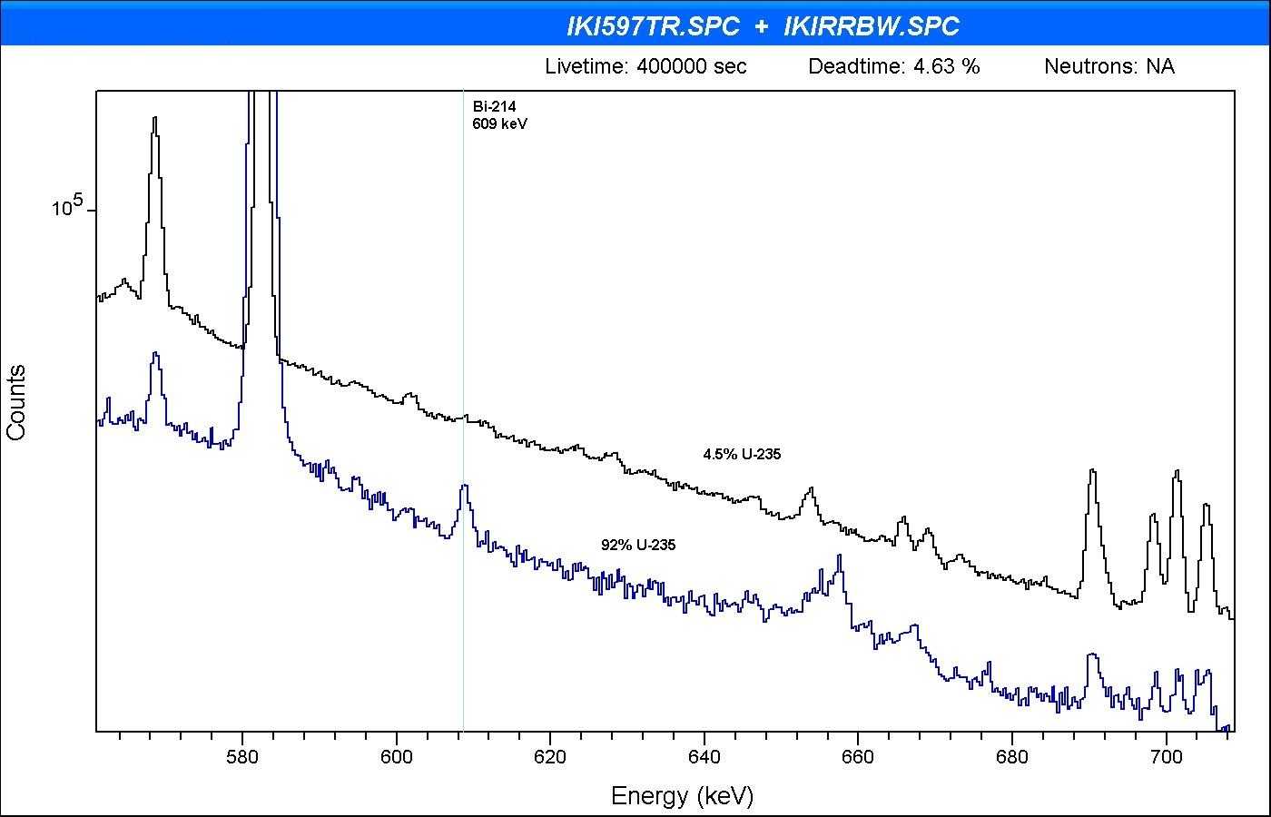

*FIG. 2. LEU and HEU spectra, taken by a 110 cm3 well Ge detector type GCW2023*

Summarized age results obtained in the laboratory, plotted against the measured activity ratios *ABi214/AU234* are shown in Fig. 3 below.



*FIG. 3. U age determinations by gamma spectrometry at our laboratory so far*

1. Assessed lower limits of age dating

The Compton tail of 238U lines (and some time of 208Tl peaks coming from the decay of 232U being present in reprocessed material) decreases sensitivity of detecting the 609 keV line of 214Bi toward low enrichment, thereby determining lower limits of age dating, depending on the enrichment. A model calculation was carried out for a series of Ge detectors, taking into account detector parameters, including our present big coaxial detector and various well-type crystals, see the list below.

Detector types:

* Coax. Type PIGC 3520, 150 cm3 (34% rel. eff.), sample on detector cap
* Well type GCV2023, 110 cm3 (20% rel. eff.)
* Well type GCV4023, 200 cm3 (40% rel. eff.)
* Well type GCV5023, 260 cm3 (50% rel. eff.)
* Well type GCV6023, 300 cm3 (60% rel. eff.)
* Well type GCV6023*, 300 cm3 (60% rel. eff.), small mass sample (1g), placed on bottom of the well



*FIG. 4. The specific activity of 226Ra (214Bi) as a function of the age of U samples enriched to 1 – 90 %*

Curves represented in the figure by the point series denote sensitivities limited by the Compton tail for individual detectors, for sample amounts of 5 g and 3 d acquisition times (except for the lowest curve relating to sample mass of 1g placed on bottom of the well). The method is only applicable for continuous lines corresponding to various enrichments above the point series in the figure, pertaining to individual detector types.

Detectability of the 609 peak is limited, in addition, by the natural background as well.

Assessed lower detection limits of specific 214Bi activities for the detectors as function of 235U enrichment are shown in Table III and Fig. 5. It is seen that lower age limits decrease with increasing enrichment and detector efficiency.

**Table III. Assessment of lower limit of age dating as a function of enrichment for various detectors**

|  |  |  |  |  |  |  |  |  |  |  |  |  |
| --- | --- | --- | --- | --- | --- | --- | --- | --- | --- | --- | --- | --- |
|  | **235U enr.,%** | **1** | **3** | **5** | | **10** | | **30** | | **50** | **70** | **90** |
| **Minimum age, y** | | | | | | | | | | |
| **Ge detector** | **PIGC3520** | 24 | 14 | 10 | 7 | | 4 | | 3 | | 2.2 | 1.9 |
| **CGW2023** | 22 | 12 | 9 | 6.5 | | 3.5 | | 2.7 | | 2 | 1.8 |
| **CGW4023** | 19 | 11 | 8.5 | 5.7 | | 3.2 | | 2.4 | | 1.9 | 1.6 |
| **CGW5023** | 18 | 10 | 8 | 5.2 | | 3 | | 2.2 | | 1.8 | 1.5 |
| **CGW6023** | 17 | 9.5 | 7 | 5 | | 2.8 | | 2 | | 1.5 | 1.3 |
| **1g, 10%, CGW6023\*** | 12 | 7 | 5.2 | 3.7 | | 2 | | 1.5 | | 1.2 | 1 |

*Small mass (1g) sample is placed on the bottom of the well

Tabulated data are represeted also in graphical form in Fig. 5 below.

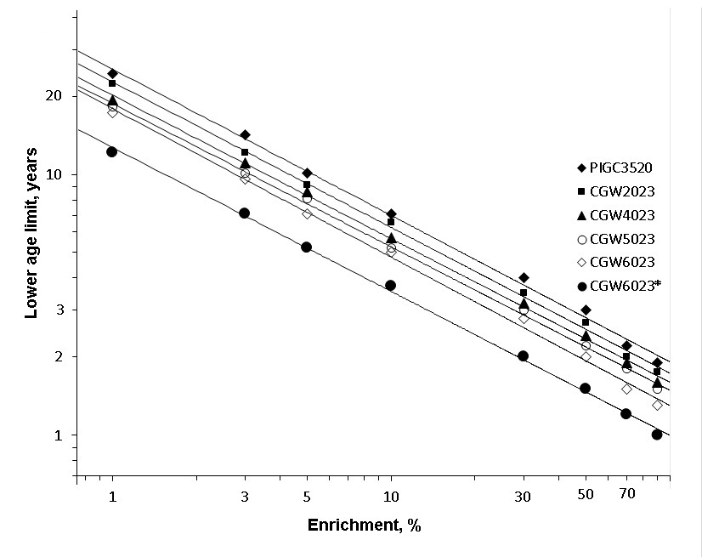

*FIG. 5. Lower limit of age dating as a function of enrichment for various detector types*

Note that ICP-MS is capable of dating NU of 0.2 year old at least; but dating of even younger LEU and HEU materials is also possible of course (it depends also on the amount of the material). By laser ablation (LA-ICP-MS) it is not as sensitive as the destructive method, but it may be the only applicable method in certain cases.

1. Summary

* Advantages of gamma-spectrometry:
  + - non-destructive
    - no sample preparation
    - preservation of evidence
    - relatively simple equipment
    - provides a faster result in general
    - no dismantling (e.g. fuel)
    - suitable for in-field analysis
* HRGS for uranium age dating:
  + - 13 samples of various ages and enrichments were dated so far
    - The youngest: age 6.7±0.7 yr, E=91%
    - The less enriched: E=4.4 %, age of 54±7 y
    - With the new well detector, for 5gU, the lowest age limit expected to ~6 y for samples of E=5%, whereas to ~1 y for samples of E=90 %,
    - for NU it is expected to ~15 y.
* “Difficult” samples: low-enriched young samples
* Further development:
  + higher efficiency detector
  + suppression of background fluctuations

The following observations can finally be concluded:

* Results from HRGS analysis are in sound agreement with mass spectrometric measurements.
* Two methods were developed that do not require reference material of known age.
  + Relative efficiency calibration: in arbitrary measurement geometry, chemical form.
* The accuracy of age dating measurements by HRGS is close to that of age dating by of mass-spectrometry in certain cases (aged material, high enrichment). The “difficult” samples are the same as in the case of mass spectrometry: low-enriched and “young” uranium.
* HRGS provides a faster result in general in age dating of HEU, and is non-destructive.
* Although DA methods usually provide more sensitive analysis with lower detection limits, they cannot be used for the characterization of items which cannot be dismantled.
* Combination of different analytical techniques increases the confidence in the results and can help to further narrow down the set of possible origins and intended uses of the investigated materials.
* Better detectors are needed to improve accuracy.
* Age dating by HRGS is suitable for in-field analysis.

It can be summarized that gamma-spectrometric age dating of uranium is, within the described limits, a reliable tool for determining the age of uranium samples encountered in combating illicit trafficking of nuclear materials and in nuclear safeguards.

The Centre for Energy Research (EK, Budapest) possessing a high resolution ICP-SFMS mass spectrometer and a scanning electron microscope, is capable of nuclear forensic characterization of most types of nuclear material. It is hoped that the newly acquired large CWG 6023 well-type HPGe would render possible a more comprehensive and successful activity of it.

**Acknowledgments**

This work was supported by the International Atomic Energy Agency in the frame of the Coordinated Research Project “Application of Nuclear Forensics in Illicit Trafficking of Nuclear and other Radioactive Material” [6] under contract No. 13839 - as well as by the Hungarian Atomic Energy Authority.

Thanks are due to Mr. S. Szabo for preparing some figures.

REFERENCES

1. NGUYEN, C.T., Age dating of highly enriched uranium by gamma spectrometry, Nucl. Instr. Meth. B 229 (2005) 498-506.
2. NGUYEN, C.T., ZSIGRAI, J., Gamma-spectrometric uranium age-dating using intrinsic efficiency calibration, Nucl. Instr. Meth. B 243 (2006) 187-192.
3. DRAGNEV, T.N., J. Radioanal. Chem. 36 (1977) 491;

DRAGNEV, T.N., DAMJANOV, B.,P., Proc. IAEA Symp. Nuclear Material Safeguards, Vienna, 1978, IAEA-Sm-231/130, Vol.I, 1978, p. 739.

1. WALLENIUS, M., MORGENSTERN, A., APOSTOLIDIS, C., MAYER, K., Determination of the age of highly enriched uranium, Anal. Bioanal. Chem. 374, (2002), 379-384.
2. BERLIZOV, A.N., GUNNINK, R., ZSIGRAI, J., NGUYEN, C.T., TRYSHYN, V.V., Performance testing of the upgraded uranium isotopics multi-group analysis code MGAU. Nucl. Instr. Meth. A 575 (2007), 498-506.
3. INTERNATIONAL ATOMIC ENERGY AGENCY: LAKOSI, L., et al., “Development of nuclear forensics methods and techniques for combating illicit trafficking of nuclear and other radioactive material”, Application of Nuclear Forensics in Combating Illicit Trafficking of Nuclear and Other Radioactive Material, IAEA-TECDOC-1730, Vienna, (2014) 25–47.

1. † Present address: Institute for Transuranium Elements, JRC, EC, 76125 Karlsruhe, Germany