Investigating macro- and micro-scale material provenancing signatures in uranium ore concentrates/yellowcake

A. Wotherspoon, L. Vance, J. Davis, J. Hester, D. Gregg, G. Griffiths, I. Karatchevtseva, Y. Zhang, T. Palmer, E. Keegan, N. Blagojevic, E. Loi, D. Hill, and M. Reinhard.

Institute of Materials Engineering, Australian Nuclear Science and Technology Organisation, New
Illawarra Road, Lucas Heights NSW 2234 Australia

Abstract

Australia possesses the world’s largest estimated recoverable resources of uranium bearing ore, and consequently it is of interest to ensure the safe extraction and export of this high value fungible commodity.

Currently, no singular analysis technique has been capable of elucidating the origins of all UOC materials. The Australian Nuclear Science and Technology Organisation’s Nuclear Forensics Research Facility (ANSTO-NFRF) is in the process of examining diffuse reflectance spectroscopy (DRS) of yellowcake materials in the range of the near-infrared (IR) (4000-12500 cm-1), and as colour is an important indicator of processing, the UV/VIS wavelengths (50000-12500 cm-1) amongst other techniques. We have also examined the far-infrared in transmission mode (700-20 cm-1), to distinguish between UOC of known ore/mining/extraction age containing different species and polymorphs of uranium and confirmed phases/structures with XRD and/or neutron diffraction. SEM provided substantive answers on particulate morphology. Neutron and X-ray diffraction allowed identification of minor phase differences, characteristic of material provenance/processing. Positron annihilation lifetime spectroscopy showed only quite minor differences between samples.

1. Introduction
The earliest stages of the nuclear fuel cycle involve the production of uranium ore concentrate (UOC).
Presently, tracing either the source or provenance of unknown UOC is a formidable task and results in most cases to a simple narrowing of potential sources. The main efforts on ‘profile’ analyses comprise chemical and elemental signatures and physical characteristics. Still in its comparative infancy, Nuclear Forensics is a developing discipline, but pivotal to dealing with nuclear security events. A number of physical analysis based techniques have been applied to determine origin[1] for nuclear based materials. UOC samples by virtue of their lesser purity, have been examined by elemental and anionic impurity content[2],[3],[4],[5]. Other workers in this field have examined U, Pb, Sr isotopes [6],[7],[8] and rare earth ‘profiles’[9,10]. Independently these techniques are usually not sufficiently discriminatory for positive identification. Elemental and anionic data [2] from UOC sourced from primarily Australia and Canada, suggest that statistical analysis of phosphorite and quartz-pebble conglomerate, contained a distinct impurity composition. Samples grouped according to their geographical region of origin appeared to contain distinctive impurities in certain cases (Elliott Lake and Bancroft, Ontario).

A less labour intensive analysis, based upon the Visible/Near-Infrared Reflectance Spectroscopy (VS/NIR DRS) over the range of 350-2500 nm has been used [11]. Investigations using DRS in the far-infra-red region to measure pure samples of UO2, U3O8 and γ-UO3 began as early as 1989[12], but it is only relatively recently that the Vis/NIR region was examined[11]. In this paper we seek to further study the complementary nature of the various instrumental techniques examined to provide additional clues and further aid the elucidation of unknown yellowcake materials.

2. Samples and Experimental
Ten UOC samples from Australia were used in the course of this study. Although uranium production in Australia begun in the period from 1954-1971, we decided to examine only operating and exporting
second generation mines (1976 to present), viz. Beverley, Ranger, and Olympic Dam (O.D.).
Table 1: Australian uranium ore concentrate samples analysed for uranium speciation and microstructural features[2].

Mine/mill  (sample name) | Region  or State | Period of  operation | Deposit Type | Primary U  minerals |  | Gangue  Minerals |  | Processing
Olympic  Dam | South  Australia | 1988- | Hematite/breccia  complex | Uraninite,  coffinite brannerite |  | Iron  oxides, Chlorite,  sericite,  clay minerals |  | Complex  processing  (due to recovery of Cu, U, Ag, and Au). H2SO4 leach, SX,  (NH4)2SO4  strip, NH3  pptn of U
Ranger | Northern  Territory | 1980- | Unconformity  related | Uraninite,  brannerite, pitchblende |  | Refractory  gangue, chlorite  Muscovite, Clay  minerals |  | H2SO4 leach, SX,  (NH4)2SO4 strip, NH3 pptn of U
Beverley | South  Australia | 2001- | Sandstone  Basal/Palaeochannel | Coffinite,  uraninite |  | Quartz,  clay, feldspar, traces of gypsum |  | H2SO4 leach/H2O2, IX, washed  with salt/dil. H2SO4, neutralized NaOH(aq), pptn with H2O2

IX=ion exchange, SX=solvent extraction, pptn=precipitation.

The samples ranged in colour from dark yellow (Beverley, UO4.nH2O) to dark green/black (U3O8,
Ranger and Olympic Dam) respectively. Colour is indicative of calcination temperature.

Experimental

Scanning Electron Microscopy (SEM)
The powdered material was dropped onto a double sided conductive carbon adhesive tape and approximately 50 Å of platinum was evaporated onto the surface under vacuum to prevent charging
during SEM examination. The SEM used was a JEOL JSM-6300 SEM operated at 15 keV. The instrument is housed in a dedicated active characterization laboratory for handling radioactive
samples. The powdered material was also mounted in an epoxy resin and polished to a 1-micron diamond finish. Approximately 50 Å of carbon was evaporated onto the surfaces under vacuum to
prevent charging. These epoxy mounted samples were then analysed with a Zeiss Ultra Plus SEM
operated at an accelerating voltage of 15 kV.

VIS/NIR Spectroscopy
Diffuse reflectance (DR) spectra over the range of 350-2500 nm were measured on pressed pellets at ambient temperature using a Cary 5000 spectrophotometer (Agilent, Palo Alto, CA) equipped with a
Labsphere Biconical Accessory. Spectra are referenced to that of a Labsphere certified standard
(Spectralon), and transformed into absorption units. Samples were analyzed as pellets as received.

X-ray Diffraction (XRD)
Chemical phase information was obtained through XRD pattern matching using the X’Pert Highscore
package (Panalytical, Spectris, UK) and the 2009 database from the International Centre for
Diffraction Data (ICDD). Powder XRD patterns were collected on all yellowcake samples on a Panalytical powder diffractometer. The diffractometer uses a Cu Kα graphite monochromated source and is outfitted with a D/Tex silicon strip detector. Typically, the collection of the XRD patterns took
6 hours per material.

Neutron Diffraction
We used neutron diffraction as a complementary technique due to the higher relative sensitivity of
neutrons to light atoms in the presence of U when compared with XRD. This would expose otherwise invisible differences in the samples, notably diffuse scattering from hydrogenous material.

Neutron diffraction patterns were collected on the Echidna High Resolution Powder Diffractometer at the OPAL reactor, ANSTO, Australia (Liss et.al.)[13] at a wavelength of 1.62A with 10’ pre-sample collimation. One pattern required 6h to acquire.

Transmission IR
Far-infrared spectroscopy (Far-IR) spectra were obtained on a Nicolet Nexus 8700 FTIR spectrometer (Thermo Electron Corporation, Madison, WI) using the DTGS PE detector. Spectra were collected in transmission mode from 150 to 700 cm–1 range by averaging 1024 scans with 4 cm-1 resolution. Powders were diluted with dried CsI and pressed into pellets.

Positron Annihilation Lifetime Spectroscopy (PALS)
Positron annihilation lifetime spectroscopy (PALS) is a non-destructive spectroscopy technique to study voids and defects in solids.[2] The source of the positrons is sodium-22. This annihilation releases gamma rays that can be detected; the time between emission of positrons from a radioactive source and detection of gamma rays due to annihilation of positrons with electrons corresponds to the
lifetime of the positron. For solids containing free electrons (such as metals or semiconductors), the implanted positrons annihilate rapidly unless voids such as vacancy defects are present. If voids are available, positrons will reside in them and annihilate less rapidly than in the bulk of the material, on time scales up to ~several ns, depending on the void geometry.

The PALS apparatus was a fast-fast coincidence spectrometer, with scintillation detectors based on Hamamatsu H3378-51 (25SE25) photomultiplier tubes and BaF2 scintillators (Nucletron, Newton, NSW2042, Australia). A 1.1 MBq 22NaCl source was used for collecting spectra; the source was encapsulated in 8 µm Kapton foil. Experiments were carried out in a sandwich geometry between two
identical samples. The time resolution of the instrument was determined to be 265 ps from the FWHM
of a 60Co prompt peak under actual experimental conditions.

3. Results and Discussion

SEM
The SEM results for three mines are presented in Fig. 1 and 2 for particulate and polished epoxy mounted particulate respectively.
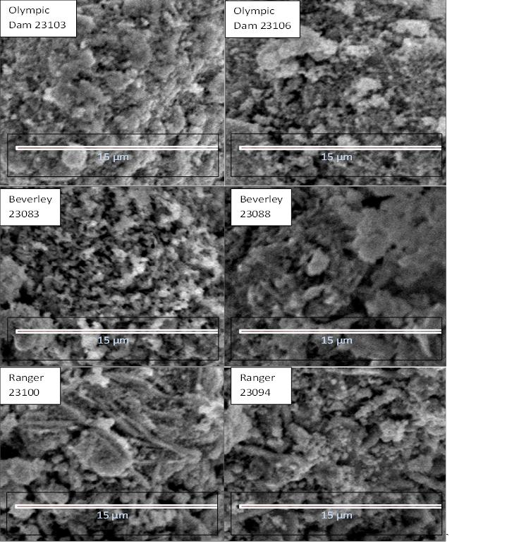

Fig.1: SEM for intact particulate yellowcake samples coated with platinum. All magnifications X
1500.

Figs.1 and 2 illustrate the different structures of intact and polished UOC materials respectively at
1,500 X magnification. All particulates in the main have similar sizes (~100 µm) and are almost spherical in shape; however intrinsic surface morphological differences could be observed. Examining both U3O8 containing materials, one can see that both Ranger and O.D. have large particle sizes with surficial adherence of smaller particles of approximately 1/8th the diameter of the parent.
O.D. presented a much smoother surface for the large particles, quite unlike Ranger material which had rod-like protrusions. Beverley, the sole uranium peroxide hydrate, also presented a roughened surface with the appearance of scale-like features. In all cases, cutting and polishing through the particles and examination at 1,500 X more clearly illustrated the gross internal micro-structural features, and in particular the crystalline rod structure present in the Ranger UOC.
Olympic
Dam NFS13-
95-1_03
Olympic
Dam NFS13-
94-5_05

15 µm 15 µm

Beverley

NFS13-088-6_07
Beverley

NFS13-090-5_03

15 µm 15 µm

Ranger

NFS13-092-6_03
Ranger

NFS13-096-2_03
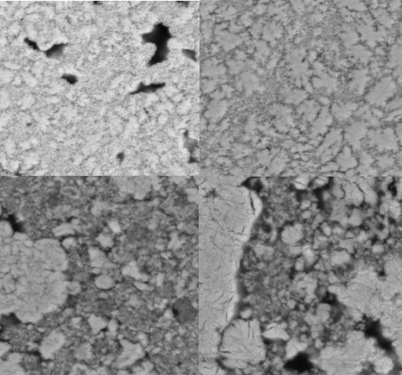
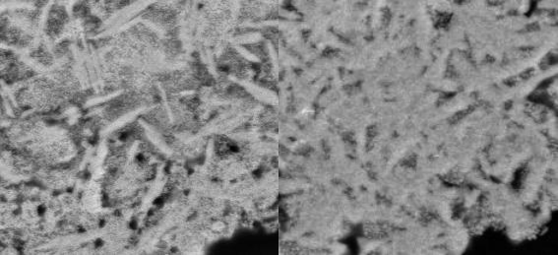

15 µm 15 µm

Fig.2: SEM Epoxy mounted, polished, carbon coated, yellowcake samples.

Diffuse Reflectance Spectrometry/Transmission IR
DRS in NIR has been recently shown to be a particularly useful non-destructive technique for
identifying the speciation, notably the valence, of uranium. This was demonstrated herein, with Figs.
3 and 4 showing major differences in the absorption of the two U3O8 samples vs the UO4.nH2O. Subtle differences in the absorption peaks were observed between the two U3O8 exporting mines (Fig.
4, ~1500 and 1860 nm) will be examined further to determine the consistency for multivariate
discrimination for this uranium oxide from these two mines.
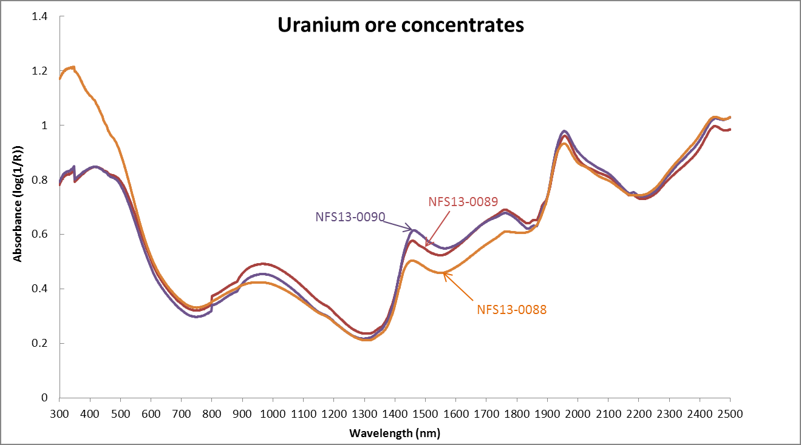
OH Combination

OH Overtone

Fig.3: Full scan Vis/NIR spectra of Beverly UOCs (UO4.nH2O).

OH Combination band
UO3.nH2O

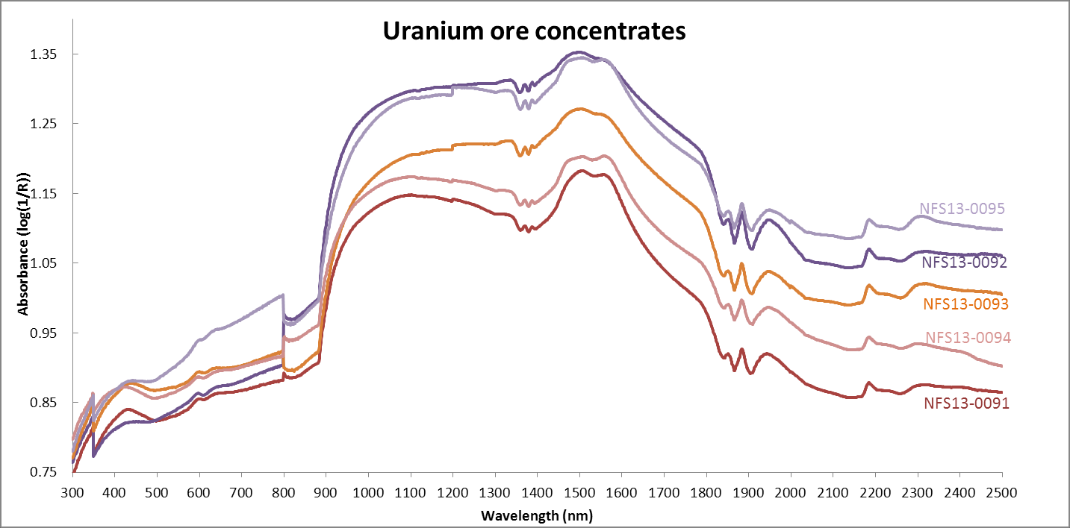
+5 oxidation state crystal field absorptions (U3O8)

Fig.4: Full scan Vis/NIR spectra of Olympic Dam (NFS13-0094+0095) and Ranger (NFS13-0091 to
NFS13-0093) UOCs (U3O8). Note grating changes at ~350 and 780 nm in both Figures 3 and 4.

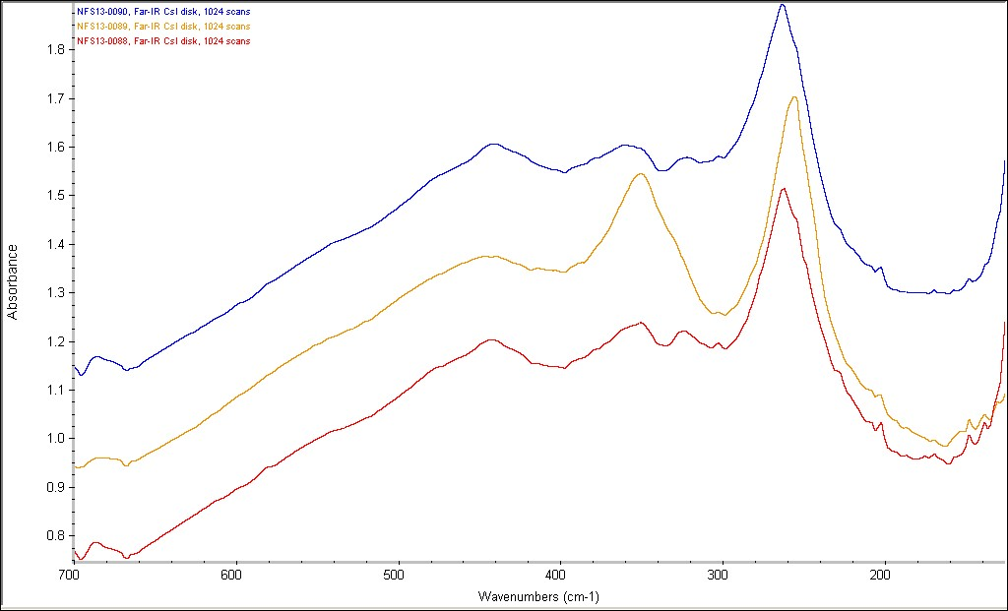

Fig. 5.: Transmission mode Far IR of Beverley UOC (CsI disk)

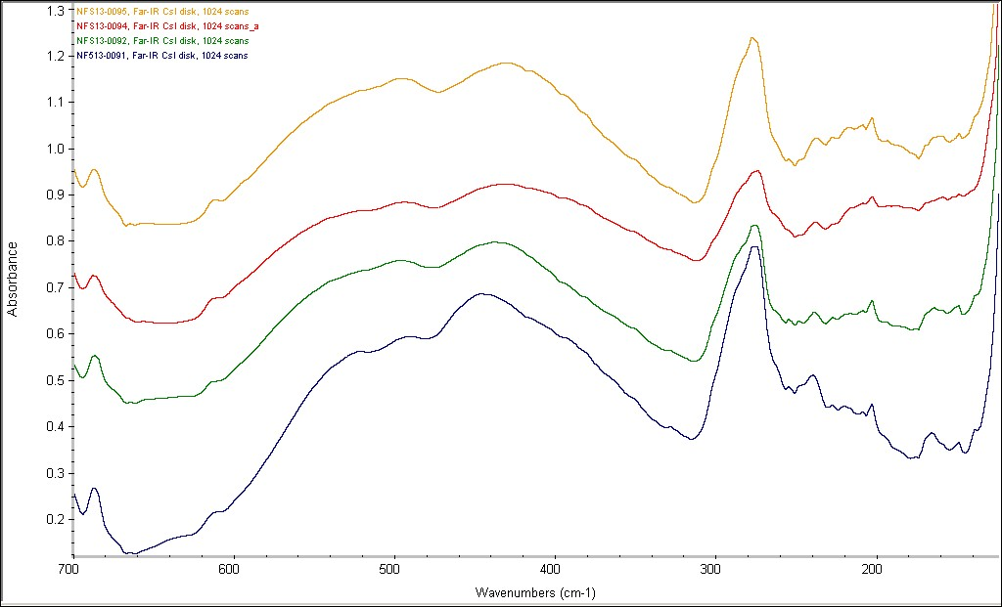

Fig. 6.: Transmission mode Far IR of Olympic Dam (NFS13-0094+0095) and Ranger UOC (NFS13-
0091 to NFS13-0093) as CsI disks.

Transmission far IR also appears to be capable of identifying the speciation of uranium. This was demonstrated herein, with Figs. 5-7 showing gross differences in the phonon absorption of the two U3O8 samples vs the UO4.nH2O. Samples from the two U3O8 mines (Fig. 6) will be analysed numerous times to determine the consistency for multivariate discrimination to aid identification. However, as these spectra have weak peaks due to lattice mode vibrations, they may be of limited usefulness in identifying subtle differences in common speciation from mines producing the same UOC type.
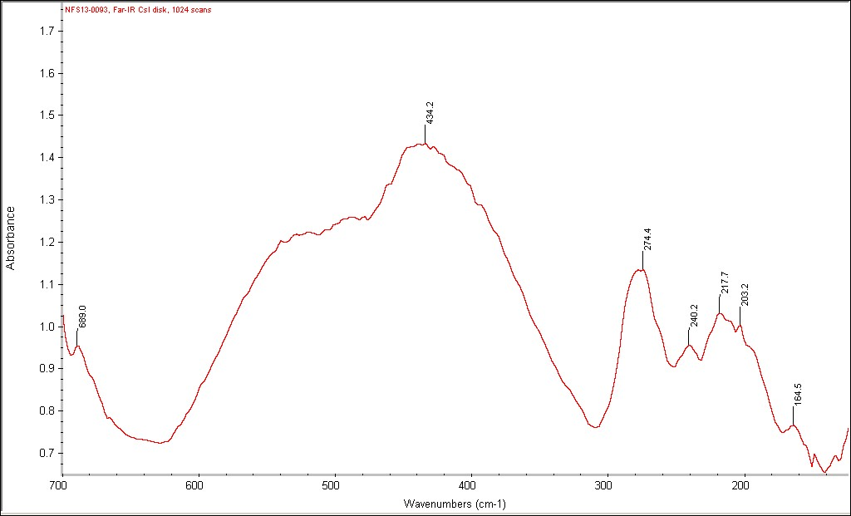

Fig.7: Transmission mode Far IR of Ranger UOC (CsI disk)

X-Ray and Neutron Diffraction (ND)
The neutron diffraction patterns confirmed the XRD phase identifications, and as expected the ND
displayed high backgrounds in those samples with relatively high amounts of water, due to incoherent scattering from H atoms.

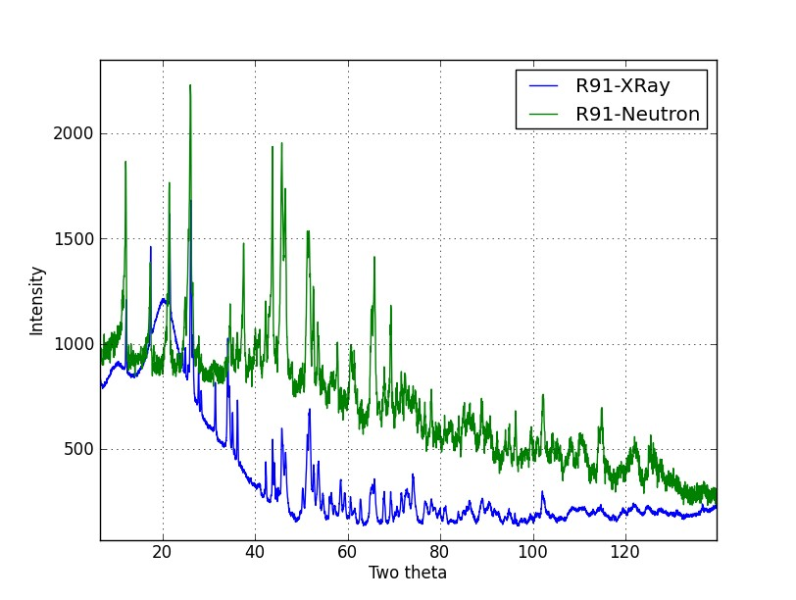

Fig. 8: Overlay of Ranger UOC X-ray and neutron patterns normalised to the same λ (Cu Kα)
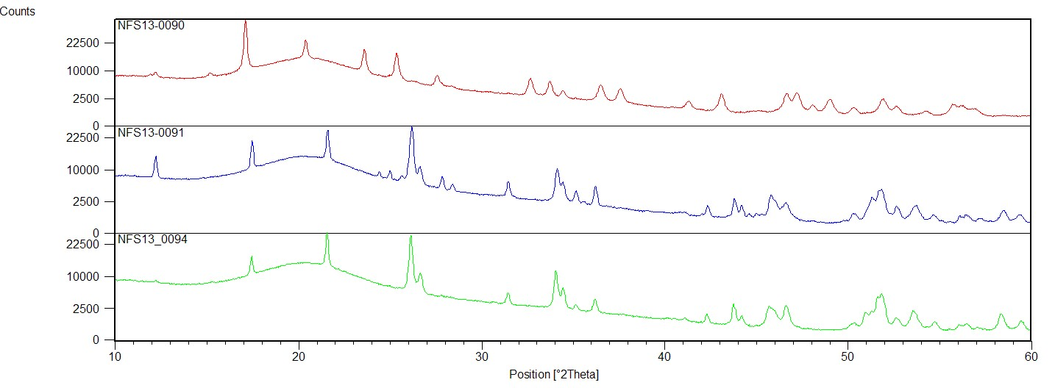

*
*
*

Fig. 9: XRD patterns of respectively Beverley (upper trace in red), Ranger middle trace in blue, and Olympic Dam mine UOC Samples. Distinguishing lines differentiating Ranger from OD are indicated as shown*. Diffuse scattering due to sample holder is evident from 2θ=13-26˚.

XRD is routinely used for phase determination and quantification in industrial settings. Following standard phase identification procedures and with comparisons to published ICDD data, the Ranger sample is predominantly U3O8 and UO3.2H2O, whilst Olympic Dam is predominantly U3O8 and trace UO3.2H2O[13]. The Beverley sample, which is exported as uranium peroxide, does contain a majority of UO4.2H2O and trace UO4.4H2O and UO3.2H2O[14].

PALS
The PALS results (Table II) on all four samples examined were very similar, so the potential of PALS for discrimination at this stage is not strong. However we have several more samples for study at a later stage. The very weak second lifetime component is not understood as yet, but maybe due to surface effects from the different powders or grain boundary effects.

Table II: Positron Annihilation Lifetime Spectroscopy (PALS) of Selected UOCs

Sample ID | Intensity T1/T2 |  | Ave.T1 Lifetime |  | Ave.T2 Lifetime  (N=2)
Ranger 1 | 95.6/4.4 |  | 0.32 |  | 1.6
Olympic Dam 1 | 97.9/2.2 |  | 0.31 |  | 1.1
Beverley 2 | 95.0/5.0 |  | 0.34 |  | 1.7
Beverley 1 | 98.8/1.2 |  | 0.34 |  | 1.6

4. Conclusion
The results from a collection of experimental techniques have gone a long way in differentiating properties of yellowcake samples from different sources. We suggest IR in both DRS and transmission
mode operation are useful non-destructive techniques for identifying the speciation of the yellowcake,
but may not have sufficient discriminating power to infer the origin of the two U3O8 producing mines (Ranger and O.D.). SEM morphology discriminates between all three mines, with different structural features evident in material from all three mines. The SEM morphology of Ranger, which has the presence of crystalline rod-like structures, is suggested to contain significantly higher UO3.2H20 in comparison to O.D (Fig.9, additional peaks). In future work we will endeavour to clarify the identity of these rod-like protuberances in Ranger material and perform slow scanning of the UV/VIS/NIR region in DRS mode and by transmission far IR regions. We will attempt to confirm if subtle spectral features can be used to further differentiate U3O8 from Ranger and Olympic Dam mines. Differences in U3O8 and UO4.nH2O samples in PALS maybe minimal, but more samples are available for study.

5. References
1. MAYER K, WALLENIUS M, RAY I (2005) Nuclear Forensics - A Methodology Providing Clues
On The Origin Of Illicitly Trafficked Nuclear Materials. Analyst 130 (4):433-441. DOI:DOI
10.1039/B412922A
2. KEEGAN E, WALLENIUS M, MAYER K, VARGA Z, RASMUSSEN G (2012) Attribution Of
Uranium Ore Concentrates Using Elemental And Anionic Data. Applied Geochemistry 27 (8):1600-
1609. DOI:10.1016/J.APGEOCHEM.2012.05.009
3. KEEGAN E, RICHTER S, KELLY I, WONG H, GADD P, KUEHN H, ALONSO-MUNOZ A (2008) The Provenance Of Australian Uranium Ore Concentrates By Elemental And Isotopic Analysis. Applied Geochemistry 23 (4):765-777. DOI:10.1016/J.APGEOCHEM.2007.12.004
4. SVEDKAUSKAITE-LEGORE J, RASMUSSEN G, ABOUSAHL S, VAN BELLE P (2008) Investigation Of The Sample Characteristics Needed For The Determination Of The Origin Of
Uranium-Bearing Materials. Journal Of Radioanalytical And Nuclear Chemistry 278 (1):201-209. DOI:DOI 10.1007/S10967-007-7215-Y
5. BADAUT V, WALLENIUS M, MAYER K (2009) Anion Analysis In Uranium Ore Concentrates
By Ion Chromatography. Journal Of Radioanalytical And Nuclear Chemistry 280 (1):57-61. DOI:10.1007/S10967-008-7404-3
6. SVEDKAUSKAITE-LEGORE J, MAYER K, MILLET S, NICHOLL A, RASMUSSEN G,
BALTRUNAS D (2007) Investigation Of The Isotopic Composition Of Lead And Of Trace Elements
Concentrations In Natural Uranium Materials As A Signature In Nuclear Forensics. Radiochimica
Acta 95 (10):601-605. DOI:DOI 10.1524/RACT.2007.95.10.601
7. RICHTER S, ALONSO-MUNOZ A, EYKENS R, JACOBSSON U, KUEHN H, VERBRUGGEN A, AREGBE Y, WELLUM R, KEEGAN E (2008) The Isotopic Composition Of Natural Uranium Samples - Measurements Using The New N(U-233)/N(U-236) Double Spike IRMM-3636. Int J Mass Spectrom 269 (1-2):145-148. DOI:DOI 10.1016/J.IJMS.2007.09.012
8. VARGA Z, WALLENIUS M, MAYER K, KEEGAN E, MILLETT S (2009) Application Of Lead
And Strontium Isotope Ratio Measurements For The Origin Assessment Of Uranium Ore
Concentrates. Analytical Chemistry 81 (20):8327-8334. DOI:10.1021/AC901100E
9. VARGA Z, WALLENIUS M, MAYER K (2010) Origin Assessment Of Uranium Ore Concentrates
Based On Their Rare-Earth Elemental Impurity Pattern. Radiochimica Acta 98 (12):771-778. DOI:10.1524/RACT.2010.1777
10. VARGA Z, KATONA R, STEFANKA Z, WALLENIUS M, MAYER K, NICHOLL A (2010) Determination Of Rare-Earth Elements In Uranium-Bearing Materials By Inductively Coupled Plasma
Mass Spectrometry. Talanta 80 (5):1744-1749. DOI:10.1016/J.TALANTA.2009.10.018
11. KLUNDER GL, PLAUE JW, SPACKMAN PE, GRANT PM, LINDVALL RE, HUTCHEON ID (2013) Application Of Visible/Near-Infrared Reflectance Spectroscopy To Uranium Ore Concentrates For Nuclear Forensic Analysis And Attribution. Appl Spectrosc 67 (9):1049-1056
12. YU BZ, HANSEN WN, WARD J (1989) The Far-Infrared Spectra Of UO2, Alpha-U3O8, and
Gamma-UO3 Using The Light Pipe Reflection Method. Appl Spectrosc 43 (1):113-117
13. VOCHTEN R, DEGRAVE E, LAUWERS H (1990) Transformation Of Synthetic U3O8 Into
Different Uranium Oxide Hydrates. Miner Petrol 41 (2-4):247-255. DOI:DOI 10.1007/BF01168498
14. TAYLOR P, WOOD DD, DUCLOS AM (1992) The Early Stages Of U3O8 Formation On
Unirradiated Candu UO2 Fuel Oxidized In Air At 200-300-Degrees-C. Journal Of Nuclear Materials
189 (1):116-123. DOI:DOI 10.1016/0022-3115(92)90425-K

