Resources and Forensics Signatures to Help Determine the Origin of Sealed Radiological Sources

David Chamberlain, Jodi Canaday, Yu Tang, James Morman, Jennifer Steeb, Seema Naik, Yifen Tsai, and Vivian Sullivan (Argonne National Laboratory)

Kevin Carney, Martha Finck, Dan Cummings, Jeff Gigilio, and James Summers (Idaho National Laboratory)

ABSTRACT

In a crime scene that involves radiological material, analysis of the source capsule and the radiological material could provide law enforcement with valuable clues to the sources manufacturer. Identification of the source manufacturer has the potential to provide further leads on where the radiological sealed source was obtained, including when the loss of regulatory control might have occurred. These signatures include materials of construction, dimensions, weld details, and the elemental composition and isotopic abundances of the radioactive material.

Argonne and Idaho National Laboratories have for the past 11 years been working on identifying signatures that could be used to identify specific source manufacturers. These signatures have been collected in a library that now contains the most complete forensics information on radioactive source signatures than any other database in the world. In addition to the collection of signatures from a variety of sources, both laboratories have developed and validated procedures for age dating of common radiological materials. These activities are described.

INTRODUCTION

In a crime scene that involves radiological material, analysis of the source capsule and the radiological material could provide law enforcement with valuable clues to the sources manufacturer. Identification of the source manufacturer has the potential to provide further leads on where the radiological sealed source was obtained, including when the loss of regulatory control might have occurred. These signatures include materials of construction, dimensions, weld details, and the elemental composition and isotopic abundances of the radioactive material.

A database or library of known signatures is needed by the law enforcement community. Many countries have regulations in place to track or document the radiological sealed sources that are used in their country, but these databases are typically focused on regulatory requirements and not for forensics purposes. We know of two organizations that maintain a database of forensics signatures of sealed sources: the International Atomic Energy Agency (IAEA) and Argonne/Idaho National Laboratories. The IAEA has developed and maintains a database called the International Catalogue of Sealed Radioactive Sources and Devices (ICSRS). The second is housed at Argonne National Laboratory and is referred to as the Radiological Sealed Source Database (RSSD); details on this database are described in this paper.

Argonne National Laboratory, with support from the Idaho National Laboratory, maintains the RSSD and includes sealed radioactive sources and the devices that house them. The purpose of the database is to aid U.S. government agencies, including law enforcement and first responders, in identifying radioactive sources or devices, including the manufacturer and distributor. The RSSD houses a searchable collection of pictures, construction diagrams, dimensions, and chemical compositions of sources and devices sold anywhere in the world. The information encompasses both currently distributed source and device models and historical, discontinued ones. The latter are necessary because the half-life of many nuclides in sealed sources and radioactive devices is beyond that of most current commercial products.

Currently, the RSSD is the most complete compilation of its kind in the world. Argonne and Idaho National Laboratories have worked together for the past 11 years to populate this database with relevant signatures that could then be used to identify specific sealed source manufacturers.

DATA COLLECTION

The RSSD contains technical information compiled from manufacturers and distributors of radiological sealed sources. Data collection involves various strategies, including vendor catalogs (Figure 1 displays the cover of a Mayak catalog), web pages, technical publications, interactions with foreign governments and companies, attendance at technical meetings, and site visits to foreign and domestic source production and distribution facilities, and interactions with the US Nuclear Regulatory Commission. For the RSSD, the Nuclear Regulatory Commission's Source and Device Registry was the primary resource for collecting signatures. Non-disclosure agreements are used to protect information obtained directly from source producers and distributors. Information obtained through all of these methods is contained in a searchable database and in company profiles, country summaries, isotope summaries, and individual source reports.

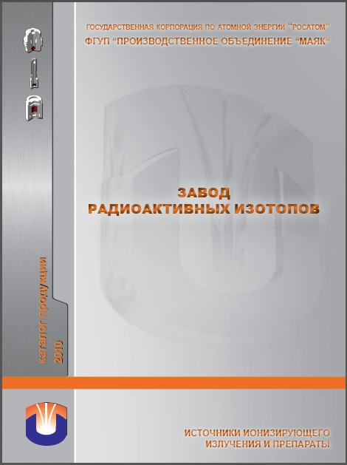

Figure 1. Example of manufacturers catalog (Mayak) with useful forensics information.

A ¹³⁷Cs capsule from a major source producer is shown in Figure 2. It is important to capture design features that could differentiate this source from other manufacturers. Some potential signatures that differentiate manufacturers are shown in Figure 2 and include labels, engravings, number of capsules, dimensions, weld details, and materials of construction.

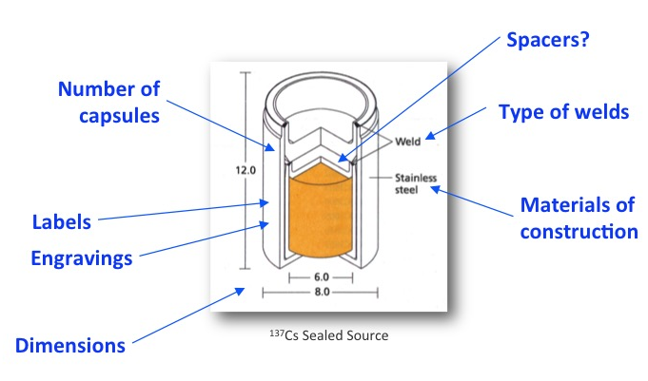

Figure 2. A ¹³⁷Cs sealed source with design features that could differentiate this capsule from other manufacturers are noted.

CHEMICAL ANALYSIS

Although the shape and dimensions of source capsules may help identify the manufacturer, additional information from the analysis of the radiological material would be helpful to better pinpoint the manufacturer or supplier of a particular source (see Figure 3).

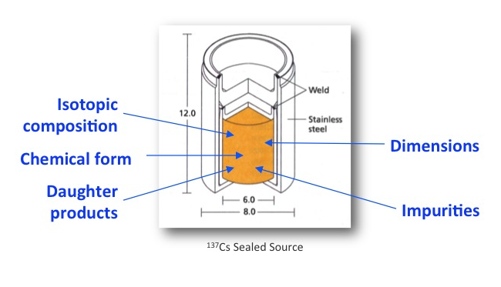

Figure 3. Analysis of the radiological material in a sealed source could provide additional information about the sources origins.

The careful analysis of parent-daughter decay pairs can provide the “time since purification” or time since the “end of irradiation” of the radioactive material. This apparent age of the source, therefore, provides an estimated date when the source material/capsule was manufactured. Knowing the manufactured date information and the manufacturer could lead to sales records and/or to exclude other manufacturers based on company histories. Analysis of trace elements or impurities in the radioactive material may also lead to an understanding of the processing history, including purification methods, type of reactor that was used to generate the material, and the original source of the target material.

This “age dating” technique requires analysis of both radioactive and stable isotopes. For the analysis of stable isotopes mass spectrometry measurements are essential, however the parent-daughter decay pairs used in age dating often have the same atomic mass and require chemical separations to eliminate isobaric interferences in the mass spectrometric measurement. For example, the parent Cs-137 interferes with the measurement of the stable daughter Ba-137 (see Figure 4) by mass spectrometry; similarly Co-60 interferes with the measurement of the daughter Ni-60.

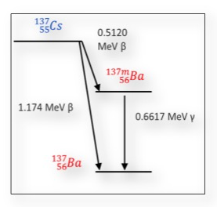
Figure 4. Radioactive decay of radioactive ¹³⁷Cs to the stable ¹³⁷Ba atom.

Sample dissolution methodologies and separation procedures for age dating analysis have been completed for ¹³⁷Cs [1,-4], ⁹⁰Sr [5], and ⁶⁰Co [6] sources. The process typically involves dissolving a representative sample and then using extraction chromatography to separate the parent isotope from the daughter. Separation schemes using Gas Pressurized Extraction Chromatography (GPEC) have been developed for Cs/Ba (Figure 5) and Sr/Zr methods as well as separations using Omnifit column system with DOWEX 1x8 resin that was used for Co/Ni separations (Figure 6). Analysis is completed using analytical techniques such as inductively-coupled-plasma mass spectrometry (ICP-MS), thermal ionization mass spectrometry, or by gamma counting the radioactive fraction. Details are described elsewhere [1-6].

With careful analysis to prevent environmental contamination of the samples, source ages can be determined. An example of this using the GPEC system for a ¹³⁷Cs sample is shown in Figure 7. Two laboratories conducted these analyses over a five-year period on a sealed source capsule that was dated 27 October, 1965.

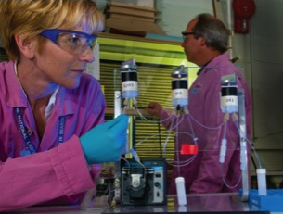 | 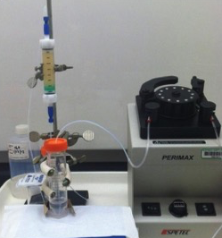
Figure 5. Gas Pressurized Extraction Chromatography (GPEC) that was used for Cs/Ba separations. | Figure 6. Omnifit column system with DOWEX 1x8 resin that was used for Co/Ni separations.

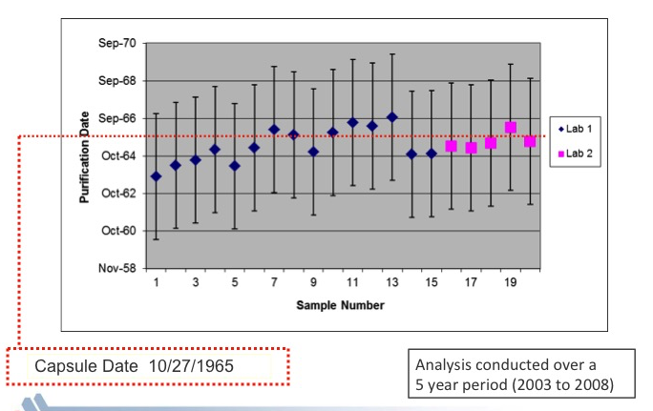

Figure 7. Summary of age dating results of a ¹³⁷Cs source with expanded uncertainties using GPEC system by two laboratories.

SUMMARY

Argonne and Idaho have compiled the most complete database of forensics signature information on radioactive sealed sources in the world, with over 10,000 models currently documented. Information is contained in a searchable database and includes company profiles, country summaries, isotope summaries, and individual source reports. This information can be used to aid law enforcement personnel in their investigations to help identify the manufacturer and original owner of the source.

We do not expect that examination of a sealed source and the radiological material will always lead to a specific source model or manufacturer. But it is likely that these examinations will reduce the number of possibilities to be considered for further evaluation. For example, using information contained in the RSSD, knowing that the radiological material is ¹³⁷Cs reduces the number of possible source models from over 10,000 to just under a 1000 possibilities. Further details such as the source strength, number of capsules, and/or capsule dimensions can further eliminate possible models.

REFERENCES AND ACKNOWLEDGEMENTS

1. Daniel Cummings, James Sommers, Mary Adamic, Marcos Jiminez, Jeffrey Giglio and Kevin Carney. Characterization of Sealed Radioactive Sources: Uncertainty Analysis to Improve Detection Methods, , Journal of Radioanalytical and Nuclear Chemistry, Volume 282, Issue 3, pp 923-928, December 2009.
2. Characterization of a Sealed Americium-Beryllium (AmBe) source by inductively coupled plasma mass spectrometry (ICP-MS). James Sommers, Daniel Cummings, Mary Adamic, Jeffrey Giglio and Kevin Carney, Journal of Radioanalytical and Nuclear Chemistry, Volume 282, Issue 3, pp 929-932, December 2009.
3. James Sommers, Daniel Cummings, Jeffrey Giglio, Kevin Carney. "Age" determination of irradiated materials utilizing inductively coupled plasma mass spectrometric (ICP-MS) detection, Journal of Radioanalytical Nuclear Chemistry (2009) 282:591-595.
4. Jennifer Steeb, Carol Mertz, Giselle Sandi, Dean Bass, Don Graczyk, Margaret Goldberg. Microseparations of cesium and barium in glass. Journal of Radioanalytical and Nuclear Chemistry, Volume 292, Issue 2, pp 757-762, May 2012.
5. JL Steeb, DG Graczyk, Y Tsai, CJ Mertz, AM Essling, VS Sullivan, JJ Giglio, KP Carney, MR Finck, and DB Chamberlain. Application of mass spectrometric isotope dilution methodology for ⁹⁰Sr age-dating with measurements by thermal ionization mass spectrometry and inductively coupled plasma mass spectrometry, J. Anal. At. Spectrom. 28 (9): 1493 – 1507 (2013).
6. L Charbonneau, JM Benoit, S Jovanovic, N St-Amant, S Kiser, MW Cooke, JF Mercier, K Nielsen, D Kelly, P Samuleev, R Galea, K Moore, PRB Saull, DB Chamberlain, JL Steeb, DG Graczyk, Y Tsai, VS Sullivan, IC Dimayuga, Y Shi, R Rao, and D Lariviere. A nuclear forensics method for determining the age of radioactive cobalt sources, Anal. Methods, 2014, 6, 983.

A radiological sealed source can be defined as a radiological material that has been sealed into a metal container that can then be safely handled without fear of spreading contamination. Specifics of these sources depends upon the final use the manufacturer and the country of origin.
The IAEA has developed a database of sealed radioactive source models and models of devices containing sealed radioactive sources. The International Catalogue of Sealed Radioactive Sources and Devices (ICSRS) contain key manufacturing data for source and device models. Like Argonne’s database, the ICSRS does not contain a list of actual physical sources or devices with their serial number, owner or location. But it can help identifying the model for a given (or "found") individual source or device and provide manufacturer, application area and the level of threat associated with a source model. An effort to update this database with more current information from member countries has been proposed.
Regulations in the United States (10 CFR Part 35) require NRC licensees to use only sources and devices as approved and listed in the Sealed Source and Device Registry. Therefore, starting with information from this database enabled Argonne/Idaho to get detailed signature information on sealed sources that are used and/or manufactured in the United States. Since the Registry’s primary use is regulatory, the forensics information was not in a searchable form and had to be manually extracted.

