Probing Forensic Signatures of Nuclear Materials

Marianne Wilkersonª, William S. Kinmanª, Stosh A. Kozimorª, Alison L. Pugmireª, Brian L. Scottª, Alison L. Tamasiª, Gregory L. Wagnerª, and Justin R. Walensky^{b}

ªLos Alamos National Laboratory
P.O. Box 1663
Los Alamos, New Mexico 87545
United States of America

^{b}Department of Chemistry
University of Missouri – Columbia
Columbia, Missouri 65211
United States of America

Abstract. Processes conducted to purify uranium-bearing materials are chemical in nature. These activities provide the opportunity for chemical reagents or reaction intermediates to carry over into uranium end-products. Measurements of the chemical species in uranium oxide conversion materials may provide information important to forensic analyses, and signatures of the detectable chemical species may transform over time. To better evaluate detectable process signatures from conversion materials, we have initiated an effort to measure chemical speciation and to monitor temporal changes in materials subjected to controlled temperatures and relative humidities.

- INTRODUCTION

It has been reported that new analytical approaches are needed for the field of nuclear forensic science, and that there is interest in developing tools that are sensitive to chemical speciation for forensic analyses [1-2]. The range of chemical compositions of uranium oxides is considerable and complicated, providing challenges to measurement and interpretation, particularly in non-crystalline materials [3]. Previous work conducted by our research team to study environmental samples containing uranium revealed the value of synchrotron-based X-ray Absorption Spectroscopy for probing chemical speciation of non-crystalline materials containing actinides [4]. We explored the use of synchrotron-based micro-X-ray absorption techniques developed at the Stanford Synchrotron Radiation Lightsource (SSRL) Beam Line 2-3 to image elemental compositions and chemical speciation of environmental samples containing actinide oxide materials with the intent of understanding future transport and fate of actinides in the environment.

One component of forensic analyses of interdicted materials is characterization of morphologies. Identification of chemical speciation of both major and minor components in a sample may be correlated with process history [5-9]. Both classes of signatures may be impacted over time by temperature and relative humidity. We employ powder X-ray diffraction (pXRD) analysis and synchrotron-based extended X-ray absorption fine structure (EXAFS) spectroscopy to characterize chemical speciation in uranium oxide powder samples, and to probe temporal changes in the valence states and chemical speciation following storage under controlled conditions of temperature and relative humidity. These tools provide complementary means for characterizing subtle changes in the material.

- EXPERIMENTAL

The cornerstone of this work is the ability to synthesize and analyze high-purity uranium oxides samples from U960, a NIST Standard Reference material, for eventual comparison with uranium oxides prepared using common conversion processes. We prepared U₃O₈ by dissolution of U metal in HCl_{[conc]}, followed by precipitation of uranyl peroxide hydrate [3]. The UO₂(O₂) was heated in air to 500ºC for 8 hours to form amorphous uranium trioxide (A-UO₃). The orange A-UO₃ was then ground using a mortar and pestle, returned to the ceramic boat, and heated at 800ºC under air for 20 hours. The product is a dark black powder. The phase was confirmed by powder X-ray diffraction analysis.

Subsamples were subjected to controlled temperatures and relative humidities (LTLH: 5ºC and 25% relative humidity; HTLH: 37ºC, 15% relative humidity; LTHH: 5ºC and 97% relative humidity; HTHH: 37ºC, 89% relative humidity) in order to measure and compare potential changes in morphology versus chemical speciation as a function of time. Aging vessels consisting of modified Swagelok fittings are described elsewhere [10]. Lithium iodide and potassium nitrate salt solutions were used to control relative humidities within the aging vessels [11].

Powder X-ray diffraction measurements were collected on either a Bruker D8 Discover diffractometer quipped with either a Hi-Star area detector or a NiI scintillation detector, and monochromatized Cu K_{α} X-rays, or on a Bruker D8 Advance diffractometer equipped with a Lynxeye 1-3 silicon strip detector and unconditioned Cu K_{α} X-rays. Samples for EXAFS measurements were prepared by diluting the uranium oxide analyte with boron nitride and then finely grinding the mixture with a Wig-L-Bug. Each mixture was loaded into nested aluminum sample holder equipped with Kapton windows and sealed with indium wire. Measurements were conducted at SSRL on end stations 10-2 and 11-2 under dedicated operating conditions (3.0 GeV, 5%, 450 mA) using a Si[220] (ϕ = 90) double-crystal monochromator. Morphologic images of materials were collected on an FEI Quanta 200F Field Emission Scanning Electron Microscopy (SEM).

- RESULTS

The pXRD analysis of high purity U₃O₈ material reveals pure α-U₃O₈, as shown in Figure 1. The purity of this material contrasts the compositions of legacy materials of known pedigree but prepared using synthetic routes common to commercial processing of uranium oxides. In these legacy materials, it was possible to measure chemical precursors, such as uranyl fluoride hydrate, uranyl peroxide hydrates, or ammonium diuranate [3].

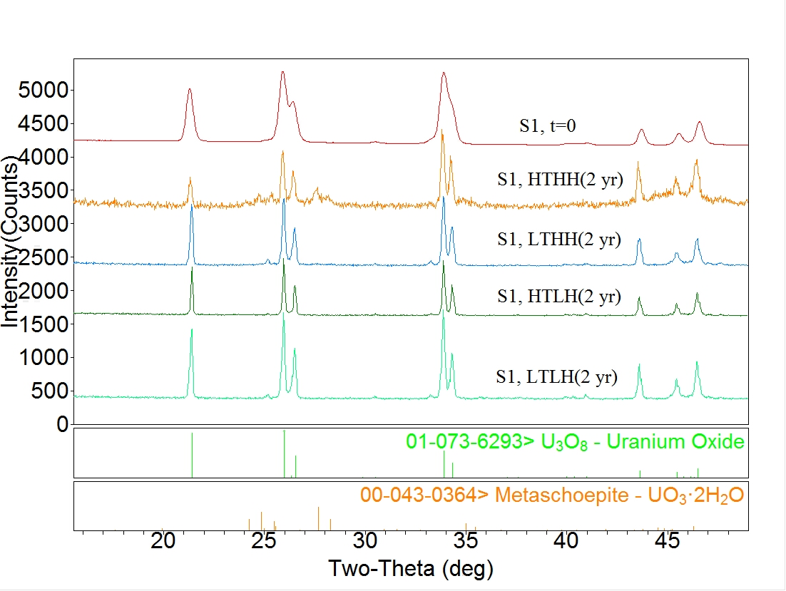
FIG. 1. Powder X-ray diffraction patterns of U₃O₈ measured following synthesis of the material (time = 0), and after storage for 2 years under the following conditions: High Temperature High Relative Humidity (HTHH), Low Temperature High Relative Humidity (LTHH), High Temperature Low Relative Humidity (HTLH), and Low Temperature Low Relative Humidity (LTLH).

The EXAFS spectrum for high purity U₃O₈ is shown in Figure 2. The U-O and U-U scattering paths calculated from α-U₃O₈ were used to model the EXAFS data sets.

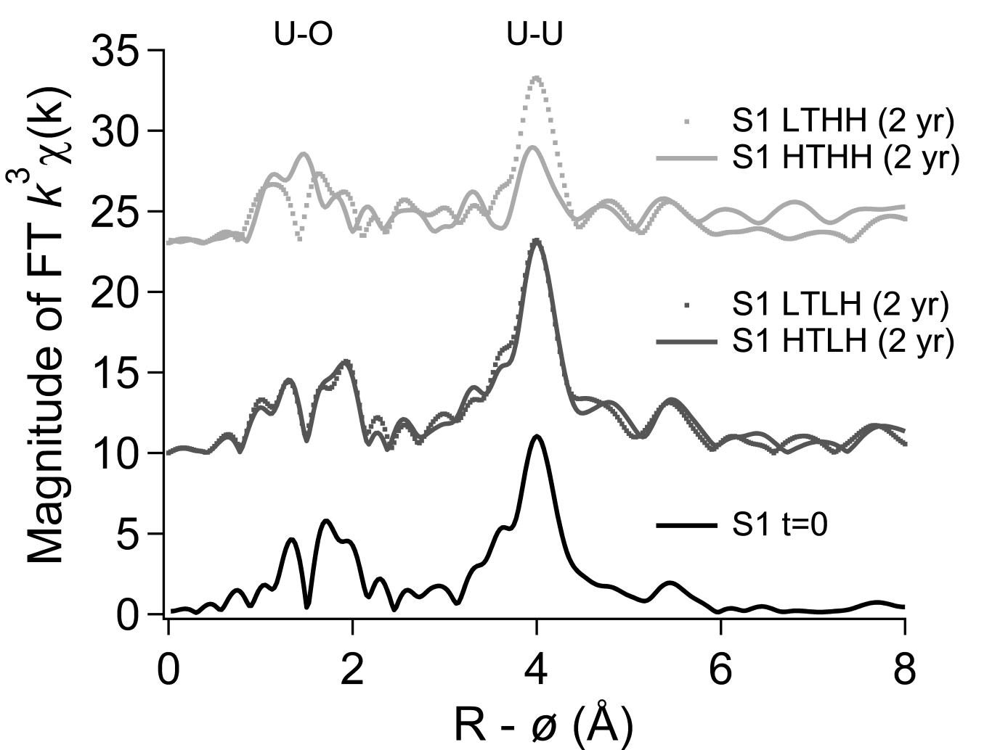
FIG. 2. Fourier Transforms of U L_{III} EXAFS data of U₃O₈ measured following synthesis of the material (time = 0), and after storage for two years under the following conditions: High Temperature High Relative Humidity (HTHH), Low Temperature High Relative Humidity (LTHH), High Temperature Low Relative Humidity (HTLH), and Low Temperature Low Relative Humidity (LTLH).

An SEM image reveals that the material is composed of fairly spherical granules approximately 2 μm in diameter (Figure 3), which is comparable with the morphology measured from the uranyl peroxide precursor.

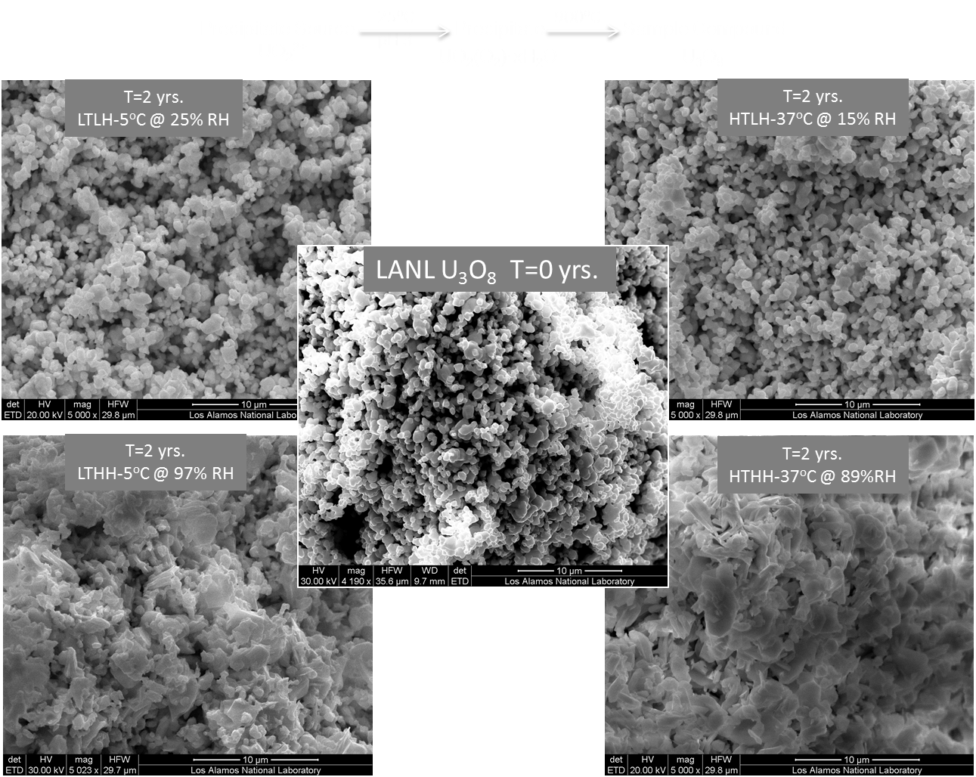

FIG. 3. SEM images at 5000X of U₃O₈ measured following synthesis of the material (time = 0), and after storage for two years under the following conditions: High Temperature High Relative Humidity (HTHH), Low Temperature High Relative Humidity (LTHH), High Temperature Low Relative Humidity (HTLH), and Low Temperature Low Relative Humidity (LTLH).

Ingrowth of metaschoepite (UO₃·2H₂O) is measured following exposure of U₃O₈ to controlled relative humidity and temperature over two years. Comparison of X-ray diffraction patterns with reference lines reported in the Cambridge Crystallographic Database reveals both U₃O₈ and UO₃·2H₂O in the subsamples stored under high temperature and high humidity after two years (Figure 1). Significant changes are observed in the Fourier Transforms (FT) of the samples stored under high humidity conditions in terms of reduced amplitude in the U-U region, and changes in the number and position of peaks in the U-O region, particularly at high temperature. The FTs of the EXAFS data are not significantly altered in terms of the U-O local structure after exposure to low humidity conditions after two years (Figure 2). While the subsamples stored at low relative humidities maintain a similar shape after two years of storage, images of the two samples stored under high relative humidity conditions reveal visible flattening and loss of granule definition (Figure 3).

4. CONCLUSIONS

Our studies show that chemical signatures indicative of reaction history are measurable, and that chemical signatures may change under certain conditions. Further work is being conducted to exploit the rich, albeit complex, information from these complimentary probes to support the reconstruction of a sample’s process history.

ACKNOWLEDGEMENTS

This work has been supported by the U.S. Department of Homeland Security Domestic Nuclear Detection Office, competitively awarded contracts IAA HSHQDC-13-X-00269 and HDHQDC-08-X-00805. This support does not constitute an expressed or implied endorsement on the part of the Government. A.L.T. would like to thank that U.S. Department of Homeland Security under Grand Award Number 2012-DN-130-NF0001-02 and the Seaborg Institute for supporting her graduate studies to contribute to this work. J.W.’s contribution is based upon work supported by the U.S. Department of Homeland Security under Grand Award Number, 2012-DN-130-NF0001-02. Previous work to study environmental samples was conducted under support from LANL Laboratory Directed Research and Development. LA-UR 14-24687

REFERENCES

[1] MAYER, K., Expand nuclear forensics, Nature 503 (2013) 461-462.
[2] JOINT WORKING GROUP OF THE AMERICAN PHYSICAL SOCIETY AND
THE AMERICAN ASSOCIATION FOR THE ADVANCEMENT OF SCIENCE,
Nuclear Forensics - Role, State of the Art, Program Needs.
[3] GRENTHE, I., DROZDZYNSKI, J., FUJINO, T., BUCK, E. C., ALBRECHT-SCHMITT, T. E., WOLF, S.F., Uranium. (The Chemistry of the Actinide and Transactinide Elements, 3rd ed.), Morris, L. R., Edelstein, N. N., Fuger, J., Katz, J. J., Eds., Springer: Dordrecht, The Netherlands (2006) Chapter 5, 253-698.
[4] FELMY, A. R., CANTRELL, K. J., CONRADSON, S. D., Physics and Chemistry of the Earth 35 (2010) 292-297.
[5] INTERNATIONAL ATOMIC ENERGY AGENCY, Application of Nuclear Forensics in Combating Illicit Trafficking of Nuclear and Other Radioactive Material, IAEA-TECDOC-1730, Vienna (2014).
[6] MAYER, K., WALLENIUS, M., FANGHÄNEL, T., Nuclear forensic science – From cradle to maturity. J. Alloys Compd. 444-445 (2007) 50-56.
[7] TANDON, L., HASTINGS, E., BANAR, J., BARNES, J. BEDDINGFIELD, D., DECKER, D., DYKE, J., FARR, D., FITZPATRICK, J., GALLIMORE, D., GARNER, S., GRITZO, R., HAHN, T., HAVRILLA, G., JOHNSON, B., KUHN, K., LAMONT, S., LANGNER, D., LEWIS, C., MAJIDI, V., MARTINEZ, P., MCCABE, R., MECKLENBURG, S., MERCER, D., MEYERS, S., MONTOYA, V., PATTERSON, B., PEREYRA, R. A., PORTERFIELD, D., POTHS, J., RDEMACHER, D., RUGGIERO, C., SCHWARTZ, D., SCOTT, M., SPENCER, K., STEINER, R., VILLARREAL, R., VOLZ, H., WALKER, L., WONG, A., WORLEY, C., Nuclear, chemical, and physical characterization of nuclear materials. J. Radioanal. Nucl. Chem. 276(2) (2008) 467-473.
[8] HASTINGS, E. P., LEWIS, C., FITZPATRICK, J., RADEMACHER, D., TANDON, L., Characterization of depleted uranium oxides fabricated using different processing methods. J. Radioanal. Nucl. Chem. 276(2) (2008) 475-481.
[9] MAYER, K., WALLENIUS, M., VARGA, Z., Nuclear Forensic Science: Correlating Measurable Material Parameters to the History of Nuclear Material. Chemical Reviews 113 (2012) 884-900.
[10] ANOVITZ, L. M., RICIPUTI, L. R., COLE, D. R., GRUSZKIEWICZ, M. S., ELAM, J. M., J. Non-Cryst. Solids 352 (2006) 5652.
[11] ASTM INTERNATIONAL, E104-02(2012), Standard Practice for Maintaining Constant Relative Humidity by Means of Aqueous Solutions.

Present address: Chemistry – Nuclear and Radiochemistry, MS J514, Los Alamos National Laboratory, Los Alamos, New Mexico, 87545, U.S.A.

