Translating Research Findings into Operational Capabilities in Nuclear Forensics: The Australian Experience

K Tooleª, T. Evansª, E Youngª, A Goodman-Jones^{b}, C Chang^{b}, P Roffey^{b}, D Hillª, M Reinhardª

ªInstitute of Materials Engineering,
Australian Nuclear Science and Technology Organisation (ANSTO),
Lucas Heights, New South Wales,
Australia

^{b}Forensics,
Australian Federal Police (AFP),
Canberra, Australian Capital Territory,
Australia

Abstract: Research has demonstrated that some evidence types, such as DNA, fingermarks and digital devices, may yield valuable investigative information in spite of ionising radiation exposure but may not be amenable to decontamination. The investigation of a nuclear security event may involve the examination of evidence contaminated with radionuclides. And thus the development of protocols for its safe handling is important. Given the frequency of such events and competing operational and fiscal demands, law enforcement forensic laboratories are disinclined to develop and maintain these capabilities. Equally, it may not be viable for a nuclear or radiological facility to establish full forensic capabilities. Australia has sought to meet this requirement through a collaborative partnership between the Australian Nuclear Science and Technology Organisation’s (ANSTO) Nuclear Forensic Research Facility (NFRF) and the Australian Federal Police (AFP). Under this arrangement AFP forensic scientists undertake examination of evidence in the NFRF and NFRF staff, who have experience in both forensic science and nuclear science, form a key part of the analytical team by serving as the ‘interface’ between these disciplines. ANSTO and the AFP have developed capabilities vital to Australia for the handling of forensic evidence contaminated with radionuclides.

Introduction
The Australian Nuclear Science and Technology Organisation (ANSTO) is home to the Nuclear Forensic Research Facility (NFRF), which was commissioned in 2009. The NFRF is the central hub for nuclear forensics in Australia and possesses the unique capabilities required to undertake nuclear forensic examinations in support of investigations. Such capabilities include facilities for handling radioactive and nuclear materials and evidence contaminated with radionuclides, access to a broad range of analytical services, staff with training and experience in fields ranging from radiochemistry to forensic science, and subject matter expertise for data interpretation.

The role of the Australian Federal Police (AFP) is the enforcement of Commonwealth criminal law in Australia and the protection of Commonwealth and national interests from crime in Australia and overseas. The AFP also provides community policing services in the Australian Capital Territory, Jervis Bay, the External Territories and at Australia’s major airports. The AFP’s Forensic portfolio provides a range of standard and innovative forensic science and technical intelligence services to support national and international operations, regional capacity building and community policing activities. ANSTO and the AFP have a long-standing relationship which includes research collaborations, training and development and exercise facilitation and participation. This relationship has been formalized by a Memorandum of Understanding.

Over a number of years, the NFRF has undertaken research to explore the effects of ionising radiation on forensic evidence and the handling of exhibits contaminated with radionuclides [1-6]. This research has demonstrated that some evidence types, such as DNA and fingermarks, may yield information in spite of radiation exposure but are not amenable to decontamination. Since these evidence types can provide valuable operational intelligence and/or highly probative evidence for court proceedings, the development of capabilities in the safe handling and examination of forensic evidence contaminated with radionuclides is an important step in preparing to respond to and investigate a nuclear security incident.

The International Atomic Energy Agency (IAEA) notes that the examination of forensic evidence contaminated with radionuclides “presents a unique challenge” [7]. Three options were considered in Australia for the carriage of capabilities in the safe handling and examination of forensic evidence contaminated with radionuclides; sole carriage by law enforcement such as the AFP, sole carriage by a radiological or nuclear facility such as ANSTO or joint carriage by law enforcement and a nuclear research facility. The sole carriage of the capabilities by law enforcement or a radiological or nuclear facility, given the requirements for establishment of the infrastructure, training and development of personnel and implementation of a comprehensive regulatory framework, is not feasible given other demands on resources. However joint carriage, utilising the existing capabilities of each organization, is a viable option and in this spirit a series of projects have been undertaken under the Memorandum of Understanding to develop this joint capability. This paper will describe in greater detail the technical aspects of this project, such as the modifications required to make the infrastructure at a nuclear research facility suitable for forensic examinations and the training required for AFP forensic scientists to work in a radiation environment. It will also describe the lessons learned through this project and plans for on-going collaboration.

Work to date

Initial glove box set up

As a component of previous research, two glove boxes in the NFRF (shown in Figure 1) were custom fitted for the decontamination and examination of forensic evidence. The purpose of the glove boxes, which operate at negative pressure, is two-fold. The glove box provides an atmosphere for the sample separate from that in which the user operates, providing protection against internal contamination with radionuclides. Furthermore, the glove box serves to protect forensic evidence from DNA or trace material contamination when the provision of more conventional measures (such as designated clean laboratories) for radionuclide contaminated evidence may not be cost-effective.

- Air intake  - Exhaust  - Pressure gauge  - Air-lock portal  - Windows  - Glove portal  - General purpose outlets  - Lighting  - Laptop  - Camera  - Polilight™ | 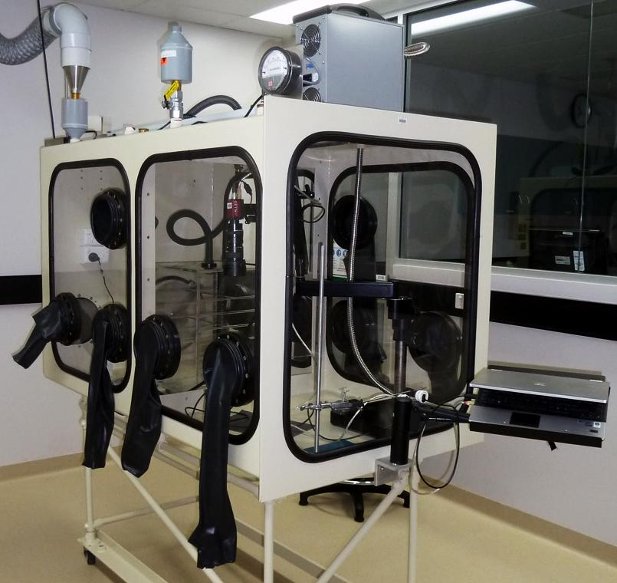  8.  1  2  3  4.  5  6.  7.  11.  10.  9
Figure 1 Glove box with fixtures and fittings labelled

Image capture was identified as a high priority for both glove boxes. Images of submitted samples need to be collected for integrity, reference, and evaluation of samples. It is preferable to image contaminated samples prior to processing, as well as utilising a camera for recording developed and enhanced fingermarks. A camera system was installed inside each glove box comprising a small (29 x 44 x 74 mm) FireWire colour camera (Stingray F201C, Allied Vision Technology) with a macro zoom lens (LMZ69M, Kowa) attached to a flexible arm on a heavy base stand (MA242201, View Solutions). The FireWire connection was fed externally from the glove box and connected to a laptop. The small camera was valuable in a space-constrained environment, with the flexible arm enabling allowing a high degree of manoeuvrability and control. Lighting for forensic imaging was achieved through the permanent inclusion of a light guide connected to a suitable light source. This allowed the Polilight® (model PL500; Rofin Australia), a variable wavelength high intensity light source designed for forensic purposes housed externally to the glove box for maintenance and space saving reasons.

One glove box was equipped for fingermark development on both non-porous and porous surfaces. Standard procedures for these techniques were followed but conducted in the glove box rather than as a bench-top procedure which is more typical. On non-porous surfaces such as plastic or glass, one of the most common techniques for the development of fingermarks is cyanoacrylate fuming. The cyanoacrylate (superglue) vapours react with lipid components of the fingermark, producing a hard white polymer which can subsequently be visualized by applying a fluorescent stain such as Rhodamine 6G. A customized cyanoacrylate-fuming chamber was built and introduced to the glove box prior to the final window being fitted. This set-up allows the fuming chamber to be independently ventilated through a DeFumigator™ cyanoacrylate fume extractor (FR300, Sirchie®). Noxious odours and fumes are extracted, assisting in limiting excess build-up of solid cyanoacrylate on the internal surfaces of the glove box. The heat source is a USB powered heating block that provides sufficient heating loads to vaporize the cyanoacrylate. On porous surfaces such as paper, chemical reagents which react with the amino acid components of fingermarks are most commonly used for fingermark visualization. Among these reagents is indanedione-zinc, which upon heating will form a fluorescent product. The standard bench-top procedure uses an ironing press to heat the sample, which was replaced with a commercial hair straightener due to the size constraints of the glove box.

The second glove box was equipped for DNA extraction. The first stage of forensic DNA analysis is extraction, in which the DNA is separated from the substrate and other cellular components. Research has demonstrated that two commercially available extraction kits, the DNA IQ™ System (Promega Corporation) and ChargeSwitch® System (Invitrogen), both of which utilize solid phase extraction principles, are effective in extracting DNA away from radioactive contaminants [4]. The resultant radionuclide-free DNA extract can then safely be analysed at a conventional forensic laboratory. These findings led to one glove box being fitted with the tools needed to undertake these extractions such as a heat block, microcentrifuge and vortex.

Training and personal dosimetry program
A custom training program has been developed to prepare AFP staff to undertake evidence examinations in the NFRF glove boxes. This training incorporated standard ANSTO training, such as a site safety induction and face-to-face basic radiation safety training, as well as training specific to the NFRF including a laboratory induction and glove box training. All of the components of this training program are captured in the ANSTO Business Management System, which is certified to ISO 9001. It is intended that these training elements will form, in conjunction with discipline-specific requirements, a casework authorization (approval to independently undertake a specific type of examination on evidentiary samples, gained through training and demonstration of practical competence) for the handling of forensic evidence contaminated with radionuclides in each forensic discipline.

During the development of the training program it was identified that two levels of glove box training, including the topics summarised in Table 1, are required:
- Glove Box User training is required for those who will be undertaking operations in the glove boxes, and thus is the level of training required for AFP staff to undertake examinations in the glove boxes.
- Glove Box Operator training is required for those who will be undertaking and supervising operations in the glove boxes and conducting maintenance of the glove boxes and is restricted to NFRF staff.

Table 1 Training topics for Glove Box Users and Operators
Glove Box User | Glove Box Operator
- Pre-use inspection  - Contamination testing for glove integrity  - Routine contamination monitoring  - Posting in  - Emergency response (ventilation failure, fire, pinhole or major tear in glove) | All Glove Box User topics and:  - Posting out of waste and other items through bag port  - Changing gloves  - Changing waste bag  - Changing filters

In addition to training, AFP staff who are to undertake examinations of contaminated evidence must be enrolled in ANSTO’s personal dosimetry program. A baseline internal dosimetry measurement is undertaken, with further monitoring to be scheduled on an as-needed basis. Individual thermoluminescent dosimeters (TLDs) have been issued to the AFP staff authorized to work in the NFRF, and are part of the internal dosimetry program managed by ANSTO.

Digital evidence
The first forensic discipline to develop operational protocols for the handling of evidence contaminated with radionuclides was digital forensics. Previous work, undertaken in the context of decontamination of evidence exposed to bioterrorism agents, has demonstrated that it may be possible to extract useful data from consumer electronics exposed to gamma radiation [8]. Digital evidence, which covers an enormous range of items such as mobile phones (also known as cell phones), computers, tablets, external data storage devices and personal GPS units may, as well as being valuable during investigations and prosecutions, be a key source of intelligence to prevent or mitigate further incidents.

A key step in a digital forensics examination is the transfer of data from the evidential device to a computer for further analysis. This occurs via a write blocker, which prevents any changes to data on the device, to preserve the integrity of the data. If the device is contaminated, it may be necessary to contain it in a glove box. However, it is not practical to also contain the write blocker and computer for reasons such as space and handling constraints, expense, the difficulty of keeping equipment updated and the need undertake forensic data capture and preservation so that the data can be further analysed in a digital forensics laboratory. Thus, it was necessary to develop an interface which could be used to export data from a device within the glove box via a write blocker to a computer outside the glove box. The requirements of ANSTO and the AFP for this interface which were considered during the design process are summarized in Table 2.

Table 2 Requirements for the design of the glove box digital evidence interface
ANSTO Requirements | AFP Requirements
- Maintains negative pressure of the glove box during normal operations and any required change of components  - Does not compromise the integrity of the glove box window to which it is fitted  - Is adaptable over time without major modification if new types of cables are developed  - Can be easily used by glove box operators, including change of components  - Doesn’t interfere with other operations in the glove box  - Can be constructed from commercially available components | - Provide flexibility to accommodate all common cable types  - Utilizes cables >1.5m long  - Includes only commercially supplied cables and components  - Does not disrupt signal integrity  - Addresses the possibility of cable failure by redundancy or the ability to replace cables

A range of options were considered, from commercially available high-vacuum data feed-throughs to fixing cables in high vacuum Klein Flange (KF) or ConFlat (CF) feed-throughs using resin to fully custom-built systems. However, the requirement which ultimately came to have most weight in selecting the most appropriate system was the need to accommodate a wide range of cables (twenty one different cables were considered in the initial design phase) and future cable forms as consumer electronics technology evolves. Thus, flexibility of the system became a key feature.

The final design, shown in Figure 2, is remarkable for its simplicity. Cables are threaded through a length of PVC conduit and fixed in place with resin. This conduit is then passed through a cable gland to secure it though the glove box window. As the opening of the cable gland is relatively small, an experienced operator can replace the conduit without compromising the negative pressure of the glove box by utilising the ventilation controls. All components are commercially produced and are readily available and easily used, meaning that a feed-through for a new cable type could be fabricated within hours if required during a casework examination.

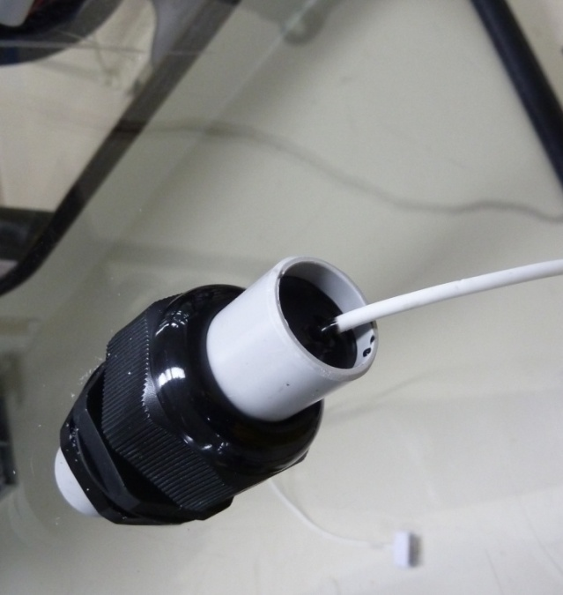
Figure 2 Glove box feed through for digital evidence cables

Other challenges in the examination of contaminated digital evidence were also identified. The first was the size of the glove box port – it would simply not be possible to transfer a desktop computer tower or large laptop computer into the glove box. This can be overcome through in-field removal of the hard drives from their casings; although this approach is generally not preferred it may be required in these circumstances. A further issue was the use of touch-screen devices, which are largely unresponsive when wearing neoprene glove box gloves. This was readily overcome by the use of a stylus. Other fine manipulation of components and tools in the glove box was found to be challenging, an issue which can ultimately only be overcome through experience and practice. A final challenge, which remains outstanding, is that of getting an active mobile network device into a forensically safe state (i.e. SIM removed, in airplane mode, or turned off) inside the glove box. Items can be packaged for transport in such a way that they are shielded from radiofrequency signals, which will prevent their connection to the network. However when this packaging is removed the device may connect to the network, allowing remote alteration or deletion of data, before it can be put in a forensically safe state. In conventional digital evidence examinations this is overcome by the handling of the device at this stage in a Faraday box; however, this is clearly not feasible when the device has to be handled in a glove box. Solutions such as the construction of a glove box which acts as a Faraday box, the conversion of the laboratory structure into a Faraday box or erecting a temporary Faraday cage around the glove box and users as required were determined not to be possible. Various options, including the use of a broadband radiofrequency noise generator (“mobile phone jammer”), femtocell or Faraday tent within the glove box, are currently being considered, although all pose regulatory and/or practical challenges.

Planned Work

Further training
The training and personal dosimetry programs described in Section 2.2 will continue to be implemented as new forensic disciplines work to develop protocols for in-glove box examinations, with refresher training provided as appropriate. In addition, it has been identified that there is a need to extend training beyond those analysts who will work in the NFRF laboratories. Training is to be provided to enhance the confidence of other AFP Forensics staff (such as forensic biologists, fingerprint examiners and forensic exhibit registry staff) who may be involved in the handling or examination of evidence arising from a nuclear security event. Two distinct audiences have been identified:
- Analysts receiving samples, such as DNA extracts, which have been decontaminated in the NFRF
- Analysts receiving samples exposed to radiation but not contaminated.
Custom training will be developed and delivered by ANSTO’s Radiation Protection Advisors, in collaboration with NFRF staff, focusing on areas of radiation safety applicable to these audiences. For example, those handling decontaminated samples will be educated about the ways in which radiation can be measured and thus decontamination effectiveness can be verified, whilst the focus for those handling samples exposed to radiation will be the distinction between radiation exposure and contamination.

Operational implementation of fingermark and DNA examinations
Plans have been devised for the development of operational capabilities for the examination of contaminated fingermark and DNA evidence. This may require the development of new work practices; for example, fingermark examiners and biologist generally work alone on a given exhibit but experience has demonstrated that a team of two examiners working opposite each other is most efficient when operating in the glove box environment.

As previously noted in Section 2.1, the two glove boxes were equipped for examination of fingermarks and DNA at the time at which they were originally retrofitted. However, after consultation with operational law enforcement a number of modifications have been undertaken. The first is an upgrade of the camera system, installing a system identical to that used in the AFP laboratories (Nikon D600 with Nikon AF-S Micro 60mm f2.8G ED (1:1) lens, run with Nikon Camera Control Pro 2). This will have several benefits; image quality will be equal to that produced by the AFP laboratories, the training required for operators will be significantly reduced as they will already be familiar with the system, and the new system is more user-friendly with features such as auto-focus. In addition, the camera stands have also been modified, eliminating the need for a heavy base by affixing them to the base and roof of the glove box. This has created more floor space if the glove box, which has been identified as a need during method development.

Further modifications are also planned. In addition to the still cameras, video cameras are to be fitted to both glove boxes, with feeds to screens situated outside the laboratory. These will allow forensic experts who are not trained in glove box operations to observe and provide feedback and assistance during complex examinations, enable oversight of examinations by investigators and assist with the implementation of As Low As Reasonably Achievable (ALARA) radiation protection principals by allowing non-essential personnel to be located outside the laboratory. Finally, ultraviolet (UV) lights are to be installed in both glove boxes and the cyanoacrylate fuming chamber. UV lights are commonly used in forensic laboratories, including the AFP, for the DNA decontamination of rooms and fingerprint fuming chambers. The UV lights will be fitted into quartz sleeves attached to the glove box, allowing their easy removal for maintenance without compromising the glove box integrity.

DNA decontamination poses a challenge which may not be addressed by UV lights alone. A major problem with their use as a decontamination tool is shadowing; that is, any areas in shadow will not be decontaminated. An alternative means of decontamination is wiping surfaces with a disinfectant such as hypochlorite; however, this technique will also be limited by the reduced flexibility and dexterity of glove box operators. Given these issues, it has been determined that an alternative sample environment is required for the search stage of DNA analysis, where an area of interest is isolated from a large item (e.g. a blood stain on an item of clothing), which is the stage when the risk of contamination of items and/or the work environment is greatest. The proposed solution is the use of a disposable glove bag (CaptAir Pyramid, erlab) customized with a bag out port. This will allow the searching and sub-sampling of items to be done in the glove bag, with samples placed into microcentrifuge tubes and bagged out. The glove bag, still containing the larger item of evidence, can then be stored. The extraction of the sample, a stage at which the risk of DNA cross-contamination between samples is lower, can then be conducted in the glove box. This transfer from a glove bag to a glove box is necessary as there is not sufficient space to accommodate the tools or manoeuvrability within the glove box to complete the extraction process. Although the risk of contamination is lower at this stage, vigorous decontamination protocol utilizing both the UV lights and hypochlorite solutions will be implemented.

A further requirement for the handling of DNA samples in the glove boxes has been the implementation of biosafety protocols in the NFRF as ideally human specimens should be handled in a Physical Containment 2 (PC2) laboratory [9]. Many of the engineering controls required for laboratories handling radioactive material meet or exceed those required for a PC2 laboratory, so major structural changes were not required. However, significant new procedures for the handling of these materials, waste management and spill clean-up were implemented, changes were made to personal protective equipment, staff will undergo training and a health management program (including relevant vaccination) will be applied to all staff that may have contact with these samples. All changes were made in accordance with best practice guidelines (such as Australian Standards) and based on careful risk assessment of relevant activities.

DNA research
As noted in Section 2.1, previous research conducted in collaboration with the NFRF has demonstrated that the commercially available DNA IQ™ System and ChargeSwitch® System extraction kits are effective in removing radioactive contamination from DNA samples [4]. However, this research was limited in scope, considering only caesium-137. More recent research has demonstrated that the ChargeSwitch® System is also effective at removing americum-241, cadmium-109, cobalt-60, uranium and thorium from DNA samples [10]. However, the combined body of research to date does not cover the full range of radioisotopes of security concern, nor has the extraction kit currently used by the AFP, the QIAamp DNA Investigator Kit (Qiagen), been assessed for its effectiveness in removing radioactive contaminants from forensic DNA samples. Thus it was identified that to support the development of operational capabilities for extraction of DNA from contaminated forensic evidence, research should be done to validate the suitability of the QIAamp DNA Investigator Kit for decontamination of DNA samples across a broad range of radioisotopes. Validation studies such as these are vital in ensuring the reliability of forensic evidence and its defensibility in court. The DNA IQ™ System and ChargeSwitch® System will also be included in this study in order to facilitate comparison with previous work and to offer operational alternatives should the QIAamp DNA Investigator Kit be found unsuitable.

The general study design is as follows:
- A known quantity of blood, fixed on filter paper, will be spiked with a standard radioisotope solution. The radioisotopes to be included in this study are those previously identified in the literature as being of security concern: americium-241, cobalt-60, caesium-137, iodine-131, iridium-192 and strontium-85 (a gamma emitting surrogate for strontium-90) [11]. Samples will be prepared in combinations of high and low DNA and radioisotope concentrations. Appropriate blanks will also be prepared to quantify background radiation levels in the samples.
- The DNA will be extracted from samples using manual protocols (i.e. without automation) for the QIAamp DNA Investigator Kit, DNA IQ™ System and ChargeSwitch® System.
- Gamma spectrometry will be performed on extracts to quantify the residual radioactive contamination within samples.
- If radioactivity levels are below safety thresholds, quantification and profiling of the DNA will be performed by the AFP in their conventional forensic laboratories.

Lessons Learned

Understanding of organizational cultures
This project has required and continues to require extensive collaboration between ANSTO, a research organization, and the AFP, a law enforcement organization. Research and law enforcement cultures differ in innumerable ways, and an understanding and acceptance of these differences was vital to the success of this project. An important tool for acquiring this cultural understanding is cross-training; as previously described in Section 2.2 AFP staff participated in ANSTO safety and radiation protection training, and in addition a NFRF staff member undertook the AFP’s forensic induction training. The existence of a Memorandum of Understanding between the two organizations, and the Project Arrangements developed under it, provides a formal structure which guided relationships and communications between the organizations. Finally, the participation in the project of staff from both agencies with long-term collaborative relationships is of benefit.

Potential applicability to non-nuclear security applications
In considering the value of this capability, it became apparent that the ability to handle forensic evidence contaminated with radionuclides may be of value in the investigation of a range of incidents beyond those traditionally considered “nuclear security events” (although they may technically be such). Of the two main “branches” of nuclear forensics – the examination of radioactive or nuclear material and examination of contaminated evidence – the latter is more likely to be called upon in such cases. Radioactive materials are becoming more widespread as more applications are discovered and developing countries become increasingly industrialized, and thus more likely to be encountered by law enforcement. Examples of such incidents which may require this capability are:
- The death of an individual who has undergone brachytherapy [12]
- Violent crime involving a victim who has recently had a nuclear medicine procedure
- An offence at a nuclear medicine clinic
- An accident during the transport of industrial or medical radioisotopes
- Radioactive or nuclear material encountered incidentally at a crime scene [13].
In considering this potential broader range of applications, it becomes clearer that the capability to handle forensic evidence contaminated with radionuclides is of importance to law enforcement.

Importance of a diverse project team
The diverse range of activities required to deliver the outcomes of this project could not be achieved by scientists from one discipline, or even by scientists alone. At the core of the project team iss staff that have expertise in both nuclear science and forensic science, who act as an ‘interface’ between these two, at times, divergent disciplines. However, this is supplemented by forensic scientists from law enforcement, ensuring operationally validated methods are applied that would withstand court testimony. The NFRF is also supported by a wide range of services which provide support across ANSTO, as a nuclear organization, at large; health physics, workplace health and safety, training, regulatory affairs, security and engineering are all crucial to the success of this work. Making use of these existing capabilities also significantly reduces the fiscal, personnel, infrastructure and regulatory demands of this project. However, it remains important for individuals within each organization to be delegated responsibility for coordination of their organization’s capability development activities in order for projects to proceed in a timely manner.

Value of hands-on experience
A key component of this project was creating opportunities for AFP staff of all levels to get hands-on experience conducting forensic examinations in the glove box environment. This allows the full spectrum of staff, from senior decision makers to operational teams, to gain a greater appreciation of the importance of training and experience in this environment. This is far more effective than simply describing the limitations on dexterity and flexibility and ergonomic challenges posed by the glove box. It was recognized that implementation of ad hoc procedures in response to an incident may cause significant safety hazards and regulatory non-compliance as well as compromise the integrity of the evidence.

Accepting limitations
The project seeks to provide a facility for the forensic examination of radionuclide contaminated evidence. Currently capability is focussed on the three highest demand forensic services, namely digital forensics, fingerprints and DNA analysis. All of these disciplines have approached this project with the understanding that the limitation of space, dexterity and access within the glove box will limit the range of procedures that can be undertaken and will require modifications from standard operating procedures, for example, whilst DNA extractions are now automated in most forensic laboratories manual protocols are necessary in the glove box due to space. Hence, in their development of procedures, disciplines have focussed on key procedures and/or those of highest strategic value.

Need for common language
Working at the interface of two scientific disciplines, nuclear science and forensic science, means that there is often no common language. At times, as illustrated in this paper by the word “contaminated”, the same word may have very different meanings. International efforts are moving to combat these challenges; for example, the Nuclear Forensics Lexicon which formed part of the Netherland’s gift basket at the 2014 Nuclear Security Summit is now widely available as a smart phone application. However, practitioners from both disciplines must work together on a smaller scale to develop a workable vocabulary, as well as be alert to the risk of miscommunication which may come with this issue.

Conclusions
The development of a national capability for the handling of forensic evidence contaminated with radionuclides is not a trivial task. As this paper has demonstrated, significant commitment and collaboration by law enforcement (AFP) and research (ANSTO) has been, and continues to be, required to develop credible processes in Australia, with work ongoing in the disciplines of DNA and fingermarks. This project draws upon the full spectrum of expertise in both agencies, and provides learning opportunities that can be applied to future collaborations between the AFP and ANSTO and other agencies.

Acknowledgements
Thank you to Dr Serena Abbondante (AFP) for her continuing thoughtful management of these projects and Adam Sarbutt and Bruce Hudson (ANSTO) for their technical assistance.

References

1. COLELLA, M., et al., The Recovery of Latent Fingermarks from Evidence Exposed to Ionizing Radiation. Journal of Forensic Sciences, 2009. 54(3): p. 583-590.
2. COLELLA, M., et al., The Effect of Ionizing Gamma Radiation on Natural and Synthetic Fibers and Its Implications for the Forensic Examination of Fiber Evidence. Journal of Forensic Sciences, 2011. 56(3): p. 591-605.
3. PARKINSON, A., COLELLA, M., AND EVANS, T., The Development and Evaluation of Radiological Decontamination Procedures for Documents, Document Inks, and Latent Fingermarks on Porous Surfaces. Journal of Forensic Sciences, 2010. 55(3): p. 728-734.
4. ABBONDANTE, S., The effect of radioactive materials on foresic DNA evidence: Procedures and interpretation, 2009, University of Canberra.
5. HOILE, R., et al., Gamma Irradiation as a Biological Decontaminant and Its Effect on Common Fingermark Detection Techniques and DNA Profiling. Journal of Forensic Sciences, 2010. 55(1): p. 171-177.
6. INTERNATIONAL ATOMIC ENERGY AGENCY, Application of Nuclear Forensics in Combatting Illicit Trafficking of Nuclear and Other Radioactive Materials. IAEA TECDOC No 1730 2014, Vienna: IAEA.
7. INTERNATIONAL ATOMIC ENERGY AGENCY, Nuclear Forensics in Support of Investigations 2013, Vienna: IAEA.
8. HOILE, R., et al., Bioterrorism: The effects of biological decontamination on the recovery of electronic evidence. Forensic Science International, 2011. 209(1-3): p. 143-148.
9. AS 2243.3:2010 - Safety in laboratories Part 3: Microbiological safety and containment 2010: Standards Australia.
10. KRAJKO, J., HRNECEK, E., AND MAYER, K. DNA extraction from radioactively contaminated forensic evidence. paper presented at ITWG-16. 2011. Kiev, Ukraine.
11. FERGUSON, C.D., KAZI, T., AND PERERA, J., Commerical Radioactive Sources: Surveying the Security Risks, 2003, Monterey Institute of International Studies - Centre for Nonproliferation Studies: California.
12. EITZEN, D., WILLS, S., AND HOOKER, A. Dealing with the radioactive body. paper presented at 21st International Symposium on the Forensic Sciences. 2012. Hobart, Australia.
13. KEEGAN, E., et al., Nuclear Forensic Analysis of an Unknown Uranium Ore Concentrate Sample Seized in a Criminal Investigation in Australia. Forensic Science International, 2014. 240: p. 111-121.

The term “contamination” may have two meanings in the context of this work, an issue previous identified by the international community [7]. In nuclear science, “’contaminated evidence’ refers to the presence of radioactive material on or within physical evidence” [7]. In forensic science, “‘contaminated evidence’ refers to the direct or indirect transfer of extraneous material to a forensic sample or scene of a crime”[7]. In this paper, the terms “contaminated” or “contamination” will refer to evidence contaminated with radionuclides, whilst more specific descriptions such as “DNA contamination” will be used as appropriate.
A femtocell is a small low-power cellular base station which will connect to a service provider’s network via broadband. Mobile network devices in the vicinity will connect to the femtocell in preference to the broader network, and the femtocell can in turn be configured to not pass these connections to the broader network, isolating the mobile network device from the network.

