|  |
| --- |
| National Nuclear Forensics Library at Japan Atomic Energy Agency |
| Y. Kimura, N. Shinohara, Y. Funatake, M. Watahiki, Y. Kuno |
| Department of Science and Technology for Nuclear Material Management[1], Japan Atomic Energy Agency |

**Abstract:**        Japan Atomic Energy Agency (JAEA) has started R&D on nuclear forensics technology from JFY 2011. One of main topics of the R&D project is to develop national nuclear forensics library (NNFL) and evaluation methodology for interpretation of nuclear material attributions. JAEA has developed a prototype system of nuclear forensics library for future NNFL in Japan (prototype NNFL) based on data related to nuclear materials and other radioactive materials that the JAEA has possessed in the past research activities. A concept building of prototype database on nuclear materials and related nuclear fuel cycle facilities was almost completed with its basic data handling system. As the next step of the prototype NNFL project, it is planned to carry out the development of: prototype database on other radioactive materials; image verification function for microscope images; multivaliate analysis function for seizure analysis; and knowledge accumulation system for nuclear forensics analysis. Data gathering on nuclear materials in JAEA has been also continued and they will be populated into the prototype nuclear meterials database. It is expected that the developed prototype NNFL and its operational methods will be transferred to the responsible authorities after the national framework of nuclear forensics in Japan will be constructed in the near future.

**1. Introduction**

      Illicit trafficking of nuclear materials and other radioactive materials has been an issue of concern in international society since early 1990s. Once the unknown nuclear/radioactive materials are detected and seized from a nuclear security event, the questions such as their origins, history and intended use of the seized materials should be addressed. These questions can be answered by nuclear forensics activity, and it supports to identify the deficiencies to be improved in the national nuclear security system [1].

In November 2009, Governments of Japan and ~~Government of~~ the USA were agreed on “Japan-US Joint Statement toward a World without Nuclear Weapons” at the US-Japan Summit meeting. In this statement, it was declared that the governments intend to expand nuclear non-proliferation, safeguards and security cooperation. It includes the area of nuclear forensics together with others such as nuclear measurement and detection technologies, human resource development, training and infrastructure assistance for countries interested in nuclear energy, and coordination of our respective Member States support programs to IAEA safeguards. Also at the Nuclear Security Summit in 2010 (Washington D.C., USA), the Japan Government issued the national statement to develop the technologies related to measurement and detection of nuclear materials for nuclear forensics within three-years timeframe, and to share them with the international community for the contribution on the strengthening global nuclear security system. In response to the two statements, Japan Atomic Energy Agency (JAEA) that possesses sufficient analytical capabilities to fulfil this nuclear forensics mission has initiated an R&D project on nuclear forensics technology from JFY 2011. One of main topics of the R&D project is to develop prototype system of nuclear forensics library for future NNFL in Japan (prptotype NNFL) and evaluation methodology for interpretation of nuclear material attributions.

This paper describes the current status and future plan on the development of prototype NNFL.

**2. General Concept of NNFL and NNFL Development at JAEA**

     A nuclear forensics library is an organized collection of data and information about nuclear and other radioactive materials produced, used, or stored within a country [2]. The purpose of nuclear forensics activities is to identify the origin, history and intended uses of nuclear and other radioactive materials found and seized from outside of regulatory control. In this context, a nuclear forensics library enables to compare the seized materials with characteristics of known materials to provide information about a material’s origin and history. Therefore, a nuclear forensics library is one of the most important elements in the nuclear forensics activities as a whole (**FIG.I**).



*FIG. I. National nuclear forensics library and nuclear forensics activity*

Recently, the development of nuclear forensics library has been carried out in some countries and the concept of national nuclear forensics library (NNFL) with point-of-contact (POC) is the most popular in current international society [3]. The prototype NNFL project at JAEA also follows this concept. JAEA has continued to develop a prototype system of NNFL based on data related to nuclear materials and other radioactive materials that JAEA has possessed in the past research activities. This is because JAEA is a nuclear research institute and cannot have access to data of all target materials in Japan. It is expected that the prototype system and the knowledge obtained from the development project will be transferred to the future responsible authority after the national nuclear security regime and national response plan in Japan will be established in the future.

**3. Current Status and Future Prospects of the prototype NNFL Development at JAEA**

**3.1 Concrete Concept of an NNFL**

     The development of the prototype NNFL at JAEA was initiated from crystalizing its general concept of nuclear forensics library by regarding it as a “library”. A library is generally defined as a facility or an organization which collects sources of information and provides accesses to them. In the same manner, a nuclear forensics library can be defined as a system which collects and enables to refer data on nuclear materials and other radioactive materials, and the most basic function of a national nuclear forensics can be isolated as “database” and “data query”. The database is an organized collection of data, and it’s corresponding to an organized assembly of bookshelf in a library. The structure of database is to be designed according to its objectives and kinds of collected data. The data query function is corresponding to, for instance, book information terminal or librarian in a library. It is to be designed according to the structure of database appropriately so that an user can obtain necessary information from database rapidly and accurately. According to the crystalizing study on the concept of nuclear forensics library, JAEA has addressed the development of nuclear material database and its basic data query functions for the database in the prototype NNFL as the initial step of the project from 2011 JFY.

**3.2 Nuclear Material Database and Basic Data Query**

     The data items included in the database on nuclear material database, which is utilized to identify the origin, history and intended use of seized materials in nuclear forensics, were studied based on three points of view: requirement of nuclear forensics library; “signatures” for nuclear forensics analysis; and available data sources.

**TABLE 1** shows the requirements of nuclear forensics library and required information related to nuclear materials which is to meet the requirements. The most important requirement of a nuclear forensics library (or nuclear forensics activities) is to identify the seized materials and its origin, history and intended uses. To achieve it, it is required to make all existing nuclear materials in a country into a “catalogue”. It is important to accumulate information like significant characteristics to identify each material and process/usage record to identify the origin and history. Another important requirement is the accumulation and interpretation for the measurement results of nuclear materials. Sample information, measurement data of many kinds of nuclear forensics analysis and the analytical results based on the measurement data were also important information to be accumulated in a nuclear forensics library.

The second view point on the data item study is “signatures” for nuclear forensics analysis. In nuclear forensics, various kinds of analysis will be made for one seized materials to find out　its identity, and the discriminative characteristics of the material is usually called as signature. The discriminative characteristics of nuclear materials in a country can be made clearly by determination of nuclear fuel cycle processes and their product materials [4]. JAEA has various facilities which can cover almost all stages of a nuclear fuel cycle, and it was found that the discriminative characteristics of nuclear materials in each stage can be categorized into 6 classes;

* Physical (e.g. density, colour, transparency and brashness),
* Chemical (e.g. chemical form, major element and chemical homogeneity),
* Impurities,
* Isotope compositions,
* Microstructure (e.g. particle shape, size and crystal structure), and
* Others (e.g. container and serial No.).

TABLE I: REQUIREMENTS OF NUCLEAR FORENSICS LIBRARY

|  |  |  |
| --- | --- | --- |
| **Requirements** | **Necessary Data Types** | **Necessary System Functions** |
| Collection of Information on NMs | * General Information  (Facility, Process, Process Duration, Intended Use, History, Shape etc…) * Material Data  (Elemental, Isotopic, Chemical, Physical, Microscopic etc…) | * Data Entry, Search, Update |
| Interpretation and Accumulation of NF Measurement Data | * Sample General Information  (Archive, Collected Situation, Transportation etc…) * Measurement Data  (Sample Shape, Chemical, Physical, Elemental, Isotopic, Microscopic, Radiation, Analyst, Uncertainty etc…) * Burnup Analysis Data * Age Determination Data | * Analysis Data Entry, Search, Update * Graphing * Age Calculation by Analysis Data * Statistical Analysis |

**TABLE II** shows the example of discriminative characteristics in the stage of uranium fuel fabrication process. A seized material will be analysed and identified by one or some of these characteristics in nuclear forensics analysis.

TABLE II: DISCRIMINATIVE CHARACTERISTICS IN URANIUM FUEL FABRICATION

|  |  |  |
| --- | --- | --- |
| Process | | Uranium Fuel Fabrication |
| Target Materials | | UO2 Powder, Pellet, Cladding |
| Key Material Characteristics | Physical | Dimension, Density, Radioactivity, Reflected Color, Transmitted Color, Absorbance, Cladding, O/M, Porosity, Mechanical Properties, Corrosion |
| Chemical | Chemical Form/Compound, Homogeneity, Inclusions (Organic Substance), Water Amount |
| Impurities | U [Gd (Gd2O3), F, Al, Ba, Bl, Ca, Ce, Cr, Fe, K, La, Mg, Mn, Mo, Na, Nb, Nd, Ni, P, Pb, Pr, Sr, Th, Tl, W, Y, Yb, Ru, Zn, Zr, Dy, Dr, Hf, Ho, La, Tb, B, U…] Cladding [Sn, Fe, Cr, Ni, Fe+Cr, Fe+Cr+Ni, O, Al, B, Ca, Cd, C, Co, Cu, Hf, H, Mg, Mn, Mo, Ni, Nb, N, Si, Ti, W, U...] |
| Isotopic | U-234/U-235/(U-236)/U-238, U-234/Th-230,  U-235/Pa-231, (U-236/Th-232), O-16/O-18 |
| Microscopic | Powder Av., Max., Min. Sizes, Powder Shape Homogeneity, Powder Aspect Ratio, Surface Roughness, Weld |
| Others | Container, Model No., Serial No., He Pressure (Rod) |

The third view point on the data item study is available data sources. In many cases, the raw material data to be registered in a nuclear forensics library comes in a variety of formats (e.g., electronic/hard copy, various units). Therefore, to ensure successful data processing and database compiling, it is necessary to perform a preliminary survey on existing materials. A good preliminary survey makes it possible to know the variety and amount of target materials, relevant data, and other related information. The variety forms of data sources in JAEA were collected, and their availability and priority for data-collecting were assessed. Available information for a nuclear forensics library was found out in many kinds of data sources;

* Nuclear fuel design standards,
* QC standard and analysis data,
* Post irradiation experiments data,
* Fuel cycle process and facility information, and
* Material accounting data.

It was found that the first three types of information are especially useful as the data source of a library because many discriminative characteristics of nuclear materials are summarized in them. The material accounting data, on the other hand, was found to be comparatively unuseful for nuclear forensics purpose since the data is limited to the fissile isotopes for safeguard program. Furthermore, some of the other data, which cannot be collected from existing data sources for some reason like storage limitation, could be complemented by computation analysis and additional analysis of remaining material samples.

**FIGURE II** shows the overview structure of the nuclear material database [5] and the example of user interface of the prototype system of the NNFL developed in JAEA was shown in **FIGRE III**.



*FIG. II. Overview structure of the nuclear material database*

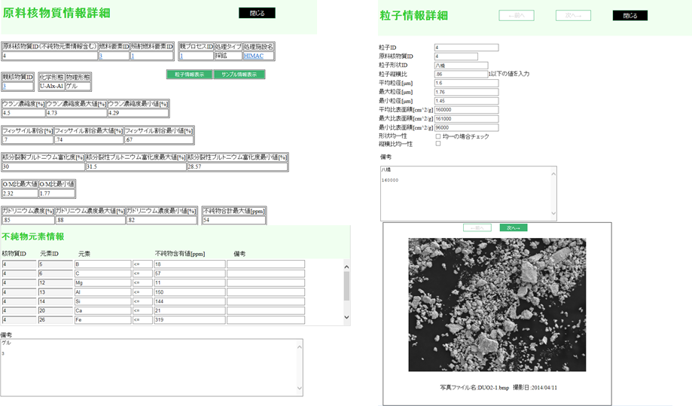

*FIG. III. Prototype system of the NNFL at JAEA*

The number of data items in the nuclear material database is about 550 items, and they are divided into about 70 tables. The data structure was designed based on relational database structure and it consists of two small databases. The first of these databases was named Nuclear Fuel & Fuel Cycle DB and stores raw nuclear materials data and product nuclear fuels in addition to information on their parent processes and parent fuel cycle facilities. The second database was named Sample & Analysis DB, which stores analysis results of nuclear forensics data, quality control, material accounting, and other datasets.

**3.3 Future Plan**

     Currently, the development of nuclear material database and its associated system for data query has been almost completed and the prototype system of NNFL at JAEA will be improved by some development items as follows:

* Computational evaluation tool for nuclear forensics analysis (e.g. multicomponent analysis tool),
* Database of other radioactive materials, and
* “Knowledge base” for the NNFL system.

The data-collecting in JAEA will be also continued. Although it is expected that the present prototype system will be transferred to the future national responsible authority for nuclear forensics activities in Japan, the establishment of national nuclear security system including national response plan is remained as a big challenge.

**4. Conclusion**

     JAEA has continued to develop a prototype system of nuclear forensics library for future NNFL in Japan based on data related to nuclear materials and other radioactive materials that JAEA has possessed in the past research activities as one of main topics of the R&D project for nuclear forensics technology. The nuclear material database in the prototype NNFL has been developed with its associated system for data query from 2011 JFY and it has been almost completed. It is expected that the prototype NNFL will be transferred to the future national responsible authority for nuclear forensics activities in Japan, but the establishment of national nuclear security system including national response plan is remained as a big challenge.

**REFERENCES**

|  |  |
| --- | --- |
| [1] | IAEA, “Nuclear Forensics Support,” IAEA Security Series No.2 (2006). |
| [2] | J.F. WACKER, et. al. “Proposed Framework for National Nuclear Forensics Libraries and International Directions,” PNNL-SA-70589 (2011). |
| [3] | Presentation Material in PAS-21 National Nuclear Forensics Library  Workshop, Tokai, Japan, 14-15 May (2012). |
| [4] | IAEA, “DEVELOPMENT OF A NATIONAL NUCLEAR FORENSICS LIBRARY,” Draft of IAEA Nuclear Security Series NO.XX (2013). |
| [5] | Y. KIMURA. et. al, to be submitted (2014). |

1. Present Department: Integrated Support Center for Nuclear Nonproliferation and Nuclear Security (ISCN)